Supplementary Information
Figures
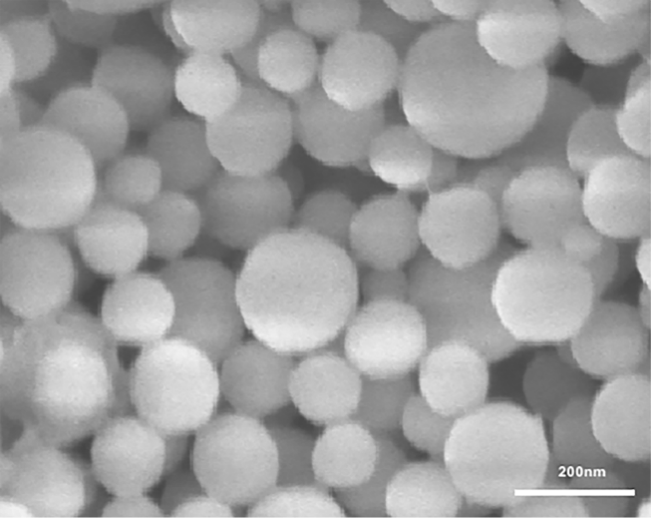
Figure S1. SEM image of L-(CaP-ZnP) NPs.
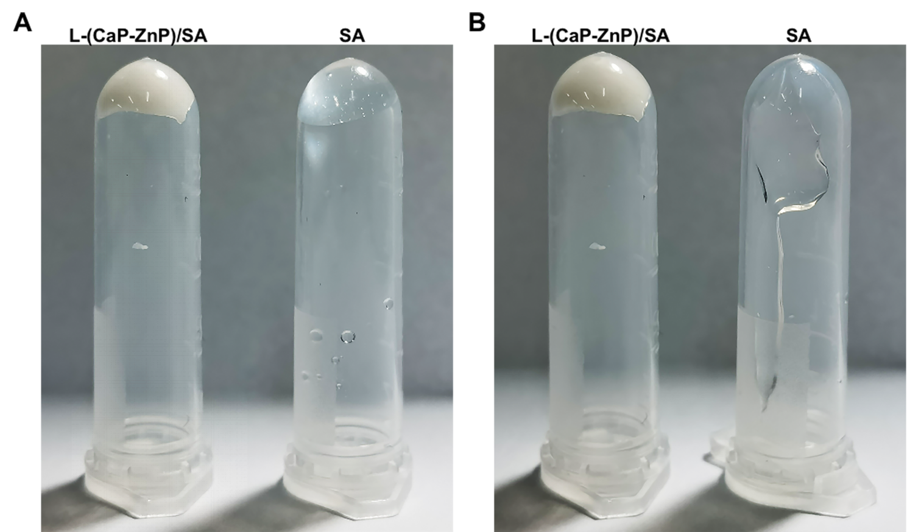
Figure S2. The Comparison of Viscosity between L-(CaP-ZnP)/SA nanocomposite hydrogel and SA hydrogel at room temperature. (A) 0 minute (B) After 10 minutes.
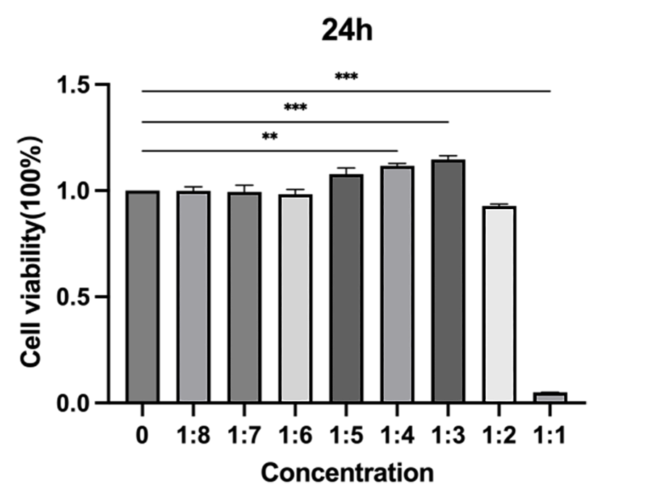
Figure S3. Cytotoxicity of the L-(CaP-ZnP)/SA nanocomposite hydrogel towards hDPSCs with a co-incubation time of 24h.
Error bars indicate mean ± standard deviation. Asterisks indicate statistically significant differences (**P < 0.01, and ***P < 0.001).
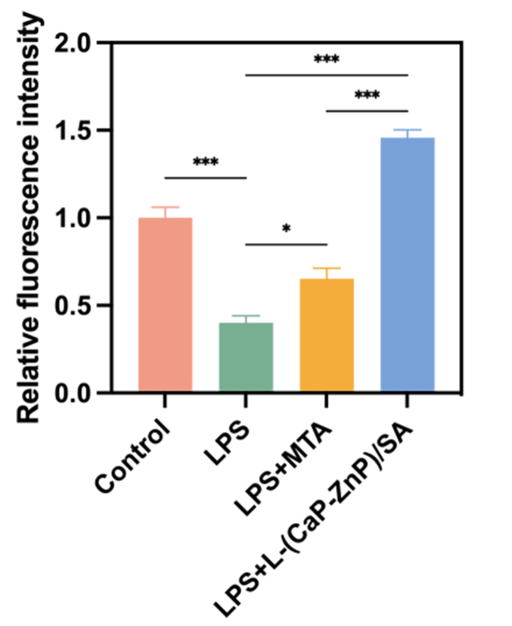
Figure S4. Quantitative calculation of Runx2 fluorescence intensity related to Figure 4C. Error bars indicate mean ± standard deviation. Asterisks indicate statistically significant differences (*P < 0.05, and ***P < 0.001).
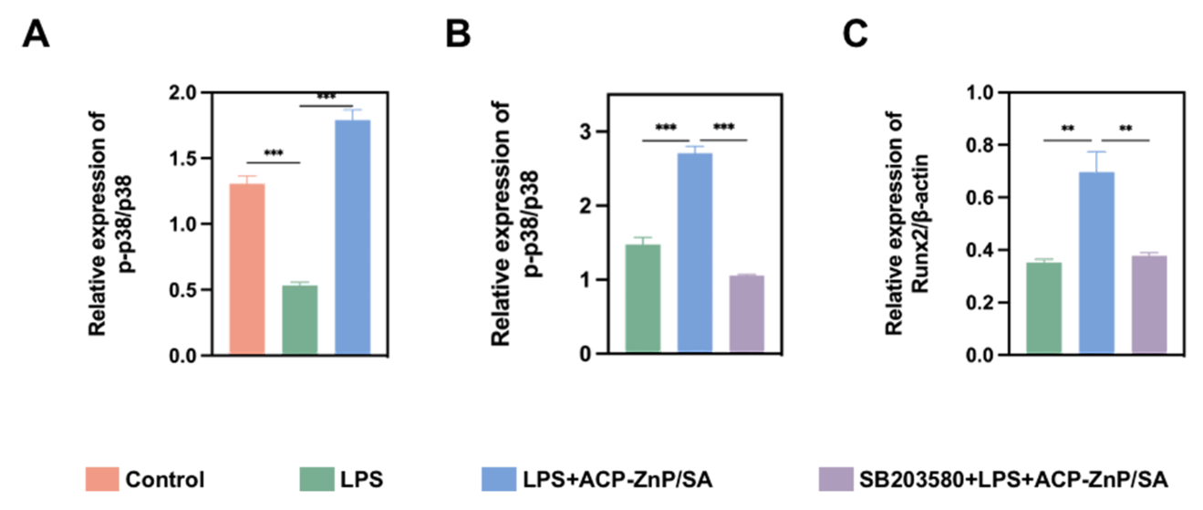
Figure S5. Semiquantitative protein expression related to Figure 5A-C. (A, B) Semiquantitative analysis of p-p38 and p38 protein expression. (C) Semiquantitative analysis of Runx2 protein expression. Error bars indicate mean ± standard deviation. Asterisks indicate statistically significant differences (**P < 0.01, and ***P < 0.001).
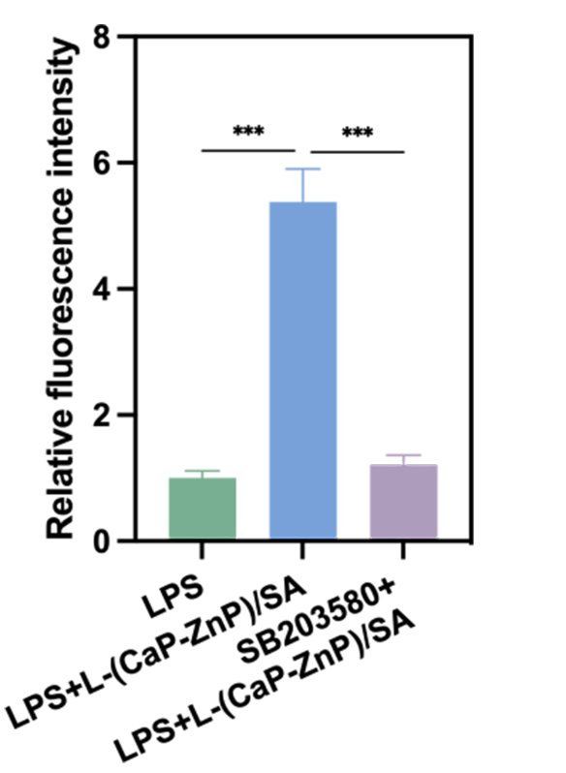
Figure S6. Quantitative calculation of Runx2 fluorescence intensity related to Figure 5H. Error bars indicate mean ± standard deviation. Asterisks indicate statistically significant differences (***P < 0.001).

Table S1. Primers of genes for qRT-PCR
Gene name | Forward Premier (from 5’-3') | Reverse Premier（from 5’-3'）
Human GAPDH | GGAGCGAGATCCCTCCAAAAT | GGCTGTTGTCATACTTCTCATGG
Human DSPP | AAAGTGGTGTCCTGGTGCAT | CCTGGATGCCATTTGCTGTG
Human DMP1 | TTCCTCTTTGAGAACATCAACCTG | ACTCACTGCTCTCCAAGGGT
Human BSP | CACTGGAGCCAATGCAGAAGA | TGGTGGGGTTGTAGGTTCAAA
Human ALP | ATCTTCCTGGGCGATGGGAT | CCACATATGGGAAGCGGTCC
Human Runx2 | CACTGGCGCTGCAACAAGA | CATTCCGGAGCTCAGCAGAATAA
Human OPN | GAAGTTCTGAGGAAAAGCAGC | GGACTTACTTGGAAGGGTCTCT
Human IL-1β | TGGCTTATTACAGTGGCAATGAGGATG | TGTAGTGGTGGTCGGAGATTCGTAG
Human IL-6 | GGTGTTGCCTGCTGCCTTCC | GTTCTGAAGAGGTGAGTGGCTGTC
Human TNF-α | CGTGGAGCTGGCCGAGGAG | AGGAAGGAGAAGAGGCTGAGGAAC
Mouse GADPH | AGGTCGGTGTGAACGGATTTG | GGGGTCGTTGATGGCAACA
Mouse IL-1β | ATGAAGGGCTGCTTCCAAAC | TCTCCACAGCCACAATGAGT
Mouse IL-6 | GGAGCCCACCAAGAACGATA | ACCAGCATCAGTCCCAAGAA
Mouse TNF-α | CTCATGCACCACCATCAAGG | ACCTGACCACTCTCCCTTTG
Mouse IL-10 | CTGGACAACATACTGCTAACCG | GGGCATCACTTCTACCAGGTAA
Mouse Arg-1 | TGGCTTGCGAGACGTAGAC | GCTCAGGTGAATCGGCCTTT

