Supplement Information
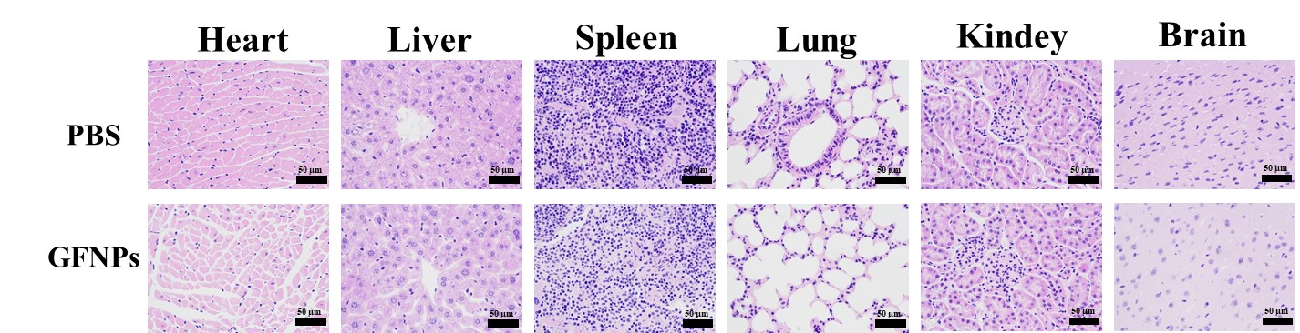
Fig. S1 HE staining after mice injected with GFNPs and PBS. Scale bar = 50 µm.
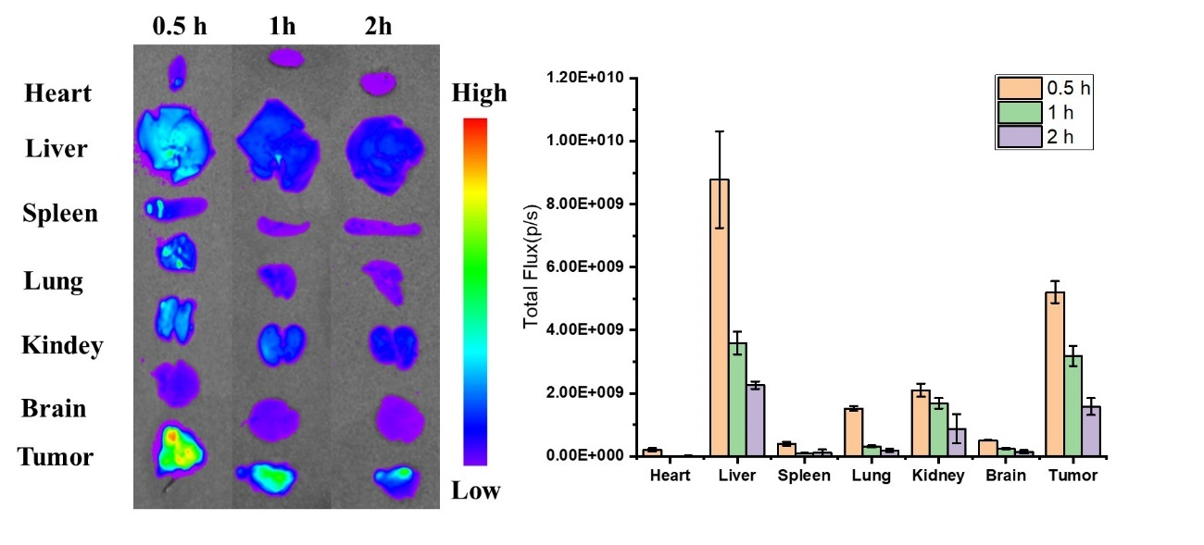
Fig. S2 GFNPs body metabolism from 0.5 h to 2 h. Data was exhibited as the Mean ± SEM. n=5. * p < 0.05, ** p < 0.01.
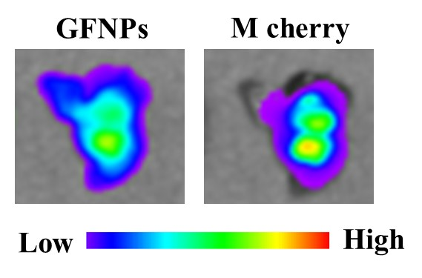
Fig. S3 GFNPs tissue fluorescence imaging in tumor tissue formed by M cherry marked SW1990 cells.
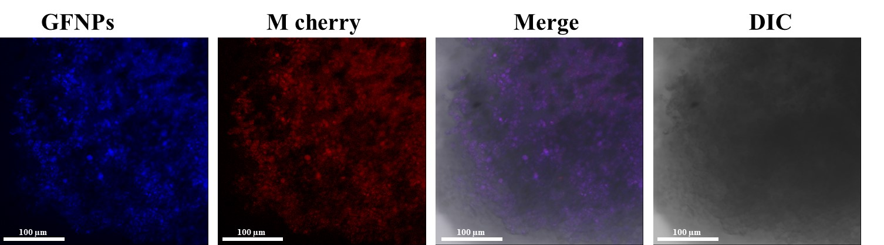
Fig. S4 GFNPs fluorescence imaging in spheroid formed by M cherry marked SW1990 cells. Scale bar = 100 µm.

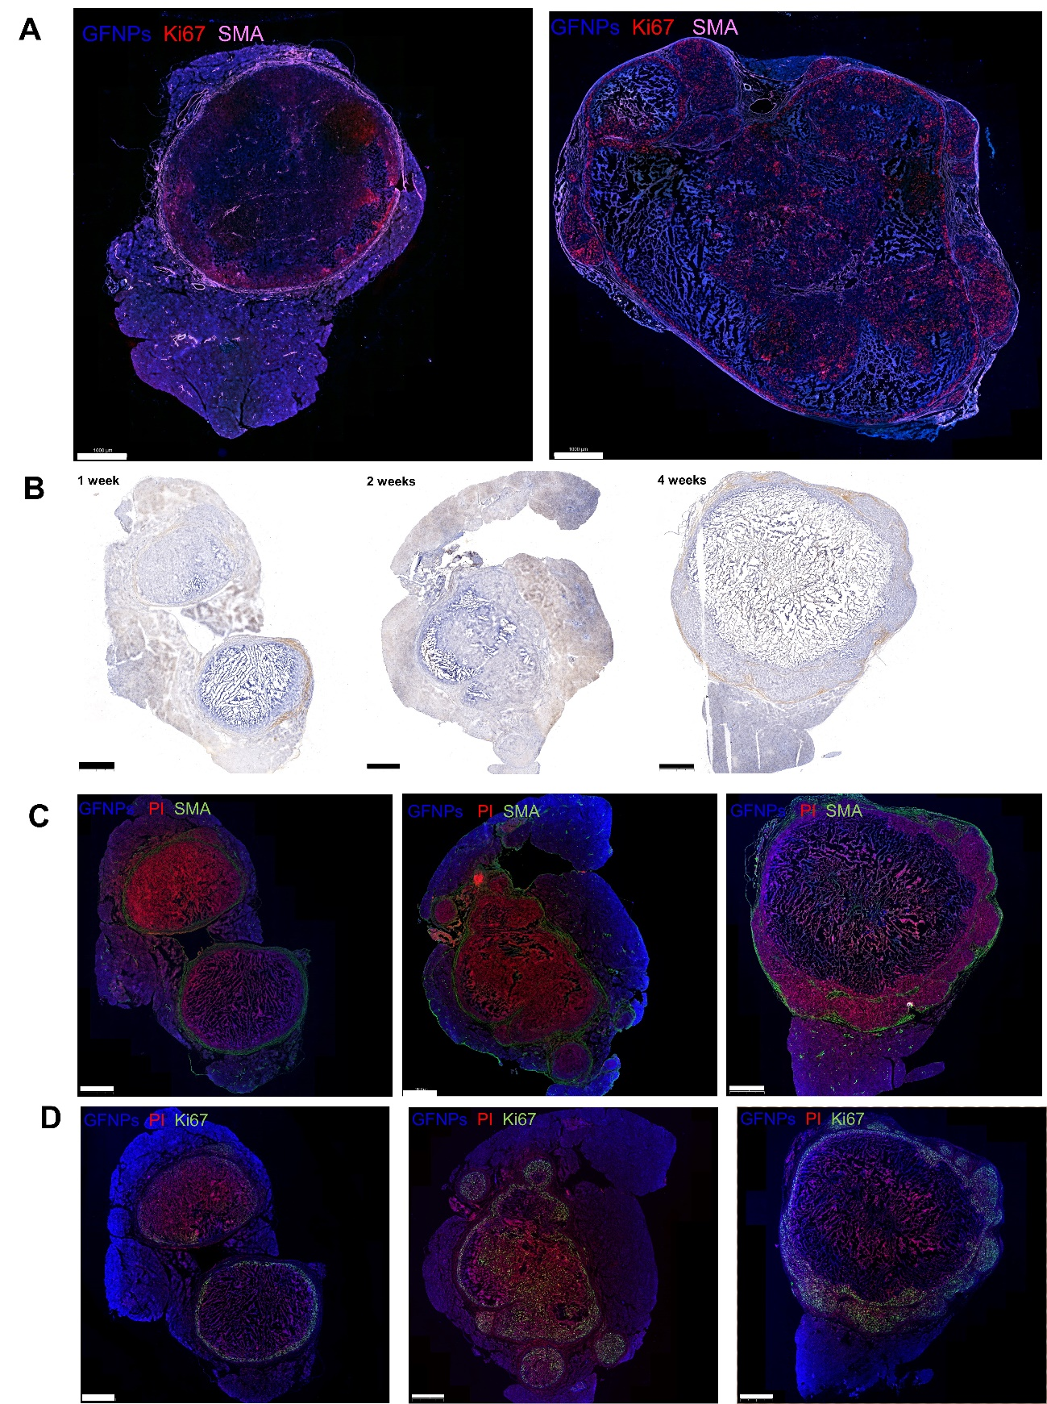
Fig. S5 (A) Immunofluorescence scans of 2 and 4 weeks orthotopic transplanted pancreatic tumor tissue. Blue-GFNPs, Red-PI, Green-SMA. (B) Immunohistochemical tracings of SMA in orthotopic transplanted pancreatic tumor tissue at 1, 2 and 4 weeks. (C) Immunofluorescence scans of 1, 2 and 4 weeks orthotopic transplanted pancreatic tumor tissue. Blue-GFNPs, Red-PI, Green-SMA. (D) Immunofluorescence scans of 1, 2 and 4 weeks orthotopic transplanted pancreatic tumor tissue. Blue-GFNPs, Red-PI, Green-Ki67. Scale bar = 1000 µm.
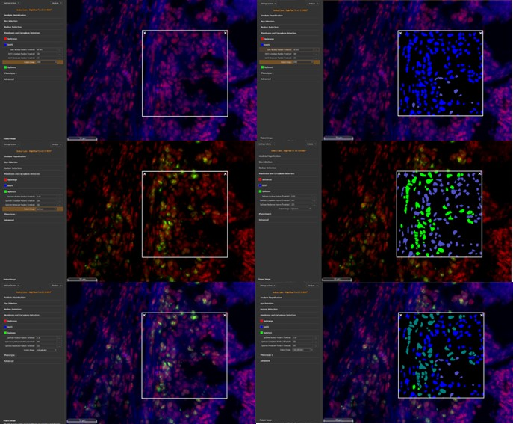
Fig. S6 Display diagram of the application of the analysis software.
Fig. S7 GFNPs in vitro fluorescence imaging. (A)blank. (B)Air exposure to change SW1990 cells membrane permeability. (C-D) GFNPs fluorescence imaging in spheroid formed by SW1990 cells. Scale bar = 20 µm.

Fig. S8 GFNPs fluorescence signal intensity was proportional to the tumor proliferation cycle. Data was exhibited as the Mean ± SEM. n=5.
Table S1 Clinical information for patients with pancreatic cancer. Ethical Number: CHEC2022-018.
