Supplementary Material
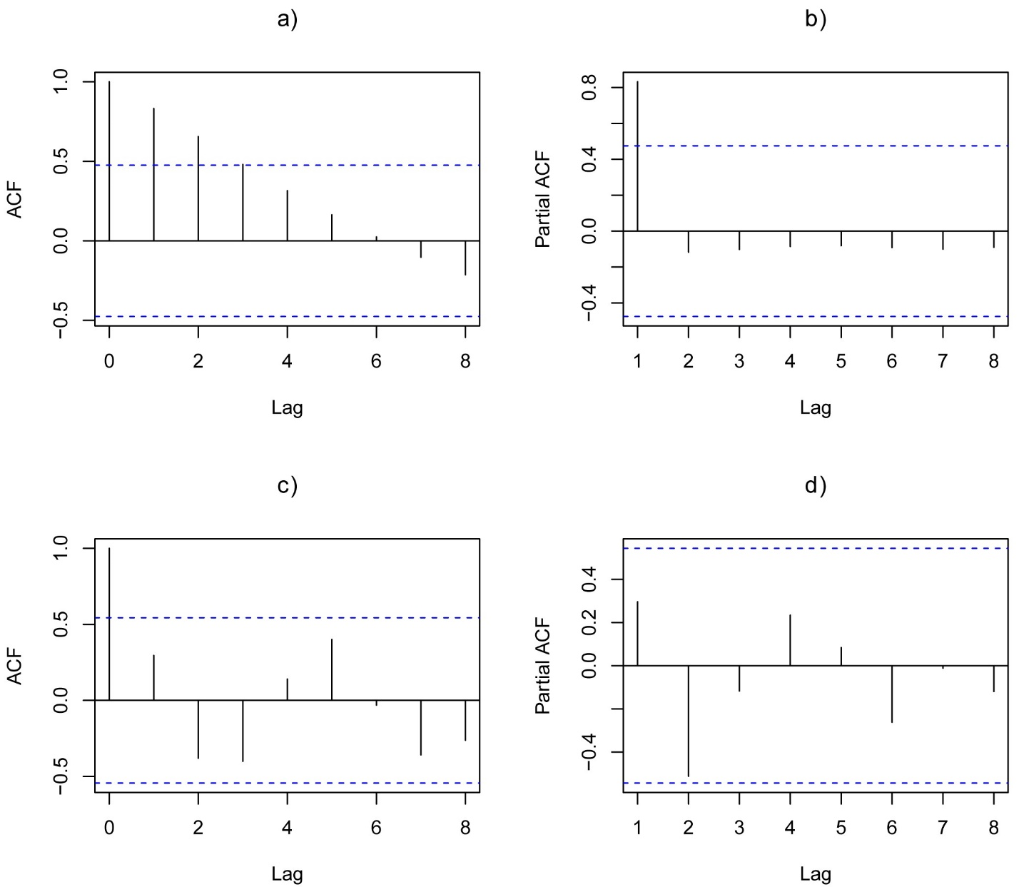
Fig S1: a) Sample autocorrelation function (ACF), b) sample partial autocorrelation function (PACF), c) smoothed autocorrelation function and d) smoothed partial autocorrelation function plots

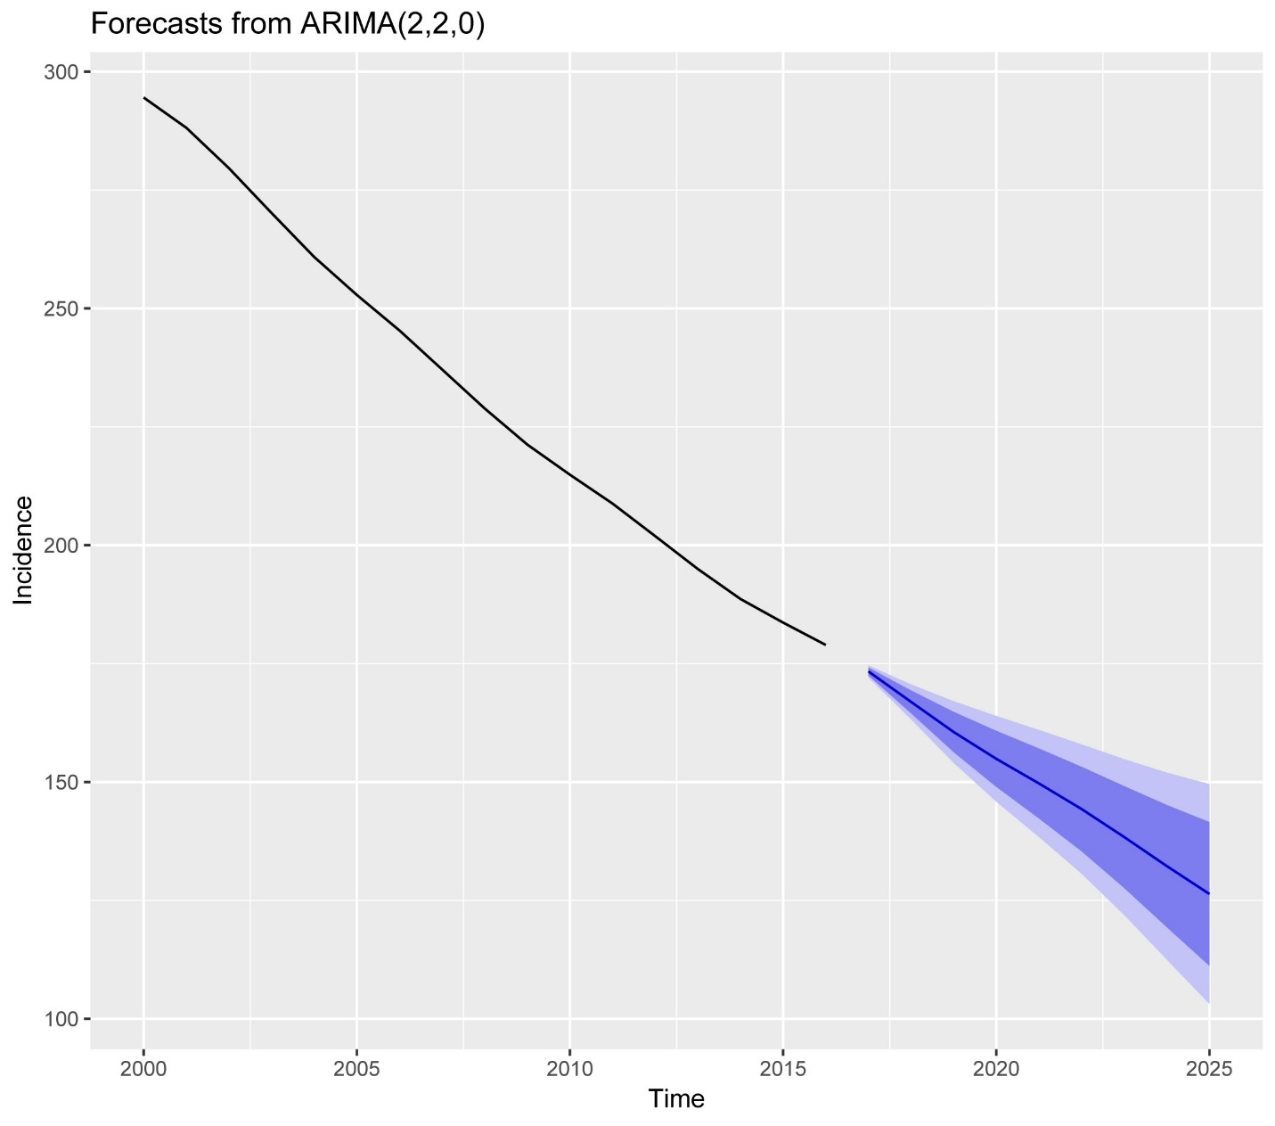

Fig S2. One-step ARIMA forecasts computed using rolling origin cross-validation (January 2000 to December 2016); ARIMA= autoregressive integrated moving average.

R Scripts
# Arima Time series analysis

> library(tseries)
> library(fpp2)
> library(forecast)
> attach(TB_2000)

> TB<-window(ts(TB_2000$Tbinci,start = 2000))
> # Number of observations
> obs<-14
> # Forecast horizon and define number of origins
> h<-1
> origins<-3
> datavalues <- setNames(vector("list",3),
+ c("actuals", "holdout","mean"))
> datavalues$actuals<-TB
> datavalues$holdout<-
+ datavalues$mean<- matrix(NA, h, origins,
+ dimnames = list(paste0("h",1:h),
+ paste0("origin",1:origins)))
> for (i in 1:origins) {
+ # fit the model
+ testmodel <-auto.arima(TB[1:(obs+i-origins-h)])

+ # drop the in sample observations and extract the first h observations

+ datavalues$holdout[,i] <- head(TB[-c(1:(obs-origins+i-h))], h)

+ # Produce forecast and write down the mean values
+ datavalues$mean[,i] <-forecast(testmodel, h=h)$mean
+ }
> datavalues$holdout

> # Get the forecast values
> datavalues$mean
> # Measure the forecast Accuracy
> # Calculate Errors
> errors<- datavalues$holdout-datavalues$mean
> errors
> boxplot(errors)
> library(MLmetrics)

> ME<-apply(errors,2,mean)
> RMSE<-sqrt(apply(errors^2,2,mean))
> MAE<-apply(abs(errors),2,mean)
> MAPE<- mean(abs(errors/datavalues$holdout) * 100)
> res<-rbind(ME,RMSE, MAE,MAPE)
> print(res)

> # Lets check the choosen data set (200-2016) option1

> library(tseries)
> TB<-window(ts(TB_2000$Tbinci,start = 2000))
> View(TB)
> train_best<-window(TB,end= 2016)
> par(mar = c(2,2,2,2))
> # common marigin
> par(mar = c(5.1,4.1, 4.1, 2.1))
> plot(TB,xlab ="Year",main= "Incidence",
+ ylim = c(150,300),col="red",lwd=2)
> adf.test(train_best)
> par(mfrow=c(2,2))
> par(mar = c(5.1,4.1, 4.1, 2.1))
> plot(train_best)
> acf(train_best, lag.max=8, main= "a)")
> pacf(train_best, lag.max=8, main= "b)")
> a<-diff(train_best, differences = 2)
> plot(a)
> adf.test(a)
> pacf(a, lag.max=8, main= "d)")
> auto.arima(train_best)
> fit.a<- auto.arima(train_best)
> summary(fit.a)

> hist(fit.a$residuals)
> checkresiduals(fit.a)
> autoplot(fit.a$residuals)
> Box.test(fit.a$residuals)
> autoplot(forecast(fit.a, h=9), lwd=2)
> autoplot(forecast(fit.a, h=9, xlab="Year", ylab="Incidence"))

## SEIRD model with demographics
> # **********************
> # During the war: SEIRD Model prediction

> library(deSolve)

> require(deSolve)

> SEIRD <- function(time, current_state, params){
+ with(as.list(c (current_state, params)),{
+ N <- S+E+I+R+M
+ dS <- ((phi)-(beta*S*I)/N -(mu*S)) +(gamma2*I+gamma1*E)
+ dE <- (0.95*(beta*S*I)/N) - (sigma*E) - (gamma1*E)-(mu*E)
+ dI <- (0.05*(beta*S*I)/N)+(sigma*E) - (gamma2*I) - (nu*I)-(mu*I)
+ dR <- (gamma2*I)+(gamma1*E) -(mu*R)
+ dM <- (mu*S) +(mu*E) + (mu*I) + (nu*I)+ (mu*R)
+
+ return (list(c (dS, dE, dI, dR, dM)))
+ })
+ }
> params <- c (phi= 0.03, mu=0.032, beta=0.3,
+ sigma=0.05, gamma1=0.19, gamma2=0.5, nu=0.389)
> initial_state <- c(S=4252965, E=1949713, I=11076, R=7088, M=1630)
> times <- 0:5
> mode.fit <- ode(initial_state, times, SEIRD, params)
> summary(mode.fit)
# exporting model out put as csv
> write.csv(mode.fit, "SEIR.fit data.csv")

