Table S1. Liver hepatocellular carcinoma（LIHC）Dataset Information list.
 | TCGA-LIHC | GSE25097 | GSE46408 | GSE84402
Platform |  | GPL10687 | GPL4133 | GPL570
Species | Homo sapiens | Homo sapiens | Homo sapiens | Homo sapiens
Samples in Normal group | 50 | 243 | 6 | 14
Samples in LIHC group | 374 | 268 | 6 | 14
Reference |  | [12] | [7] | [8]
LIHC: Liver hepatocellular carcinoma.

Table S2. GO enrichment analysis results of NMRDEGs.
Ontology | ID | Description | GeneRatio | BgRatio | pvalue | p. adjust
BP | GO: 0072524 | pyridine-containing compound metabolic process | 15/33 | 38/18800 | 1.6e-33 | 1.9e-30
BP | GO: 0019362 | pyridine nucleotide metabolic process | 14/33 | 32/18800 | 4.83e-32 | 1.92e-29
BP | GO: 0046496 | nicotinamide nucleotide metabolic process | 14/33 | 32/18800 | 4.83e-32 | 1.92e-29
BP | GO: 0019359 | nicotinamide nucleotide biosynthetic process | 13/33 | 28/18800 | 3.61e-30 | 8.61e-28
BP | GO: 0019363 | pyridine nucleotide biosynthetic process | 13/33 | 28/18800 | 3.61e-30 | 8.61e-28
MF | GO: 0016763 | pentosyltransferase activity | 8/33 | 49/18410 | 1.82e-14 | 2.21e-12
MF | GO: 0008253 | 5'-nucleotidase activity | 5/33 | 13/18410 | 1.72e-11 | 1.04e-09
MF | GO: 0008252 | Nucleotidase activity | 5/33 | 15/18410 | 4e-11 | 1.61e-09
MF | GO: 1990404 | NAD+-protein ADP-ribosyltransferase activity | 5/33 | 20/18410 | 2.05e-10 | 6.2e-09
MF | GO: 0003950 | NAD+ ADP-ribosyltransferase activity | 5/33 | 23/18410 | 4.43e-10 | 1.07e-08
NMRDEGs: Nicotinamide metabolism-related differentially expressed genes.
GO: Gene Ontology. BP: biological process. CC: cellular component. MF: molecular function.

Table S3. KEGG enrichment analysis results of NMR DEGs.
Ontology | ID | Description | GeneRatio | BgRatio | pvalue | p. adjust
KEGG | hsa00760 | Nicotinate and nicotinamide metabolism | 21/27 | 36/8164 | 6.05e-48 | 3.21e-46
KEGG | hsa01232 | Nucleotide metabolism | 8/27 | 85/8164 | 1.87e-10 | 4.95e-09
KEGG | hsa00240 | Pyrimidine metabolism | 7/27 | 58/8164 | 5e-10 | 8.84e-09
KEGG | hsa00230 | Purine metabolism | 7/27 | 128/8164 | 1.35e-07 | 1.79e-06
KEGG | hsa01240 | Biosynthesis of cofactors | 5/27 | 153/8164 | 0.0001 | 0.0013
NMRDEGs: Nicotinamide metabolism-related differentially expressed genes.
KEGG: Kyoto Encyclopedia of Genes and Genomes .

Table S4. GSEA analysis of TCGA-LIHC.
ID | setSize | enrichmentScore | NES | pvalue | p. adjust | qvalue
REACTOME_COMPLEMENT_CASCADE | 57 | -0.8375431 | -3.255242 | 1e-10 | 5.99e-09 | 4.48e-09
KEGG_RETINOL_METABOLISM | 62 | -0.8132315 | -3.197013 | 1e-10 | 5.99e-09 | 4.48e-09
KEGG_DRUG_METABOLISM_CYTOCHROME_P450 | 69 | -0.7682903 | -3.041438 | 1e-10 | 5.99e-09 | 4.48e-09
REACTOME_BIOLOGICAL_OXIDATIONS | 217 | -0.6284499 | -3.004459 | 1e-10 | 5.99e-09 | 4.48e-09
REACTOME_DRUG_ADME | 95 | -0.7079259 | -2.973698 | 1e-10 | 5.99e-09 | 4.48e-09
KEGG_COMPLEMENT_AND_COAGULATION_CASCADES | 69 | -0.7448710 | -2.948727 | 1e-10 | 5.99e-09 | 4.48e-09
REACTOME_ASPIRIN_ADME | 42 | -0.7907808 | -2.886034 | 1e-10 | 5.99e-09 | 4.48e-09
WP_COMPLEMENT_AND_COAGULATION_CASCADES | 58 | -0.7388804 | -2.876955 | 1e-10 | 5.99e-09 | 4.48e-09
KEGG_METABOLISM_OF_XENOBIOTICS_BY_CYTOCHROME_P450 | 67 | -0.7263567 | -2.861686 | 1e-10 | 5.99e-09 | 4.48e-09
REACTOME_PHASE_I_FUNCTIONALIZATION_OF_COMPOUNDS | 104 | -0.6638046 | -2.838928 | 1e-10 | 5.99e-09 | 4.48e-09
GSEA: Gene Set Enrichment Analysis.

Table S5. GSVA analysis results of TCGA-LIHC.
 | logFC | AveExpr | t | P.Value | adj.P.Val
HALLMARK_DNA_REPAIR | -0.521132148 | -0.029307063 | -12.47955862 | 8.43E-31 | 4.21E-29
HALLMARK_TNFA_SIGNALING_VIA_NFKB | 0.560586271 | -0.021469335 | 12.38289642 | 2.06E-30 | 5.15E-29
HALLMARK_XENOBIOTIC_METABOLISM | 0.578191415 | 0.01167253 | 11.52092775 | 5.15E-27 | 8.59E-26
HALLMARK_INFLAMMATORY_RESPONSE | 0.511789761 | -0.00557134 | 11.45304306 | 9.43E-27 | 1.13E-25
HALLMARK_MYC_TARGETS_V1 | -0.580054582 | -0.028502056 | -11.41892891 | 1.28E-26 | 1.13E-25
HALLMARK_KRAS_SIGNALING_UP | 0.426874623 | 0.002908456 | 11.41184043 | 1.36E-26 | 1.13E-25
HALLMARK_HYPOXIA | 0.399263859 | -0.009095682 | 11.23571756 | 6.44E-26 | 4.18E-25
HALLMARK_COAGULATION | 0.529372843 | 0.010473853 | 11.23149489 | 6.68E-26 | 4.18E-25
HALLMARK_ESTROGEN_RESPONSE_EARLY | 0.355090111 | 0.007273318 | 10.76224947 | 3.94E-24 | 1.97E-23
HALLMARK_E2F_TARGETS | -0.605429905 | -0.039246457 | -10.76212488 | 3.95E-24 | 1.97E-23
HALLMARK_ESTROGEN_RESPONSE_LATE | 0.324406581 | 0.01096607 | 10.63836869 | 1.14E-23 | 5.18E-23
HALLMARK_IL2_STAT5_SIGNALING | 0.398405687 | -0.00827816 | 10.57845472 | 1.90E-23 | 7.90E-23
HALLMARK_UNFOLDED_PROTEIN_RESPONSE | -0.42088559 | -0.039898681 | -10.56201614 | 2.18E-23 | 8.39E-23
HALLMARK_KRAS_SIGNALING_DN | 0.312921984 | 0.046053609 | 10.53960576 | 2.64E-23 | 9.42E-23
HALLMARK_COMPLEMENT | 0.387402295 | -0.001795298 | 10.06699233 | 1.38E-21 | 4.60E-21
GSVA: Gene Set Variation Analysis.

Table S6. Univariate and Multivariate Cox regression.
Characteristics | Total (N) | Univariate analysis |  |  | Multivariate analysis
Characteristics | Total (N) | Hazard ratio (95% CI) | P value |  | Hazard ratio (95% CI) | P value
NAXE | 373 | 1.416 (1.120 - 1.789) | 0.004 |  | 1.389 (1.044 - 1.846) | 0.024
NADSYN1 | 373 | 1.615 (1.112 - 2.344) | 0.012 |  | 1.270 (0.850 - 1.896) | 0.243
NT5C | 373 | 1.302 (1.066 - 1.591) | 0.010 |  | 1.048 (0.827 - 1.327) | 0.700
PNP | 373 | 1.389 (1.095 - 1.762) | 0.007 |  | 1.285 (0.987 - 1.674) | 0.063
NT5E | 373 | 1.142 (0.976 - 1.335) | 0.097 |  | 1.187 (1.010 - 1.396) | 0.037
NT5C3A | 373 | 1.582 (1.222 - 2.048) | < 0.001 |  | 1.317 (0.985 - 1.763) | 0.064
CI, confidence interval.
Supplement Figures:
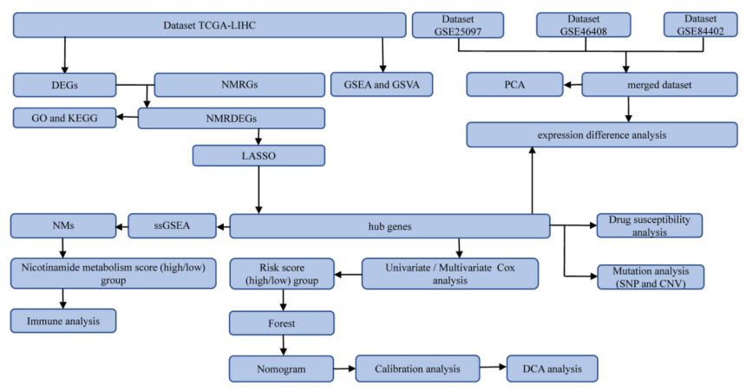
Figure S1 Flowchart of the overall research.
TCGA: The cancer genome atlas. LIHC: Liver hepatocellular carcinoma. DEGs : differentially expressed genes. NMRDEGs: Nicotinamide metabolism-related differentially expressed genes. NMRGs: Nicotinamide metabolism-related genes. GO: Gene Ontology. KEGG: Kyoto Encyclopedia of Genes and Genomes. GSEA: Gene Set Enrichment Analysis. GSVA: Gene Set Variation Analysis. LASSO: Least absolute shrinkage and selection operator. DCA: Decision curve analysis. ssGSEA: single-sample gene-set enrichment analysis. SNP: single nucleotide polymorphism. CNV: Copy number variation.

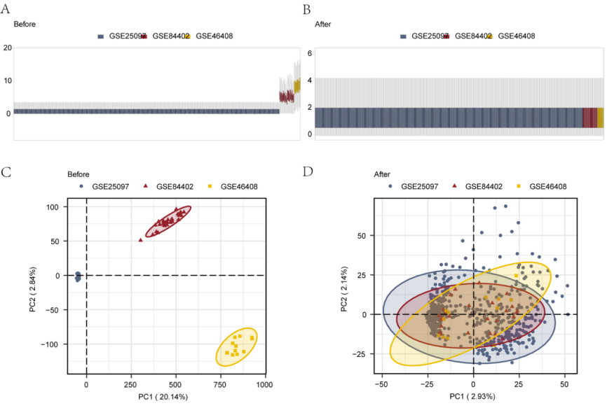
Figure S2 The sample distribution boxplot and PCA diagram of the merged dataset before and after merging
- -B. The sample distribution of the merged dataset's boxplot. C-D. The PCA graph of merged dataset. PCA: principal component analysis.

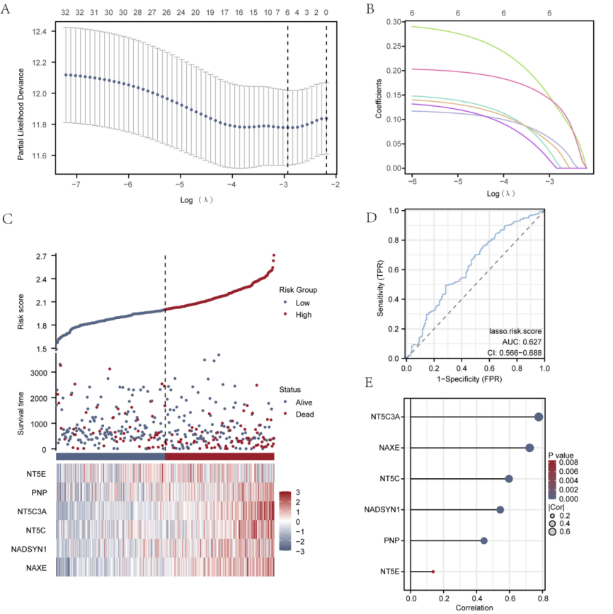
Figure S3 Construction of LASSO regression model
- LASSO regression model diagram of NMRDEGs. B. Variable trajectory plot of the LASSO regression model. C. Display of the risk factor diagram results for NMRDEGs in the LASSO regression model. D. ROC curve of the LASSO regression model. E. Lollipop plots of correlations between NMRDEGs and LASSO regression models. LASSO: Least absolute shrinkage and selection operator. NMRDEGs: Nicotinamide metabolism-related differentially expressed genes. The risk factor map consists of two parts: 1. Risk grouping: the RiskScore obtained by predicting the Cox regression prognostic model is grouped by median. 2. Survival outcome: Use dot plots to display the survival time and status of the TCGA-LIHC clinical samples in the data set.

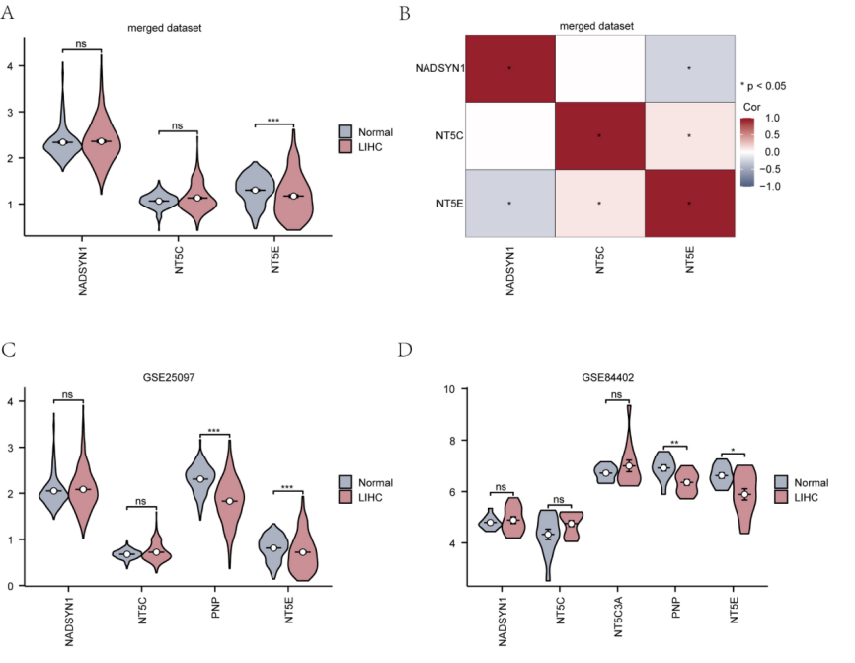
Fig. S4 The expression of key genes in GEO dataset
- The grouping comparison chart results of key genes in different groups (Normal/LIHC) of the merge datasets. B. Display of the correlation heat map results of key genes in the merge datasets. C. The grouping comparison chart results of key genes in different groups (Normal/LIHC) of GSE25097. D. The grouping comparison chart results of key genes between different groups (Normal/LIHC) of GSE84402. * P < 0.05, ** P < 0.01, *** P < 0.001.

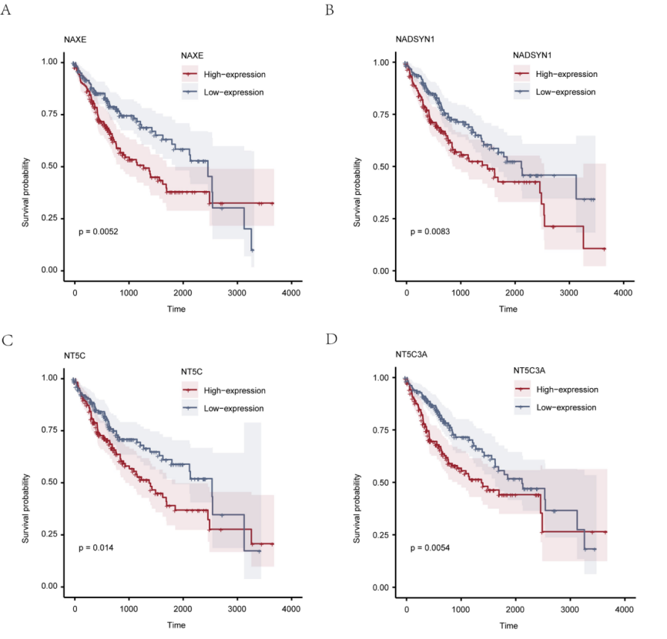

Fig. S5 K-M curve analysis of the prognosis performance of key genes
- -D. Prognostic analysis of key genes KM curve. KM curve: Kaplan-Meier curve. P < 0.05 means statistically significant

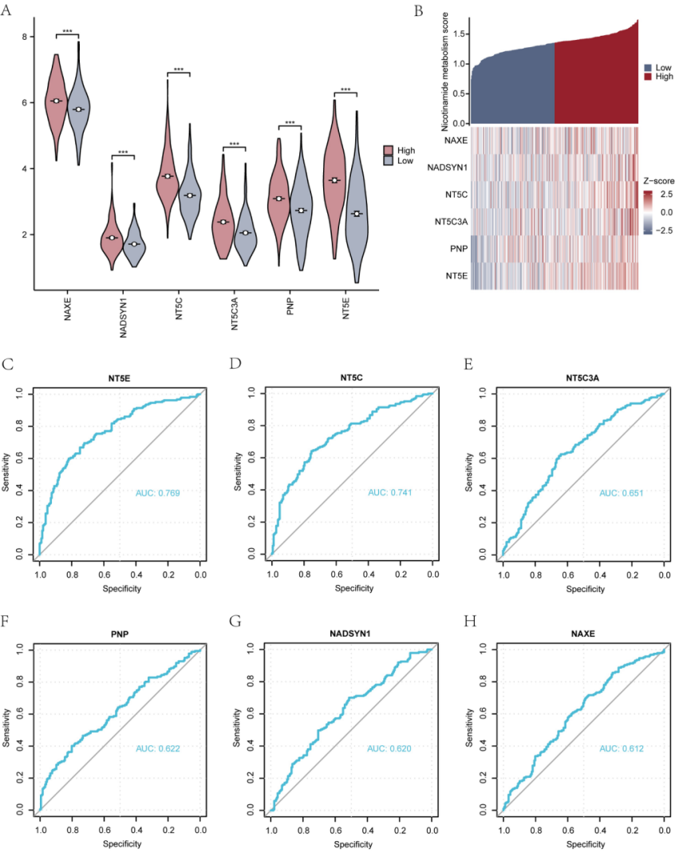
Fig. S6 The expression of key genes in the high and low nicotinamide metabolism score (High/Low) group
- The group comparison chart between High/Low groups of the nicotinamide metabolism score of the key genes. B. The co-expression heatmap results of key genes. C-H. ROC curves for prediction models based on key genes NT5E (C), NT5C (D), NT5C3A (E), PNP (F), NADSYN1 (G), NAXE (H). *** P < 0.001. ROC: Receiver operating characteristic curve. AUC values closer to 1.0 signify better predictive performance of the model.

