Table S1 GC-MS/MS quantification and confirmation ions used for Viscum album lipophilic extract (VALE) analysis by selected reaction monitoring (SRM) mode.

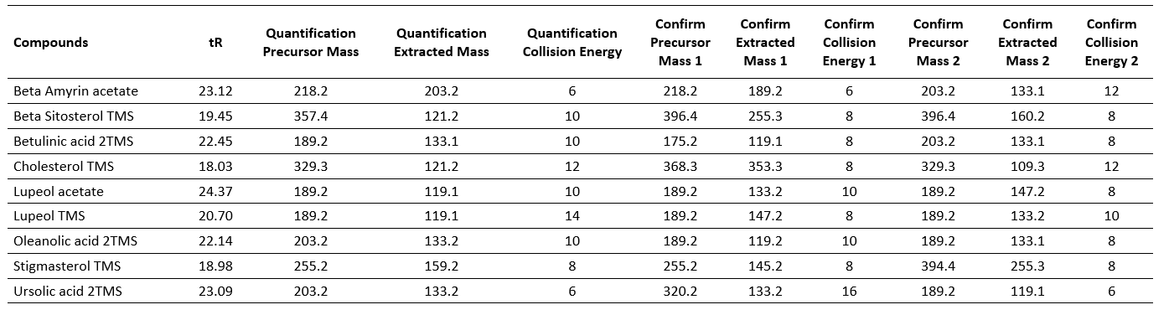

Figure S1 Thin layer chromatography obtained with the reference compounds and VALE sample. AcOEt= ethyl acetate; B+U= betulinic and ursolic acid standard; O= oleanolic acid standard.
Table S2 Required HLB for TCM oil (medium-chain trglycerides) and weight fraction of Smix (TWEEN 80®/SPAN 80®) applied for O/W emulsions.
Required HLB (MTC) | TWEEN 80 (%) | SPAN 80 (%)
8 | 5.19 | 9.81
9 | 6.59 | 8.41
10 | 7.99 | 7.01
11 | 9.39 | 5.61
12 | 10.79 | 4.21
13 | 12.20 | 2.80
14 | 13.60 | 1.40
15 | 15 | -

Figure S2 Visual appearance obtained from the HLB study of systems containing MCT (medium- chain triglycerides) and Smix (TWEEN 80®/SPAN 80®) after 24h of titration.

