Supplementary Material:

Supplementary Data
Supplementary Table 1: Eligibility Criteria
Inclusion Criteria | Exclusion Criteria*
- Adult at least 40 years of age with CB | 1. Active smoking within the last 6 months
- Sum of COPD Assessment Test (CAT) first two questions equaled at least 7 points | 2. Active respiratory infections
- Pre-procedure post-bronchodilator Forced Expiratory Volume in one second (FEV1) between 30% and 80% | 3. Lung cancer diagnosed within the last 5 years
- Cigarette smoking history of at least 10 pack years | 4. Arrhythmia
 | 5. Lung surgery
 | 6. Alpha-1-antitrypsin deficiency
 | 7. Lung valves
 | 8. Any other medical condition that would complicate study treatment in the judgement of the study physician at the time of enrollment
*No exclusions were made related to emphysema (e.g., CT based densitometry, plethysmography, etc.).

Supplementary Table 2: Schedule of Events

Supplementary Table 3: Non-serious Adverse Events
Preferred Term  (n events) | Treatment Recovery Period* | 3 Months† | 6 Months‡ | 12 Months§
Arthritis | 0 | 0 | 0 | 1
Bladder Infection | 0 | 0 | 0 | 1
COPD Exacerbation | 0 | 3 | 2 | 1
Cough | 9 | 1 | 0 | 1
Dehydration | 1 | 0 | 0 | 0
Dyspnea | 1 | 1 | 0 | 1
GI Disturbance | 1 | 1 | 0 | 0
Headache | 2 | 0 | 0 | 0
Hemoptysis | 3 | 1 | 0 | 0
Hypertension | 0 | 0 | 0 | 1
Hypotension | 0 | 1 | 0 | 0
Hypoxemia | 0 | 1 | 0 | 0
Malaise | 1 | 0 | 0 | 0
Musculoskeletal Injury | 0 | 1 | 0 | 0
Otitis | 0 | 0 | 1 | 1
Pharyngitis | 1 | 0 | 0 | 0
Pleural Effusion | 0 | 1 | 0 | 0
Pneumonia | 0 | 0 | 1 | 0
Pyrexia | 2 | 0 | 0 | 0
Rhinitis | 1 | 0 | 0 | 0
Sore Throat | 7 | 0 | 0 | 0
Upper Respiratory Tract | 4 | 1 | 1 | 1
Vertigo | 1 | 0 | 0 | 0
Wheeze | 1 | 0 | 0 | 0
Worsening Bronchitis | 3 | 1 | 2 | 3
TOTAL | 38 events in  7 patients | 13 events in  6 patients | 7 events in  4 patients | 11 events in  5 patients
There were 5 non-serious events deemed possibly or probably related to the device, all reported in one patient which included cough (2), worsening bronchitis (2) and rhinitis (1). Procedure related events occurring more than once included hemoptysis (3), sore throat (3), cough (3), and COPD exacerbation (2).
*Defined as the 30 days following either procedure.
†Defined as the follow-up period through 3 months post treatment 2, excluding the treatment recovery period.
‡Defined as the follow-up period between 3 months and 6 months after treatment 2.
§ Defined as the follow-up period between 6 months and 12 months after treatment 2.

Supplementary Figure 1.
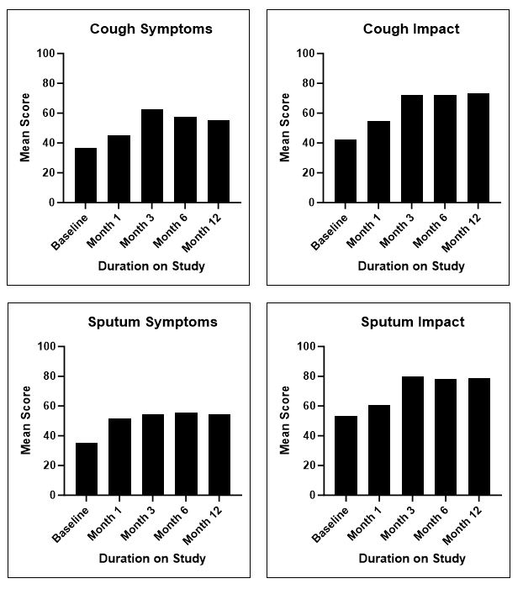
Supplementary Figure 1: Cough and Sputum Assessment Questionnaire (CASA-Q) Outcomes. Improvements in all domains were observed at each timepoint assessed in the study relative to baseline. Bars represent the mean score for n=10 patients at each timepoint.

Supplementary Methods

Biopsy Collection and Pathological Assessments
In order to assess post-procedural changes in airway cell composition, a standard flexible bronchoscopy cryo-probe (Erbe USA, Inc., Marietta, Georgia, USA) was employed to obtain endobronchial biopsies from airway mucosa tissue. Samples were collected using the methods outlined in Valipour et al.¹², except in six of the 10 cases, where tissue collection was attempted using forceps because a sterile cryo-probe was not available. Baseline biopsy samples were collected from the right lung prior to the first RheOx procedure, and biopsy samples were collected again one month later from the left lung prior to the second RheOx procedure. A third bronchoscopy was performed 3-months following the second RheOx treatment for biopsy sample collection only (right and left lung). Samples were formalin-fixed, paraffin embedded, and sectioned at 5μm per standard histopathology protocols. For each biopsy, glass slides were prepared and stained with either Hematoxylin and Eosin (H&E) or Periodic Acid Schiff (PAS) to highlight overall histomorphology and mucin, respectively. Biopsies were evaluated for degree of GCH by a blinded, independent pathologist utilizing a semi-quantitative scoring system as shown in Figure 2.

