Supporting Information

Designing mesoporous prussian blue@zinc phosphate nanoparticles with hierarchical pores for varisized guest delivery and photothermally-augmented chemo-starvation therapy
Yuan Yuan^{1,}*, Mingyi Hou^{2,}*, Xiaoning Song¹, Xintao Yao¹, Xuerui Wang¹, Xiangjun Chen² and Shengnan Li¹

¹School of Chemical Engineering and Technology, Hebei University of Technology, Xiping Road, Tianjin 300401, P. R. China; ²School of Pharmacy, Shandong New Drug Loading & Release Technology and Preparation Engineering Laboratory, Binzhou Medical University, 346 Guanhai Road, Yantai 264003, P. R. China.
*These authors contributed equally to this work

Correspondence: Shengnan Li, Xiaoning Song;
Email: lisn027@hebut.edu.cn; songxn123@hebut.edu.cn

Materials: Polyvinylpyrrolidone (PVP K30), Potassium ferricyanide (K₃[Fe(CN)₆]), Zinc oxide (ZnO), Ammonium dihydrogen phosphate (NH₄H₂PO₄), Isopropyl alcohol (IPA) were purchased from Shanghai Macklin Biochemical Co ,Ltd. Hydrochloric acid (HCl) was obtained from Tianjin Damao chemical reagent Co., Ltd. Glucose oxidase (GOx), polyacrylic acid (PAA) were provided by Sigma Aldrich. Bradford protein assay kit was purchased from Beyotime Biotechnology. Deionized (DI) water was used in all experiments. All reagents were used as received without further purification.
Characterization: The transmission electron microscopy (TEM) images were recorded with a FEI system (USA). The scanning electron micrograph (SEM) images were obtained by a field emission scanning electron microscope (Nova Nano SEM45, FEI, USA). X-ray power diffraction (XRD, D8, Bruker, Germany) was performed with high-intensity Cu Kα radiation. Fourier transform infrared spectroscopy (FT-IR) was carried out with a TENSOR 27(Bruker, Germany). The hydrodynamic diameter and zeta potential were analyzed by Zetasizer Nano-ZS (Malvern, UK). The concentrations of nanoparticles (NPs) dispersions were determined by an inductively coupled plasma atomic emission spectrometer (ICP-AES, Perkin Elmer, USA). X-ray photoelectron spectroscopy was analyzed by ESCALAB 250XI (Thermo, USA). Brunauer-Emmett-Teller (BET) surface area was collected at 77K N₂ absorption-desorption isotherms by ASAP2020MC (Micromeritics, USA). UV-vis absorption spectroscopy was performed on UV-5200PC spectrophotometer (Yuan Xi, China). Confocal laser microscopy images were recorded by a confocal laser scanning microscopy (CLSM, Leica TCS SP8).

Calculation of the photothermal conversion efficiency (η): To evaluate the photothermal conversion efficiency (η), the temperature change of aqueous dispersion (300 μL) was recorded as a function of time under continuous irradiation until the solution reached a steady-state temperature. and the cooling period was monitored to determine the linearized time data versus lnθ to obtain the system time constant. The photothermal conversion efficiency (η) can be determined as following equation:
$η=\frac{hs\left(T_{max-}-T_{surr}\right)-Q_{dis}}{I(1-{10}^{-A_{808}})}$ (1)
where $h$ is the heat transfer coefficient, $s$ is the surface area of the container, $T_{max}$and $T_{surr}$ are the solution temperature and surroundings ambient temperature, $Q_{dis}$ is the light induced heat of the solvent (water), where $I$ is the power of 808 nm laser, $A_{808}$ is the absorbance of HMPB@ZnP NPs at 808 nm, where only $hs$ is unknown in this equation for calculation. To get the $hs$, we herein introduce $τ_{s}$:
$τ_{s}=\frac{m_{D}C_{D}}{hs}$ (2)
$θ=\frac{T_{surr}-T}{T_{surr}-T_{max}}$ (3)
$lnθ=-\frac{t}{τ_{s}}$ (4)
$t$ is the total time from the start of warming to the final cool-down, $m_{D}$ is the mass of the solvent, $C_{D}$ is the heat capacity, and $τ_{s}$ is the time constant of the sample system, Thus, $hs$ can be determined by applying the linear time data from the warming-cooling period versus $-lnθ$. $τ_{s}$ can be determined by applying the linear time data from the cooling period vs $-lnθ$. The fitted curves plot of t vs $-lnθ$ is $-lnθ$ =at+b. According to the formula (4), $-lnθ=\frac{t}{τ_{s}}$ , its slope $\frac{1}{τ_{s}}$ =a, so $τ_{s}$=$\frac{1}{a}$

Calculation of Tumor inhibition rate:
$$Inhibition\left(\%\right)=\frac{(M_{Control group}-M_{Treated group}）}{M_{Control group}}×100\%$$
In this case, $M_{Control group}$ and $M_{Treated group}$ are the average mass of tumors in the control and treatment groups, respectively.

Statistical analysis: The error of parallel test was calculated as mean ± SD. Statistical difference was calculated through two-tailed t-test. Asterisks indicated significant differences (*P < 0.05, **P < 0.01, ***P< 0.001). *P < 0.05 was considered to be statistically significant.

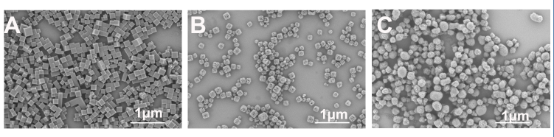
Figure S1. SEM images of (A) PB NPs, (B) HMPB NPs and (C) HMPB@ZnP NPs.

Figure S2. N₂ adsorption/desorption isotherms of pure ZnP NPs (inset: pore size distribution)

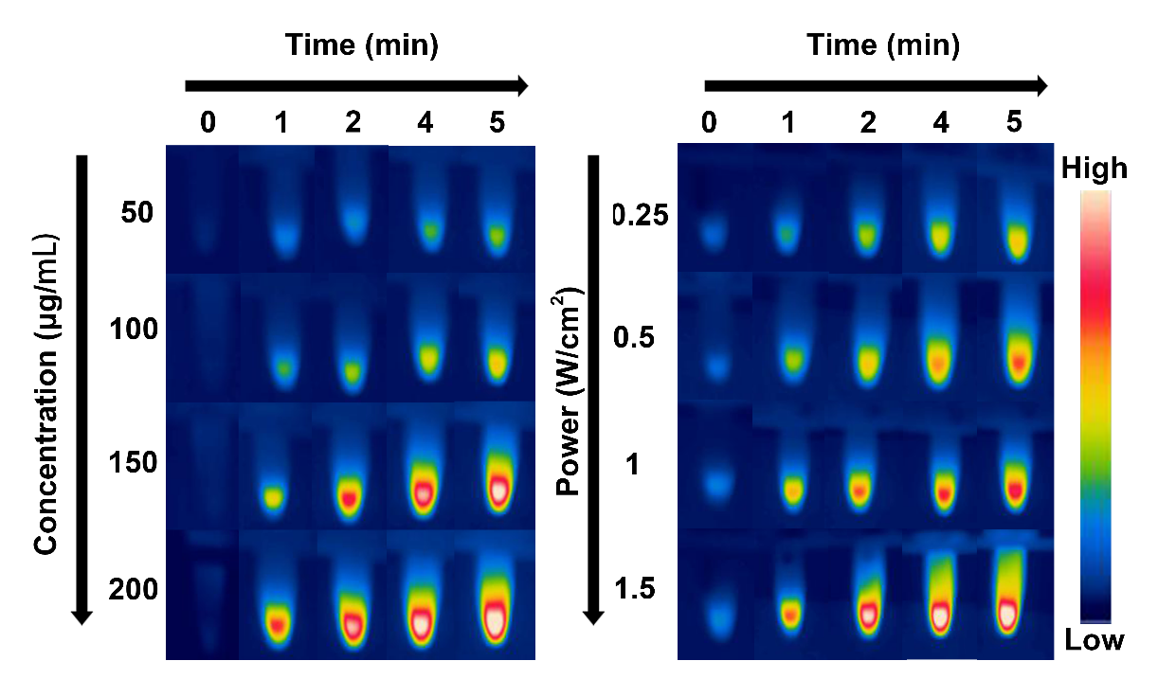
Figure S3. Infrared thermal images of HMPB-GOx@ZnP-DOX NPs under different concentrations and different laser irradiations.

Figure S4. Linear time data versus −lnθ obtained from the cooling stage.

Figure S5. Standard curve of H₂O₂

Figure S6. GOx enzymatic activity of HMPB-GOx@ZnP-DOX NPs mixing with glucose (6 mg mL⁻¹) represented by the yield of H₂O₂ under different power density with NIR laser irradiation for 5 min.

Figure S7. Cell viability of HepG-2 cells under various conditions.

Figure S8. The ATP level of HMPB@ZnP NPs, HMPB-GOx@ZnP-DOX NPs and free GOx

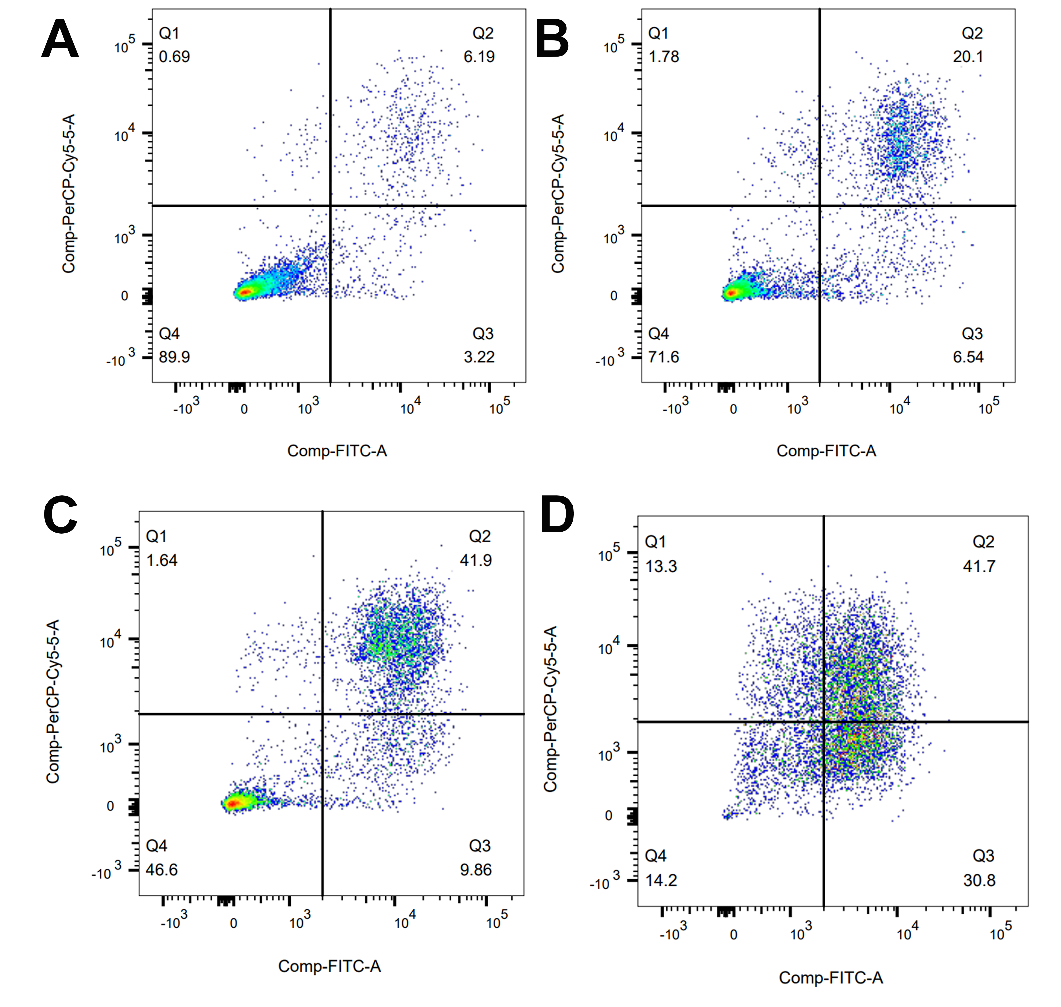
Figure S9. Flow cytometry analysis of HepG-2 cells after treatment with various NPs. (A: Control, B: HMPB-GOx@ZnP NPs, C: HMPB-GOx@ZnP-DOX NPs, D: HMPB-GOx@ZnP-DOX NPs + NIR)

Figure S10. Relative viabilities of 293T cells treated with HMPB@ZnP NPs

