Supplementary materials for

Bioactive Nanoliposomes for enhanced Sonodynamic-Triggered Disulfidptosis-Like Cancer Cell Death via Lipid Peroxidation Accumulation
Hongwei Xiang ^{1*}, Bin Shen^{1*}, Chunmei Zhang¹,Rui Li ¹
¹Department of Ultrasonography, The Third Affiliated Hospital of Chongqing Medical University, Chongqing 400016,Chongqing, People’s republic of China; No.1 Shuanghu Branch Road, Huixing Street, Yubei District, Chongqing, People’s republic of China
*These authors contributed equally to this work
Correspondence: raylee7991@hospital.cqmu.edu.cn
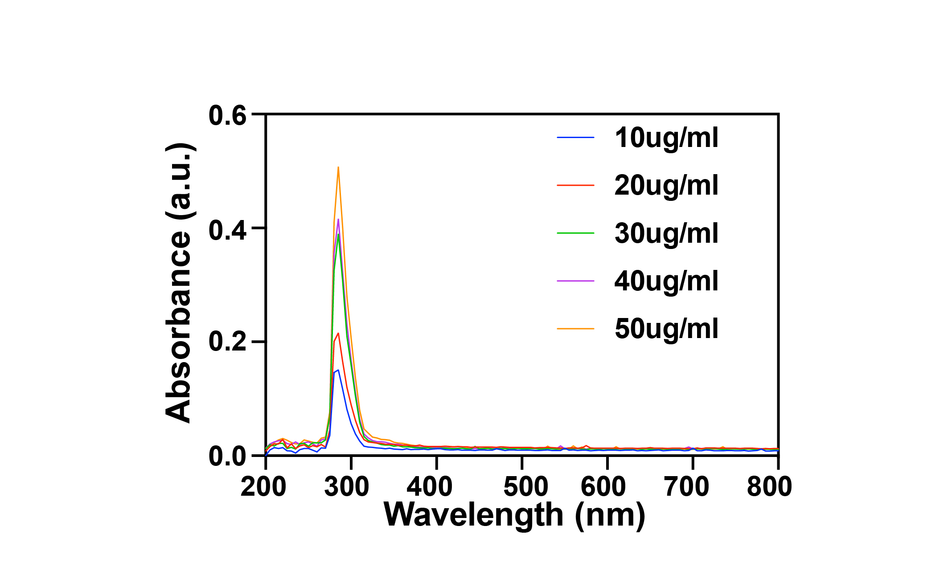
Figure S1. Ultraviolet absorption spectrogram of Sorafenib solution at various concentrations.

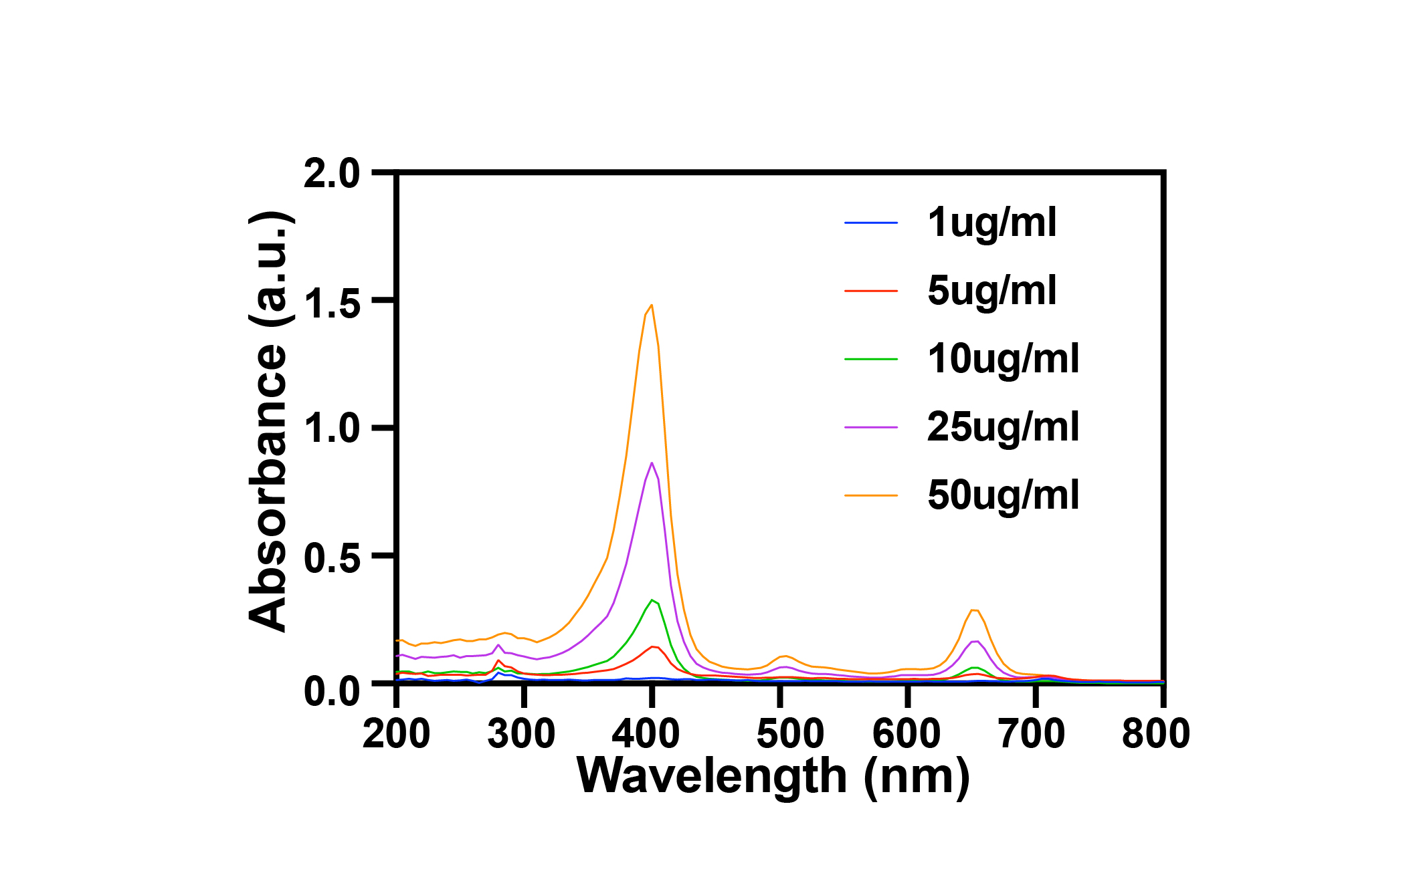
Figure S2. Ultraviolet absorption spectrogram of Ce6 solution at various concentrations.

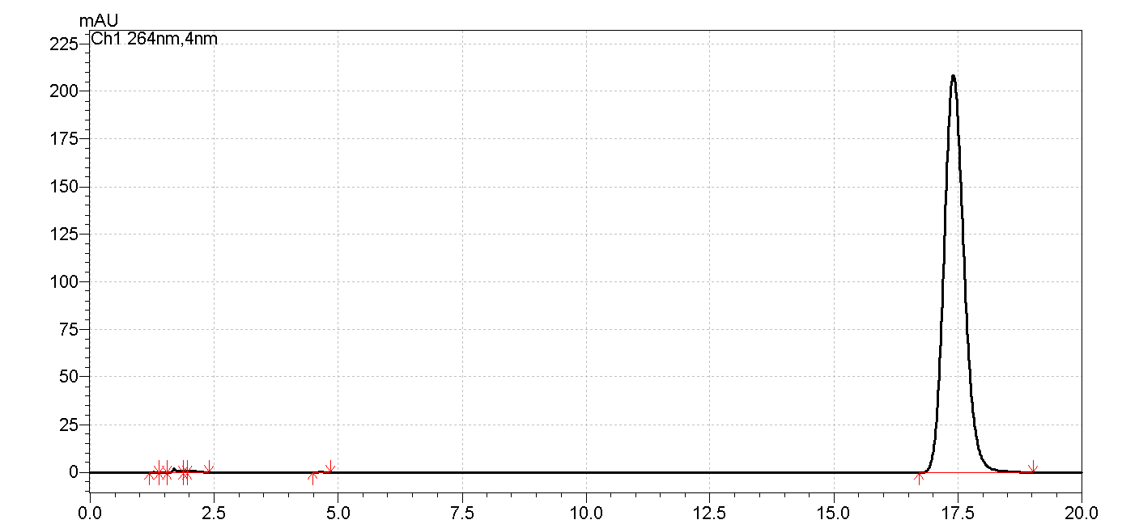

Figure S3. HPLC chromatogram of Sorafenib at 50ppm.

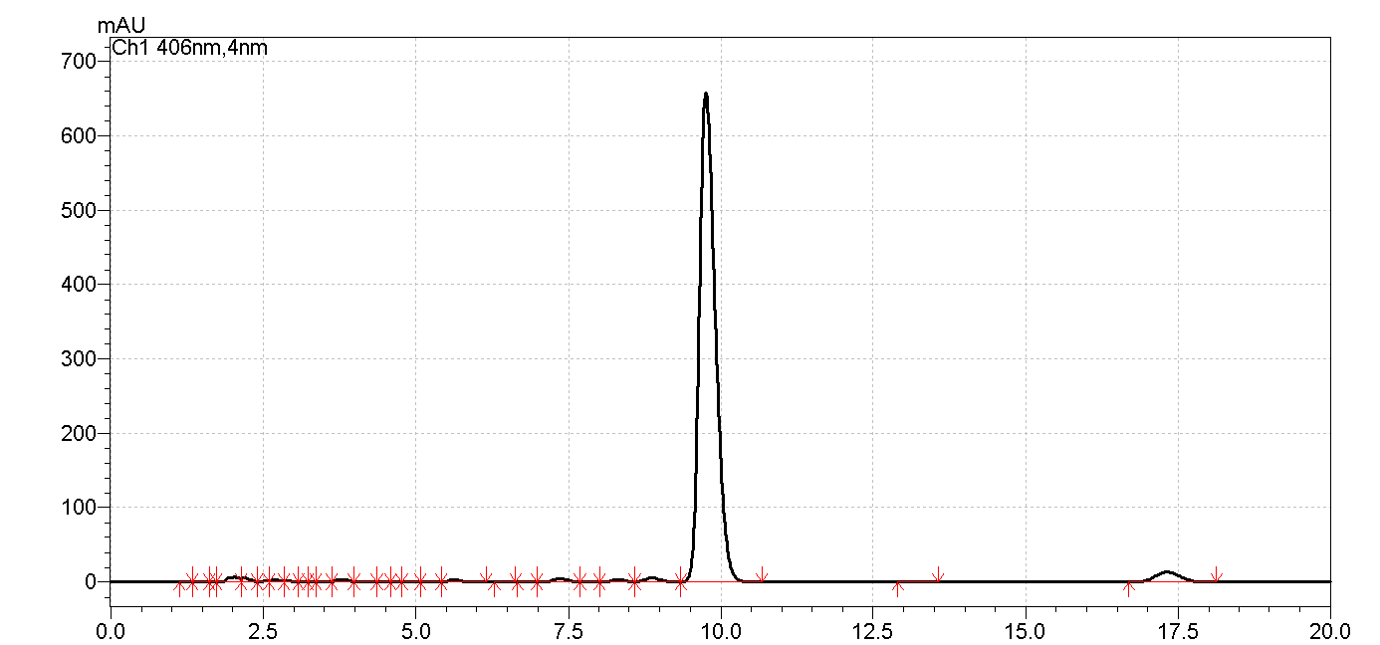
Figure S4. HPLC chromatogram of Ce6 at 50ppm

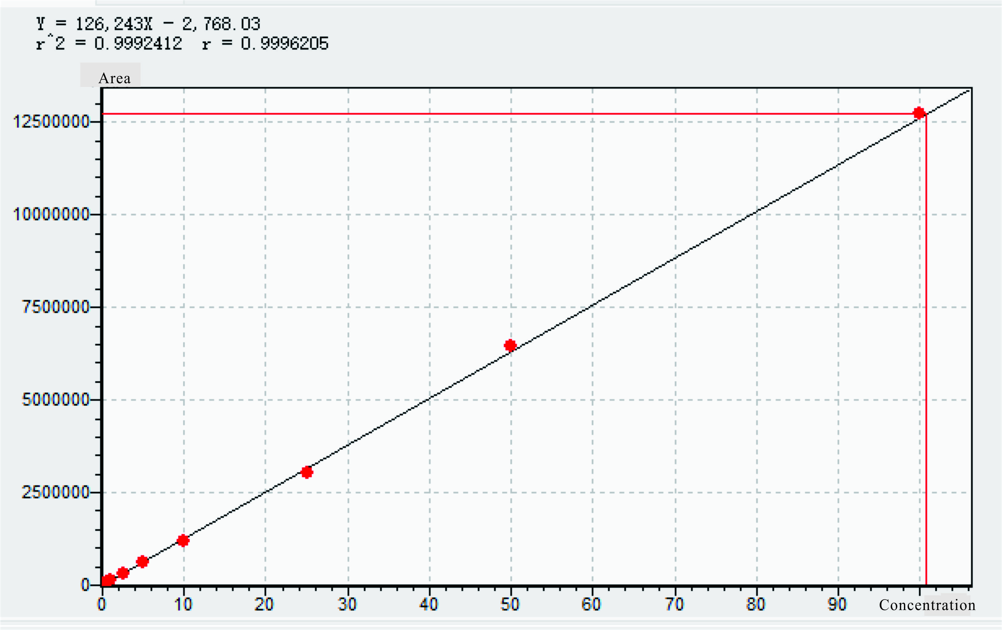

Figure S5. .HPLC standard curve of Sorafenib

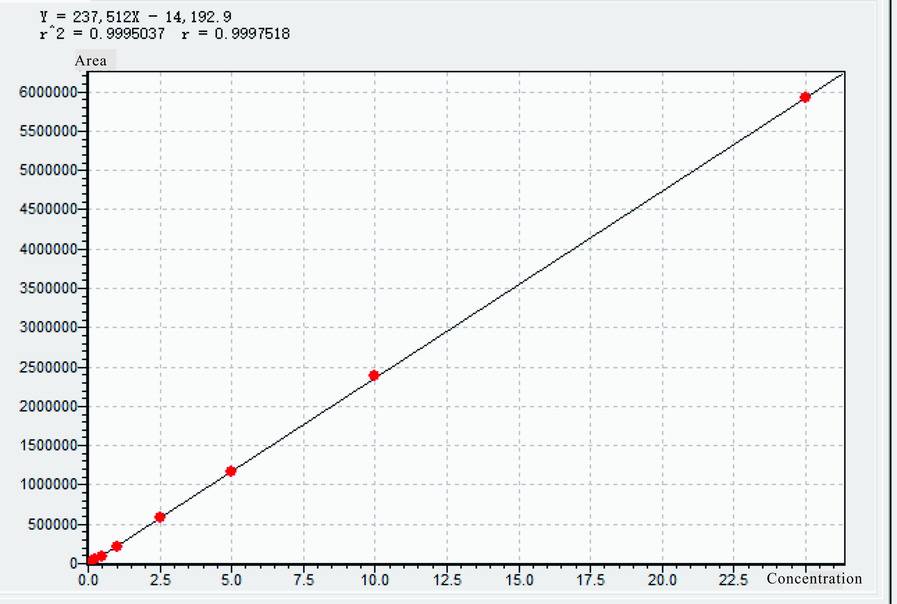

Figure S6. HPLC standard curve of Ce6.

