Supplementary Data

Supplementary Table S1. The grading of immune-related hepatitis followed the National Cancer Institute (NCI) CTCAE 5.0
Grading | AST (Aspartate aminotransferase Increased) | ALT (Alanine aminotransferase  Increased) | Total bilirubin
Grade I | >ULN - 3.0 x ULN if baseline was normal; 1.5 - 3.0 x baseline if baseline was abnormal | Same as AST | >ULN - 1.5 x ULN if baseline was normal; > 1.0 - 1.5 x baseline if baseline was abnormal
Grade II | >3.0 - 5.0 x ULN if baseline was normal; >3.0 - 5.0 x baseline if baseline was abnormal | Same as AST | >1.5 - 3.0 x ULN if baseline was normal; >1.5 - 3.0 x baseline if baseline was abnormal
Grade III | >5.0 - 20.0 x ULN if baseline was normal; >5.0 - 20.0 x baseline if baseline was abnormal | Same as AST | >3.0 - 10.0 x ULN if baseline was normal; >3.0 - 10.0 x baseline if baseline was abnormal
Grade IV | >20.0 x ULN if baseline was normal; >20.0 x baseline if baseline was abnormal | Same as AST | >10.0 x ULN if baseline was normal; >10.0 x baseline if baseline was abnormal

Supplementary Table S2. The highest grading of liver toxicity before, during, and after ICIs
 | Baseline* |  | Highest During ICI |  | Highest After ICI
 | n | % | n | % | n | %
AST | 151 | 78.2% | 171 | 88.6% | 91 | 47.2%
Grade I | 113 | 58.5% | 107 | 55.4% | 46 | 23.8%
Grade II | 26 | 13.5% | 49 | 25.4% | 18 | 9.3%
Grade III | 12 | 6.2% | 11 | 5.7% | 21 | 10.9%
Grade IV | 0 | 0.0% | 4 | 2.1% | 6 | 3.1%
ALT | 112 | 58.0% | 157 | 81.3% | 88 | 45.6%
Grade I | 93 | 48.2% | 113 | 58.5% | 54 | 28.0%
Grade II | 15 | 7.8% | 37 | 19.2% | 17 | 8.8%
Grade III | 4 | 2.1% | 5 | 2.6% | 14 | 7.3%
Grade IV | 0 | 0.0% | 2 | 1.0% | 3 | 1.6%
Total Bilirubin | 35 | 18.1% | 80 | 41.5% | 103 | 53.4%
Grade I | 18 | 9.3% | 46 | 23.8% | 31 | 16.1%
Grade II | 16 | 8.3% | 21 | 10.9% | 32 | 16.6%
Grade III | 0 | 0.0% | 12 | 6.2% | 24 | 12.4%
Grade IV | 1 | 0.5% | 1 | 0.5% | 16 | 8.3%
Abbreviations: ICIs, immune checkpoint inhibitors; AST, aspartate transaminase; ALT, alanine transaminase; *The grade of baseline liver function was defined according to CTCAE 5.0, which was summarised in supplementary file.

Supplementary Table S3. Maximum, minimum, range and median of liver enzymes in different timing.
 | AST (U/L) |  |  | ALT (U/L) |  |  | Bilirubin total (mg/dL)
 | Before ICIs | During ICIs | After ICIs | Before ICIs | During ICIs | After ICIs | Before ICIs | During ICIs | After ICIs
Maximum | 416 | 853 | 8021 | 254 | 604 | 2865 | 14.7 | 28.6 | 37.5
Minimum | 16.5 | 22 | 19 | 9 | 11 | 10 | 0.3 | 0.3 | 0.3
Median | 55 | 79 | 90 | 43 | 59.5 | 64 | 0.8 | 1.2 | 1.8
Range | 361 | 774 | 7931 | 211 | 544.5 | 2801 | 13.9 | 27.4 | 35.7

Supplementary Table S4. Potential causes of hepatitis during immunotherapy.
 | With ≥ Grade II hepatitis occurring during ICI treatment  (n = 42) |  | Without ≥ Grade II hepatitis during ICI treatment  (n = 151) |  | With ≥ Grade II hepatitis AND received corticosteroids (n = 16) |  | With ≥ Grade II hepatitis, WITHOUT corticosteroids (n = 26)
Items | n | % | n | % | n | % | N | %
Received corticosteroids | 16 | 38.1% | 37* | 24.5% | 16 | 100.0% | 0 | 0.0%
No corticosteroids prescribed | 26 | 61.9% | 114 | 75.5% | 0 | 0.0% | 26 | 100.0%
Possible etiology of hepatitis | 13 | 31.0% | 33 | 21.9% | 9 | 56.3% | 4 | 15.4%
No survey¶ | 29 | 69.0% | 118 | 78.1% | 7 | 43.8% | 22 | 84.6%
Survey for etiologies of hepatitis | 13 | 31.0% | 33 | 21.9% | 9 | 56.2% | 4 | 15.4%
Hepatitis B carrier | 29 | 69.0% | 96 | 63.6% | 11 | 68.8% | 18 | 69.2%
Hepatitis C carrier | 10 | 23.8% | 36 | 23.8% | 3 | 18.8% | 7 | 26.9%
no HBV, HCV infection | 6 | 14.3% | 24 | 15.9% | 2 | 12.5% | 4 | 15.4%
Positive for HSV, HDV, VZV, EBV, or CMV infection | 0 | 0.0% | 0 | 0.0% | 0 | 0.0% | 0 | 0.0%
Positive for ANA | 0 | 0.0% | 2 | 1.3% | 1 | 6.3% | 1 | 3.8%
*Most patients in this category (n = 37) received corticosteroids because of skin rashes, and dermatitis. Few patients received one single dose of corticosteroids before systemic chemotherapy. The corticosteroids were not prescribed for hepatitis in this category. ¶In this row, many physicians (69.0–78.1%) did not perform surveys for potential aetiologies of hepatitis. Some (74.1%–76.7%, data not shown in this table) of them had a chronic infection with hepatitis B or C. In the groups who received the standard survey for HSV, HDV, and VZV infection, none (0.0%) were found to be positive, which might be due to selection bias in the relatively small case cohort. (Abbreviations: ICI, immune checkpoint inhibitors; HSV, herpes virus; HDV, hepatitis D infection; VZV, Varicella Zoster Virus; EBV, Epstein-Barr virus; CMV, cytomegalovirus, ANA.)

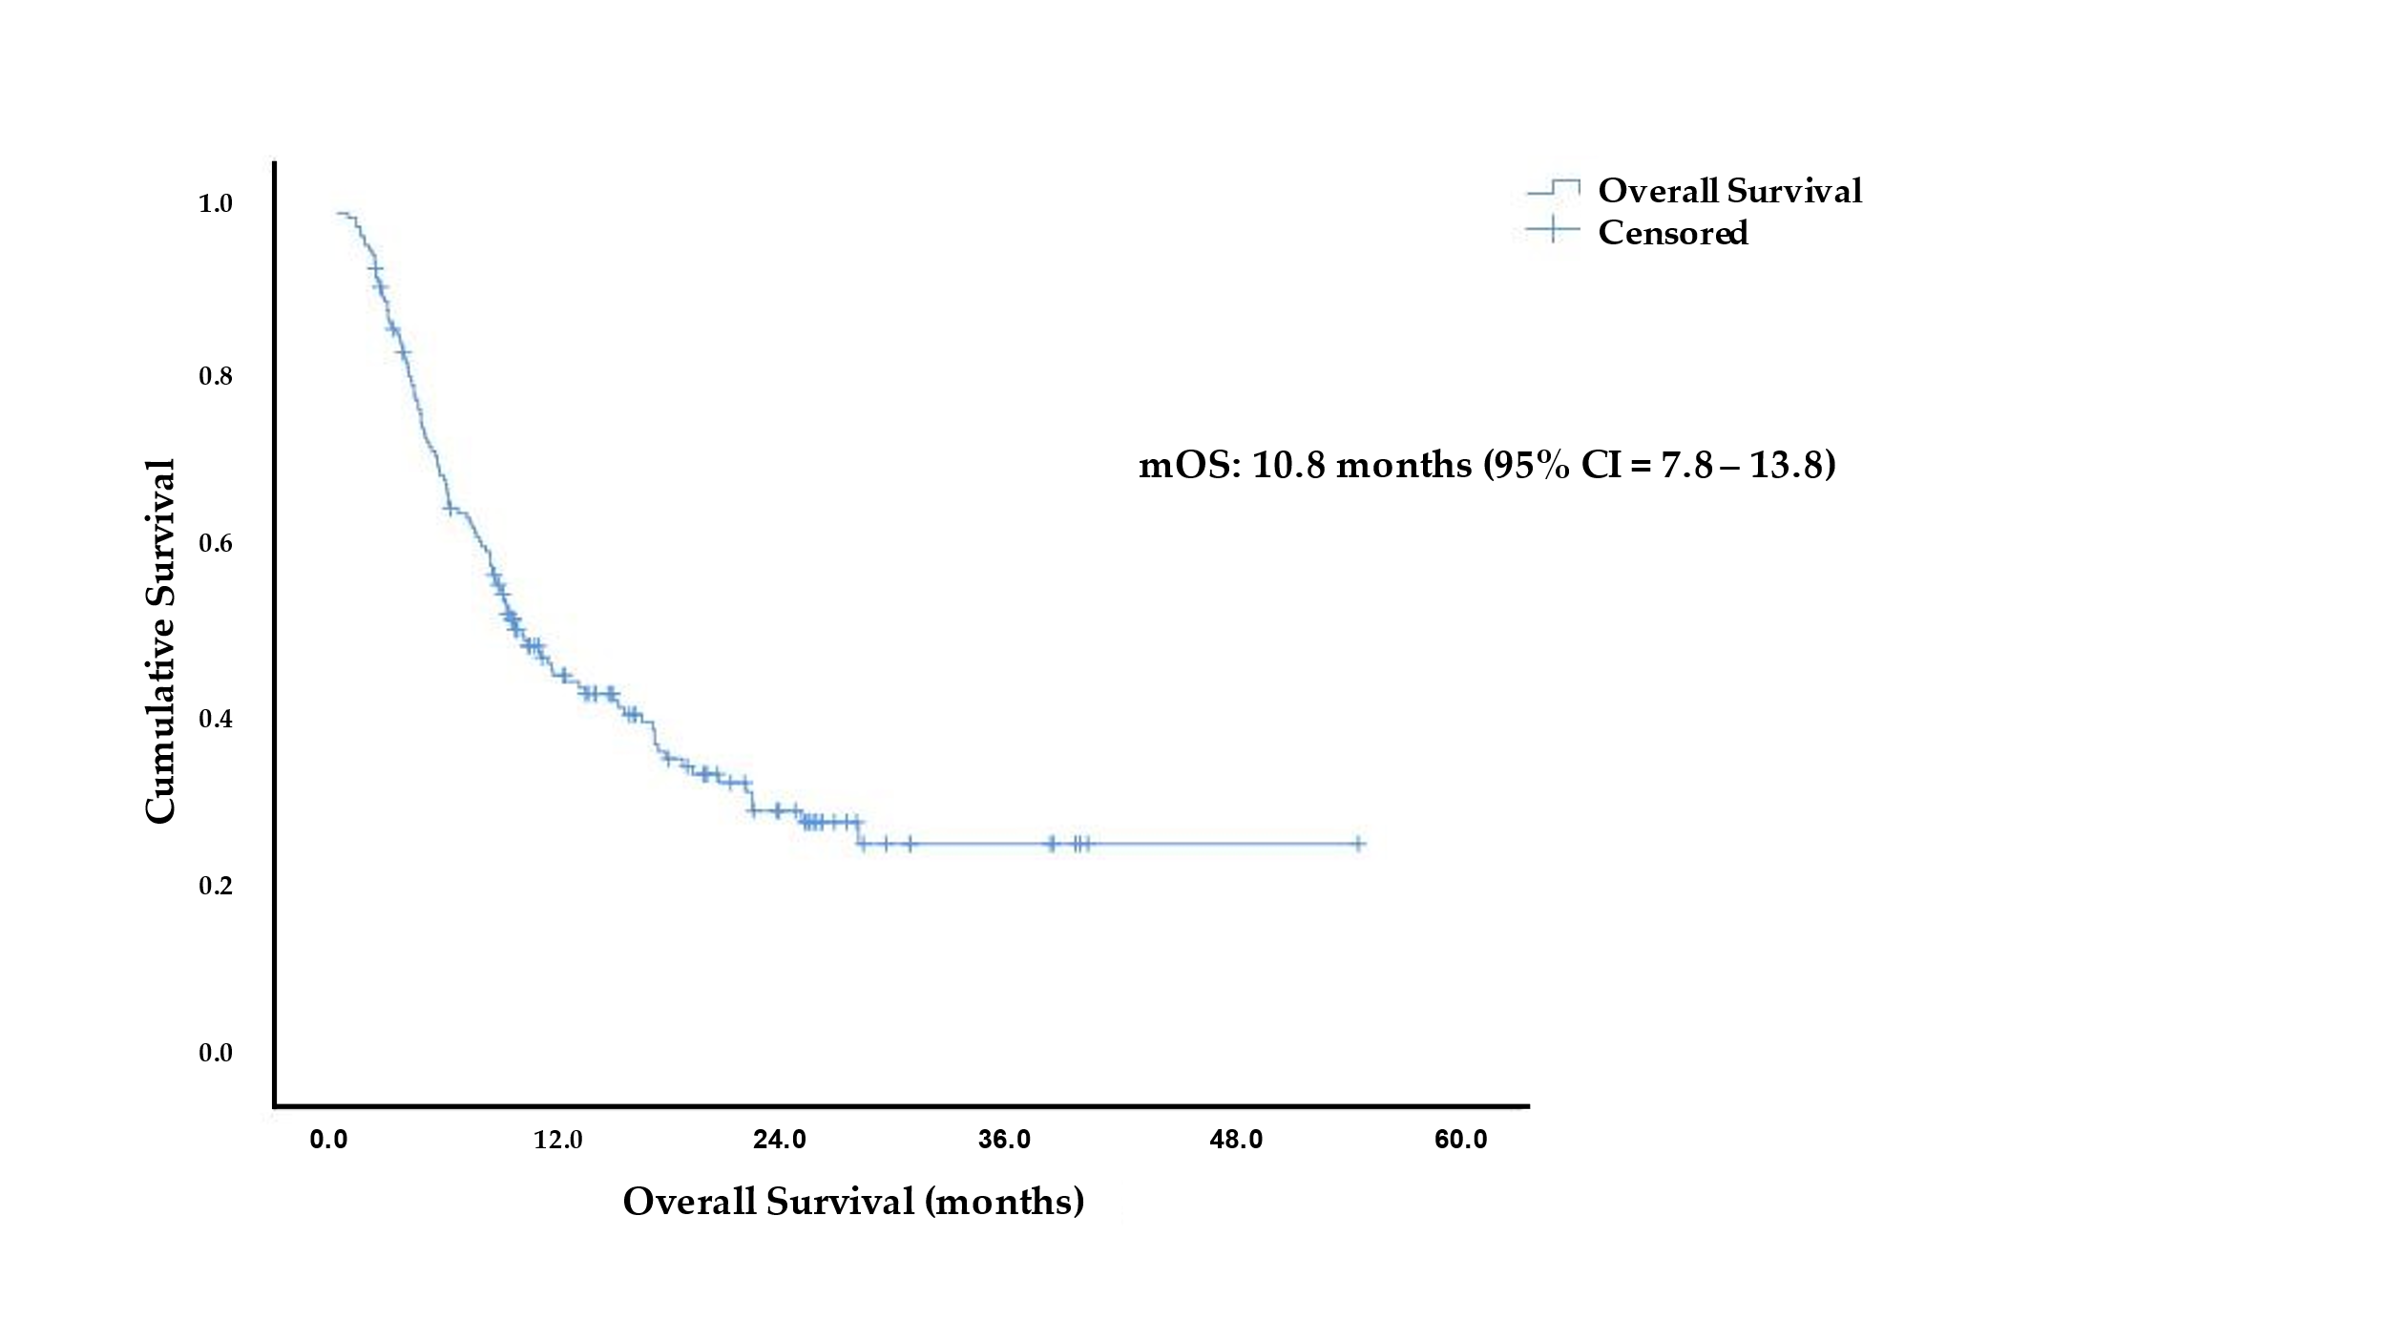
Supplementary Figure S1. Overall Survival of patients receiving immune checkpoint inhibitor.

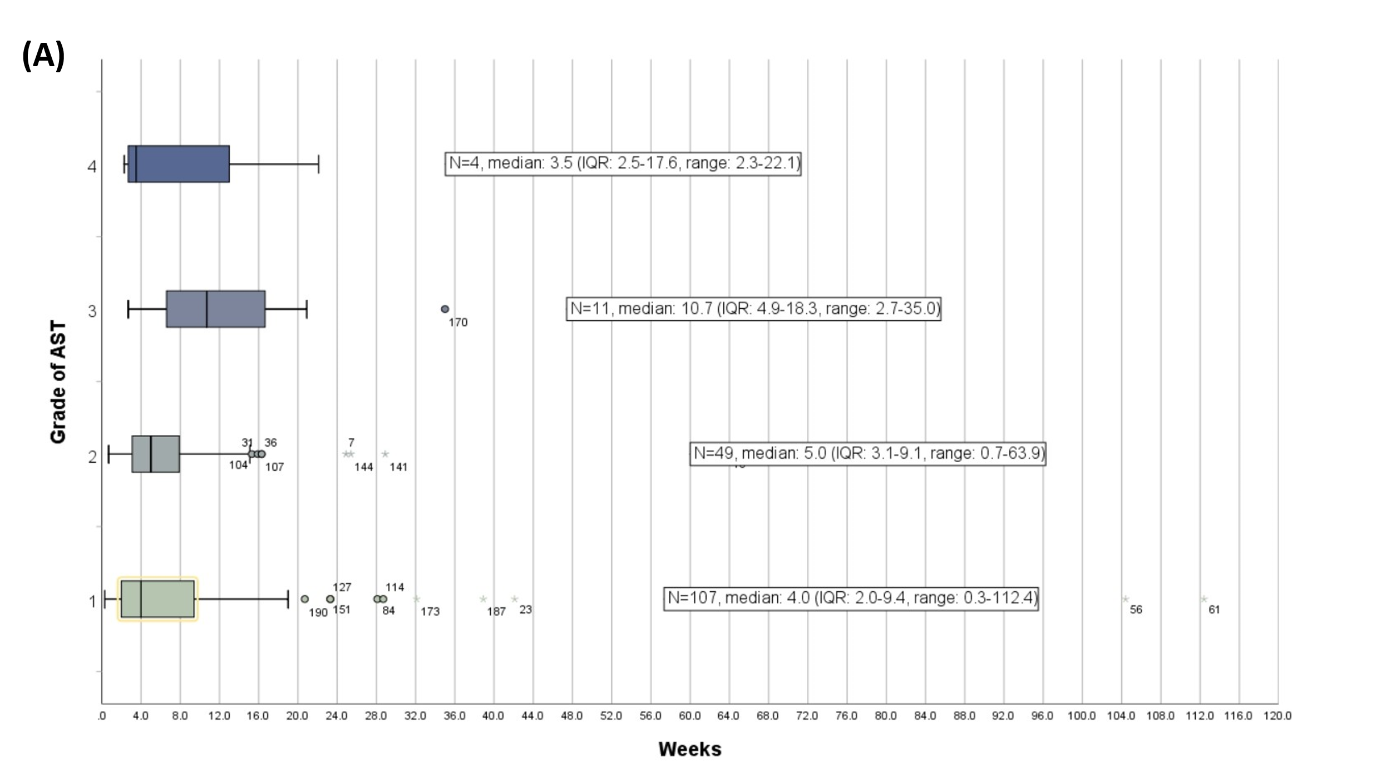
Supplementary Figure S2A. The timing of the highest grade of AST elevation during ICI treatment. (IQR, interquartile range).
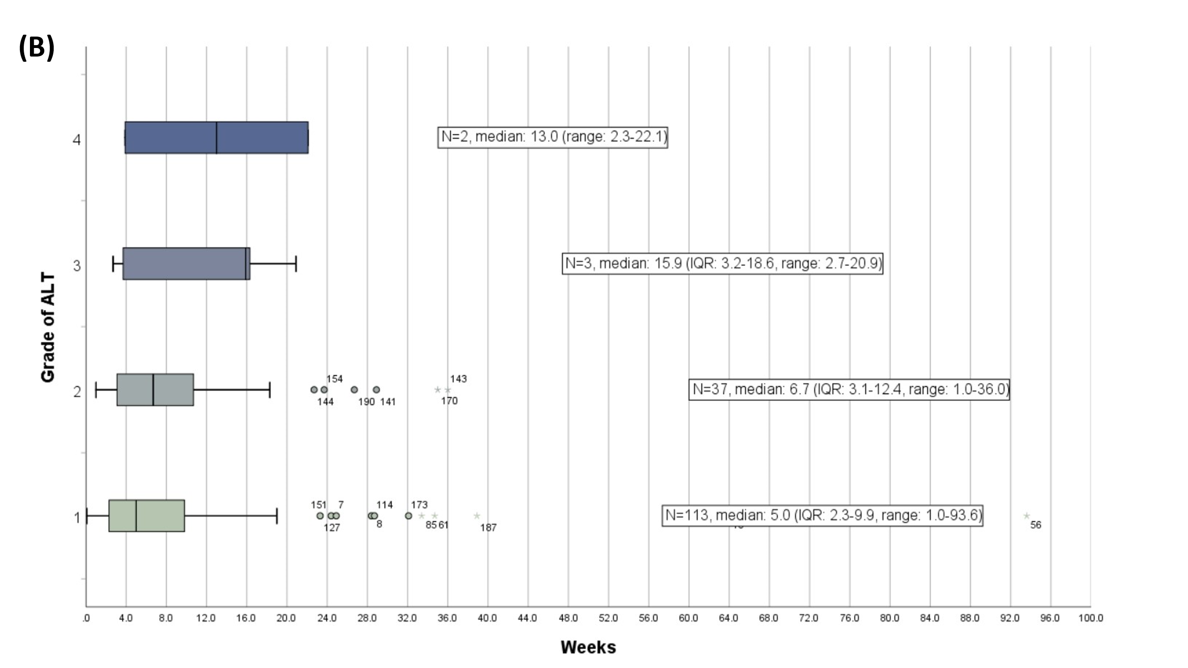

Supplementary Figure S2B. The timing of the highest grade of ALT elevation during ICI treatment. (IQR, interquartile range).
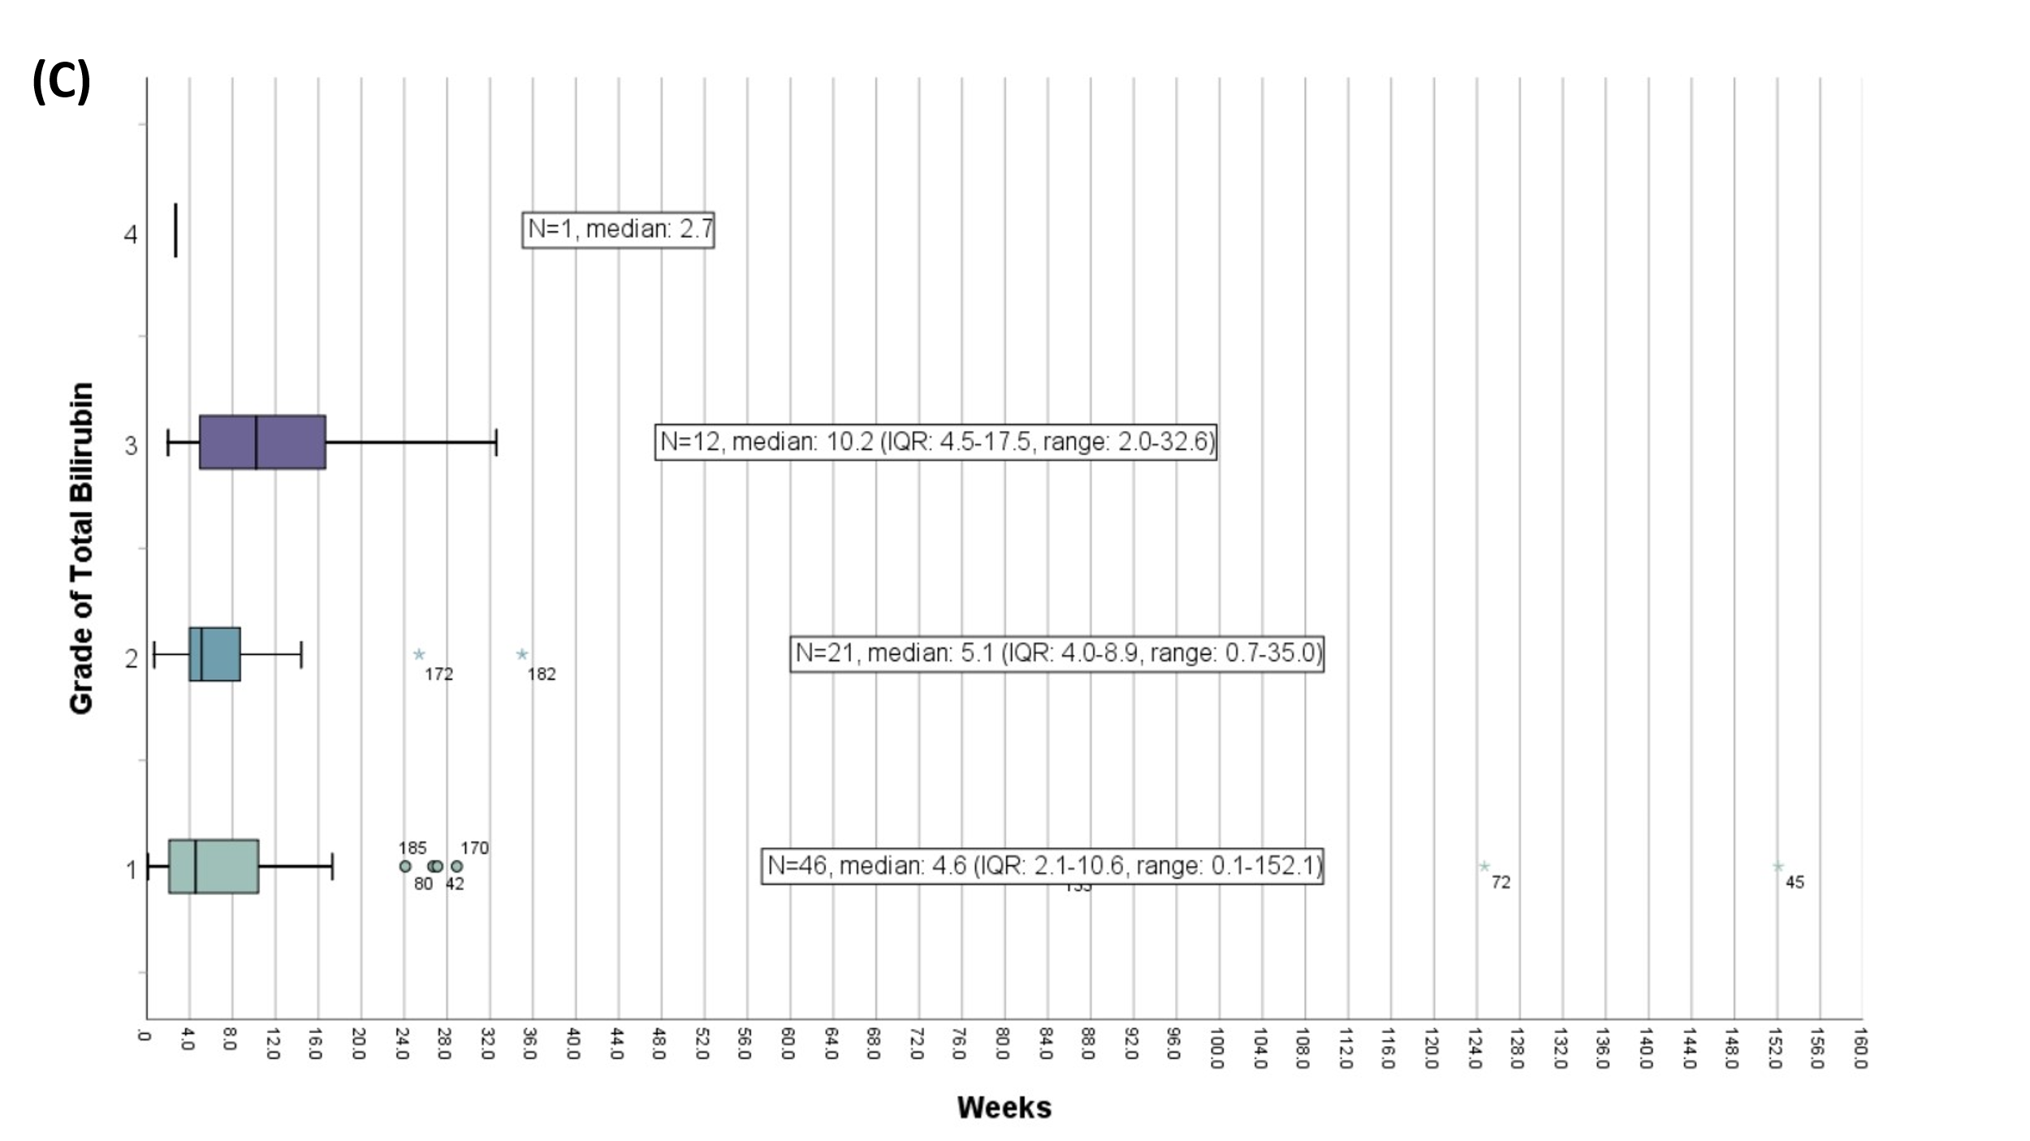
Supplementary Figure S2C. The timing of the highest grade of total bilirubin elevation during ICI treatment. (IQR, interquartile range).

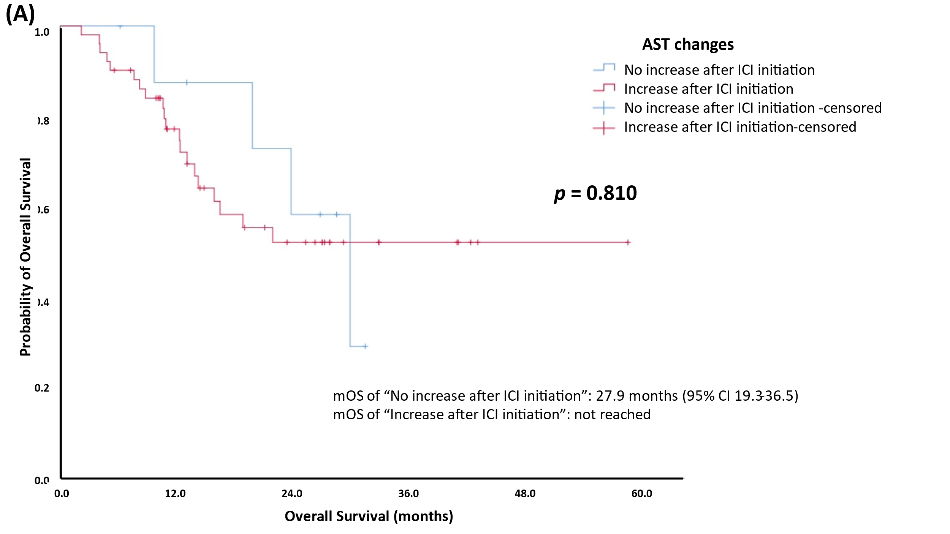
Supplementary Figure S3A). The change patterns of AST and the overall survival.
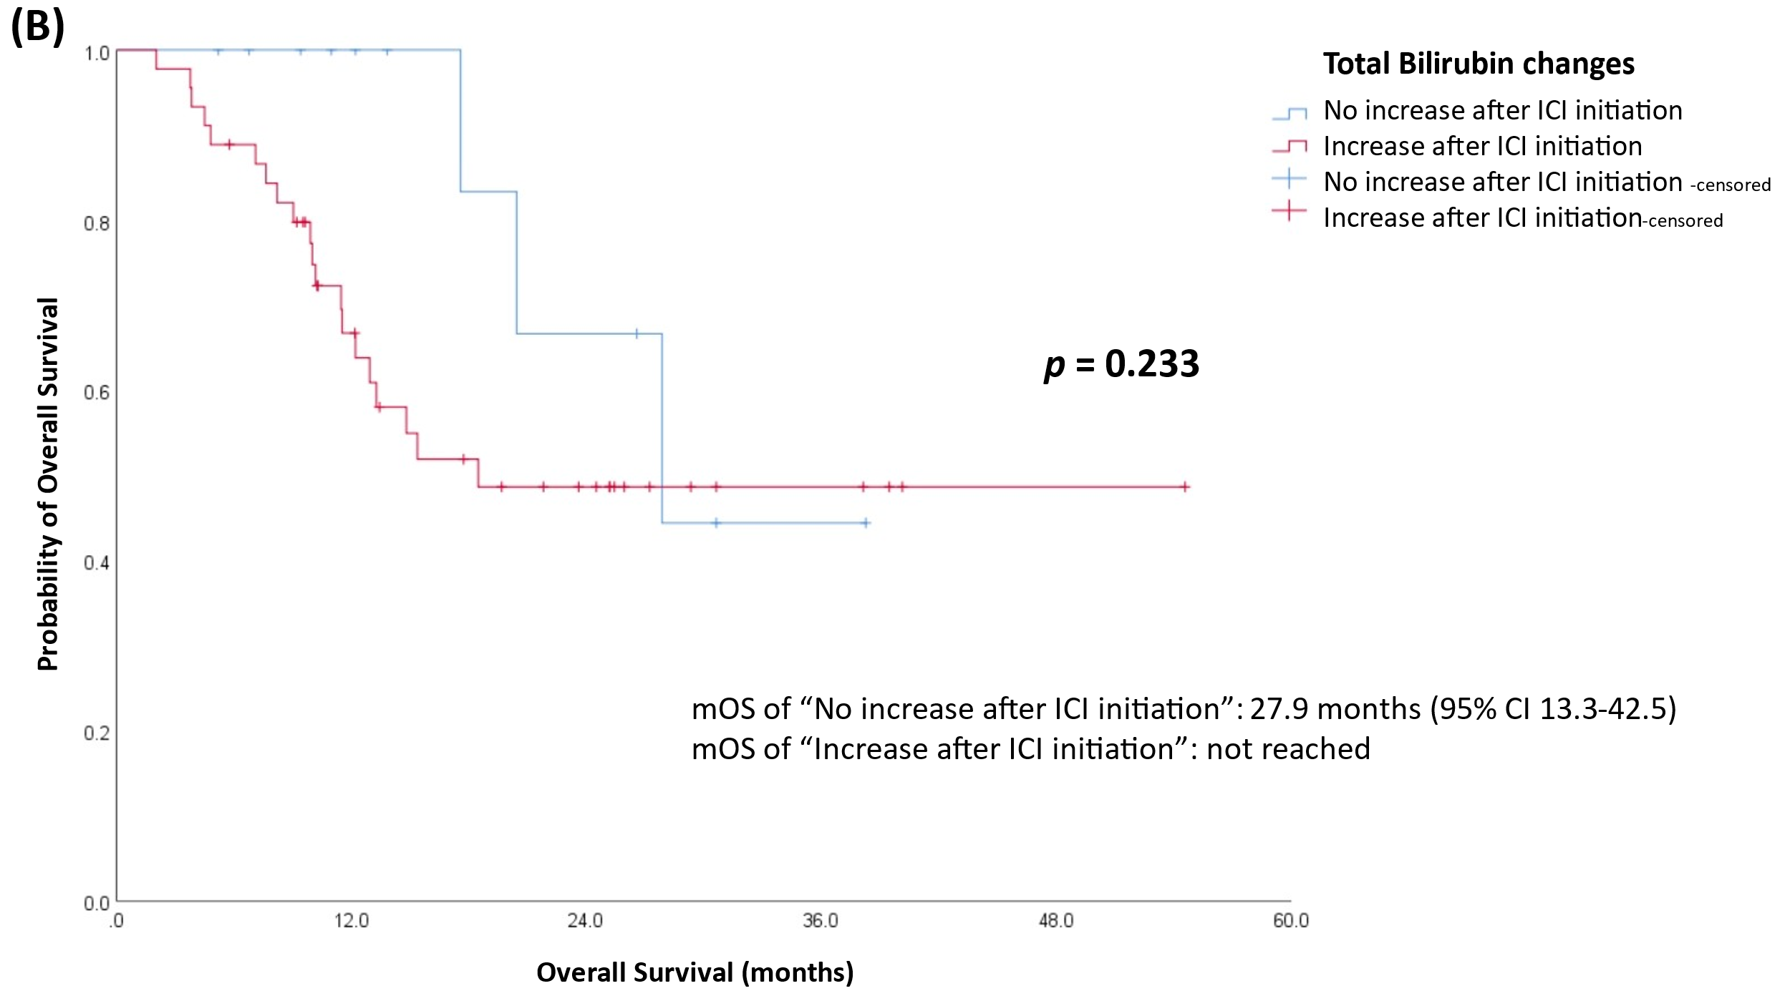
Supplementary Figure S3(B). The change patterns of total bilirubin and the overall survival.
Supplementary Figure S4. Survey and management for patients with higher or equal to grade 2 hepatitis.

