Supplementary Materials
Supplementary Algorithm 1: Algorithm of Ising model with covariates
Algorithm 1. Estimating a personal symptom network.
- Denote a dataset as $D=\{\left(x_{i1},…,x_{id},y_{i1},…,y_{ip}\right), i=1,…,n\}$.
- For $j=1,…,p$,
  - Treat $y_{j}$ as the outcome and $y_{j^{'}}, j^{'}≠j$, $x_{l}, l=1,…d$ as predictors.
  - Fit a $l_{1}$-regularized logistic regression with varying penalty parameter $ρ$:
$$logit P\left(y_{j}=1\right)=μ_{j}+\sum_{l=1}^{d}{α_{jl}x_{l}}+\sum_{j^{'}≠j}{\left(σ_{jj^{'}}+\sum_{l=1}^{d}{γ_{jj^{'}l}x_{l}}\right)y_{j^{'}}}.$$
  - Compute the eBIC value for each $ρ$ with $p$ extended to $p+d+d(p-1)$.
  - Identify $ρ$ that yields the lowest eBIC.
  - Collect the resulting regression parameters $\hat{μ}, \hat{Σ},\hat{α}$ and $\hat{γ}$.
- The estimated threshold for $y_{j}$ is ${\hat{μ}}_{j}+\sum_{l=1}^{d}{{\hat{α}}_{jl}x_{l}}$, and the estimated pairwise association between $y_{j}$ and $y_{j^{'}}$ is either ${\hat{σ}}_{jj^{'}}+\sum_{l=1}^{d}{{\hat{γ}}_{jj^{'}l}x_{l}}$ or ${\hat{σ}}_{j^{'}j}+\sum_{l=1}^{d}{{\hat{γ}}_{j^{'}jl}x_{l}}.$
- Determine the final associations between nodes using the AND rule:
  - If ${\hat{σ}}_{jj^{'}}≠0$ and ${\hat{σ}}_{j^{'}j}≠0$, the major pairwise association between $y_{j}$ and $y_{j^{'}}$ is $({\hat{σ}}_{jj^{'}}+{\hat{σ}}_{j^{'}j})/2$; otherwise it equals zero.
  - If ${\hat{γ}}_{jj^{'}l}≠0$ and ${\hat{γ}}_{j^{'}jl}≠0$, the $x_{l}$-related pairwise association between $y_{j}$ and $y_{j^{'}}$ is $({\hat{γ}}_{jj^{'}l}+{\hat{γ}}_{j^{'}jl})/2$; otherwise it equals zero.

Supplementary Subsection: Evaluation of network accuracy
To evaluate the accuracy of the estimated coefficients, we estimated their confidence intervals (CIs) based on their empirical distributions derived by bootstrap. Following bootstrap testing, a $1-α$ CI can be approximated by taking the interval between quantiles $1/2α$ and $1-1/2α$ of the bootstrapped values. For personal symptom networks, the CIs can be drawn for the major effects ${\hat{μ}}_{j}$ and ${\hat{σ}}_{jj^{'}}$, as well as for the $x_{l}$-related coefficients ${\hat{α}}_{jl}$ and ${\hat{γ}}_{jj^{'}l}$.

Three centrality metrics (strength, betweenness, and closeness) are commonly used to quantify the importance of nodes in a network. Strength indicates the sum of edge weights connected to a node, betweenness counts node occurrences on the shortest path between two other nodes, and closeness represents the average distance from a node to others [39-41]. As discussed in Epskamp et al. [29], sampling distributions of centralities generated by bootstrap are often biased, resulting in incorrect CIs of centrality indices. Therefore, it is suggested to investigate the accuracy of the estimated centralities based on stability of their order calculated using subsets of data [29]. Centralities are stable if the order of centrality indices remains the same after re-estimating the network with smaller samples (Figure 1 and 2 in [29] are examples of networks with unstable and stable centralities). Case-dropping bootstrap can be used to investigate centrality stability, in which a random proportion of subjects in the inference dataset is dropped for network re-estimation and centrality re-calculation [29]. Correlations between the original centralities obtained based on the whole inference data and those obtained from subsets are calculated. If the correlation remains high even after randomly dropping a large proportion of data, there is a higher degree of confidence that the centralities are stable. Different from networks estimated at the population level, in which centralities of nodes are the same for all subjects, personal symptom networks result in different centrality values for each subject, making the calculation of centrality correlations a very time-consuming task due to the large sample size $n$. To address this challenge, we suggest reducing the number of individual networks considered for centrality calculation by focusing only on representative subjects. In practical applications, covariates $X$ are often numeric or categorical. We propose to create representative pseudo-subjects by calculating the mean of the numeric covariates and generating unique combinations of categorical values. For example, if $X=(X_{1},…,X_{5})$, where $X_{1}$ is numeric and $X_{2},…,X_{5}$ are binary variables. Then a total of $1×2^{4}=16$ pseudo-subjects are created, each with $X_{1}={\overline{X}}_{1}$ and $(X_{2},…,X_{5})$ taking on one of the 16 combinations of ${\left\{0,1\right\}}^{4}$, reducing the total number of networks considered for centrality calculation from $n$ to 16. These pseudo-subjects represent the network structure of the study population, making the calculation of the centrality correlations more feasible.

Once the accuracy of the estimated coefficients and the stability of the centralities are evaluated, researchers can perform tests to determine whether a specific coefficient or centrality of a symptom is significantly different from the others. This can be done by taking the difference between bootstrap values of one coefficient (or centrality) and another coefficient (or centrality) and constructing a bootstrapped CI around these difference values. Then a null-hypothesis test can be performed to see whether a certain coefficient (or centrality) differs from another by checking if the bootstrapped CI contains zero.

Supplementary Subsection: Additional simulations
In addition to the simulation studies presented in the main manuscript, we conducted additional simulation experiments to demonstrate the performance of the proposed method in estimating personal symptom networks across various scenarios. In the first scenario (a), we varied the rewiring probability $θ∈\{0.0,0.3,0.5,0.8,1.0\}$ to manipulate the structure of the generated network, transitioning from a ring lattice ($θ=0.0$) to a small-world network ($0<θ<1$), and finally to a random network ($θ=1.0$). In the second scenario (b), we varied the probability $p_{B}∈\{0.1,0.2,0.3,0.4,0.5\}$ of the Bernoulli distribution for the covariates $X$, reflecting different prevalence rates observed in real-world situations. In the third scenario (c), we varied the number of nodes $n_{node}∈\{5,10,15,20,25\}$ considered in generating the network, representing various network sizes encountered in real data analysis. In the last scenario (d), we examined the influence of the strength of the covariate-related correlation on estimating the personal symptom network by setting different values for the covariate-related correlation between nodes, specifically $γ_{jj^{'}l}∈\{1.0,1.5,2.0,2.5,3.0\}$. All other settings in these simulation scenarios remained the same as those described in the main manuscript “Simulation” section. Supplementary Table 1 presents the results of TPR, FPR, and MCC obtained from these simulation experiments. The analysis revealed that the TPR, FPR, and MCC values remained relatively stable when varying the rewiring probability $θ$ or the number of nodes $n_{node}$. However, when the Bernoulli probability $p_{B}$ was as low as 0.1, there was a notable decrease in TPR and MCC values, although the FPR remained well controlled. Increasing the strength $γ_{jj^{'}l}$ of the covariate-related correlation led to a decrease in FPR values and an increase in MCC values, while the TPR values remained quite consistent.

Supplementary Table 1: The TPR, FPR, and MCC values for the identification of coefficients in the simulated personal symptom networks. Scenario (a): varying rewiring probability $θ$; (b) varying the Bernoulli probability for covariates $X$; (c) varying the number of nodes; (d) varying the strength of the covariate-related correlation. TPR: true positive rate; FPR: false positive rate; MCC: Matthew’s correlation coefficient.
Scenario |  | TPR | FPR | MCC
a | $$θ=0.0$$ | 1.000 (0.000) | 0.023 (0.008) | 0.873 (0.038)
 | $$θ=0.3$$ | 0.999 (0.008) | 0.020 (0.009) | 0.889 (0.041)
 | $$θ=0.5$$ | 0.996 (0.021) | 0.018 (0.008) | 0.893 (0.040)
 | $$θ=0.8$$ | 0.998 (0.012) | 0.020 (0.008) | 0.888 (0.038)
 | $$θ=1.0$$ | 0.997 (0.016) | 0.019 (0.009) | 0.892 (0.042)
b | $$p_{B}=0.1$$ | 0.496 (0.254) | 0.008 (0.007) | 0.606 (0.181)
 | $$p_{B}=0.2$$ | 0.903 (0.128) | 0.014 (0.007) | 0.856 (0.083)
 | $$p_{B}=0.3$$ | 0.976 (0.060) | 0.017 (0.007) | 0.890 (0.048)
 | $$p_{B}=0.4$$ | 0.995 (0.021) | 0.019 (0.008) | 0.891 (0.041)
 | $$p_{B}=0.5$$ | 0.999 (0.008) | 0.020 (0.009) | 0.889 (0.041)
c | $$n_{node}=5$$ | 1.000 (0.000) | 0.060 (0.029) | 0.854 (0.061)
 | $$n_{node}=10$$ | 0.999 (0.008) | 0.020 (0.009) | 0.889 (0.041)
 | $$n_{node}=15$$ | 0.984 (0.062) | 0.012 (0.005) | 0.886 (0.044)
 | $$n_{node}=20$$ | 0.968 (0.069) | 0.008 (0.003) | 0.884 (0.041)
 | $$n_{node}=25$$ | 0.935 (0.101) | 0.005 (0.002) | 0.882 (0.049)
d | $$γ_{jj^{'}l} =1.0$$ | 0.992 (0.021) | 0.030 (0.011) | 0.840 (0.046)
 | $$γ_{jj^{'}l}=1.5$$ | 0.999 (0.010) | 0.026 (0.010) | 0.860 (0.045)
 | $$γ_{jj^{'}l}=2.0$$ | 0.999 (0.008) | 0.020 (0.009) | 0.889 (0.041)
 | $$γ_{jj^{'}l}=2.5$$ | 0.999 (0.009) | 0.017 (0.007) | 0.904 (0.037)
 | $$γ_{jj^{'}l}=3.0$$ | 0.997 (0.020) | 0.015 (0.007) | 0.911 (0.038)

Supplementary Table 2: Tests of associations between cancer diagnosis and experiences of symptom domains. The p-values were obtained from Chi-squared tests.
 |  | Leukemia | Lymphoma | CNS | Solid | Non-malignancy and histiocytosis (excluded) | p-value
Cardiac | No | 535 | 254 | 207 | 448 | 15 | $$7.08×{10}^{-8}$$
 | Yes | 67 | 74 | 15 | 93 | 0
Pulmonary | No | 550 | 270 | 213 | 486 | 13 | $$3.57×{10}^{-6}$$
 | Yes | 52 | 58 | 9 | 55 | 2
Sensation | No | 399 | 210 | 127 | 357 | 11 | $$1.33×{10}^{-1}$$
 | Yes | 203 | 118 | 95 | 184 | 4
Nausea | No | 496 | 274 | 202 | 464 | 15 | $$1.19×{10}^{-2}$$
 | Yes | 106 | 54 | 20 | 77 | 0
Movement | No | 511 | 275 | 130 | 487 | 14 | $$<2.20×{10}^{-16}$$
 | Yes | 91 | 53 | 92 | 54 | 1
Pain | No | 448 | 227 | 173 | 399 | 12 | $$2.04×{10}^{-1}$$
 | Yes | 154 | 101 | 49 | 142 | 3
Memory | No | 411 | 255 | 106 | 457 | 9 | $$<2.20×{10}^{-16}$$
 | Yes | 191 | 73 | 116 | 84 | 6
Fatigue | No | 497 | 250 | 178 | 458 | 12 | $$3.40×{10}^{-2}$$
 | Yes | 105 | 78 | 44 | 83 | 3
Anxiety | No | 403 | 209 | 171 | 385 | 12 | $$6.68×{10}^{-3}$$
 | Yes | 199 | 119 | 51 | 156 | 3
Depression | No | 404 | 217 | 159 | 406 | 12 | $$1.55×{10}^{-2}$$
 | Yes | 198 | 111 | 63 | 135 | 3

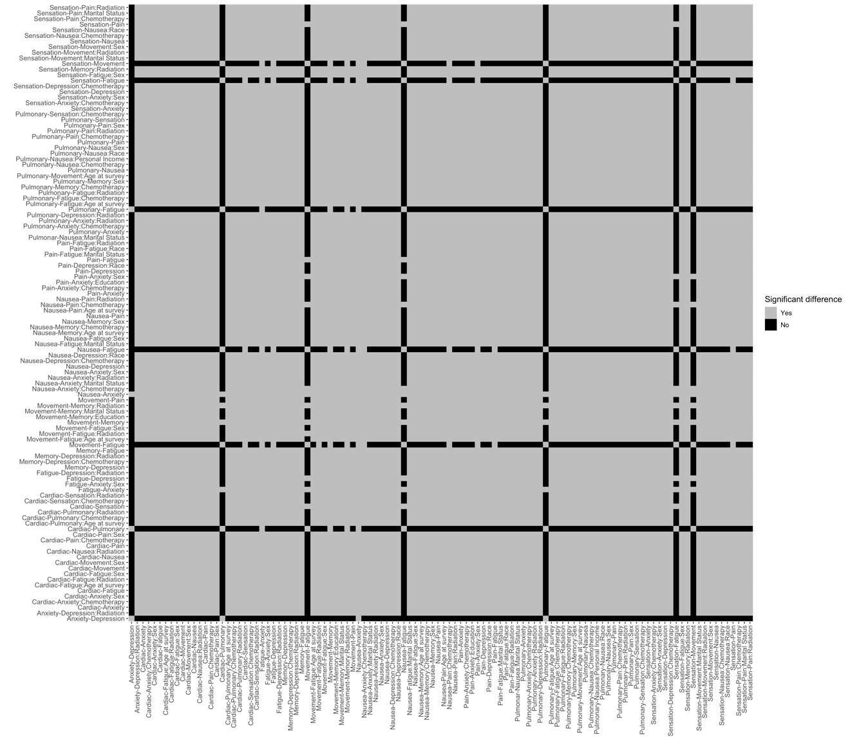
Supplementary Figure 1: Tests of differences between the identified pairwise associations in the constructed personal symptom network.

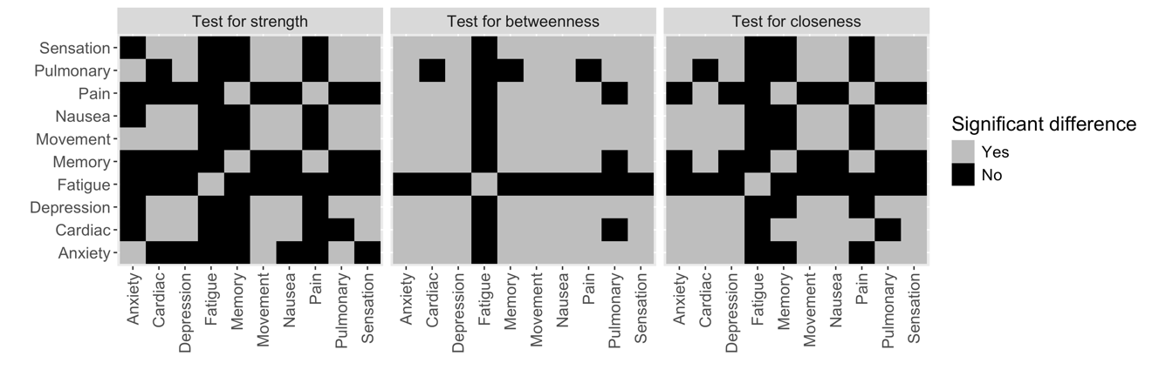
Supplementary Figure 2: Tests of differences between the centralities for symptoms in the constructed personal symptom network for one representative subject: a White non-Hispanic male, aged 30.9 years (mean) at survey with below college/post-graduate education, ever married or lived as married, and never received chemotherapy and/or radiation.

