Table S1 Peak area of each peak after the plasma samples were treated with different volumes of β-glucosidase
Enzyme dosage | Metabolite Ⅰ  [mAU*s] |  |  | Metabolite Ⅱ  [mAU*s] |  |  | Curcumin  [mAU*s] |  |  | ∆ Metabolite Ⅰ  [mAU*s] | ∆ Metabolite Ⅱ  [mAU*s] | ∆Curcumin  [mAU*s] | ∆ Metabolite Ⅱ/∆  Curcumin
Enzyme dosage | Peak area | average | SD | Peak area | average | SD | Peak area | average | SD
0μL | 169.2184 | 102.0316 | 58.6327 | 854.4708 | 596.6568 | 223.3117 | 2.6720 | 3.1660 | 0.6459 | / | / | / | /
0μL | 75.6659 | 102.0316 | 58.6327 | 471.8840 | 596.6568 | 223.3117 | 2.9291
0μL | 61.2105 | 102.0316 | 58.6327 | 463.6156 | 596.6568 | 223.3117 | 3.8968
1μL | 48.7509 | 35.8115 | 11.6412 | 315.1789 | 250.1503 | 56.7835 | 296.1140 | 326.1294 | 35.6476 | -66.2201 | -346.5065 | 322.9635 | -1.07
1μL | 32.4954 | 35.8115 | 11.6412 | 224.9035 | 250.1503 | 56.7835 | 316.7434
1μL | 26.1881 | 35.8115 | 11.6412 | 210.3685 | 250.1503 | 56.7835 | 365.5309
2μL | 30.67252 | 21.6565 | 7.8084 | 77.62789 | 67.9020 | 9.3332 | 440.8454 | 469.2862 | 43.7556 | -80.3751 | -528.7548 | 466.1203 | -1.13
2μL | 17.0844 | 21.6565 | 7.8084 | 67.05958 | 67.9020 | 9.3332 | 447.3419
2μL | 17.2125 | 21.6565 | 7.8084 | 59.01861 | 67.9020 | 9.3332 | 519.6714
5μL | 27.1970 | 24.6273 | 2.2333 | 30.70957 | 33.0266 | 2.5306 | 609.1490 | 609.1450 | 25.8528 | -77.4042 | -563.6302 | 605.9791 | -0.93
5μL | 23.5305 | 24.6273 | 2.2333 | 32.64323 | 33.0266 | 2.5306 | 583.2902
5μL | 23.1545 | 24.6273 | 2.2333 | 35.72697 | 33.0266 | 2.5306 | 634.9958
Notes: the concentration of the metabolites (mainly Metabolite Ⅱ) was calculated using the conversion factor of 1.
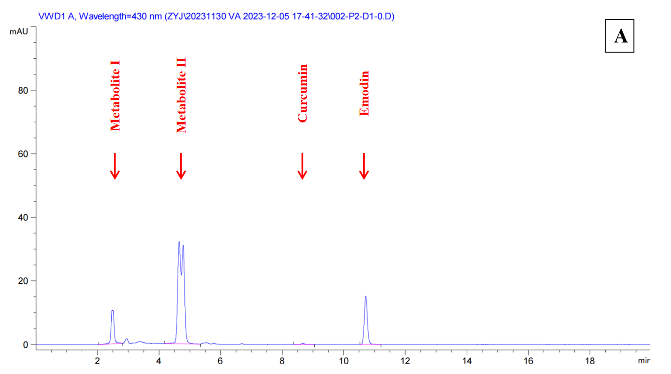
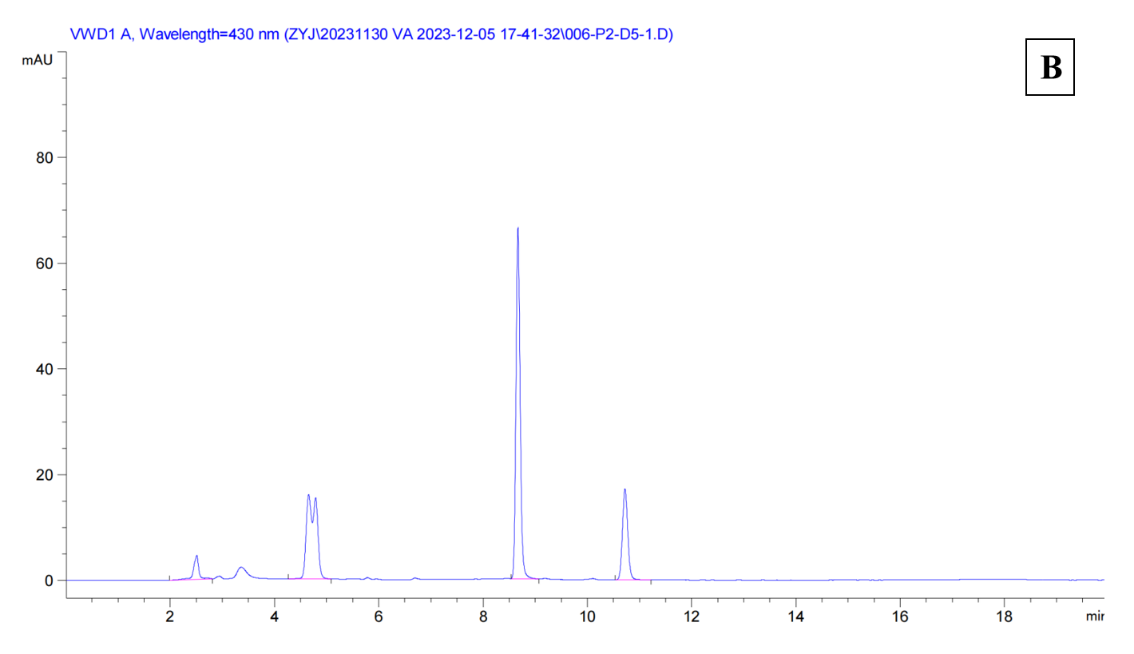
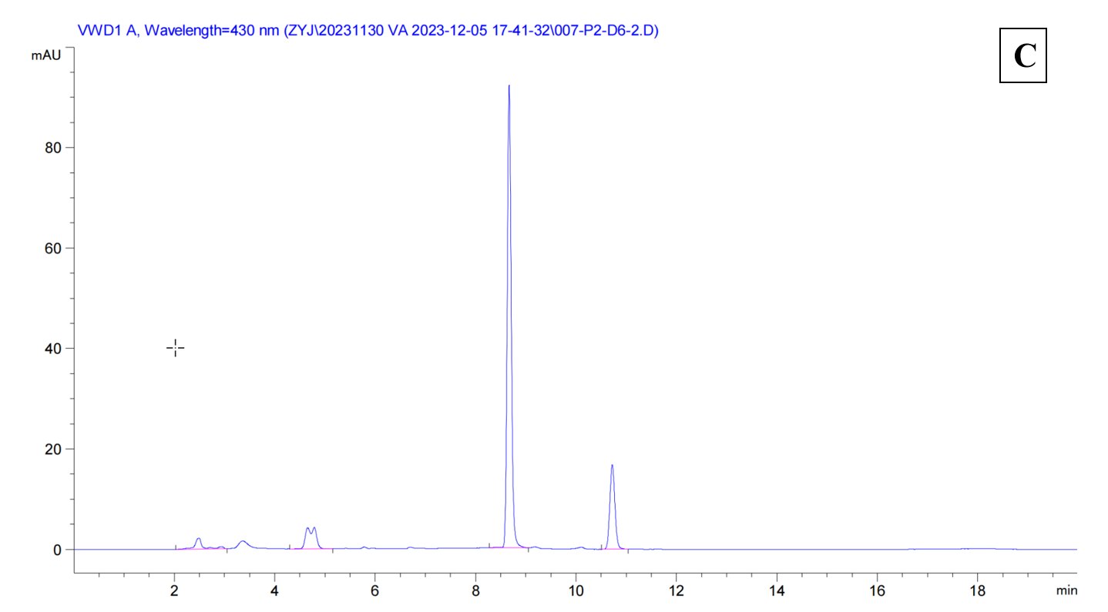
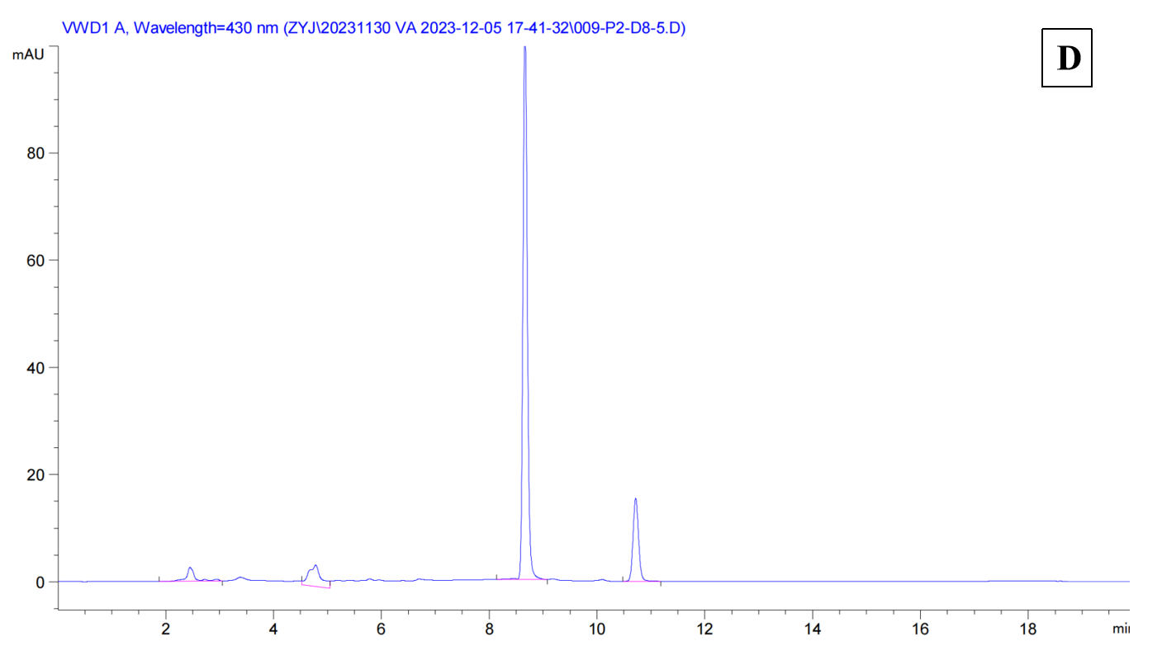
Figure S1 Chromatograms of plasma samples treated with (A) 0 μL, (B) 1 μL, (C) 2 μL and (D) 5 μL enzymes.

