Supplementary materials
Table S1 Association between testosterone and COPD in different subgroups.
Variables | OR 95%CI | p | p for interaction
Testosterone
Sex |  |  | 0.347
Male | 0.938 (0.666, 1.322) | 0.726
Female | 0.670 (0.492, 0.912) | 0.015
Age |  |  | 0.025
<60 | 0.662 (0.422, 1.037) | 0.062
≥60 | 0.770 (0.637, 0.929) | 0.026
Race |  |  | 0.043
Hispanic | 0.587 (0.379, 0.911) | 0.045
Non-Hispanic White | 0.731 (0.591, 0.904) | 0.008
Other race | 1.133 (0.691, 1.859) | 0.575
Education |  |  | 0.706
Under high school | 0.713 (0.484, 1.049) | 0.120
High school or equivalent | 0.566 (0.356, 0.901) | 0.020
Above high school | 0.854 (0.644, 1.134) | 0.232
Marital status |  |  | 0.752
With partner | 0.773 (0.578, 1.034) | 0.072
Widowed, divorced or separated | 0.737 (0.541, 1.003) | 0.048
Never married | 0.753 (0.383, 1.481) | 0.359
PIR |  |  | 0.465
<1.3 | 0.804 (0.615, 1.052) | 0.094
1.3≤PIR<3.5 | 0.618 (0.475, 0.803) | 0.002
≥3.5 | 0.912 (0.574, 1.449) | 0.657
BMI |  |  | 0.784
<25 | 1.005 (0.642, 1.573) | 0.980
25≤BMI<30 | 0.794 (0.587, 1.074) | 0.112
≥30 | 0.652 (0.461, 0.920) | 0.019
Hypertension |  |  | 0.369
Yes | 0.786 (0.611, 1.010) | 0.053
No | 0.722 (0.527, 0.991) | 0.041
Diabetes |  |  | 0.471
Yes | 0.676 (0.471, 0.970) | 0.033
No | 0.772 (0.603, 0.990) | 0.039
Smoking |  |  | 0.096
Never smoker | 0.746 (0.544, 1.025) | 0.062
Former smoker | 0.860 (0.623, 1.185) | 0.305
Current smoker | 0.604 (0.440, 0.828) | 0.005
Stroke |  |  | 0.570
Yes | 0.483 (0.300, 0.777) | 0.008
No | 0.788 (0.625, 0.993) | 0.041
Cancer |  |  | 0.251
Yes | 0.680 (0.501, 0.924) | 0.018
No | 0.804 (0.615, 1.051) | 0.090
Alcohol consumption |  |  | 0.549
Yes | 0.744 (0.604, 0.918) | 0.010
No | 0.787 (0.549,1.128) | 0.228
Coronary heart disease |  |  | 0.082
Yes | 0.867 (0.635, 1.184) | 0.399
No | 0.740 (0.593, 0.922) | 0.012
Thyroid diseases |  |  | 0.609
Yes | 0.763 (0.493, 1.180) | 0.181
No | 0.764 (0.600, 0.973) | 0.030
Liver diseases |  |  | 0.373
Yes | 0.737 (0.172, 3.156) | 0.541
No | 0.767 (0.625, 0.943) | 0.016
PIR: poverty-to-income ratio; BMI: body mass index

Table S2 Association between estradiol and COPD in different subgroups.
Variables | OR 95%CI | p | p for interaction
Estradiol
Sex |  |  | 0.919
Male | 0.778 (0.504, 1.201) | 0.209
Female | 0.728 (0.643, 0.824) | <0.001
Age |  |  | 0.037
<60 | 0.749 (0.606, 0.924) | 0.012
≥60 | 0.692 (0.531, 0.901) | 0.011
Race |  |  | 0.072
Hispanic | 1.011 (0.674, 1.516) | 0.950
Non-Hispanic White | 0.721 (0.603, 0.863) | 0.002
Other race | 1.116 (0.902, 1.381) | 0.340
Education |  |  | 0.646
Under high school | 0.789 (0.641, 0.971) | 0.027
High school or equivalent | 0.580 (0.402, 0.838) | 0.008
Above high school | 0.839 (0.719, 0.980) | 0.028
Marital status |  |  | 0.596
With partner | 0.858 (0.668, 1.102) | 0.192
Widowed, divorced or separated | 0.705 (0.571, 0.871) | 0.004
Never married | 0.778 (0.450, 1.346) | 0.319
PIR |  |  | 0.569
<1.3 | 0.772 (0.620, 0.961) | 0.023
1.3≤PIR<3.5 | 0.769 (0.620, 0.955) | 0.021
≥3.5 | 0.830 (0.650, 1.060) | 0.113
BMI |  |  | 0.573
<25 | 0.855 (0.723, 1.012) | 0.061
25≤BMI<30 | 0.770 (0.589, 1.008) | 0.052
≥30 | 0.701 (0.588, 0.835) | 0.001
Hypertension |  |  | 0.034
Yes | 0.849 (0.714, 1.009) | 0.055
No | 0.715 (0.543, 0.941) | 0.020
Diabetes |  |  | 0.070
Yes | 0.770 (0.573, 1.036) | 0.071
No | 0.788 (0.676, 0.917) | 0.015
Smoking |  |  | 0.710
Never smoker | 0.746 (0.461, 1.208) | 0.195
Former smoker | 0.810 (0.631, 1.041) | 0.085
Current smoker | 0.785 (0.627, 0.982) | 0.034
Stroke |  |  | 0.427
Yes | 0.783 (0.474, 1.294) | 0.257
No | 0.787 (0.704, 0.881) | 0.003
Cancer |  |  | 0.080
Yes | 0.623 (0.434, 0.895) | 0.015
No | 0.848 (0.725, 0.992) | 0.038
Alcohol consumption |  |  | 0.955
Yes | 0.823 (0.714, 0.949) | 0.028
No | 0.660 (0.497, 0.875) | 0.020
Coronary heart disease |  |  | 0.075
Yes | 0.804 (0.518, 1.248) | 0.364
No | 0.797 (0.689, 0.923) | 0.006
Thyroid diseases |  |  | 0.448
Yes | 0.662 (0.491, 0.891) | 0.011
No | 0.818 (0.702, 0.952) | 0.014
Liver diseases |  |  | 0.005
Yes | 2.345 (0.466, 10.714) | 0.178
No | 0.767 (0.667, 0.883) | 0.002
PIR: poverty-to-income ratio; BMI: body mass index

Table S3 Independent SNPs associated with testosterone in the GWAS database.
SNP | Beta | SE | p | Sample size | Effect_allele | Other_allele | EAF | F | R^2
rs11240695 | 0.0183046 | 0.00231952 | 1.80E-15 | 382988 | A | C | 0.246864 | 62.27650659 | 0.326739543
rs10192634 | 0.0166649 | 0.00225554 | 4.50E-13 | 382988 | T | C | 0.268761 | 54.58890178 | 0.339162819
rs113017476 | 0.0874817 | 0.00518438 | 7.80E-65 | 382988 | A | G | 0.039246 | 284.7349477 | 0.088543582
rs10279715 | -0.014209 | 0.0020076 | 1.30E-12 | 382988 | G | A | 0.46265 | 50.09249396 | 0.393140955
rs10982156 | 0.0256267 | 0.00408608 | 3.70E-10 | 382988 | A | T | 0.069716 | 39.33431932 | 0.13523772
rs10978435 | -0.0175351 | 0.00215378 | 4.80E-16 | 382988 | C | T | 0.315582 | 66.28477925 | 0.360153666
rs11389722 | -0.0112928 | 0.00205942 | 2.80E-08 | 382988 | GT | G | 0.487563 | 30.06861478 | 0.38104923
rs10892924 | 0.0187203 | 0.00203107 | 3.00E-21 | 382988 | T | A | 0.568234 | 84.9524338 | 0.387608999
rs112295236 | 0.0313604 | 0.00411368 | 2.30E-14 | 382988 | G | C | 0.063633 | 58.11686464 | 0.133670861
rs10745954 | 0.0129654 | 0.00199861 | 6.10E-11 | 382988 | G | A | 0.480447 | 42.08387555 | 0.39528452
rs111475133 | -0.0176792 | 0.00259395 | 1.40E-11 | 382988 | TA | T | 0.196457 | 46.45174323 | 0.279566686
rs1104608 | 0.0119033 | 0.00203942 | 5.80E-09 | 382988 | C | G | 0.425454 | 34.06602106 | 0.3856631
rs1050541 | -0.0304246 | 0.00206597 | 8.40E-49 | 382988 | G | T | 0.556976 | 216.8711252 | 0.379552497
rs10445374 | -0.0194906 | 0.00199961 | 4.80E-22 | 382988 | C | T | 0.513897 | 95.00792157 | 0.395045404
rs10212007 | 0.01963 | 0.00348949 | 3.10E-08 | 382988 | G | C | 0.090377 | 31.64584401 | 0.17657023
EAF, effect allele frequency

Table S4 Independent SNPs associated with estradiol in the GWAS database.
SNP | Beta | SE | p | Sample size | Effect_allele | Other_allele | EAF | F | R^2
rs112881196 | 0.0249518 | 0.00219839 | 5.60E-30 | 206927 | G | C | 0.039212 | 128.8232589 | 0.499984664
rs10006452 | -0.00728098 | 0.000844823 | 5.30E-18 | 206927 | C | T | 0.48021 | 74.27595056 | 0.871316063
rs10491431 | 0.00774443 | 0.00121717 | 1.80E-10 | 206927 | A | C | 0.141 | 40.48334952 | 0.765366884
rs34019140 | -0.011661 | 0.000862566 | 6.90E-42 | 206927 | A | G | 0.435748 | 182.7624283 | 0.86658278
rs3751591 | 0.0077766 | 0.00113687 | 6.60E-12 | 206927 | G | A | 0.166931 | 46.79052405 | 0.788987226
rs113047993 | -0.00966159 | 0.00168082 | 8.70E-09 | 206927 | T | C | 0.068984 | 33.04112252 | 0.631073678
rs2547234 | -0.00760122 | 0.00113891 | 2.70E-11 | 206927 | C | T | 0.834781 | 44.54385423 | 0.788389657
rs117826558 | 0.0136375 | 0.00243043 | 2.70E-08 | 206927 | T | C | 0.033971 | 31.48497064 | 0.449981068
EAF, effect allele frequency

Table S5 Results of heterogeneity and pleiotropy test.
 | heterogeneity |  |  |  | Pleiotropy_test
 |  | Q | Q_df | p | Egger_intercept | SE | p
Testosterone | MR Egger | 12.3894 | 8 | 0.134657 | -0.00301 | 0.012092 | 0.809711
 | Inverse variance weighted | 12.48534 | 9 | 0.1873096
Estradiol | MR Egger | 4.139317 | 6 | 0.6578295 | 0.026554 | 0.017905 | 0.188585
 | Inverse variance weighted | 6.338731 | 7 | 0.5008003

Figure S1 Leave-one-out analysis for testosterone-COPD relationship.
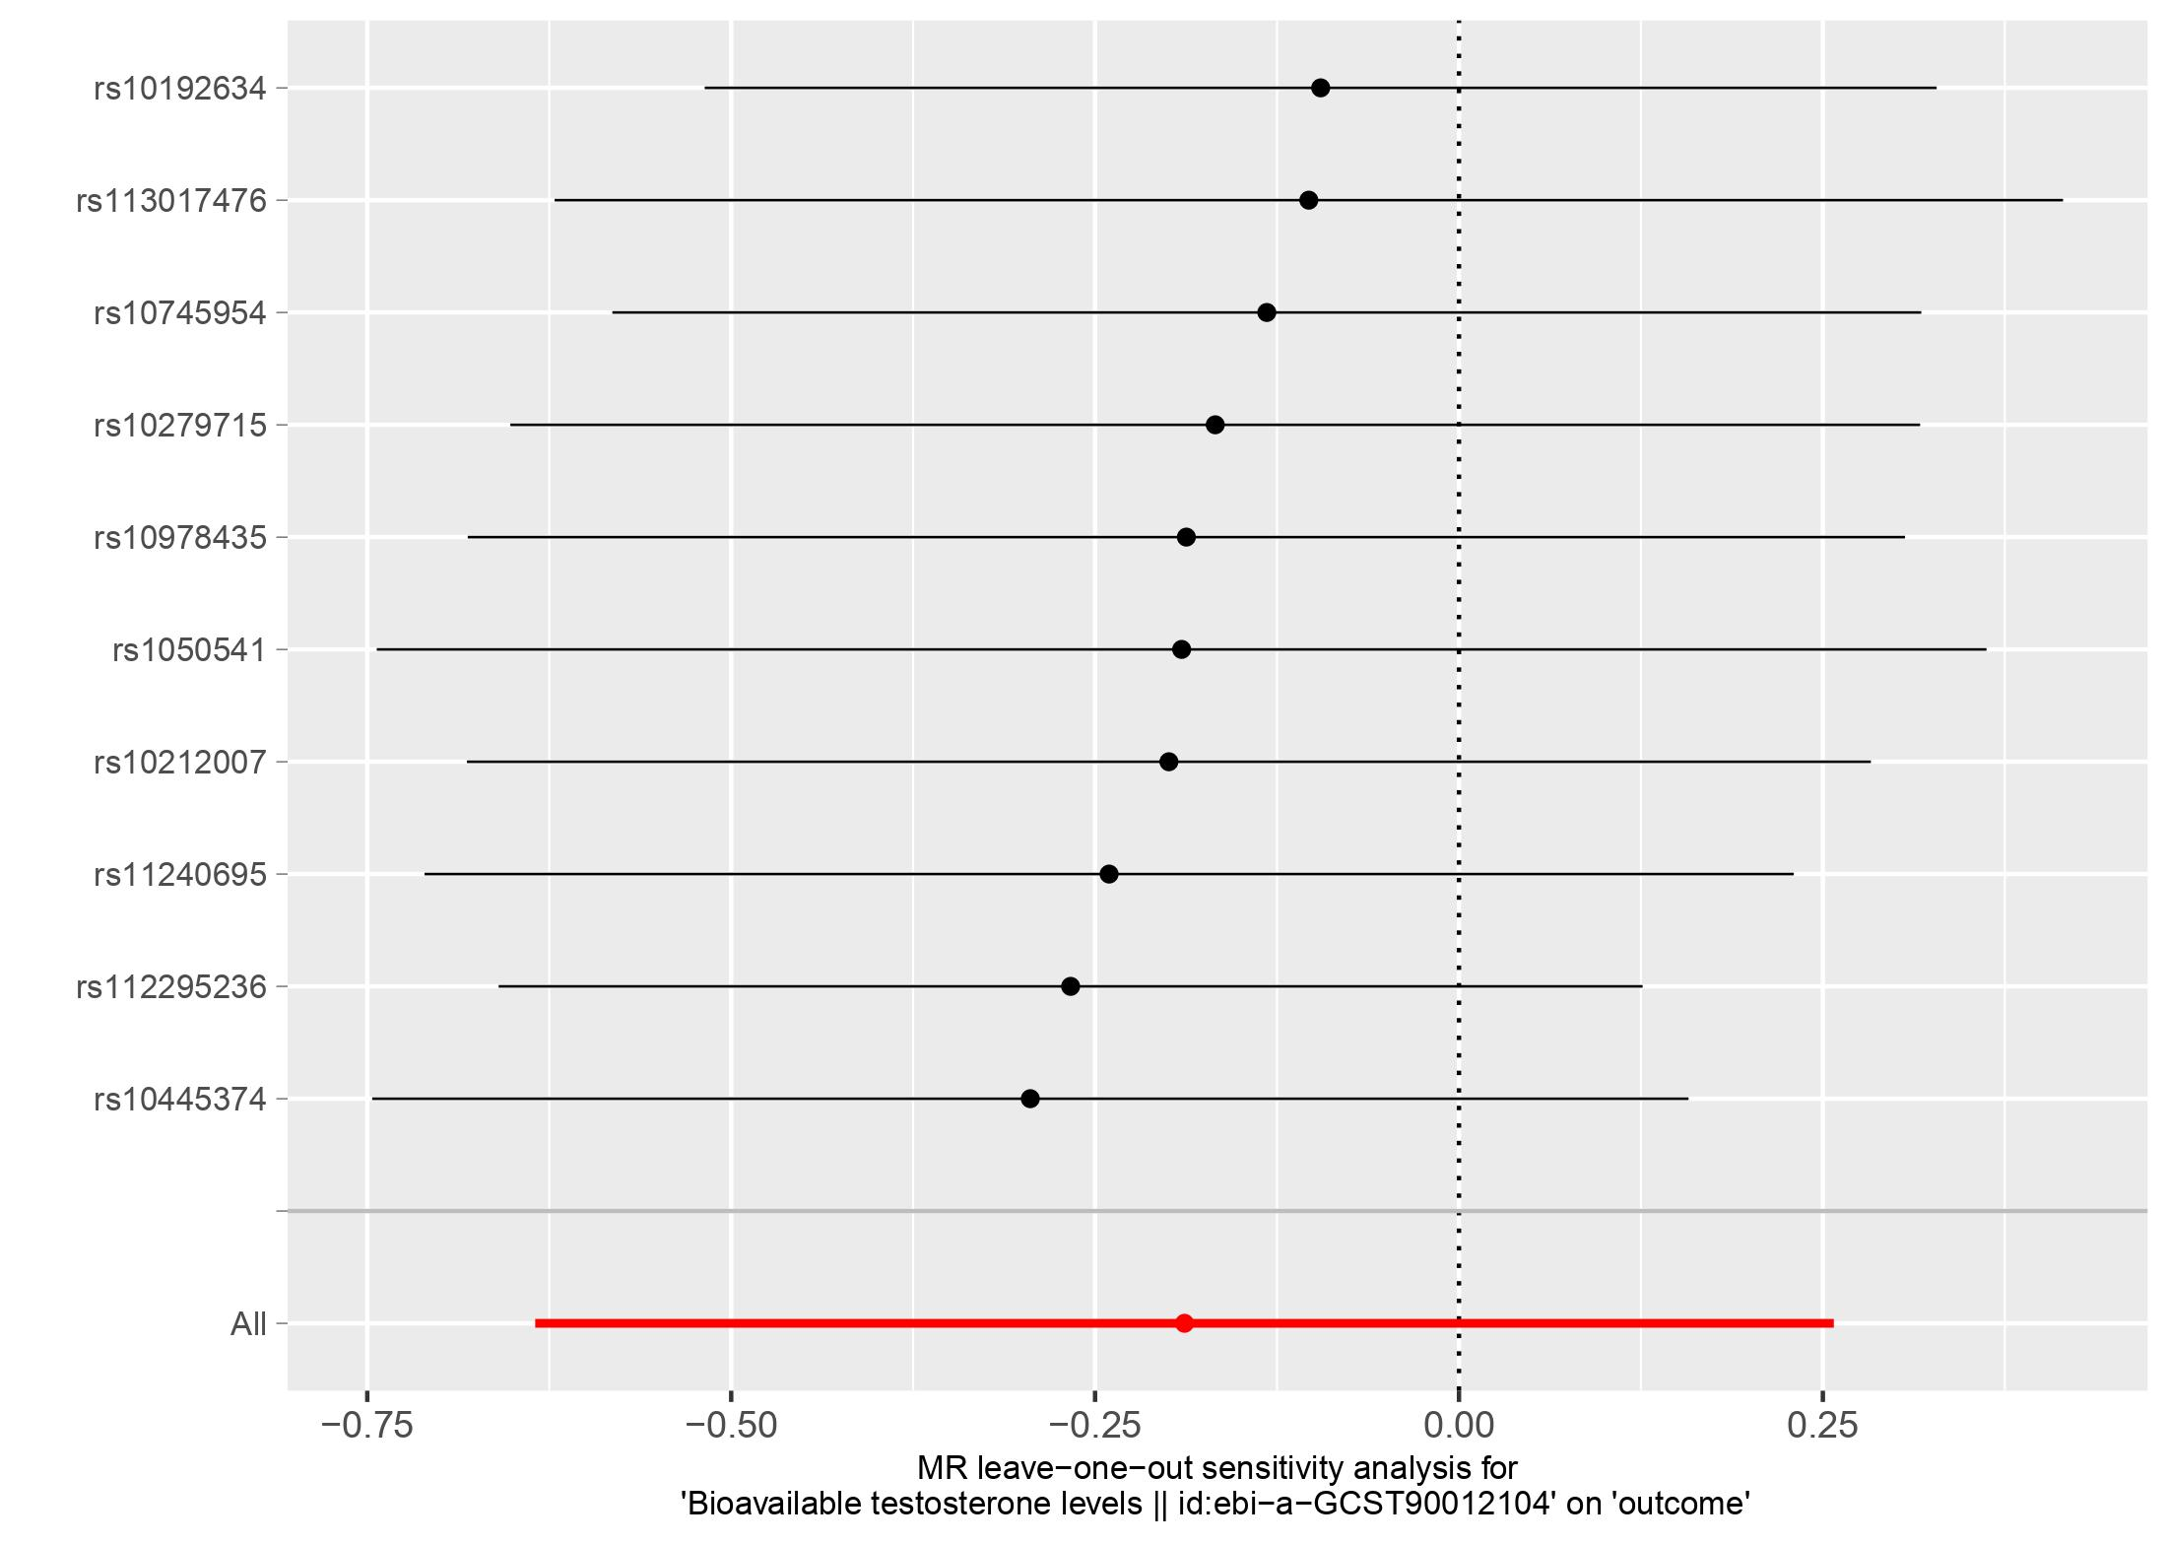
Figure S2 Leave-one-out analysis for estradiol-COPD relationship.
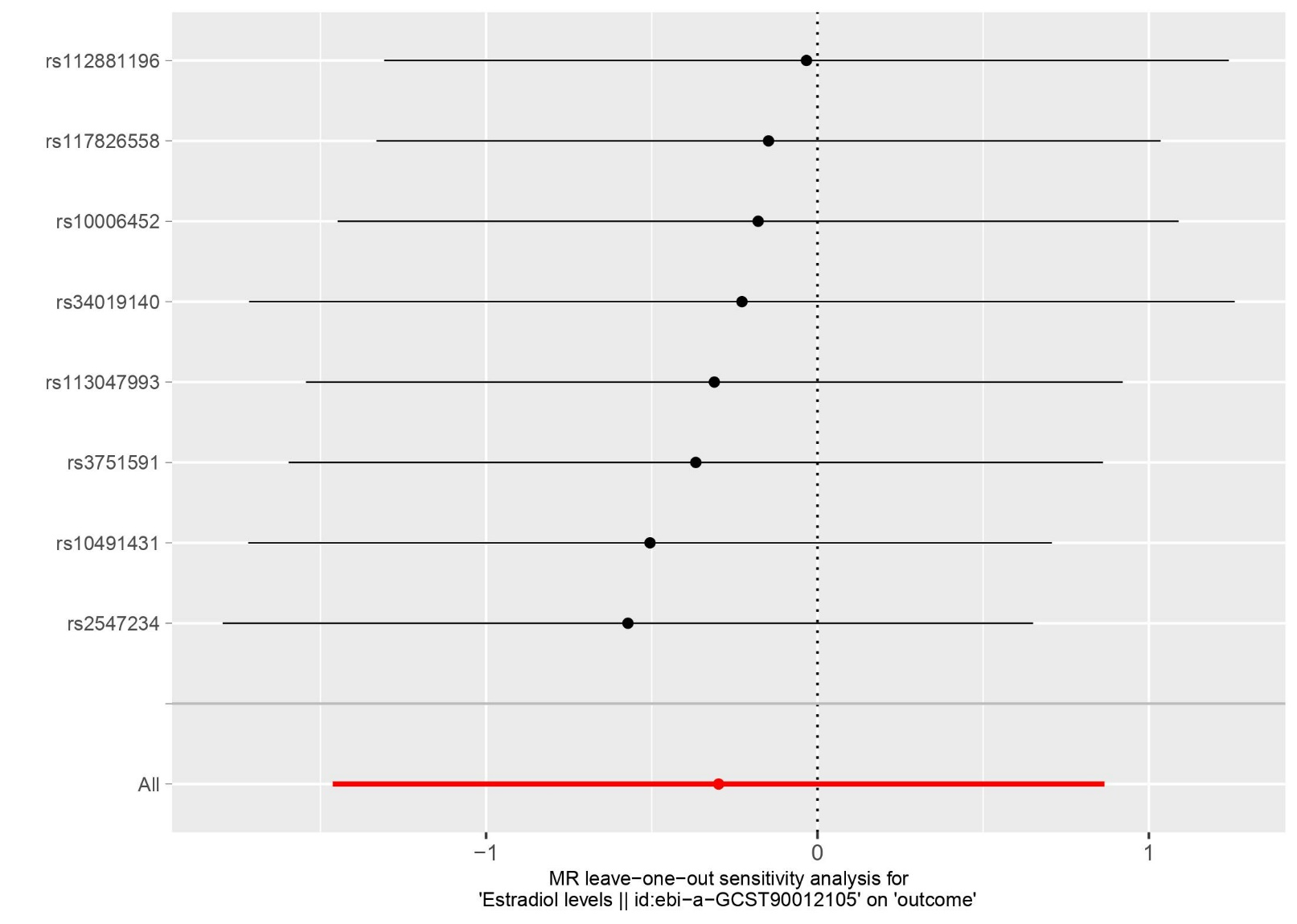

Figure S3 Scatterplot for testosterone-COPD relationship.
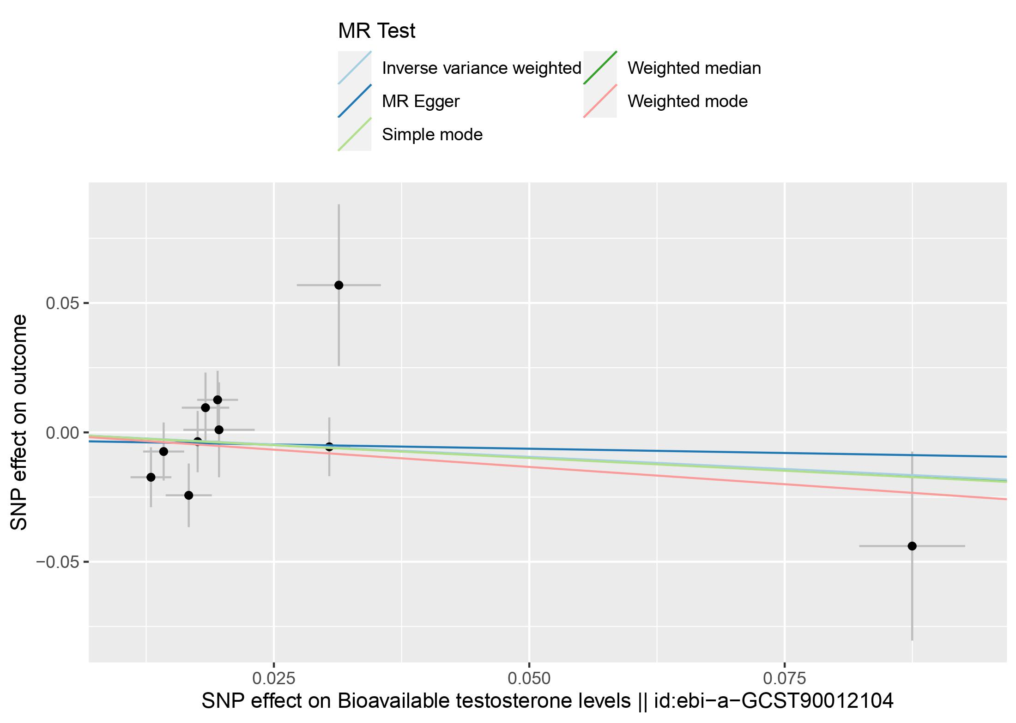
Figure S4 Scatter plot for estradiol-COPD relationship.
