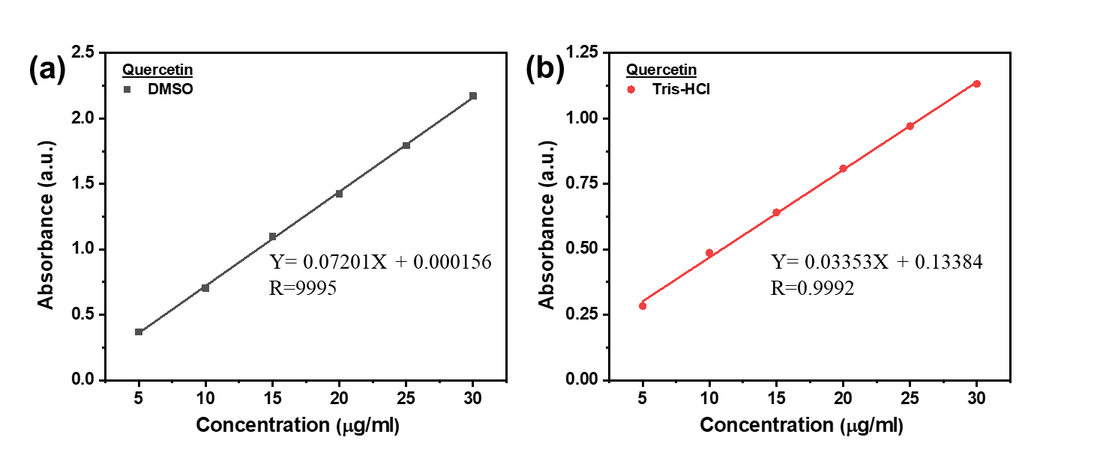
Figure S1. Standard curve of (a) QUER in DMSO and (b) QUER in Tris-HCl.

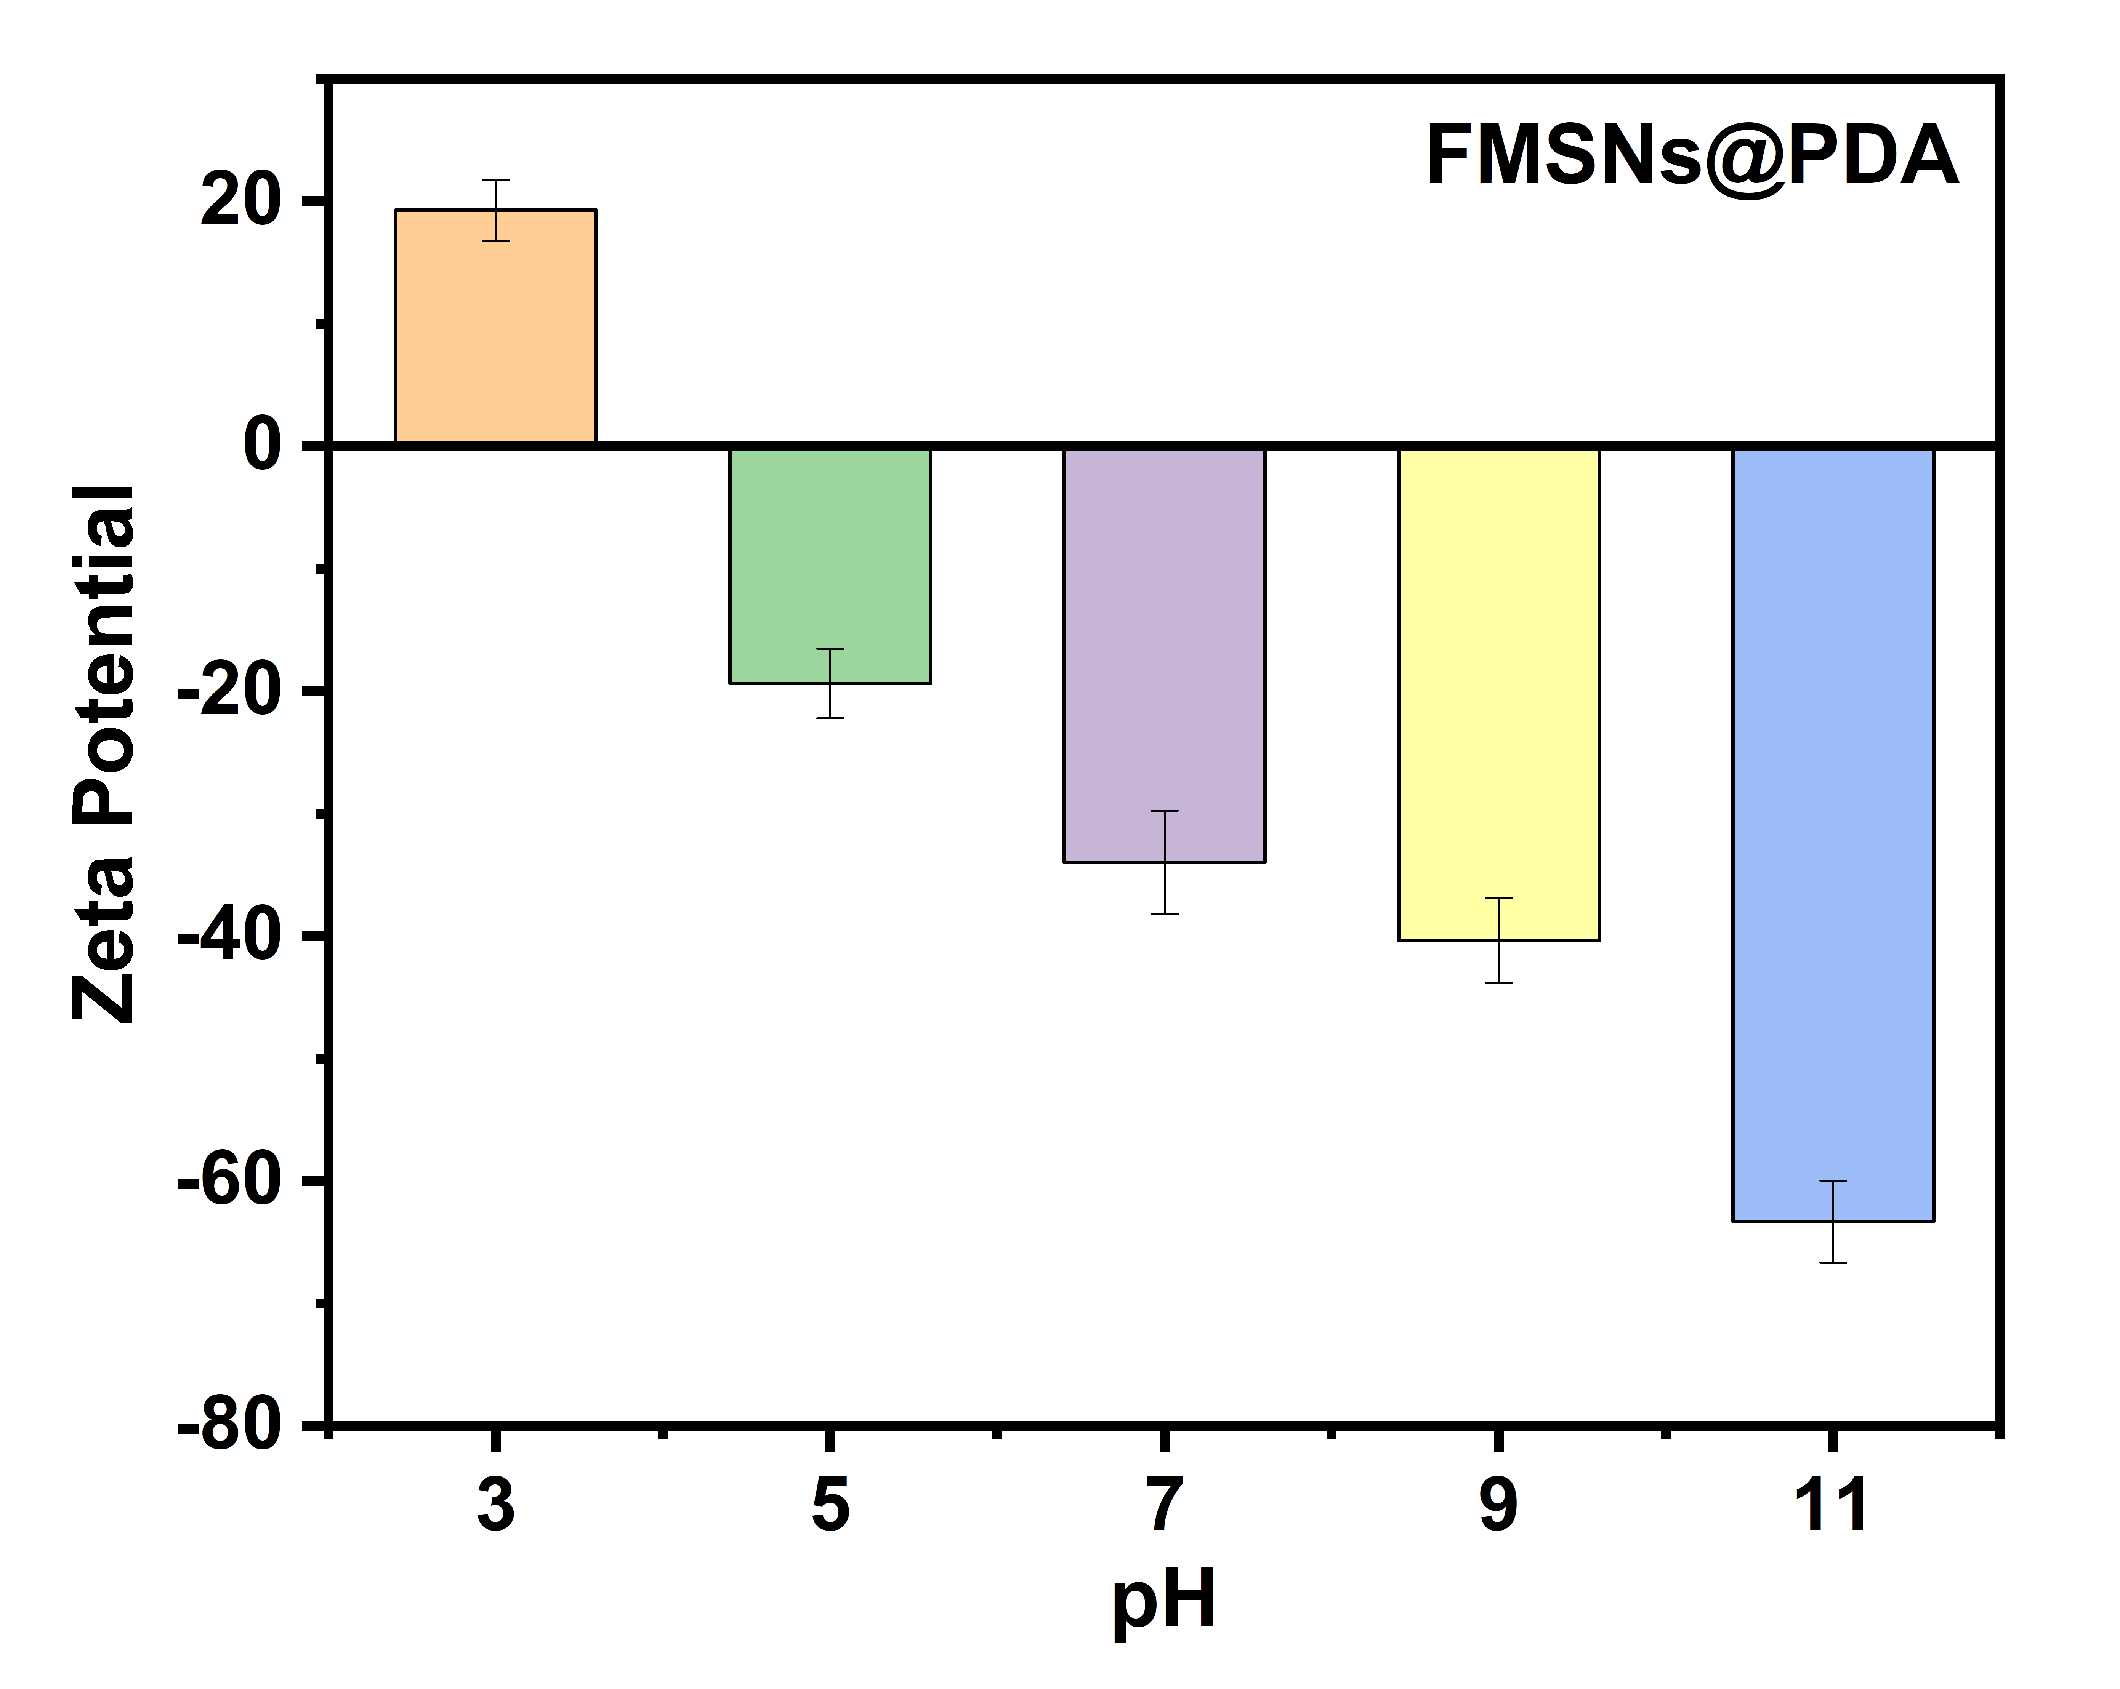
Figure S2. Zeta potentials of FMSNs@PDA in HPLC water at different pH values adjusted by HCl and NaOH agents. Zeta potential and particle size of the samples were measured by Electrophoretic Light Scattering method (ELSZ-2000, Otsuka).
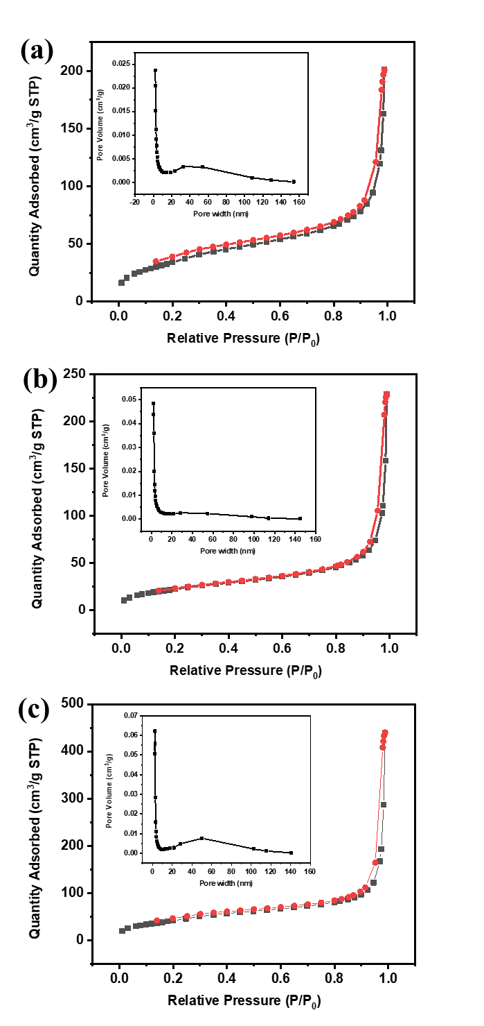
Figure S3. Nitrogen adsorption/desorption isotherms and pore size distribution by BJH analysis of (a) MSNs and (b) FMSNs (c) FMSNs@PDA.
Table S1. Zeta potential and Particles size of samples (MSNs, FMSNs and FMSNs@PDA) in PBS pH 7.4 by ELS
Samples | Zeta potential (mV) | Particle size (nm)
MSNs | -31.53 ± 1.96 | 149.6 ± 30.2
FMSNs | -21.12 ± 2.31 | 154.6 ± 22.5
FMSNs@PDA | -45.16 ± 1.45 | 164.0 ± 38.9

Table S2. Physicochemical properties of the samples measured by BET–BJT methods
Samples | Surface area (m²/g) | Pore size (nm)
MSNs | 84.51 | 9.76
FMSNs | 127.36 | 17.11
FMSNs@PDA | 156.55 | 16.70

