Supplementary Figure 1. InBodyS10 device
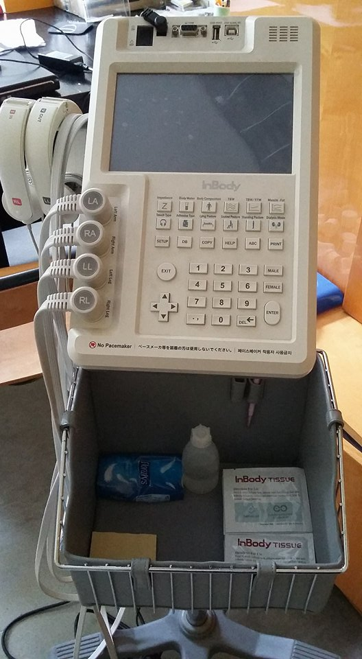

Supplementary Figure 2. Photographic illustration of electrode connection during body composition measurement
