Supplementary Figures
Supplementary Figure 1: Tet-on Jurkat T cells with inducible expression of PPARγ. Tet-on Jurkat T cells stably transduced with the pLVX-TRE3G-mCherry-IRES-hPPARγ1 vector (Tet-on Jurkat T cells PPARγ1 OE) were stimulated for 24 h with 0.001, 0.01, 0.1, 0.5 or 1 µg/ml doxycycline. Where indicated the proteasome inhibitor MG132 [10 µM] is added for the last 4 h. HEK293T cells with a similar Tet-on system (HEK293T PPARγ1 OE) were included as a positive control.
Abbreviations: 3G, third generation of the promoter; HEK293T, human embryonal kidney cell line expressing the large T-antigen of the simian virus 40; IRES, internal ribosomal entry site; MG132, carbobenzoxyl-L-leucyl-L-leucyl-L-leucine; OE, overexpressing; p, plasmid; LV, lentiviral vector; hPPARγ, human peroxisome proliferator-activated receptor γ; Tet, tetracycline; TRE, tetracycline responsive element.
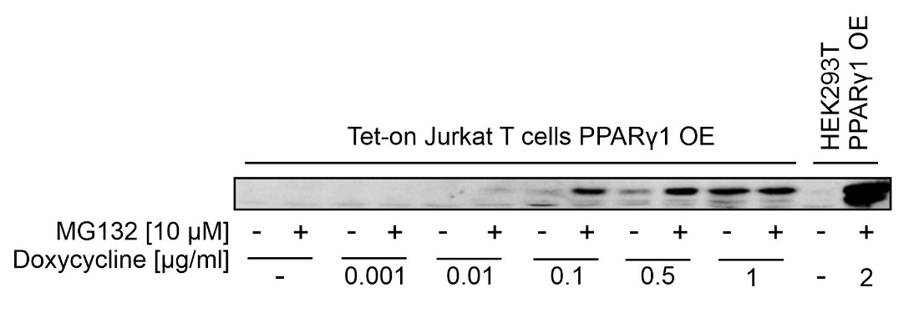

Supplementary Figure 2: Treatment of Jurkat T cells stably transduced with a Tet-on vector to express PPARγ following doxycycline stimulation. Jurkat PPARγ Tet-on T cells were seeded into a petridish and stimulate for 24 h with doxycycline to induce PPARγ expression. Afterwards cells were treated for 24 h either with 1 µM of the PPARγ agonist rosiglitazone or with a combination of rosiglitazone [1 µM] and GW9662 [10 µM], an irreversible PPARγ antagonist. Then, cells were harvested and mRNA was isolated. Following a library preparation, a next generation sequencing (NGS) approach was performed to identify PPARγ target genes. Genes regulated in response to PPARγ activation are shown in Table 1, genes regulated following PPARγ inhibition are presented in Table 2.
Abbreviations: GW9662, 2-chloro-5-nitro-N-phenylbenzamide; NGS, next generation sequencing; PPARγ, peroxisome proliferator-activated receptor γ; Tet, tetracycline.

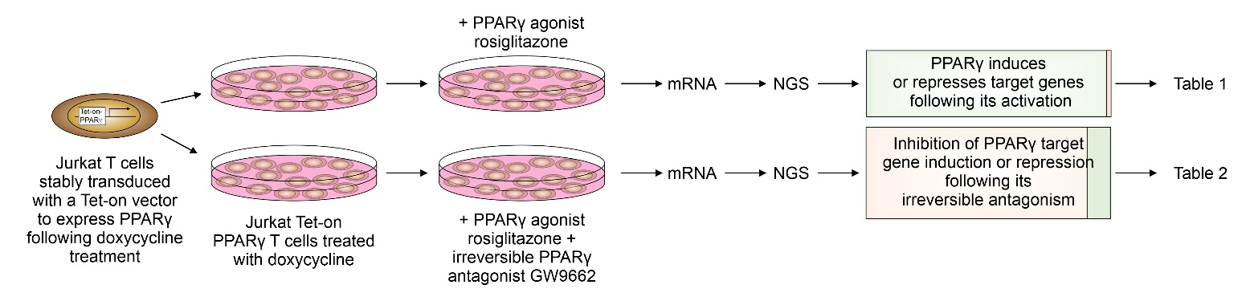
Supplementary Figure 3: Gating strategy used to determine the number of CD3⁺, CD4⁺, and CD8⁺ T cells. 100 µl of freshly drawn blood of COVID-19 patients or healthy donors were stained as described in Materials and Methods. Following erythrolysis, 50 µl of counting beads (A) were added to the sample. CD4⁺ T cells were further analysed for CRTH2, and FoxP3 expression (B). Counting beads and relevant immune cell sub-populations are shown in red and marked with a red gate.
Abbreviations: A, area; APC, allophycocyanin; APC-Cy7, allophycocyanine-cyanine 7; CD, cluster of differentiation; COVID-19, corona disease 2019; CRTH2, chemokine receptor homologue expressed on T_{h}2 cells; FITC, fluorescein-isothiocyanate; FoxP3, forkhead box protein 3; FSC, forward scatter; PE, phycoerythrin; PerCP-Cy5.5, peridinin-chlorophyll-protein-cyanine 5.5; SSC, side scatter.

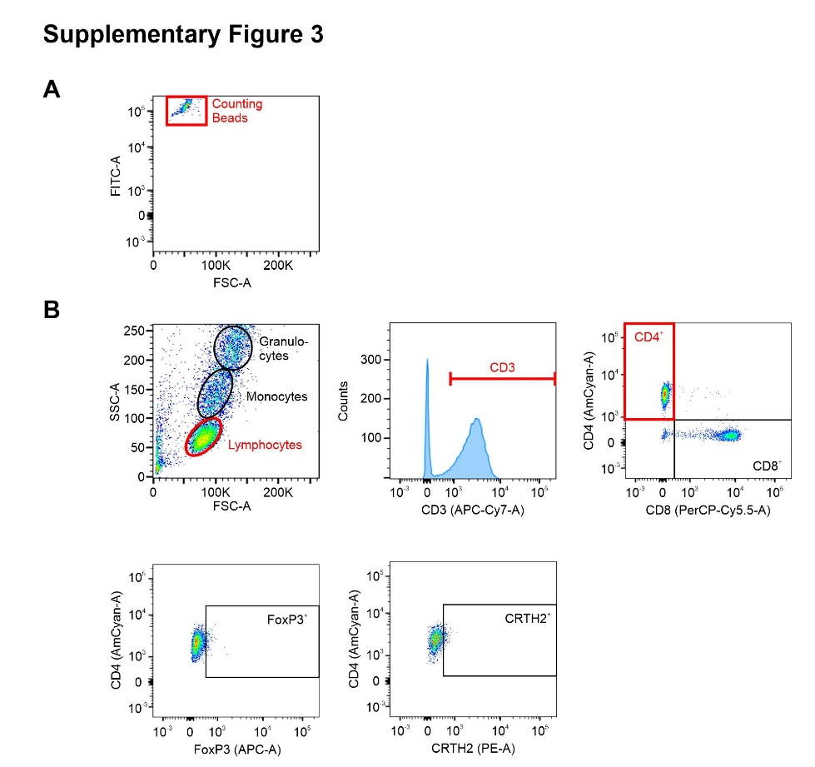

Supplementary Figure 4: Schematic diagram presenting intracellular PPARγ staining in peripheral blood cells of COVID-19 patients. Following lysis of erythrocytes, leukocytes derived from peripheral blood of COVID-19 patients were stained intracellularly with a PPARγ-specific antibody conjugated to AlexaFluor 750 (AF750) as described in Materials and Methods (A). To show specific binding of the AF750-tagged antibody, an unconjugated antibody of the identical clone was added to the staining in 10-fold excess (B). Instead, the untagged anti-PPARγ antibody, an unspecific antibody (anti-FoxP3-APC) was used in a third staining reaction in 10-fold excess (C).
Abbreviations: α, anti; ab, antibody; AF, AlexaFluor; APC, allophycocyanin; COVID-19, coronavirus disease 2019; CP, competition; FoxP3, forkhead box protein 3; PPARγ, peroxisome proliferator-activated receptor γ; s, specific; us, unspecific.

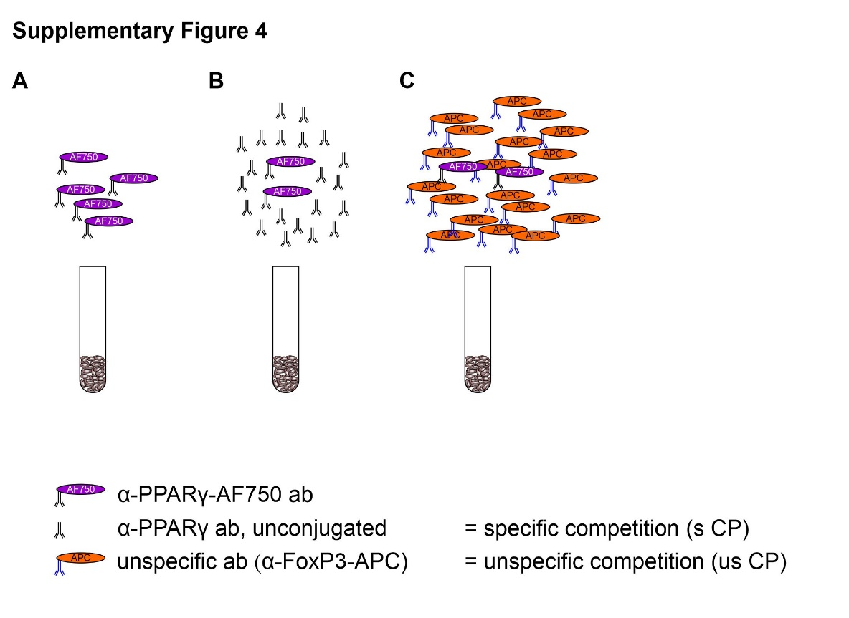

Supplementary Figure 5: Evaluation of MACS-dependent enrichment of human CD4⁺ T cells derived from peripheral blood of healthy donors before (left) and following enrichment (right). Enrichment was determined by FACS analysis. A representative result is shown.
Abbreviations: A, area; CD, cluster of differentiation; FACS, fluorescence-activated cell sorting; MACS, magnetic cell sorting; PerCP-Cy5.5, peridinin-chlorophyll-protein-cyanine 5.5.

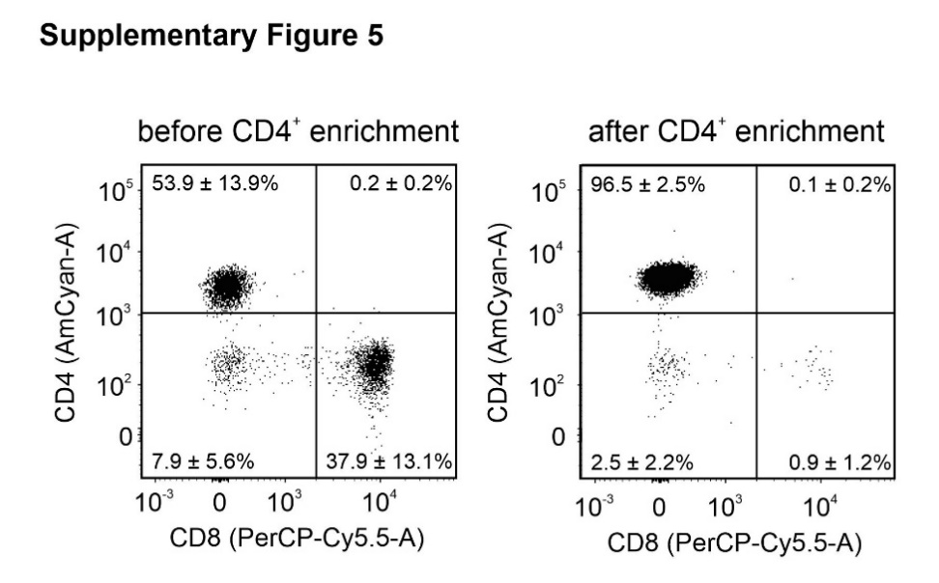

Supplementary Figure 6: Human CD4⁺ T cells were enriched by MACS separation (see Supplementary Figure 5). Afterwards, CD4⁺ T cells were differentiated for 13 days to T_{h}2 cells as described in Materials and Methods. (A) To identify the efficiency of T_{h}2 differentiation, cells were stained intracellularly for IL-4 as an T_{h}2 and for IFNγ as an T_{h}1 marker cytokine before (left panel) or after T_{h}2 differentiation (right panel). (B) To test whether T_{h}2 cells can be shifted to a T_{h}1 phenotype by mitogenic activation, we treated enriched CD4⁺ T cells before (left panel) and after T_{h}2 differentiation (right panel) with an activation cocktail, containing PMA and ionomycin as stimuli and monensin to prevent cytokine release from the cells. Concerning different requirements to prevent cytokine release, we also added BD Golgi-PlugTM, containing brefeldin A as described in Materials and Methods.
Abbreviations: A, area; BD, Becton Dickinson; CD, cluster of differentiation; IL-4, interleukin-4; IFN-γ, interferon-γ; MACS, magnetic cell sorting; PerCP-Cy5.5, peridinin-chlorophyll-protein-cyanine 5.5; PMA, phorbol myristate acetate; T_{h}1, T helper cells type 1; T_{h}2, T helper cells type 2.
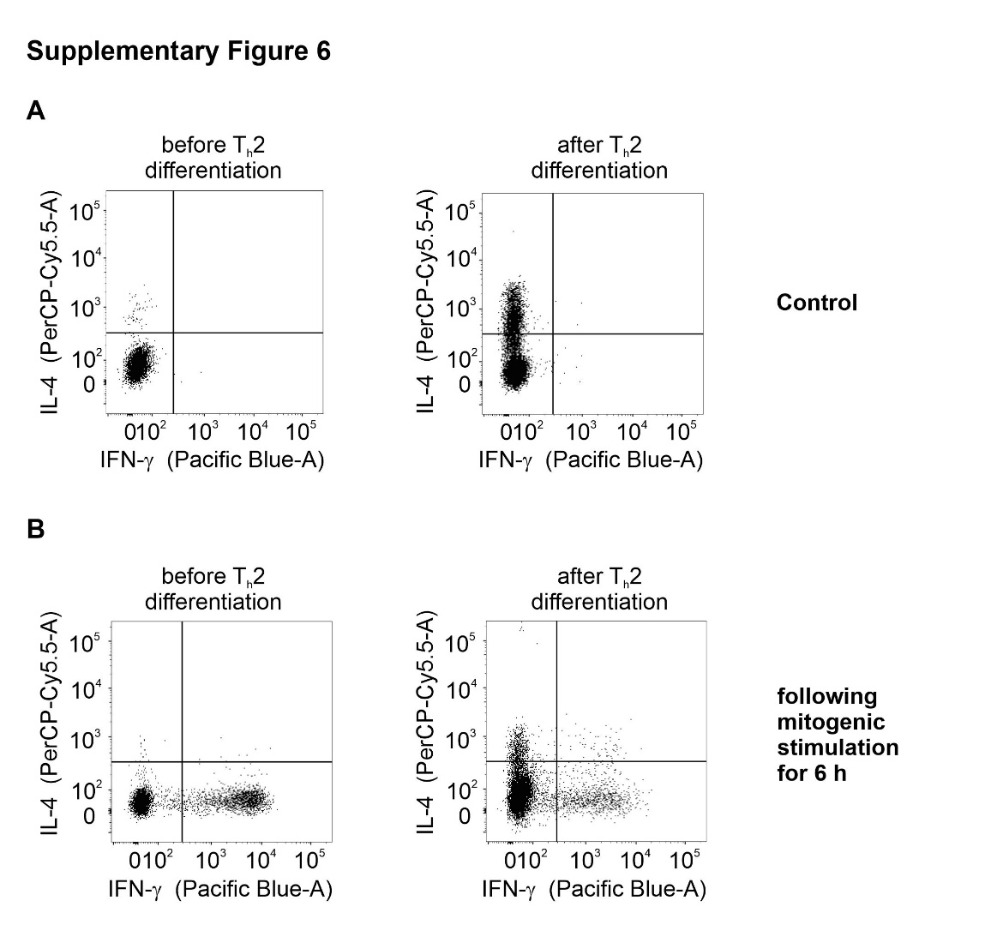

Supplementary Figure 7: Release of (A) procalcitonin (PCT), (B) IL-6, (C) C-reactive protein (CRP), and (D) lactate-dehydrogenase (LDH). Amounts were determined for 30 days intensive care unit stay (d ICU) (n = 24). Hospital’s central laboratory’s threshold levels (C) are PCT: 0,5 ng/ml, IL-6: 7 pg/ml, CRP: 0,5 mg/dl, LDH: 248 U/l and are shown as a green dashed line. To show the impact of the necessary treatment, we compared the amounts of non-ventilated (white columns, NV, n = 5 patients), ventilated (light grey columns, V, n = 12 patients) and extracorporeal membrane oxygenation (dark grey columns, E, n = 7 patients) requiring patients of (E) PCT, (F) IL-6, (G) CRP, and (H) LDH. Finally, we determined the amount of (I) PCT, (J) IL-6, (K) CRP and (L) LDH in surviving (S, n = 5 patients) vs. deceased (D, n = 19 patients) patients. In (E) to (L) means were calculated from all samples of the particular patient. These were used to determine the corresponding means, which are shown. * p < 0.05, **p < 0.01, ***p < 0.001.
Abbreviations: C, hospital’s central laboratory’s threshold levels; CRP, C-reactive protein; d, days; D, deceased; E, extracorporeal membrane oxygenation; ICU, intensive care unit; IL-6, interleukin-6; LDH, lactate-dehydrogenase; NV, non-ventilated; PCT, procalcitonin; S, surviving; U, units; V, ventilated.
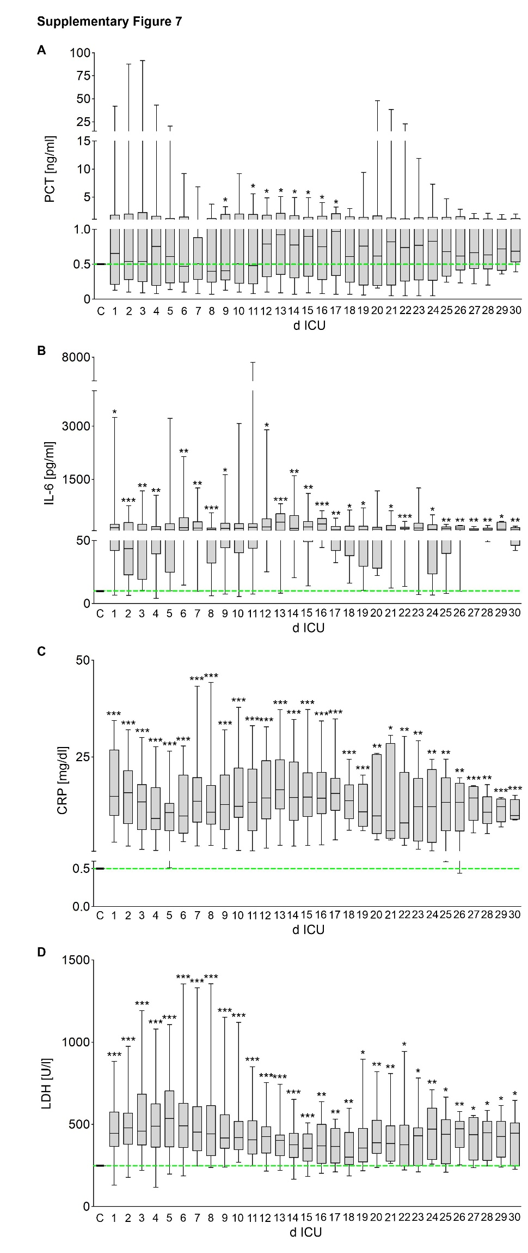
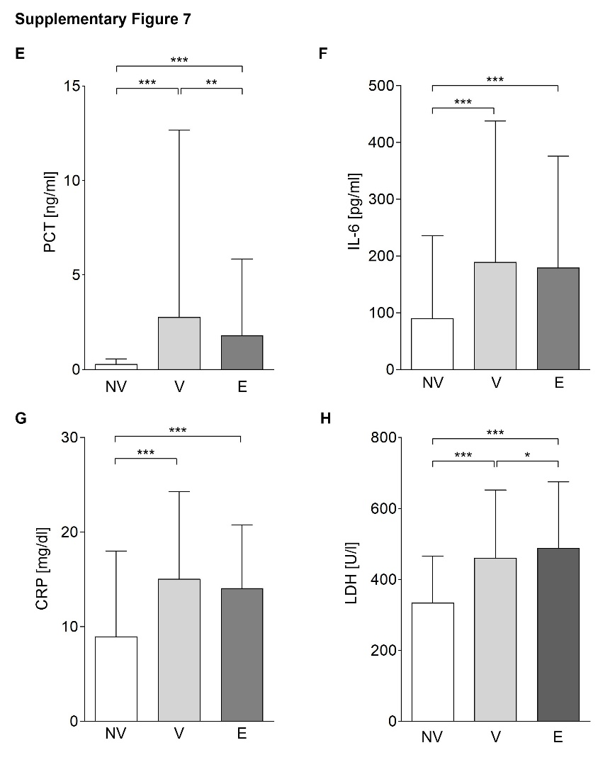
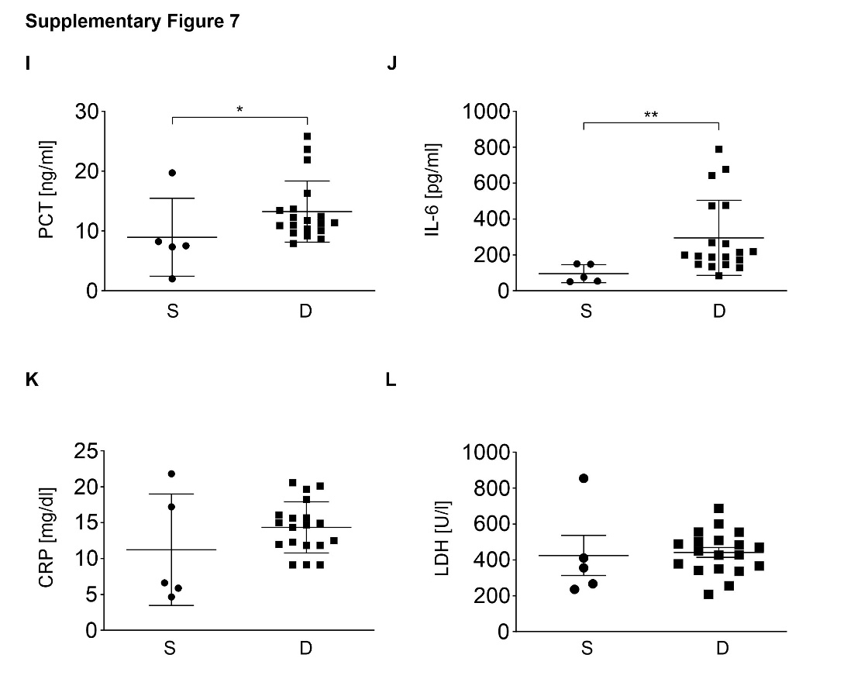

Supplementary Figure 8: Percentage of T_{h}2 cells and regulatory T cells (T_{reg}) of CD4⁺ T cells in the blood of intensive care COVID-19 patients. The chemoattractant receptor-homologous molecule expressed on T_{h}2 cells (CRTH2) surface marker was stained (A) to determine the percentage of T_{h}2 cells of CD4⁺ T cells in COVID-19 patients, who survived (S) or died (D), compared to healthy donors (HD). In a second step, the percentage of CRTH2 expressing CD4⁺ T cells of female and male patients, who survived (S) or died (D), was analysed in comparison to healthy donors (HD) (B). The percentage of FoxP3⁺ cells of CD4⁺ T cells was intracellularly detected (C) as a T_{reg} marker comparing surviving (S) or deceased (D) COVID-19 patients with healthy donors (HD). To find out whether there is a difference in the percentage of FoxP3⁺ cells of CD4⁺ T cells in male vs. female COVID-19 patients, who survived (S) or deceased (D) compared to healthy controls (HD), we determined its expression in (D). Means calculated from all samples of the particular patients were used to determine the corresponding means, which are shown. All values are presented as percentage of CD4⁺ cells in peripheral blood. * p < 0.05, **p < 0.01.
Abbreviations: CD, cluster of differentiation; COVID-19, coronavirus disease 2019; CRTH2, chemokine receptor homologue expressed on T_{h}2 cells; D, deceased; f, female; FoxP3, forkhead box protein 3; HD, healthy donors; m, male; S, survived; T_{h}2, T helper cells type 2; T_{reg}, regulatory T cells.
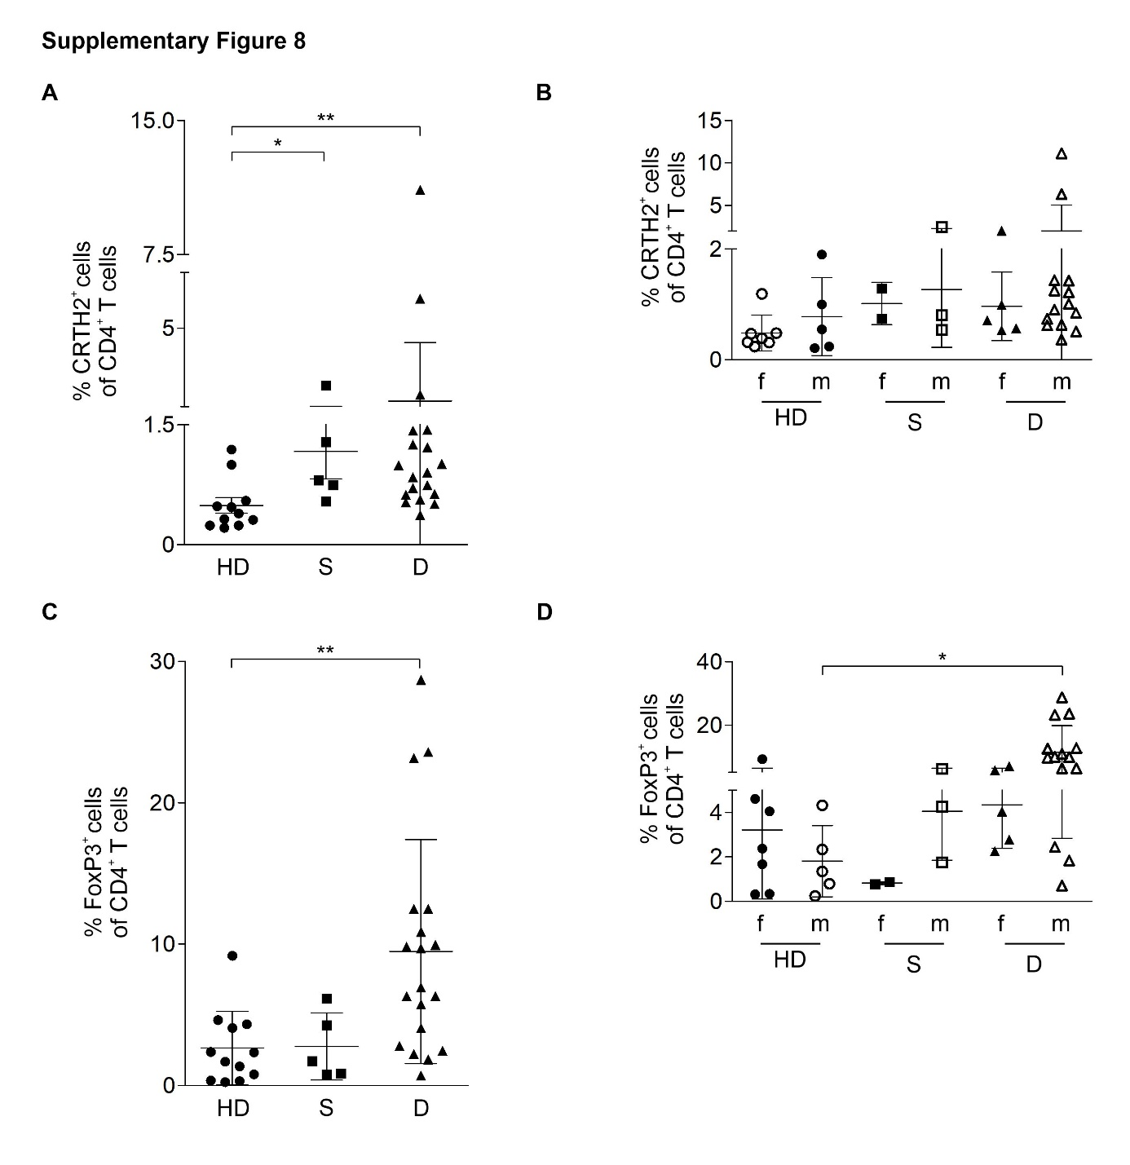

Supplementary Figure 9: Cell death of CD3⁺ T cells derived from the blood of intensive care COVID-19 patients. Patients were divided, according to their treatment regimens, into non-ventilated (NV, n = 5 patients), ventilated (V, n = 12 patients) and extracorporeal membrane oxygenation (ECMO, n = 7 patients). CD3⁺ T cells of healthy donors (n = 12 donors) was used as a control. Cell death was determined by Annexin V-staining to show apoptotic cells and 7-aminoactinomycin D (7-AAD) was used to stain necrotic cells.
Abbreviations: 7-AAD, 7-aminoactinomycin D; CD, cluster of differentiation; COVID-19, coronavirus disease 2019; ECMO, extracorporeal membrane oxygenation; NV, non-ventilated; V, ventilated.
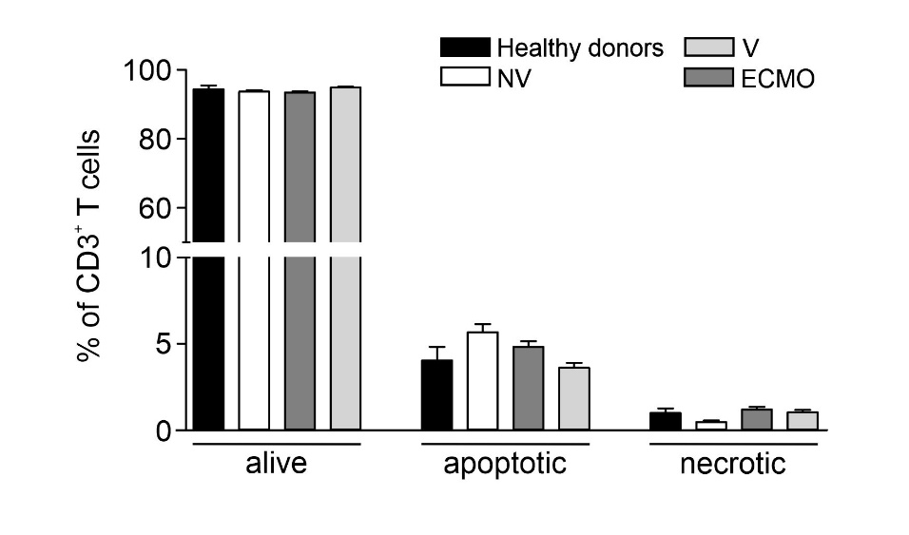

Supplementary Figure 10: To validate PPARγ transactivation, HEK293T cells were additionally transfected with a PPARγ encoding construct with a mutated first zinc-finger domain, not allowing DNA-binding (M1, C→A) and a second mutated construct not allowing ligand-binding (M2, L284A). PPARγ transactivation is determined as RLU as described in Materials and Methods. The required PPARγ-dependent reporter system is transiently transfected in parallel. ***p < 0.001.
Abbreviations: HEK293T, human embryonic kidney cells expressing the large T cell antigen of simian virus 40; M, mutated; PPARγ, peroxisome proliferator-activated receptor γ; RLU, relative luciferase units; WT, wild type

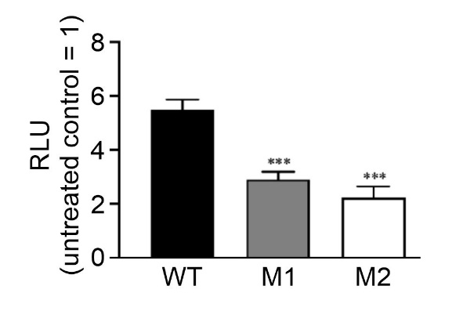

Supplementary Figure 11: Jurkat T cells have been stably transduced with a CRTH2 encoding construct (middle panel) or and CRTH2-EGFP encoding vector (right panel). Positive clones were identified by staining for CRTH2 expression as described in Materials and Methods. Positive cells have been enriched by cell sorting using a BD FACSAriaTM III cell sorter.
Abbreviations: A, area; BD, Becton Dickinson; CRTH2, chemokine receptor homologue expressed on T_{h}2 cells; EGFP, enhanced green fluorescent protein; FACS, fluorescence-activated cell sorting; FITC, fluorescein-isothiocyanate; PE, phycoerythrin; WT, wild type.

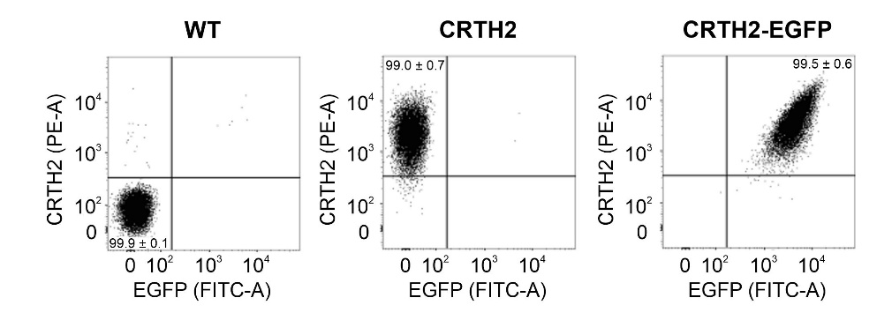

Supplementary Figure 12: Jurkat T cells have been treated with 0.1, 1, and 10 µM of 15d-PGJ₂ for 24 h. To follow cell death, cells were stained with annexin V-PE and 7-aminoactinomycin D (7-AAD) as described in Materials and Methods. In (A) the staining of wild type Jurkat T cells is depicted. The quantification of experiments using wild type, CRTH2 and CRTH2-EGFP expressing Jurkat T cells is provided in (B). ** p < 0.05.
Abbreviations: 7-AAD, 7-aminoactinomycin D; 15-dPGJ₂, 15-deoxy-∆12,14-prostaglandin J₂; A, area; CRTH2, chemokine receptor homologue expressed on T_{h}2 cells; EGFP, enhanced green fluorescent protein; PE, phycoerythrin; PerCP-Cy5.5, peridinin-chlorophyll-protein-cyanine 5.5; WT, wild type.

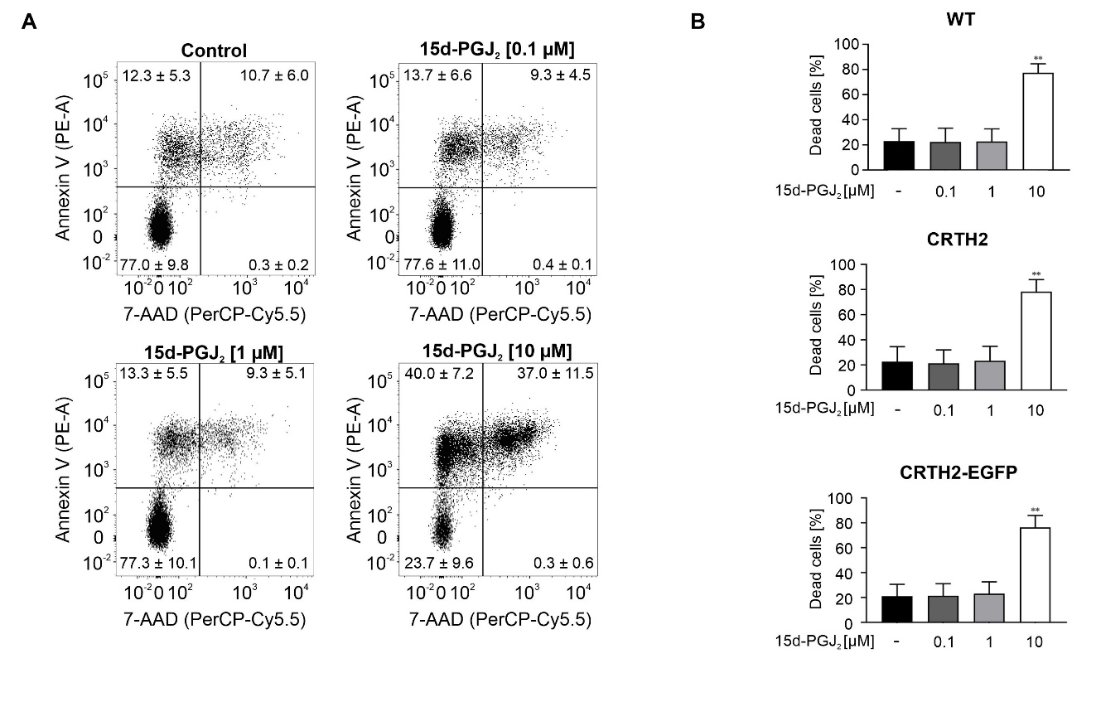

Supplementary Figure 13: CD4⁺ T cells were enriched from blood of healthy donors by positive isolation using the MACS based technology. CD4⁺ T cells were differentiated for 13 days as described in Materials and Methods. In parallel, the PPARγ antagonist GW9662 [10 µM] was added to determine the effect of PPARγ antagonization on T_{h}2 differentiation. After 13 days, CD4⁺ cells were analysed for expression of the intracellular T_{h}2 marker IL-4 (A) (n = 6) and the cell surface marker CRTH2 (B) (n = 6). * p < 0.05.
Abbreviations: CD, cluster of differentiation; CRTH2, chemokine receptor homologue expressed on T_{h}2 cells; GW9662, 2-chloro-5-nitro-N-phenylbenzamide; IL-4, interleukin-4; MACS, magnetic cell separation; PPARγ, peroxisome proliferator activated receptor γ; T_{h}2, T helper cells type 2.

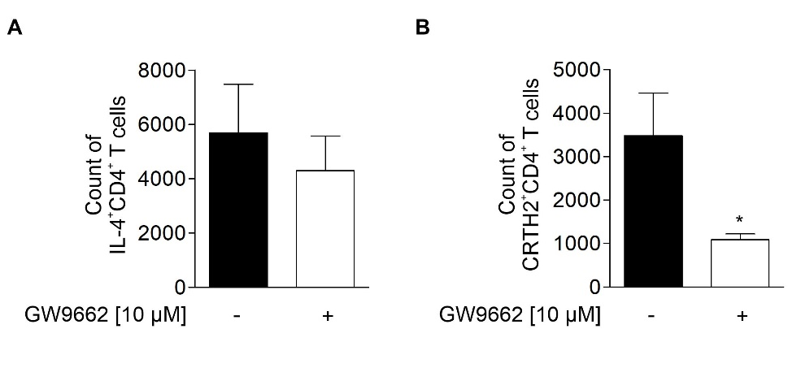

Supplementary Table
Supplementary Table 1 Abbreviations used in the manuscript

15d-PGJ2 | 15-deoxy-∆12,14-prostaglandin J₂
3G | 3rd generation of the promoter
7-AAD | 7-aminoactinomycin D
A | Area
α | Anti
ab | Antibody
AF | activation function
AF750 | AlexaFluor750
ALI | acute lung injury
A-Ox | acyl coenzym A oxidase
APC | Allophycocyanin
ATCC | American Type Culture Collection
BD | Becton Dickinson
bp | base pair(s)
CD | cluster of differentiation
CLP | cecal ligation and puncture
CMV | Cytomegalovirus
COVID | coronavirus disease
COPD | chronic obstructive pulmonary disease
CP | Competition
CPM | counts per million
CRP | c-reactive protein
CRTH2 | chemoattractant receptor-homologous molecule expressed on T helper type 2 cells
CTL | cytotoxic T cells
D | Deceased
d | Days
d/n | dominant negative
DAMP | damage-assocoated molecular pattern
DK-PGD₂ | 13,14-dihydro-15-keto-PGD₂
DMEM | Dulbecco´s modified eagle medium
DPBS | Dulbecco´s phosphate-buffered saline without Ca²⁺/Mg²⁺
DSMZ | German Collection of Microorganisms and Cell Cultures GmbH
E | extracorporeal membrane oxygenation
ECMO | extracorporeal membrane oxygenation
EGFP | enhanced green fluorescent protein
ENSG…ID | gene anotation in Ensembl
f | Female
FACS | fluorescent cell sorting
FastQC | fast quality control (software)
FCS | fetal calf serum
FDR | false discovery rate
FITC | fluorescein-isothiocyanate
FL | firefly luciferase
FoxP3 | forkhead box protein P3
FSC | forward scatter
GW9662 | 2-chloro-5-nitro-N-phenylbenzamide
HD | healthy donors
HEK | human epithelial kidney
HGNC | HUGO Gene Nomenclature Committee
Hifi | Hifidelity
HMGB1 | high mobility group protein B1
ICU | intensive care unit
ID | Identifier
IFN-g | interferon-gamma
IL | Interleukin
IHRES | internal ribosomal entry site
LDH | lactate dehydrogenase
logFC | false discovery change
LVX | Lentiviral
m | Male
MACS | magnetic cell sorting
MG132 | carbobenzoxyl-L-leucyl-L-leucyl-L-leucine
MOF | multi organ failure
NF-AT | nuclear factor of activated T cells
NF-κB | nuclear factor κ-light-chain-enhancer of activated B-cells
NGS | next generation sequencing
NV | non-ventilated
OE | Overexpression
p | Plasmid
PCR | polymerase chain reaction
PCT | Procalcitonin
PE | Phycoerythrin
PerCP | peridinin-chlorophyll-protein
PGD2 | prostaglandin D₂
PMA | phorbol-myristate 13-acetate
PPARγ | peroxisome proliferator receptor γ
PPRE | peroxisome proliferator receptor responsive element
PTEN | phosphatase and tensin homolog
RLU | Renilla luciferase
RLU | relative luciferase units
RNA | ribonulceotide acid
RPKM | reads per kilobase of exon model per million
RT | room temperature
s | Specific
S | Surviving
SARS-CoV2 | severe acute respiratory syndrome coronavirus 2
SD | standard deviation
SE | standard error
SSC | side scatter
Th1 | T helper cells type 1
Th2 | T helper cells type 2
TK | thymidin kinase
TRE | tetracycline responsive element
Treg | regulatory T cells
TXA₂ | thromboxan A₂
U | Units
us | Unspecific
V | Ventilated
wt | wild type
yr | Year

