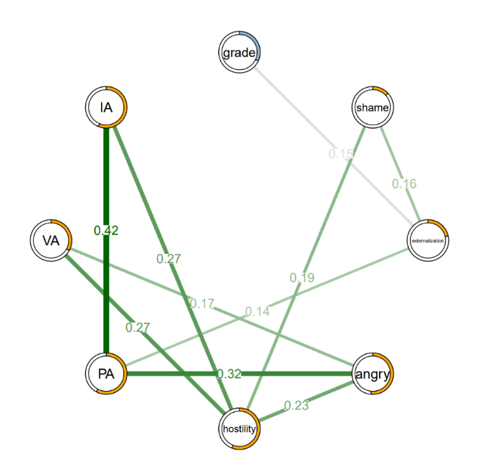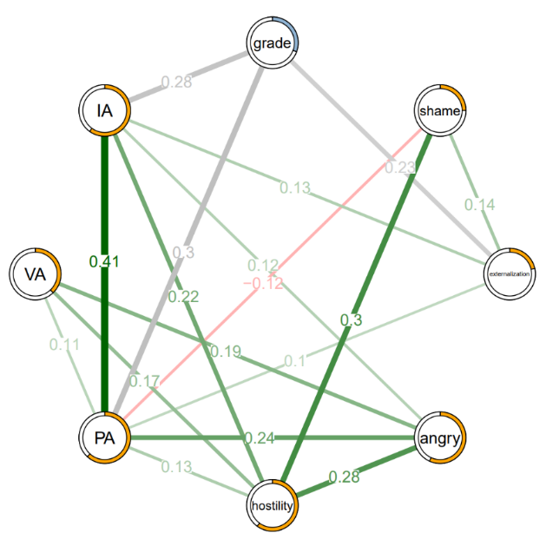
Figure S1. Two estimated network structures based on 685 males (left) and 804 females (right). The networks show the relationships among variables, including grade and psychological characteristics (externalization, angry, hostility, PA, VA, IA). The edge weights are the regression coefficients with regularization. Green edges represent positive relationships and red edges indicate negative relationships. The thickness of the edge reflects the magnitude of the relationship.

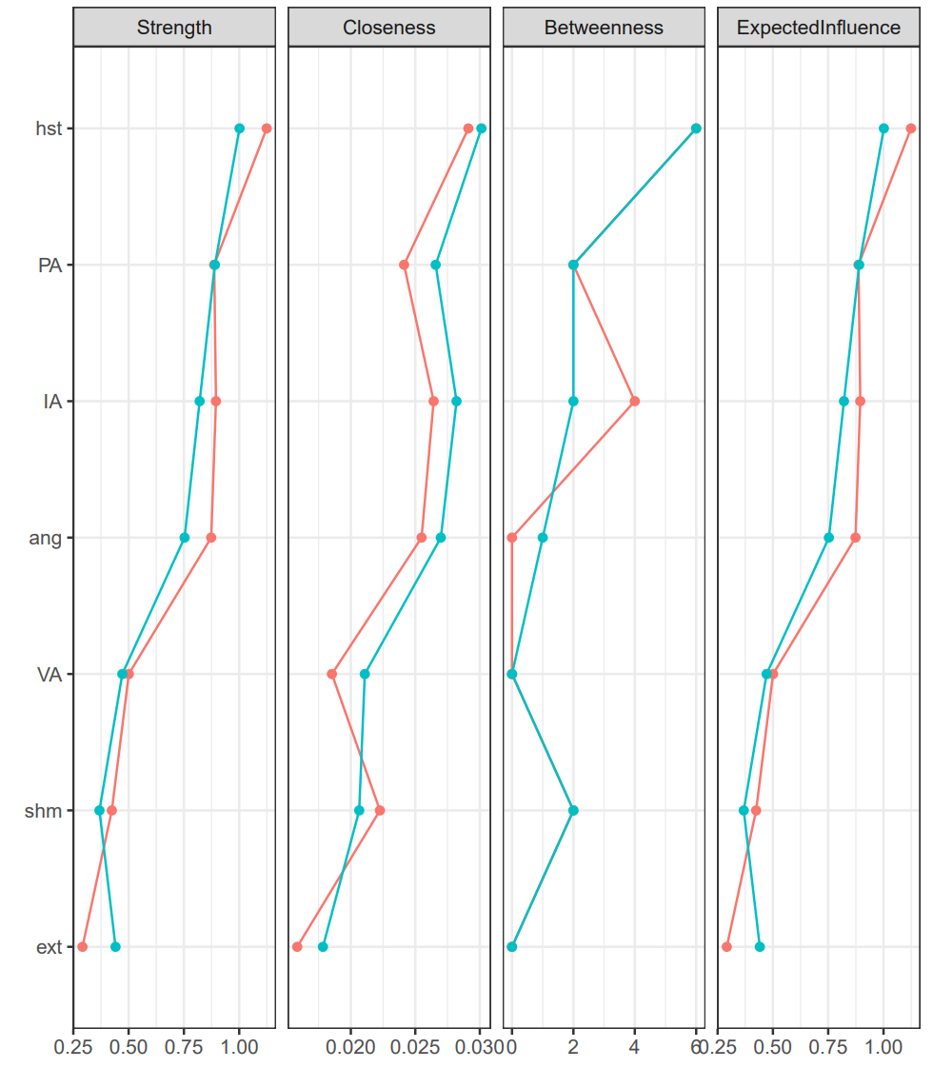

male female
Figure S2. Centrality indices for the nodes in the male and female networks, including those for strength, betweenness, closeness, and expected influence. Red and blue represent male and female networks, respectively.

Male Female
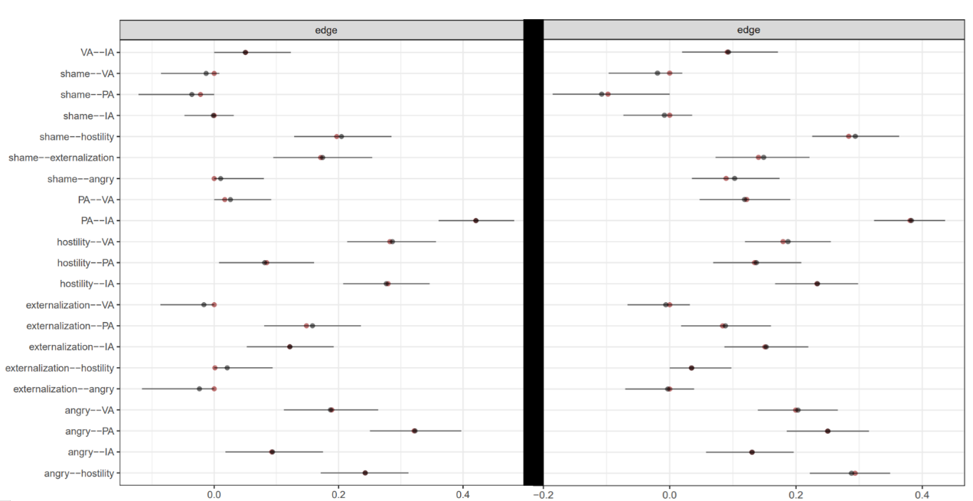
Figure S3. Bootstrap sampling results for gender-based network edge weights, black dots indicate the mean of the bootstrap sample, red dots indicate the edge weights of the samples, and black lines indicate the confidence intervals of the bootstrap sample.

Male Female

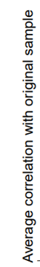
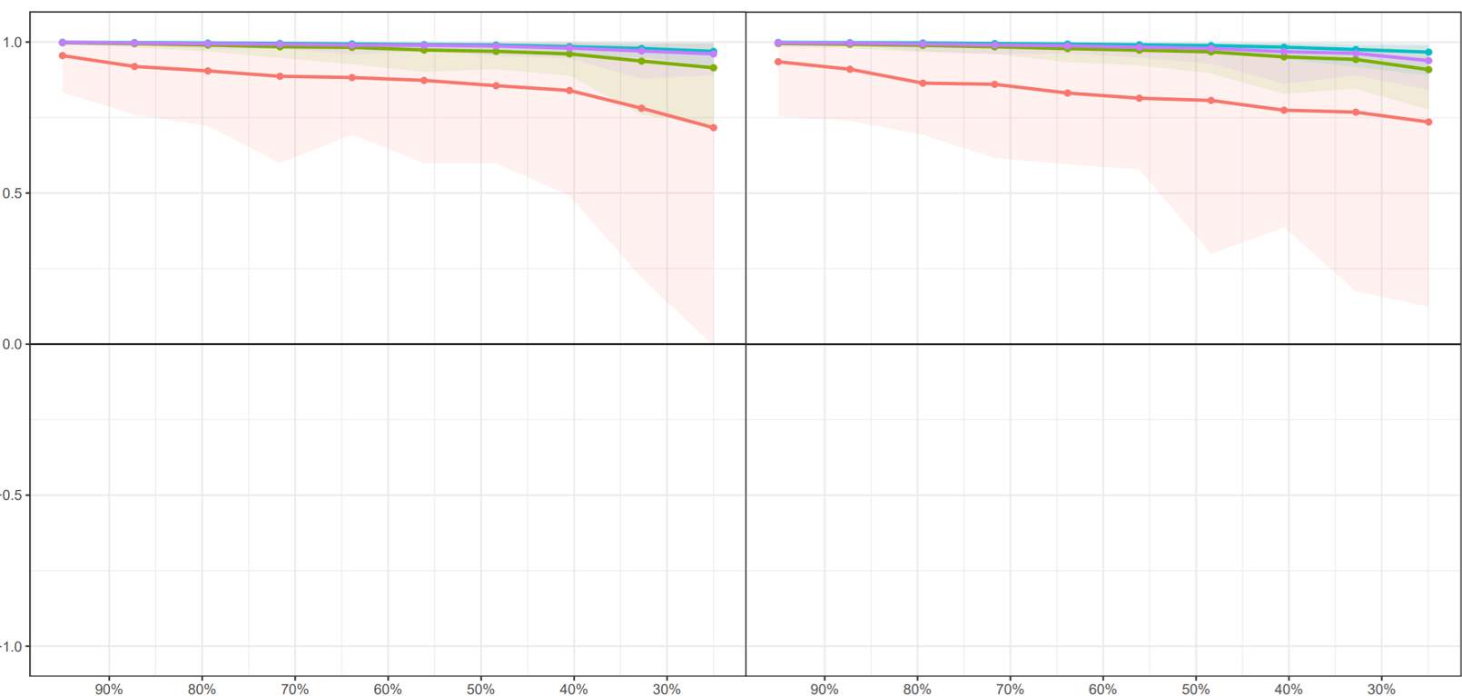
Figure S4. The results of the stability test of the centrality indicators based on different genders demonstrate the average correlation of the four centrality indicators (Strength, Closeness, Betweenness, and Expected Influence) with the original sample at different sampling ratios.

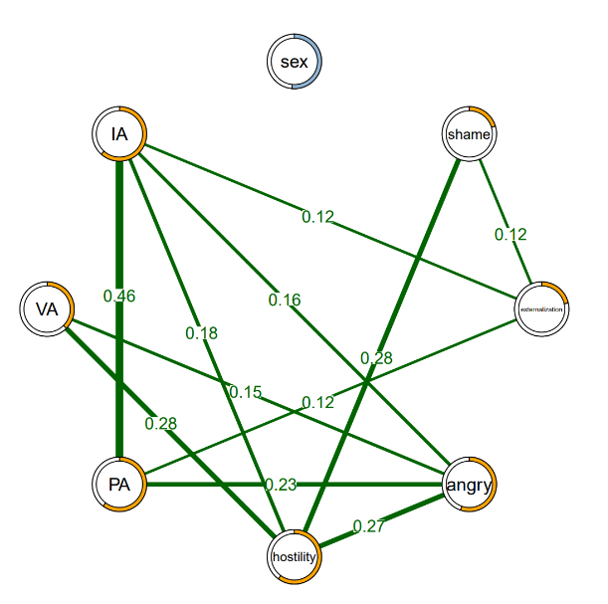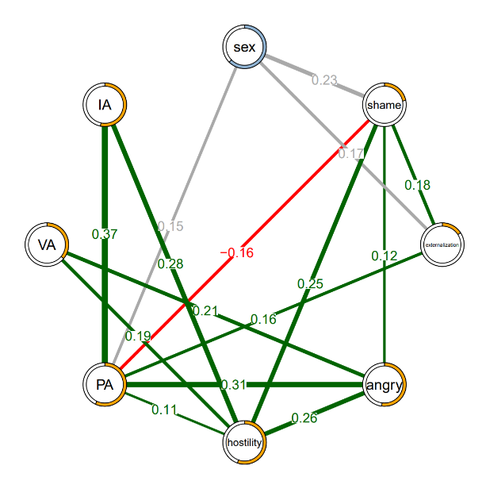
Figure S5. Two estimated network structures based on 704 youngers (left) and 785 elders (right). The networks show the relationships among variables, including gender and psychological characteristics (externalization, angry, hostility, PA, VA, IA). The edge weights are the regression coefficients with regularization. Green edges represent positive relationships and red edges indicate negative relationships. The thickness of the edge reflects the magnitude of the relationship.

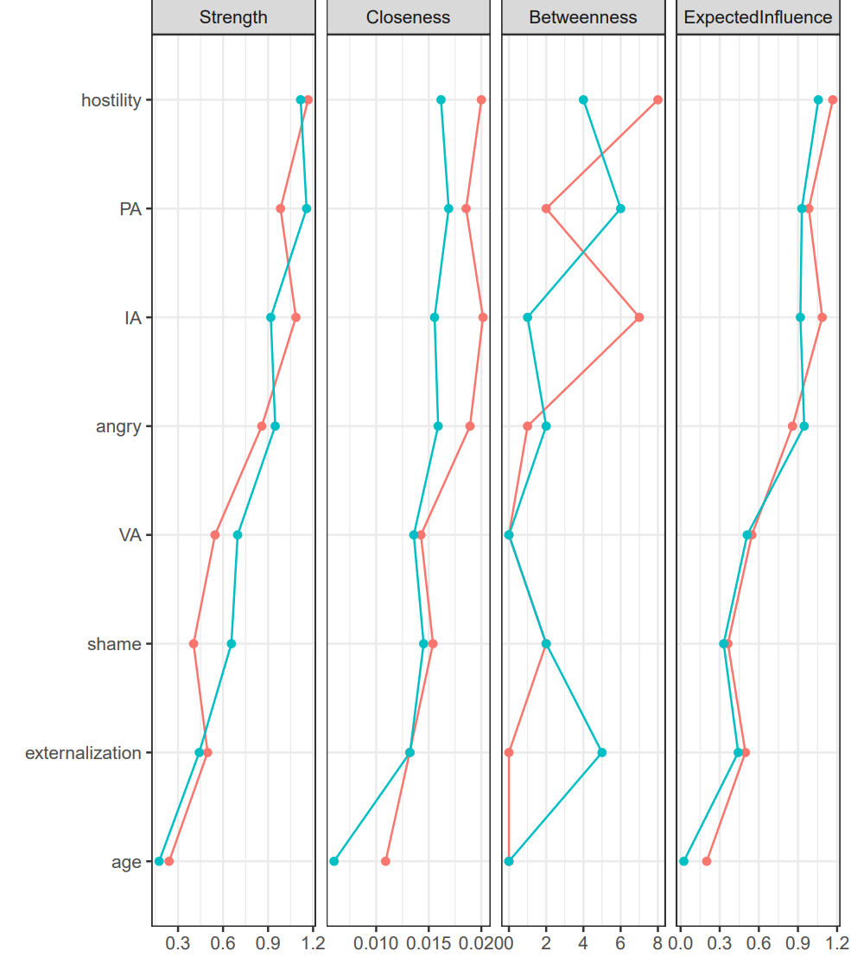
youngers elders
Figure S6. Centrality indices for the nodes in the younger and elder networks, including those for strength, betweenness, closeness, and expected influence. Red and blue represent youngers and elders networks, respectively.
Younger Elder
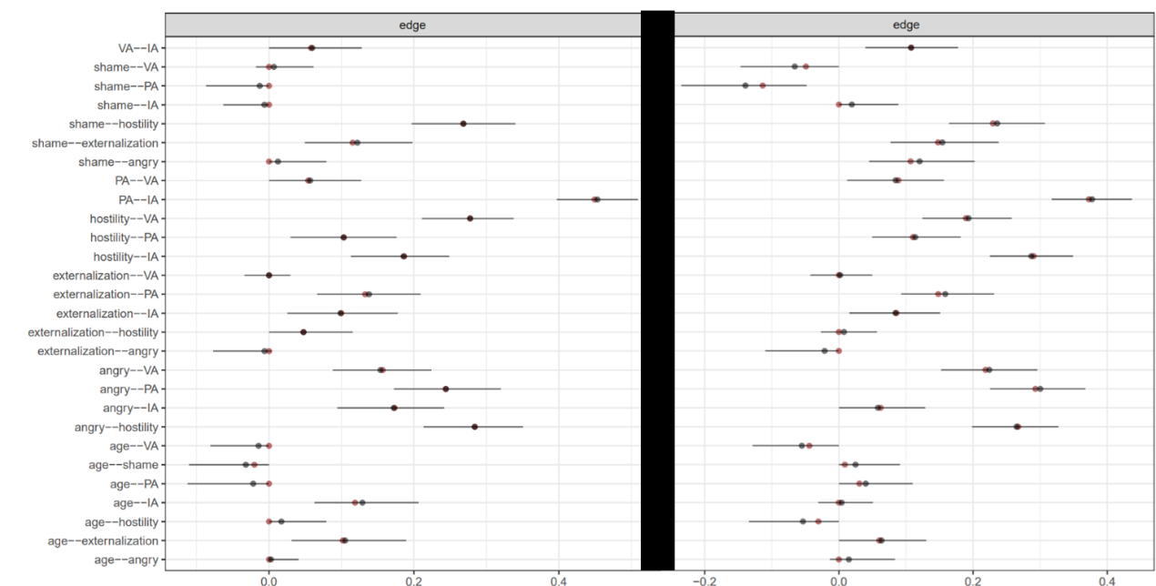
Figure S7. Bootstrap sampling results for grade-based network edge weights, black dots indicate the mean of the bootstrap sample, red dots indicate the edge weights of the samples, and black lines indicate the confidence intervals of the bootstrap sample.
Younger Elder
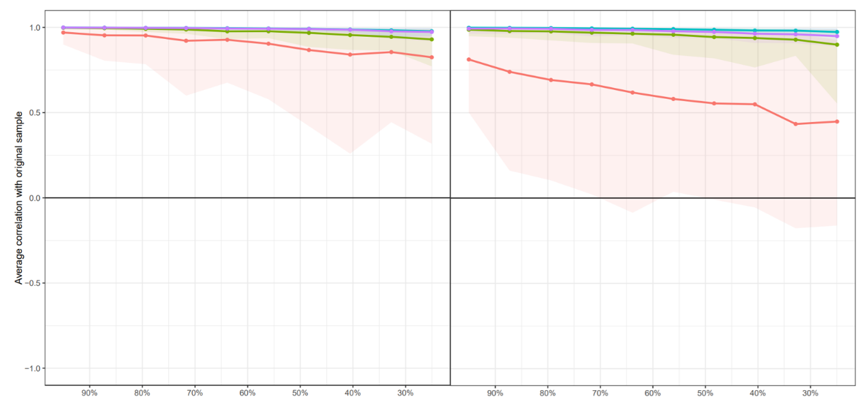
Figure S8. The results of the stability test of the centrality indicators based on different grades demonstrate the average correlation of the four centrality indicators (Strength, Closeness, Betweenness, and Expected Influence) with the original sample at different sampling ratios.

