Supplementary-Table 1. Primers of the circRNAs by real-time PCR
Primers | Sequence (5′ to 3′)
U6-F | CTCGCTTCGGCAGCACA
U6-R | AACGCTTCACGAATTTGCGT
hsa_circ_0001522-F | AAGCAGTTAGGATCTGGAGC
hsa_circ_0001522-R | TGGAGCATGTTCATCCCATT
hsa_circ_0001359-F | ATCAGCCAACGAGATCCTTC
hsa_circ_0001359-R | AGTGGAGAGGTTGATCTGGT

Supplementary-Table 2. Continuously differentially expressed circRNAs by high-throughput sequencing on day 7, day 14, and day 28
Chr_Start_End_Strand | CircBank ID | Day 7 logFC (BPD group vs non-BPD group) | Day 14 logFC (BPD group vs non-BPD group) | Day 28 logFC (BPD group vs non-BPD group)
chr8_71126138_71128999_- | hsa_circNCOA2_006 | 1.6882602 | -5.946878399 | -2.673516716
chr8_103372299_103373854_- | hsa_circUBR5_005 | 2.903517919 | -5.77987389 | -3.030472943
chr5_167915607_167921655_+ | hsa_circRARS_004 | -5.503053675 | -5.373562563 | 3.159344256
chr5_122881111_122893258_+ | hsa_circCSNK1G3_004 | -2.786653784 | -5.590975065 | -3.030472943
chr4_87967318_87968746_+ | hsa_circAFF1_005 | 1.43601232 | -7.012518832 | -2.081387093
chr3_3178944_3186394_+ | hsa_circTRNT1_003 | -3.118588515 | -6.853368111 | 2.652413575
chr3_169854207_169867032_- | hsa_circPHC3_023 | -3.284805934 | -3.415981484 | -5.620244281
chr2_64800080_64812679_+ | hsa_circAFTPH_007 | 5.482588227 | -5.117471291 | -5.363063986
chr2_32142995_32157204_- | hsa_circMEMO1_007 | 5.482588227 | -6.232126445 | -5.363063986
chr2_11426665_11427862_- | hsa_circROCK2_005 | 2.090175249 | -1.363881831 | -5.838440602
chr19_47767860_47768203_+ | hsa_circCCDC9_003 | -1.485295405 | -1.302830188 | -6.19539683
chr18_39607407_39629569_+ | hsa_circPIK3C3_033 | -5.503053675 | -5.946878399 | 3.00932644
chr18_29691717_29704808_+ | hsa_circRNF138_004 | 5.225992719 | -5.117471291 | -5.117471291
chr15_80412670_80415142_+ | hsa_circZFAND6_008 | 1.978517827 | 5.648637 | -1.680903832
chr15_41667910_41669502_+ | hsa_circNUSAP1_014 | 5.482588227 | -5.590975065 | -6.19539683
chr12_56563313_56563992_- | hsa_circSMARCC2_017 | -5.189056728 | -5.590975065 | 5.352062047
chr12_120995085_120995485_+ | hsa_circRNF10_015 | 5.482588227 | -2.659154207 | -5.620244281
chr11_117150624_117150975_+ | hsa_circRNF214_006 | -1.972560236 | -5.590975065 | -1.566566728
chr10_28436412_28438988_- | Not available | 2.586465233 | -5.946878399 | -5.363063986
chr1_65830318_65831879_+ | hsa_circDNAJC6_002 | 2.903517919 | -5.77987389 | -2.455320394

Supplementary-Figure 1. Identification of serum exosomes. A: Electron microscopy examination of exosomes. B: Detection of exosomes particle size.
Supplementary-Figure 2. Go terms of differentially expressed circRNAs. A: Comparison between the BPD group and the non-BPD group on day 7. B: Comparison between the BPD group and the non-BPD group on day 14. C: Comparison between the BPD group and the non-BPD group on day 28. D: Comparison between day 14 and day 7 in the BPD group. E: Comparison between day 28 and day 14 in the BPD group.
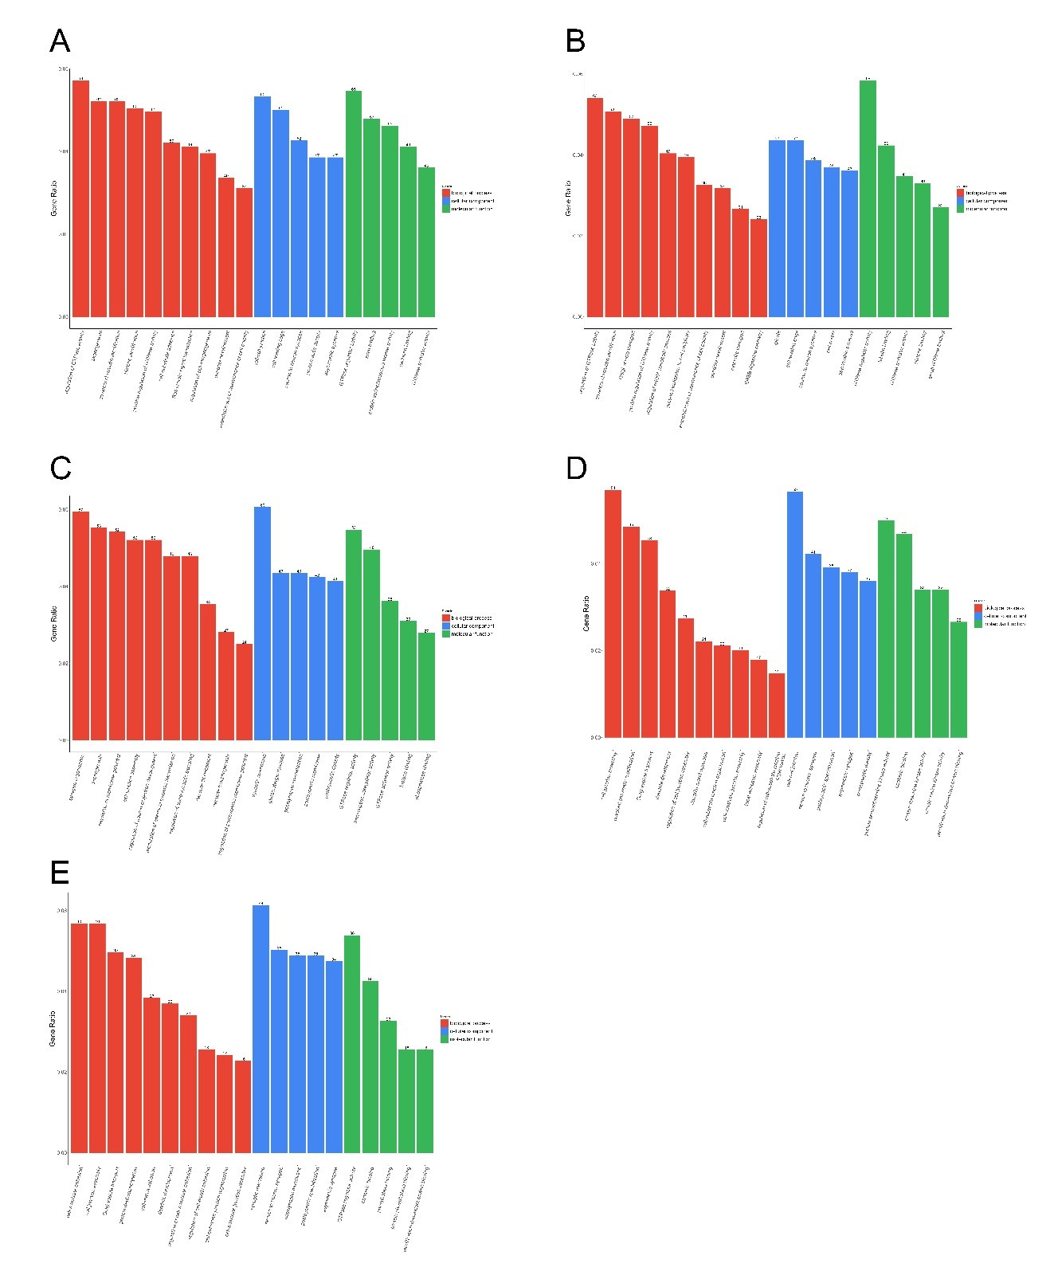

Supplementary-Figure 3. KEGG pathways of differentially expressed circRNAs. A: Comparison between the BPD group and the non-BPD group on day 7. B: Comparison between the BPD group and the non-BPD group on day 14. C: Comparison between the BPD group and the non-BPD group on day 28. D: Comparison between day 14 and day 7 in the BPD group. E: Comparison between day 28 and day 14 in the BPD group.

Supplementary-Figure 4. Potential binding site between the parental gene of circRNA (hsa_circ_0001359) and let-7 family by TargetScan.

