Supplementary Experimental Section 1
Chemicals: Na₂PdCl₄ (98%), Cu(acac)₂ (99.99%) and NaBH₄ (95%) were purchased from Aladdin (Shanghai, China). Cell counting kit 8 (CCK8) was obtained from KeyGEN (Jiangsu, China). Phosphate buffered saline, Dulbecco's modification of eagle's medium (DMEM) and fetal bovine serum (FBS) were purchased from Gibco (USA). All reagents were used without further purification.
Characterization: The morphology was observed on a transmission electron microscope (TEM, JEOL JEM-F200). The surface elements state was assessed by x-ray photoelectron spectroscopy (XPS, Thermo Scientific K-Alpha). The zeta potential was tested on a Nano Zetasizer from Malvern. A UV-visible spectrophotometer (UV-2600) was applied to record the absorption spectra of the solutions.
Fabrication of CPC NPs: First, 20 mg was dissolved in 10 mL of absolute ethanol in a beaker. Next, 50 ml of ethanol was added to another 50 ml of ethanol, then 0.1 g of Cu(acac)₂ was dispersed in the ethanol. These two solutions were then stirred at room temperature for 30 min to form a uniform solution. Next, 100 mL of NaBH₄ (0.1 M) was added drop by drop into this uniform solution to react for 2 h at room temperature. Then the solution was al-lowed to stand overnight. After the supernatant was removed, the precipitation was collected by centrifugation. The obtained product was then resuspended in ethanol and washed three to four times. At last, the black product was dried under 80 °C to obtain the CP NPs.
Next, 10 mg CP-NPs were dispersed in 50 mL of ethanol. Then 2 mg of cysteamine were dis-solved in absolute ethanol under sonication. These two solutions were then mixed to form uniform solution and kept reaction under sonication for 4 h. The black precipitation was collected by centrifugation, followed by rinse with ethanol for several times to remove the excessive cysteamine. CPC NPs were then obtained by dried 40 °C overnight.
Enzyme mimicking properties evaluation: The GSH consumption by CPC NPs was assessed by DTNB. Therefore, 100 μg/mL CPC NPs was added with 2 mm DTNB. Then the absorbance at 412 nm at a time dependent manner was evaluated on a UV-vis spectrophotometer. Next, the CAT-like activity of CPC NPs was assessed by evaluating O₂ content in H₂O₂ (0.3 mM) by a dissolved oxygen meter. Next, TMB was applied to detect the generated ·OH by CPC NPs in the presence of H₂O₂.
Cell culture: MB49 cells were obtained from Cell Bank of Chinese Academy of Sciences (Shanghai, China) and cultured in DMEM with 10 % FBS in an atmosphere with CO₂ (5 %) at 37 °C.
Cell viability evaluation on CCK 8 assay: To assess the biocompatibility, MB49 cells were seeded in 96-well plate. Next, CPC NPs with or without H₂O₂ (100 μM)at various concentrations were added. After 24 h, CCK 8 was added into the medium for cell viability assessment. For the cell viability tests, MB49 cells were seeded into 96-well plates and incubated for 24 h at 37 °C in 5 % CO₂. Then the medium was replaced by DMEM with various concentrations of CP NPs or CPC NPs and incubated for 4 h. Then, the cells were subjected to RT (8 Gy) or not. After 24 h of incubation, a CCK-8 assay was used to evaluate the cell viability.
Hypoxia alleviation in vitro: MB49 cells were seeded on the petri-dishes and cultured in a hypoxia atmosphere. Next, CPC NPs were added on MB49 (100 μg/mL). Then HIF-1α staining was conducted to observe the hypoxia status.
ROS and γ-H₂AX staining: MB49 cells were seeded in culture dishes for 24 h. Then the cells were treated with PBS or CPC NPs (100 μg/mL) with H₂O₂ (100 μM) for 4 h. Next, MB49 cells were subjected to RT or not. Then the cells were washed with PBS and incubated with 1 μL DCFH-DA (10 mM). After 15 min cells was washed with PBS and fluorescence imaging was performed by CLSM.
Clonogenic assay: Single MB49 cells were seeded on the 6-well plates at density of 1000/cell. After addition of PBS or CPC NPs (100 μg/mL) with H₂O₂ (100 μM), cells were subjected to ionizing irradiation from 0 Gy to 8 Gy. After 24 h, cell medium was replaced with fresh medium and cultured for 15 days. Then the colonies were stained with purple crystal.
WB analysis: After various treatment, MB49 cells were digested and collected. Total protein was extracted for protein analysis of Tubulin, Cleaved-caspase-3, HIF-1α and Bcl2.
Biosafety: To test the CPC NPs biosafety, mice aged 6 weeks received intravenous (i.v.) injection of PBS or CPC NPs. 15 days later, main organs including heart, liver, spleen, lung and kidney as well as blood samples were collected. Main organs were fixed in 4% paraformaldehyde for HE staining. Blood samples in two groups were sent for blood biochemical analysis and blood routine analysis.
Animals model: 6-week-old female C57BL/6 mice were purchased from Beijing Vital River Laboratories. All mice received care in terms of the guidelines for the Care and Use of Laboratory Animals and were used in terms of the Institutional Animal Care regulations and Use Committee (IACUC) of Jilin University. All animal experiments were approved by the Administration Committee of Experimental Animals in Jilin Province and the Ethic Committee of Jilin University.
Antitumor efficacy: C57BL/6 mice were transplanted subcutaneously in the right lap with 1 × 10⁶ MB49 cells. When the tumor size of the mice was 100 mm³, the mice were divided randomly into 4 groups (n = 5) and subjected to various treatments: (i) PBS (i.v. injection, 100 μL); (ii) RT (8 Gy); (iii) CPC NPs (i.v. injection, 100 μL, 1.5 mg/kg) without irradiation; (iv) CPC NPs (i.v. injection, 100 μL, 1.5 mg/kg) + laser (8 Gy). The tumor volume and body weight of the mice in each group were measured and recorded. After the mice were executed, the tumor mice in all groups were collected and dissected for dihydroethydium (DHE) staining, Ki67 and TUNEL staining. The tumor inhibition rate (TGI) was calculated according to the following formula:
$$TGI=\left(1-\frac{V_{1}}{V_{2}}\right)×100 \%$$
Where V₁ represents the tumor volume of the experimental group and V₂ represents the tumor volume of the control group.
Hypoxia alleviation in vivo: 6-week-old mice received 106 MB49 cells subcutaneous injection on right lap. When tumor volume reached approximately 200 mm3, mice received i.v. injection of PBS or CPC NPs (1.5 mg/kg). Then tumors were harvest the next day for HIF-1α staining to test the hypoxia status.
Statistical analysis: Statistical analysis was performed using two-sided Student’s t-test for two groups and one-way analysis of variance for multiple groups. P values of P < 0.05 was considered statistically significant.

Figure S1. Size distribution of CP NPs.

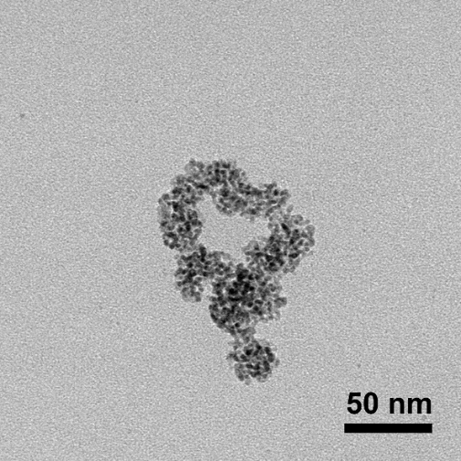
Figure S2. TEM images of CP NPs in medium after 24 h.

Figure S3. The stability analysis of CPC in PBS or 10% FBS buffer at 37 °C for 48 h (n = 3).

Figure S4. Cell viability of RAW264.7 after co-incubation of CPC NPs at various concentrations.

Figure S5. HIF-1α immunofluorescence staining of 5637 cells treated with PBS or CPC NPs under hypoxia conditions (Scale bar: 10 μm).

Figure S6. WB analysis of HIF-1α of 5637 cells treated with PBS or CPC NPs under hypoxia conditions.

Figure S7. 5637 cell viability after various treatment. Statistical significance was determined using one-way analysis of variance (ANOVA): ***p < 0.001.
Table S1. Tumor inhibition rate (TGI) in various treatment groups.
 | RT | CPC | CPC+RT
TGI (%) | 38.8 | 42.9 | 94.5

