Supplementary materials
Supplementary Table 1. Socio-demographic information and clinical features of the study sample (n=818)
Variables | Total  (N=818) |  | Male  (N=263) |  | Female  (N=555)
Variables | n | % | n | % | n | %
Marital status
Single | 318 | 38.9 | 105 | 39.9 | 213 | 38.4
Married | 465 | 56.8 | 152 | 57.8 | 313 | 56.4
Divorced or others | 35 | 4.3 | 6 | 2.3 | 29 | 5.2
Education level
Primary school or junior middle school | 172 | 21.0 | 48 | 18.3 | 124 | 22.3
Senior middle school | 149 | 18.2 | 48 | 18.3 | 101 | 18.2
University or college | 416 | 50.9 | 141 | 53.6 | 275 | 49.5
Postgraduate or above | 81 | 9.9 | 26 | 9.9 | 55 | 9.9
Employment status
Employed | 445 | 54.4 | 168 | 63.9 | 277 | 49.9
Students | 133 | 16.3 | 38 | 14.4 | 95 | 17.1
Unemployed | 240 | 29.3 | 57 | 21.7 | 183 | 33.0
Residence area
Urban | 647 | 79.1 | 213 | 81.0 | 434 | 78.2
Rural | 169 | 20.7 | 49 | 18.6 | 120 | 21.6
Missing | 2 | 0.2 | 1 | 0.4 | 1 | 0.2
First episode | 503 | 61.5 | 157 | 59.7 | 346 | 62.3
Family history of mental disorders | 116 | 14.2 | 46 | 17.5 | 70 | 12.6
 | Mean | SD | Mean | SD | Mean | SD
Age (years) | 35.8 | 12.4 | 36.7 | 12.4 | 35.4 | 12.4
HAMD-17 at baseline | 21.5 | 5.2 | 21.9 | 5.5 | 21.3 | 5.0
HAMD-17 at week 8 | 8.2 | 6.0 | 7.8 | 5.6 | 8.4 | 6.3
Change in HAMD-17 from baseline to week 8 | -13.3 | 6.8 | -14.1 | 7.3 | -12.9 | 6.5
QIDS-SR at baseline | 15.9 | 3.7 | 15.8 | 4.1 | 15.9 | 3.5
QIDS-SR at week 8 | 6.1 | 4.3 | 5.7 | 4.0 | 6.3 | 4.4
Change in QIDS-SR from baseline to week 8 | -9.8 | 4.8 | -10.1 | 5.2 | -9.6 | 4.6
SD: standard deviation.

Supplementary Table 2. Descriptive statistics of the change in PHQ-9 items and the change in Q-LES-Q-SF items from baseline to week 8.
 | n | mean | SD | median | min | max | range | skew | kurtosis
delta_dep1 | 818 | -1.38 | 1.01 | -1 | -3 | 2 | 5 | 0.35 | -0.20
delta_dep2 | 818 | -1.55 | 1.00 | -2 | -3 | 2 | 5 | 0.36 | -0.36
delta_dep3 | 818 | -1.18 | 1.19 | -1 | -3 | 3 | 6 | 0.30 | -0.37
delta_dep4 | 818 | -1.33 | 1.04 | -1 | -3 | 3 | 6 | 0.43 | 0.28
delta_dep5 | 818 | -1.18 | 1.19 | -1 | -3 | 3 | 6 | 0.21 | -0.26
delta_dep6 | 818 | -1.26 | 1.06 | -1 | -3 | 2 | 5 | 0.12 | -0.61
delta_dep7 | 818 | -1.14 | 1.02 | -1 | -3 | 2 | 5 | 0.15 | -0.19
delta_dep8 | 818 | -1.09 | 1.02 | -1 | -3 | 3 | 6 | -0.02 | -0.27
delta_dep9 | 818 | -0.58 | 0.84 | 0 | -3 | 3 | 6 | -0.58 | 1.05
delta_qles1 | 818 | 1.02 | 1.09 | 1 | -3 | 4 | 7 | 0.03 | -0.40
delta_qles2 | 818 | 1.47 | 1.07 | 1.5 | -2 | 4 | 6 | -0.20 | -0.35
delta_qles3 | 818 | 0.86 | 1.05 | 1 | -2 | 4 | 6 | 0.27 | -0.24
delta_qles4 | 818 | 0.72 | 0.99 | 1 | -3 | 3 | 6 | 0.19 | 0.09
delta_qles5 | 818 | 0.77 | 1.00 | 1 | -4 | 4 | 8 | 0.17 | 0.57
delta_qles6 | 818 | 0.70 | 1.07 | 1 | -4 | 4 | 8 | -0.01 | 0.66
delta_qles7 | 818 | 0.88 | 1.03 | 1 | -3 | 4 | 7 | 0.03 | 0.32
delta_qles8 | 818 | 0.79 | 0.99 | 1 | -2 | 4 | 6 | 0.20 | -0.13
delta_qles9 | 818 | 0.50 | 0.92 | 0 | -2 | 3 | 5 | 0.46 | 0.68
delta_qles10 | 818 | 0.47 | 0.92 | 0 | -2 | 4 | 6 | 0.39 | 0.64
delta_qles11 | 818 | 0.48 | 0.92 | 0 | -2 | 4 | 6 | 0.33 | 0.51
delta_qles12 | 818 | 0.52 | 1.04 | 0 | -3 | 3 | 6 | -0.08 | 0.16
delta_qles13 | 818 | 0.64 | 1.02 | 1 | -2 | 4 | 6 | 0.04 | 0.02
delta_qles14 | 818 | 1.22 | 0.99 | 1 | -2 | 4 | 6 | 0.03 | -0.40
Delta refers to score change from baseline to week 8.

Supplementary Table 3. Weighted adjacency matrix of the network model for the change in PHQ-9 and change in Q-LES-Q-SF from baseline to week 8
 | delta_dep1 | delta_dep2 | delta_dep3 | delta_dep4 | delta_dep5 | delta_dep6 | delta_dep7 | delta_dep8 | delta_dep9 | delta_qles1 | delta_qles2 | delta_qles3 | delta_qles4 | delta_qles5 | delta_qles6 | delta_qles7 | delta_qles8 | delta_qles9 | delta_qles10 | delta_qles11 | delta_qles12 | delta_qles13 | delta_qles14
delta_dep1 | 0 | 0.314 | 0.045 | 0.257 | 0.048 | 0.045 | 0.054 | 0.018 | 0 | 0 | -0.092 | -0.007 | 0 | 0 | 0 | -0.027 | -0.053 | 0 | 0.007 | 0 | 0 | 0 | -0.009
delta_dep2 | 0.314 | 0 | 0.094 | 0.113 | 0.050 | 0.139 | 0 | 0.077 | 0 | -0.083 | -0.104 | 0 | 0 | 0 | 0 | 0 | 0 | 0 | 0 | 0 | 0 | 0 | -0.028
delta_dep3 | 0.045 | 0.094 | 0 | 0.190 | 0.156 | 0.002 | 0.031 | 0.047 | 0 | -0.089 | 0 | 0 | -0.045 | 0 | 0 | 0 | -0.014 | 0 | 0 | 0 | -0.004 | -0.040 | -0.038
delta_dep4 | 0.257 | 0.113 | 0.190 | 0 | 0.026 | 0.046 | 0.171 | 0.004 | 0 | -0.020 | -0.064 | 0 | -0.008 | -0.036 | 0 | -0.003 | 0 | 0 | 0 | 0 | 0 | 0 | 0
delta_dep5 | 0.048 | 0.050 | 0.156 | 0.026 | 0 | 0.075 | 0.025 | 0.090 | 0.037 | -0.101 | 0 | 0 | 0 | 0 | 0 | 0 | 0 | 0 | 0 | 0 | -0.012 | 0 | -0.002
delta_dep6 | 0.045 | 0.139 | 0.002 | 0.046 | 0.075 | 0 | 0.099 | 0.114 | 0.221 | 0 | 0 | -0.049 | 0 | -0.008 | -0.022 | 0 | 0 | -0.011 | 0 | 0 | 0 | 0 | -0.035
delta_dep7 | 0.054 | 0 | 0.031 | 0.171 | 0.025 | 0.099 | 0 | 0.313 | 0.019 | -0.001 | 0 | -0.050 | 0 | -0.026 | 0 | -0.013 | 0 | -0.013 | 0 | 0 | -0.021 | -0.074 | -0.011
delta_dep8 | 0.018 | 0.077 | 0.047 | 0.004 | 0.090 | 0.114 | 0.313 | 0 | 0.079 | -0.026 | 0 | 0 | 0 | -0.006 | 0 | 0 | 0 | 0 | 0 | 0 | -0.124 | 0 | -0.004
delta_dep9 | 0 | 0 | 0 | 0 | 0.037 | 0.221 | 0.019 | 0.079 | 0 | 0 | 0 | -0.043 | -0.004 | -0.049 | -0.031 | -0.012 | 0 | 0 | 0 | 0 | -0.012 | 0 | 0
delta_qles1 | 0 | -0.083 | -0.089 | -0.020 | -0.101 | 0 | -0.001 | -0.026 | 0 | 0 | 0.203 | 0 | 0.056 | 0 | 0.047 | 0 | 0.023 | 0.042 | 0 | 0.001 | 0.020 | 0.008 | 0.239
delta_qles2 | -0.092 | -0.104 | 0 | -0.064 | 0 | 0 | 0 | 0 | 0 | 0.203 | 0 | 0.119 | 0 | 0.074 | 0.042 | 0.106 | 0.026 | 0.009 | 0 | 0 | 0 | 0 | 0.263
delta_qles3 | -0.007 | 0 | 0 | 0 | 0 | -0.049 | -0.050 | 0 | -0.043 | 0 | 0.119 | 0 | 0.231 | 0.175 | 0 | 0.084 | 0 | 0.016 | 0.070 | 0.009 | 0 | 0 | 0.027
delta_qles4 | 0 | 0 | -0.045 | -0.008 | 0 | 0 | 0 | 0 | -0.004 | 0.056 | 0 | 0.231 | 0 | 0.151 | 0.143 | 0.095 | 0.143 | 0.019 | 0.032 | 0 | 0 | 0 | 0
delta_qles5 | 0 | 0 | 0 | -0.036 | 0 | -0.008 | -0.026 | -0.006 | -0.049 | 0 | 0.074 | 0.175 | 0.151 | 0 | 0.227 | 0.115 | 0.002 | 0.013 | 0.108 | 0 | 0 | 0 | 0.034
delta_qles6 | 0 | 0 | 0 | 0 | 0 | -0.022 | 0 | 0 | -0.031 | 0.047 | 0.042 | 0 | 0.143 | 0.227 | 0 | 0.054 | 0.048 | 0.042 | 0 | 0.123 | 0 | 0 | 0.008
delta_qles7 | -0.027 | 0 | 0 | -0.003 | 0 | 0 | -0.013 | 0 | -0.012 | 0 | 0.106 | 0.084 | 0.095 | 0.115 | 0.054 | 0 | 0.280 | 0.130 | 0.013 | 0.038 | 0.023 | 0 | 0.083
delta_qles8 | -0.053 | 0 | -0.014 | 0 | 0 | 0 | 0 | 0 | 0 | 0.023 | 0.026 | 0 | 0.143 | 0.002 | 0.048 | 0.280 | 0 | 0.032 | 0.038 | 0.102 | 0.098 | 0 | 0.066
delta_qles9 | 0 | 0 | 0 | 0 | 0 | -0.011 | -0.013 | 0 | 0 | 0.042 | 0.009 | 0.016 | 0.019 | 0.013 | 0.042 | 0.130 | 0.032 | 0 | 0.215 | 0.045 | 0.050 | 0.104 | 0.006
delta_qles10 | 0.007 | 0 | 0 | 0 | 0 | 0 | 0 | 0 | 0 | 0 | 0 | 0.070 | 0.032 | 0.108 | 0 | 0.013 | 0.038 | 0.215 | 0 | 0.337 | 0 | 0 | 0
delta_qles11 | 0 | 0 | 0 | 0 | 0 | 0 | 0 | 0 | 0 | 0.001 | 0 | 0.009 | 0 | 0 | 0.123 | 0.038 | 0.102 | 0.045 | 0.337 | 0 | 0.089 | 0.056 | 0.050
delta_qles12 | 0 | 0 | -0.004 | 0 | -0.012 | 0 | -0.021 | -0.124 | -0.012 | 0.020 | 0 | 0 | 0 | 0 | 0 | 0.023 | 0.098 | 0.050 | 0 | 0.089 | 0 | 0.371 | 0.046
delta_qles13 | 0 | 0 | -0.040 | 0 | 0 | 0 | -0.074 | 0 | 0 | 0.008 | 0 | 0 | 0 | 0 | 0 | 0 | 0 | 0.104 | 0 | 0.056 | 0.371 | 0 | 0.131
delta_qles14 | -0.009 | -0.028 | -0.038 | 0 | -0.002 | -0.035 | -0.011 | -0.004 | 0 | 0.239 | 0.263 | 0.027 | 0 | 0.034 | 0.008 | 0.083 | 0.066 | 0.006 | 0 | 0.050 | 0.046 | 0.131 | 0
Delta refers to score change from baseline to week 8.

Supplementary Table 4. Weighted adjacency matrix of the network model for the change in PHQ-9 and change in Q-LES-Q-SF total score from baseline to week 8
 | delta_dep1 | delta_dep2 | delta_dep3 | delta_dep4 | delta_dep5 | delta_dep6 | delta_dep7 | delta_dep8 | delta_dep9 | delta_qles
delta_dep1 | 0 | 0.340 | 0.047 | 0.273 | 0.054 | 0.045 | 0.051 | 0.019 | 0 | -0.117
delta_dep2 | 0.340 | 0 | 0.108 | 0.124 | 0.066 | 0.143 | 0 | 0.082 | 0 | -0.123
delta_dep3 | 0.047 | 0.108 | 0 | 0.200 | 0.177 | 0.001 | 0.031 | 0.054 | 0 | -0.133
delta_dep4 | 0.273 | 0.124 | 0.200 | 0 | 0.032 | 0.047 | 0.175 | 0.003 | 0 | -0.078
delta_dep5 | 0.054 | 0.066 | 0.177 | 0.032 | 0 | 0.080 | 0.027 | 0.101 | 0.041 | -0.032
delta_dep6 | 0.045 | 0.143 | 0.001 | 0.047 | 0.080 | 0 | 0.100 | 0.117 | 0.229 | -0.082
delta_dep7 | 0.051 | 0 | 0.031 | 0.175 | 0.027 | 0.100 | 0 | 0.330 | 0.019 | -0.128
delta_dep8 | 0.019 | 0.082 | 0.054 | 0.003 | 0.101 | 0.117 | 0.330 | 0 | 0.082 | -0.063
delta_dep9 | 0 | 0 | 0 | 0 | 0.041 | 0.229 | 0.019 | 0.082 | 0 | -0.110
delta_qles | -0.117 | -0.123 | -0.133 | -0.078 | -0.032 | -0.082 | -0.128 | -0.063 | -0.110 | 0
Delta refers to score change from baseline to week 8.

Supplementary Table 5. Impact of change in PHQ-9 items on the change in Q-LES-Q-SF total score from baseline to week 8
Change in PHQ-9 items | b | t | p | r-square | AIC
Delta_DEP-1: Anhedonia | -6.96 | -13.79 | <0.001 | 19.86% | 6697.09
Delta_DEP-2: Sad mood | -7.09 | -13.77 | <0.001 | 19.83% | 6697.35
Delta_DEP-3: Sleep problems | -5.22 | -11.69 | <0.001 | 15.36% | 6741.85
Delta_DEP-4: Loss of energy | -6.46 | -13.08 | <0.001 | 18.31% | 6712.74
Delta_DEP-5: Appetite change | -3.82 | -8.40 | <0.001 | 9.05% | 6800.66
Delta_DEP-6: Guilt feelings | -5.84 | -11.82 | <0.001 | 15.63% | 6739.19
Delta_DEP-7: Difficulty in concentration | -6.39 | -12.64 | <0.001 | 17.37% | 6722.18
Delta_DEP-8: Psychomotor signs | -5.75 | -11.17 | <0.001 | 14.30% | 6752.03
Delta_DEP-9: Suicidal ideation | -5.62 | -8.77 | <0.001 | 9.68% | 6794.95
Based on generalized linear models while adjusting for age and sex. Delta refers to score change from baseline to week 8.

Supplementary Figure 1. Network stability of the network model for the change in PHQ-9 and change in Q-LES-Q-SF from baseline to week 8 by case-dropping bootstrap method
Figure legend: The x-axis represents the percentage of cases of the original sample remained at each case-dropping subset. The y-axis represents the average of correlations between the centrality indexes from the original network and the re-estimated network after case-dropping procedure. The CS-C for strength is 0.751, while the CS-C for bridge strength is 0.672.

Supplementary figure 2. Bootstrapped confidence intervals of edge weights in the network model for the change in PHQ-9 and change in Q-LES-Q-SF from baseline to week 8
Figure legend: The red dots indicate the estimated values of each edge weight, ordered from the highest to the lowest value. The black dots indicate the observed value of each edge weight. The gray area represents the 95% Confidence Intervals of edge weights, estimated with the non-parametric bootstrap procedure. Wide intervals indicate lower stability and narrow intervals indicate higher stability.

Supplementary Figure 3. Estimation of edge weight differences by bootstrapped difference test in the network model for the change in PHQ-9 and change in Q-LES-Q-SF from baseline to week 8
Figure legend: Gray boxes indicate edges that do not differ from one-another significantly. Black boxes represent edges with significant difference from one another (significance level = 0.05). Blue boxes in the edge-weight plot correspond to positive correlations and red boxes to negative correlations.

Supplementary Figure 4. Estimation of node strength differences by bootstrapped difference test in the network model for the change in PHQ-9 and change in Q-LES-Q-SF from baseline to week 8
Figure legend: Gray boxes indicate nodes that do not differ from one-another significantly. Black boxes represent nodes that differ significantly from one another (significance level = 0.05). White boxes show the values of node strength.

Supplementary Figure 5. Network stability of the network model for the change in PHQ-9 and change in Q-LES-Q-SF total score from baseline to week 8 by case-dropping bootstrap method
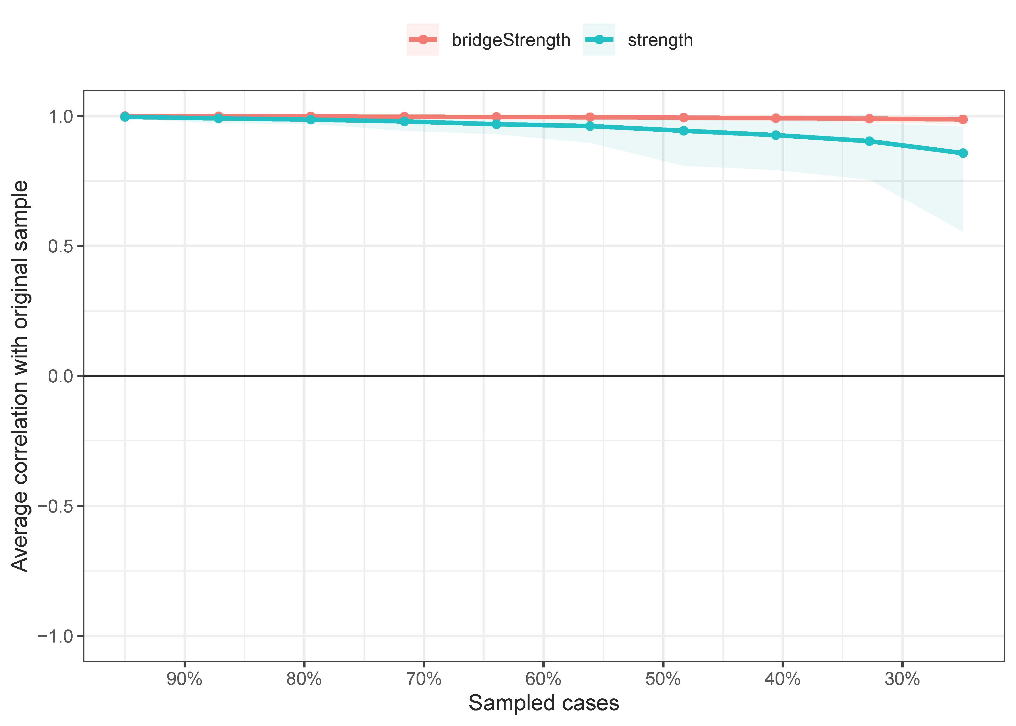
Figure legend: The x-axis represents the percentage of cases of the original sample remained at each case-dropping subset. The y-axis represents the average of correlations between the centrality indexes from the original network and the re-estimated network after case-dropping procedure. The CS-C for strength is 0.751, while the CS-C for bridge strength is 0.751.

Supplementary Figure 6. Bootstrapped confidence intervals of edge weights in the network model for the change in PHQ-9 and change in Q-LES-Q-SF total score from baseline to week 8
Figure legend: The red dots indicate the estimated values of each edge weight, ordered from the highest to the lowest value. The black dots indicate the observed value of each edge weight. The gray area represents the 95% Confidence Intervals of edge weights, estimated with the non-parametric bootstrap procedure. Wide intervals indicate lower stability and narrow intervals indicate higher stability.

Supplementary Figure 7. Estimation of edge weight differences by bootstrapped difference test in the network model for the change in PHQ-9 and change in Q-LES-Q-SF total score from baseline to week 8
Figure legend: Gray boxes indicate edges that do not differ from one-another significantly. Black boxes represent edges with significant difference from one another (significance level = 0.05). Blue boxes in the edge-weight plot correspond to positive correlations and red boxes to negative correlations.

Supplementary Figure 8. Estimation of node strength differences by bootstrapped difference test in the network model for the change in PHQ-9 and change in Q-LES-Q-SF total score from baseline to week 8
Figure legend: Gray boxes indicate nodes that do not differ from one-another significantly. Black boxes represent nodes that differ significantly from one another (significance level = 0.05). White boxes show the values of node strength.

Supplementary Figure 9. Network stability of the network model for the change in PHQ-9 and change in functional independence from baseline to week 8 by case-dropping bootstrap method
Figure legend: Functional independence was identified as the 8th item from Q-LES-Q-SF, i.e., satisfactory level on ability to function in daily life. The CS-C for strength is 0.751, while the CS-C for bridge strength is 0.751. The x-axis represents the percentage of cases of the original sample remained at each case-dropping subset. The y-axis represents the average of correlations between the centrality indexes from the original network and the re-estimated network after case-dropping procedure.

