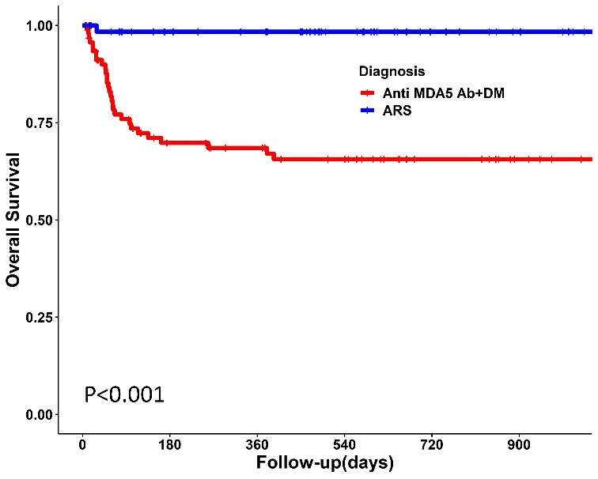
Supplementary Figure 1. Kaplan–Meier survival curves of patients with anti-MDA5 antibody positive DM and ASyS. MDA5, melanoma differentiation-associated gene 5; ASyS, anti-synthetase syndrome.

A B
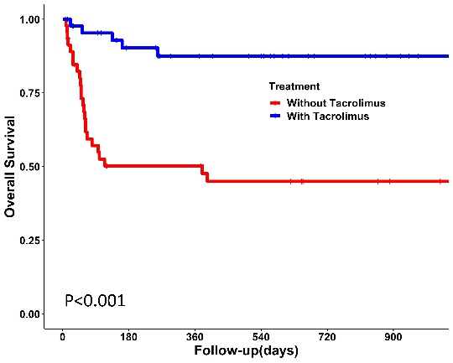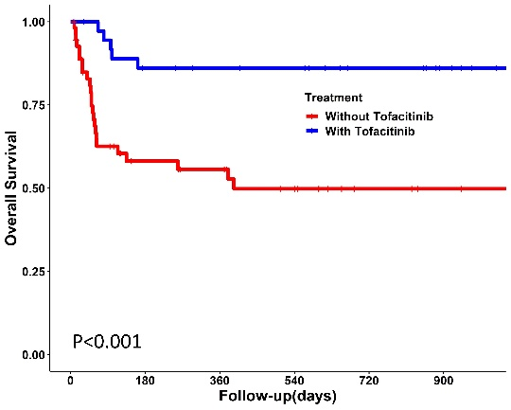
Supplementary Figure 2. Survival curves of anti-MDA5 positive DM patients according to the treatment. (A) Survival rates in patients treated with tacrolimus and without tacrolimus. (B) Survival rates in patients treated with tofacitinib and without tofacitinib.

A B
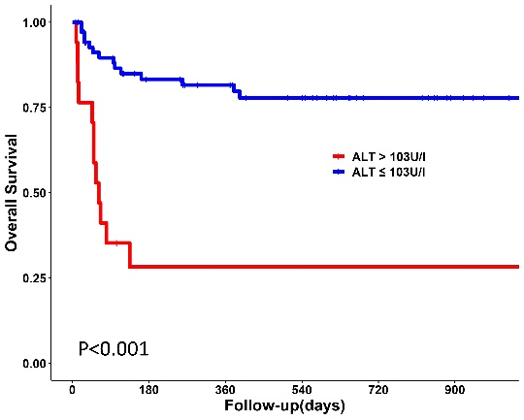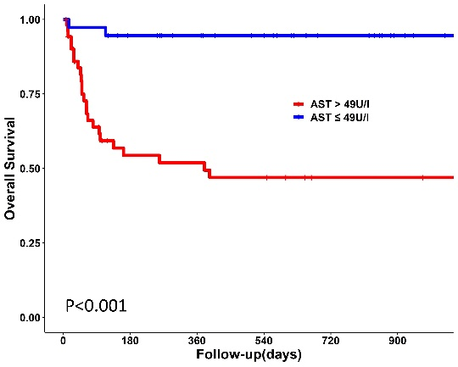
C D
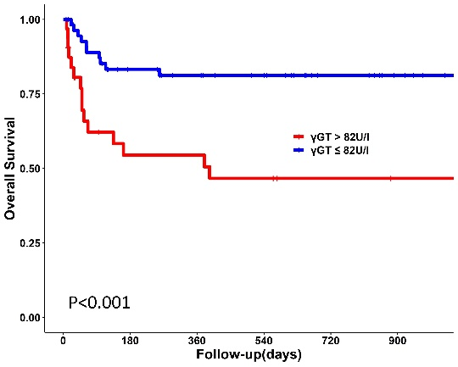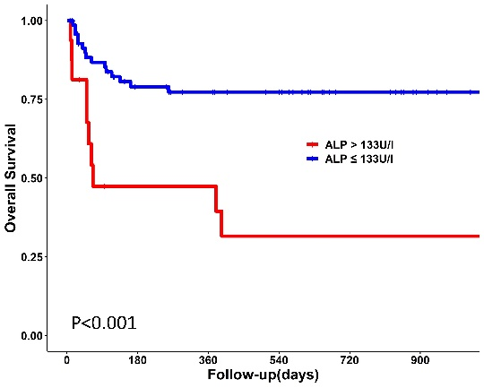
E F
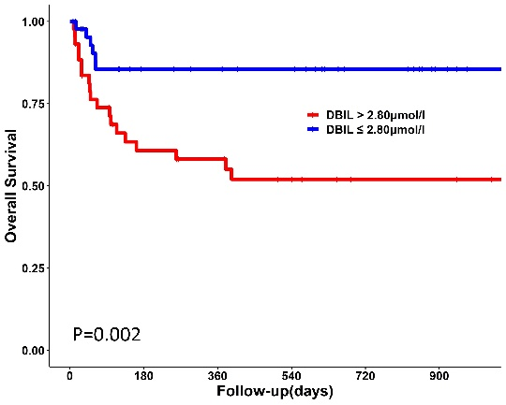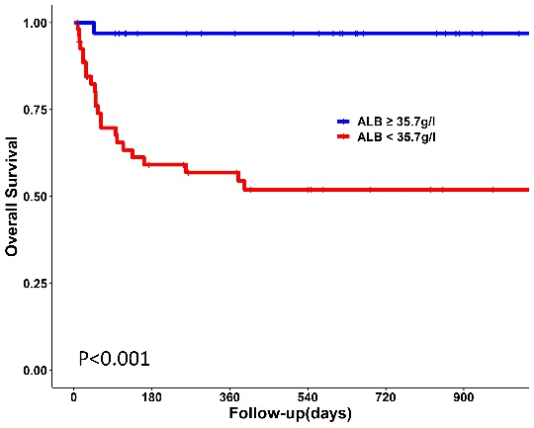

G H
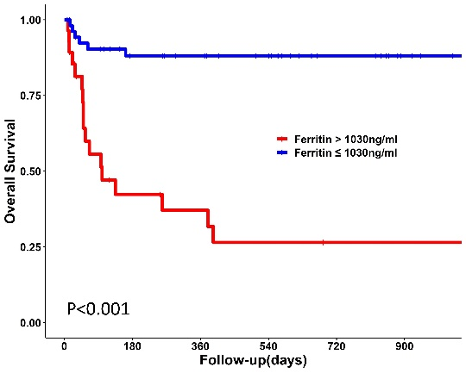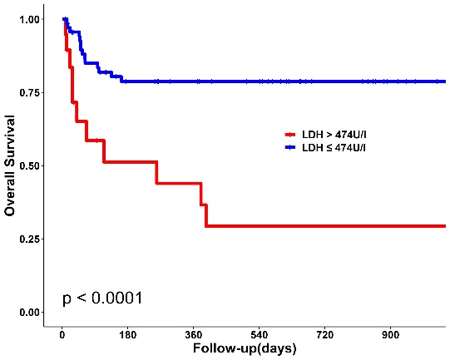
Supplementary Figure 3. Survival curves of anti-MDA5 positive DM patients stratified by level of initial ALT (A), AST (B), γGT (C), ALP (D), DBIL(E), ALB (F), ferritin (G) and LDH (H). ALT, alanine aminotransferase; AST, aspartate aminotransferase; γGT, γ-glutamyl transferase; ALP, alkaline phosphatase; DBIL, direct bilirubin; ALB, albumin; LDH, lactate dehydrogenase.

