Modelling the Costs of Sublingual Immunotherapy versus Subcutaneous Immunotherapy Based on Clinical Appointments and Impacts of Patient Travel in Sweden
Lars-Olaf Cardell^{1†} (Orchid: 0000-0003-0538-9580), Thomas Sterner^{2†} (ORCiD: 0000-0003-4771-3545), Waqas Ahmed³(ORCiD: 0000-0002-9035-7614), Andreas Kallsoy Slættanes⁴, Mikael Svärd⁵, Richard F. Pollock^{3,} * (ORCiD: 0000-0002-9873-7507)

¹ Division of ENT Diseases, Department of Clinical Science, Intervention and Technology, Karolinska Institute, Stockholm, Sweden
² Department of Economics, School of Business, Economics and Law, University of Gothenburg, Gothenburg, Sweden
³ Covalence Research Ltd, Harpenden, UK
⁴ ALK, Bøge Allé 1, DK-2970, Hørsholm, Denmark
⁵ ALK Nordic, Faktorvägen 9, SE-434 21, Kungsbacka, Sweden
† These authors contributed equally to this work and share first authorship
*Correspondence
Name: Richard F. Pollock
E-mail: pollock@covalence-research.com

Supplementary materials

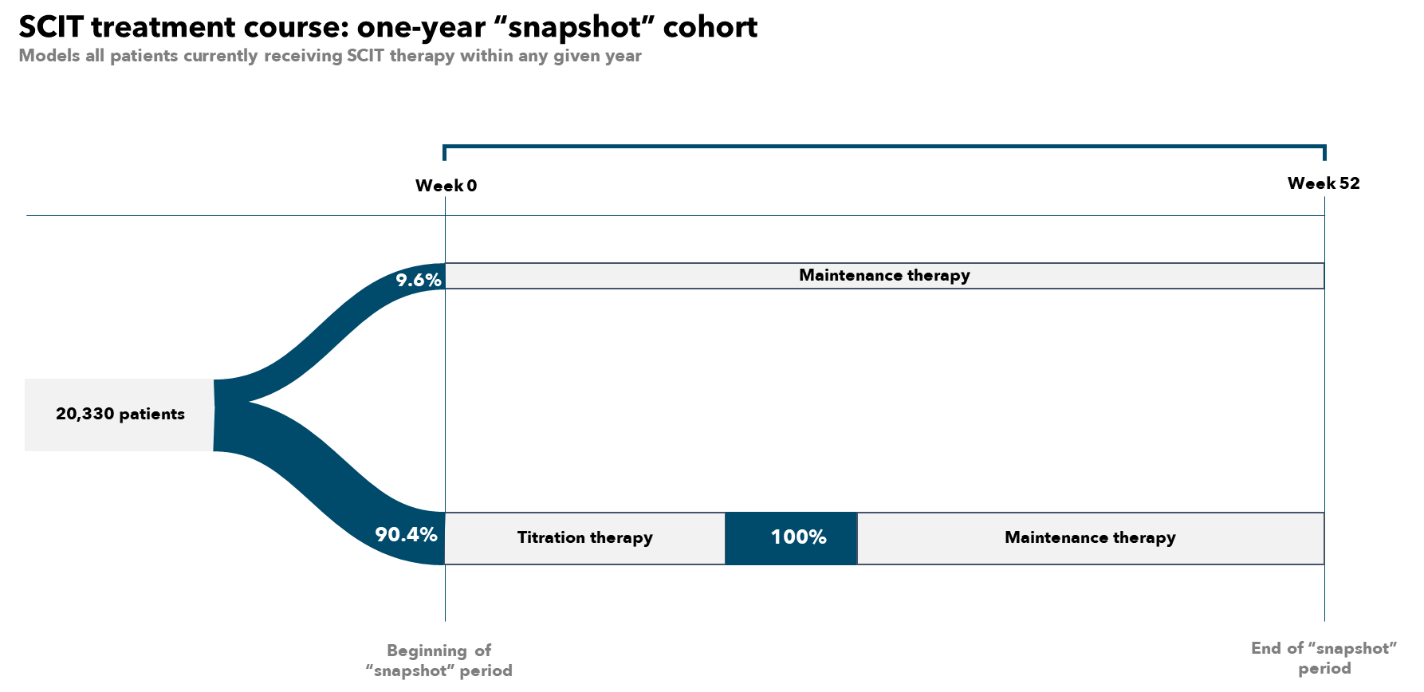
Supplementary Figure S1. SCIT treatment funnel for one-year "snapshot" cohort.

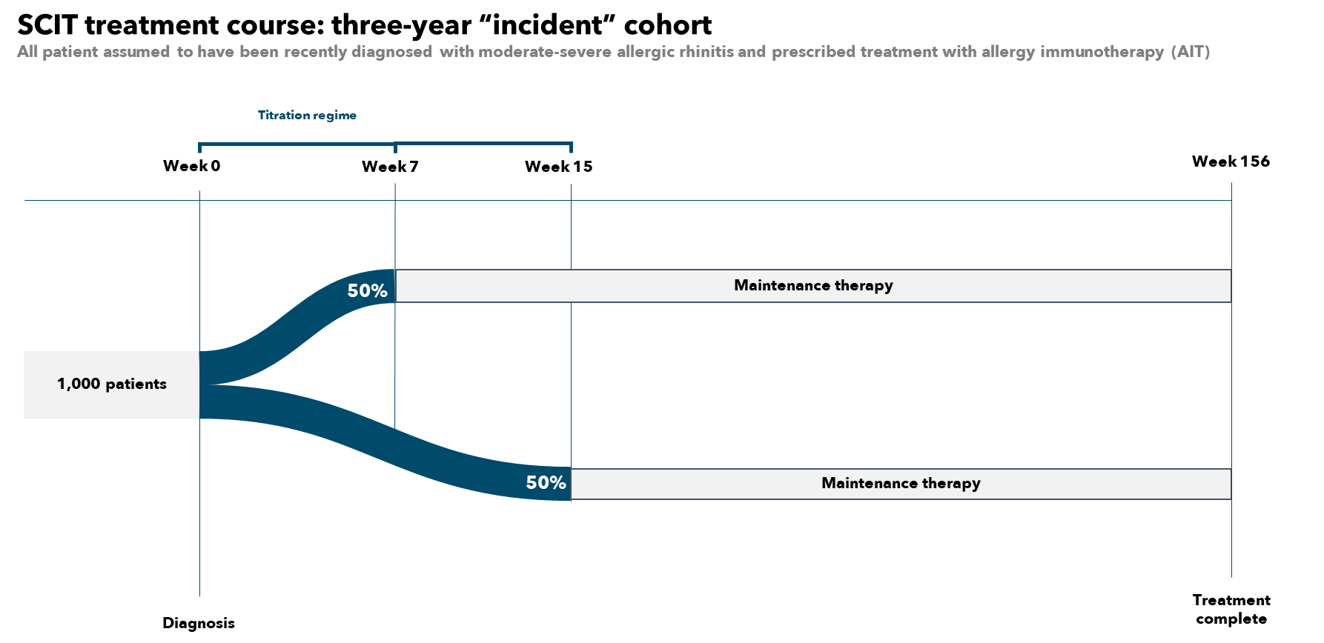
Supplementary Figure S2. SCIT treatment funnel for three-year “incident” cohort.

