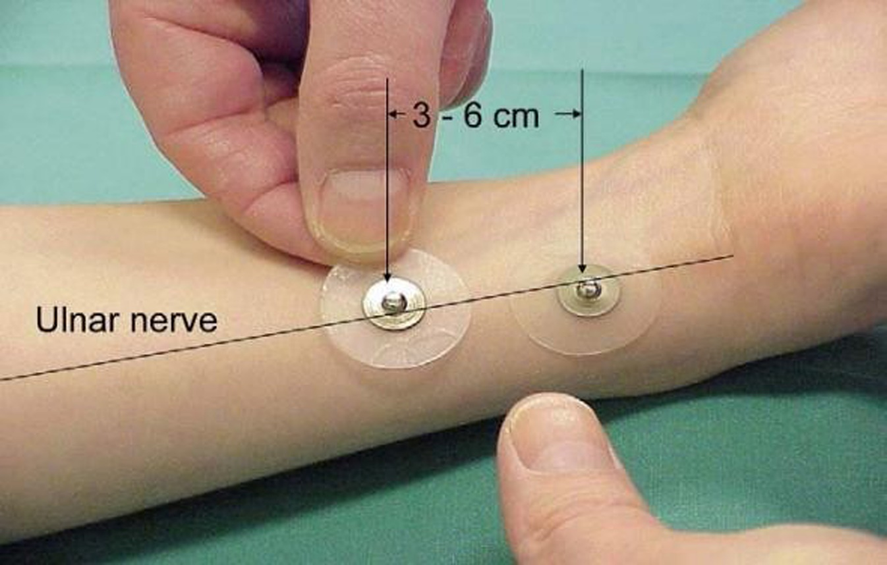
Supplemental Fig. 1. Muscle relaxation monitor electrode placement on the ulnar nerve
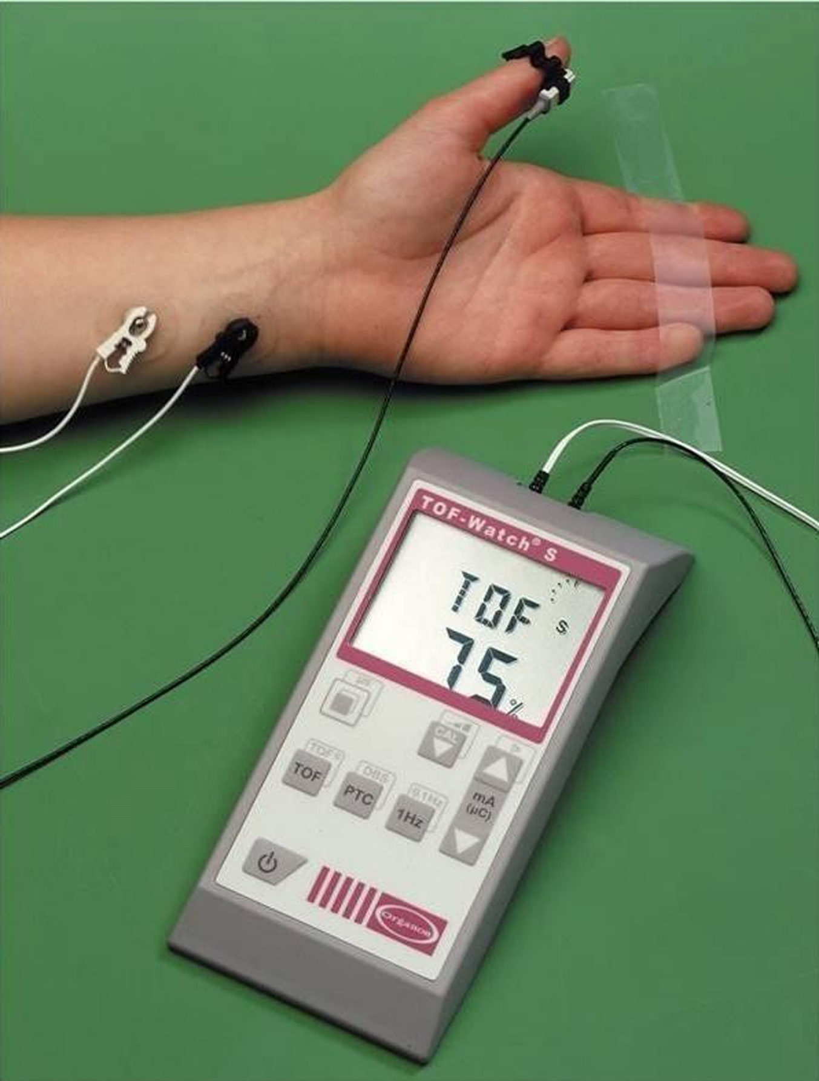

Supplemental Fig. 2. TOF values measured by the muscle relaxation monitor and the transducer position.

