Supplementary Data
Ultrasensitive hierarchical AuNRs@SiO₂@Ag SERS probes for enrichment and detection of insulin and C-peptide in serum
Tong Zhang^{1,2,3#}，Han Wu^{1,2#}，Chenling Qiu^{1,2}，Mingxin Wang^{1,2}，Haiting Wang^{1,2}，Shunhua Zhu^{1,4}，Yinhai Xu², Qingli Huang^{1, 4 *}, Shibao Li^{1,2*}

¹Medical Technology School of Xuzhou Medical University, Xuzhou, Jiangsu, 221000, People’s Republic of China
²Department of Laboratory Medicine, Affiliated Hospital of Xuzhou Medical University, Xuzhou, Jiangsu, 221000, People’s Republic of China
³Chuzhou Center for Disease Control and Prevention, Chuzhou city, Anhui 239000, China
⁴Public experimental research center of Xuzhou Medical University, Xuzhou city, Jiangsu 221004, China

#These authors contributed equally to this work

Correspondence:
Qingli Huang, Email:qlhuang@xzhmu.edu.cn
Shibao Li，Email: sdjnshlb@xzhmu.edu.cn

S1. Materials:
Chloroauric acid tetrahydrate (HAuCl₄.4H₂O) was obtained from Beijing Huawei Ruike Co., Ltd. Glutathione (GSH), 3-aminopropyl triethoxysilane (APTES), trisodium citrate, 3,3',5,5'-Tetramethylbenzidine (TMB) and 2-nitrobenzoic acid (DTNB) were obtained from Shanghai Maclin Biochemical Co., Ltd. Ethyl silicate (TEOS), Ascorbic acid (AA), Sodium borohydride (NaBH₄) and Sodium hydroxide (NaOH) were received from Shanghai Aladdin Biochemical Technology Co., Ltd. The carboxylated magnetic beads were received from Nanjing XFNANO Materials Tech Co., Ltd. Glucose were obtained from Xuzhou Weikemande Bioengineering Co.,Ltd. Bovine serum albumin (BSA), hydrochloric acid (HCl), Silver nitrate (AgNO₃), N-hydroxythiosuccinimide (NHS), Ethyl (3-dimethylaminopropyl)-carbodiimine (EDC) , sodium citrate, absolute ethyl alcohol, methyl alcohol, Cetyltrimethyl ammonium bromide (CTAB) and phosphate buffer solution (PBS, pH 5.0) were obtained from Sinopharm Group Chemical reagent Co., Ltd. Insulin antibody and C-peptide antibody were received from Beijing Biosen Biotechnology Co., Ltd. Insulin and Proinsulin C-peptide were obtained from MCE (MedChemExpress). The serum samples and the quality control serums were obtained from Clinical Lab of Affiliated Hospital of Xuzhou Medical University, and the informed consent for using the human serums have been obtained. The deionized water was used in all experiments.

S2. Characterization:
The ultraviolet-visible (UV-vis) absorption was measured by UV-1902 (AOE, China) The Raman spectra were recorded via confocal Raman spectrometer (Thermo Fisher, DXR3, America). All Raman measurements were carried out using a 785 nm laser. The laser power intensity and the acquisition time were set as 150 μWμm⁻² and 80s, respectively.

S3. Synthesis：
Preparation of seed solution
HAuCl₄·4H₂O (0.01 M, 0.05 mL) was evenly mixed with pre-configured CTAB (0.1 M, 2 mL), then freshly prepared sub-zero NaBH₄ (0.01 M, 0.12 mL) was added, reacted at 24-25℃ for 2 h after appropriate ultrasound.
Preparation of growth solution
Adding the pre-configured CTAB (0.1 M, 40 mL) into a 50 mL round-bottomed flask, placing in an oil bath heated to 25℃ in advance (1200 rpm), and added AgNO₃ (0.01 M, 0.4 mL) after stirring for a few seconds, added HAuCl₄·4H₂O (0.5 mM, 2 mL), then added dilute HCl (0.01 M, 0.8 mL) to adjust the pH to 1-2, and added AA (0.1 M, 0.32 mL) as a reducing agent after stirring for a few seconds. The color of solution changed from golden color to colorless.
Synthesis of Au NRs
The grown seed solution was ultrasonic dispersed appropriately, and 96 μL of it was injected into the growth solution with the reaction temperature adjusted to 30℃ and stirred for 30 s, then stopped stirring and reacting for 2 h. During the reaction process, the color of solution gradually changed from colorless to deep wine red. The obtained gold rod solution was centrifuged (8000 rpm, 20 min), washed three times, add deionized water to make the solution volume to 4mL, and stored at 4℃.
Preparation of Au NRs@4-MBA@SiO₂ and Au NRs@DTNB@SiO₂
2 mL of the prepared Au NRs was added into a 50 mL conical bottle, deionized water was added to the mixed solution until the volume was 40 mL, ultrasonic dispersion was performed for 5 min for uniform mixing, then the solution was placed in an oil bath heated to 30℃ in advance and stirred (300 rpm). Adding the prepared CTAB (0.1 M, 0.76 mL) and stirring for 30 min,then adding NaOH (0.1 M, 0.8 mL), stir for 10 min, adding 4-MBA (0.01 M, 0.1 mL) and stirring for a few seconds, then the prepared TEOS (80 μL, 10%, methanol) was added three times at an interval of 30 min, and continued to react in an oil bath for 24 h, then centrifuged (9500 rpm, 10 min), washed once, and then added deionized water to a solution volume of 1 mL, and stored at 4℃. The same method was used to prepare Au NRs@SiO₂@DTNB.
Preparation of SERS probe@antibody
EDC (0.1 M, 50 μL) and NHS (0.1 M, 80 μL) was added into 1 mL SERS probe (Au NRs@4-MBA@SiO₂@Ag), then slowly shaken at room temperature (150 rpm, 30 min), washed twice with PBS (0.01 M, pH 7.2) and dispersed into 1 mL PBS. Insulin antibody was added to the solution (100 μg/mL, 100 μL) and incubated at 4℃ for 12 h. BSA (50 μL, 3%) was added to the mixed solution as a blocking solution to avoid non-specific binding of antibodies, then centrifuged and dispersed into PBS (1 mL, pH 7.2) after reaction at 4℃ for 6 h. Au NRs@4-MBA@SiO₂@Ag@C-peptide antibodies were prepared by the same method.
Preparation of magnetic substrate@antibody
100 μL carboxylated magnetic beads were dispersed into 1 mL PBS, insulin antibodies were added to the solution (100 μg/mL, 100 μL), and incubated at 4℃ for 12 h. BSA (50 μL, 3%) was added to the mixture as a blocking solution to avoid non-specific binding of antibodies. After reaction at 4℃ for 6 h, the magnetic separation was dispersed into PBS (1 mL, pH 7.2). The carboxylated magnetic beads @C-peptide antibodies were prepared by the same method.

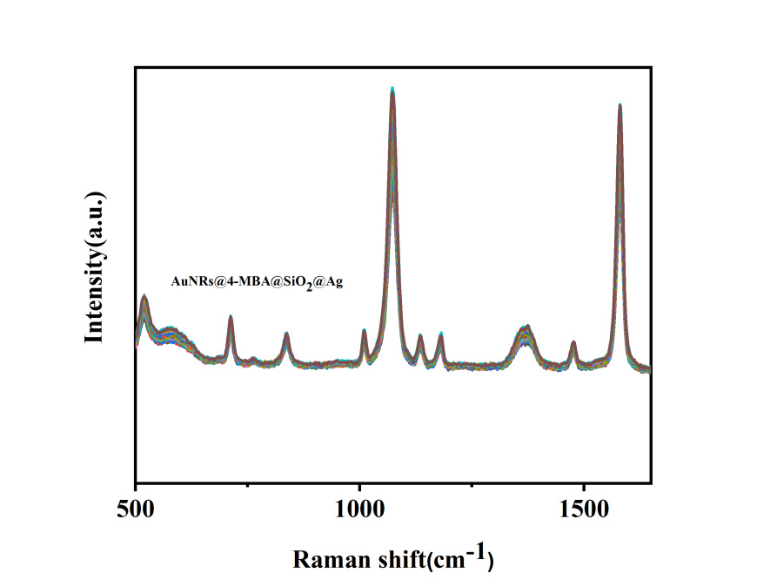

Figure. S1. 20 SERS spectra were collected repeatedly in AuNRs@4-MBA@SiO₂@Ag dispersions.

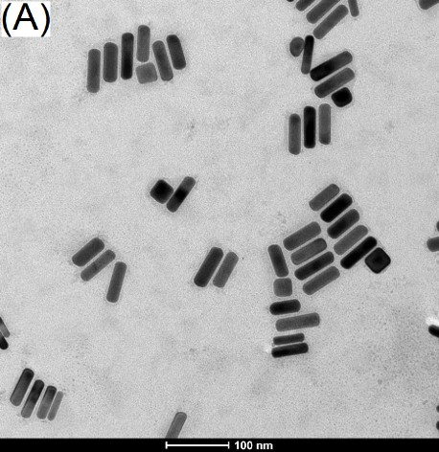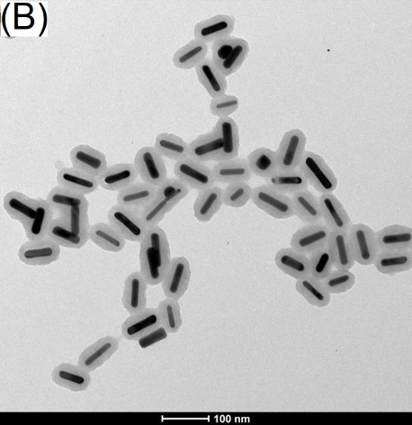
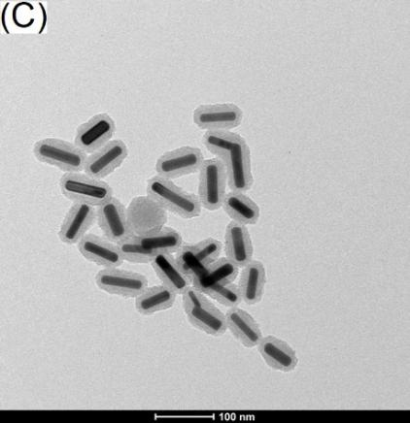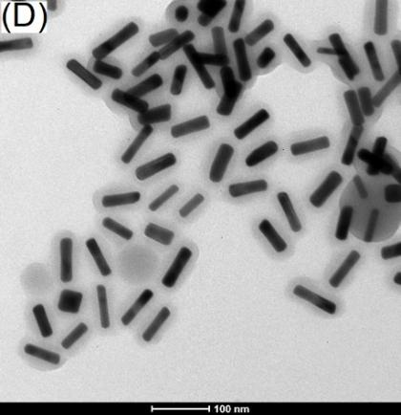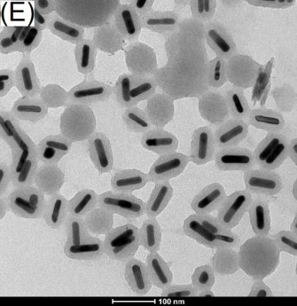
Figure. S2. Effects of different amounts of TEOS (10%, methanol) on the formation of AuNRs@SiO₂. (A) 230 μL; (B) 240 μL; (C) 270 μL; (D) 280 μL; (E) 300 μL.

Figure. S3. (A) Raman spectra of SERS probes synthesized by 4-MBA at different concentrations (0.001 mM, 0.01 mM, 0.1 mM, 1 mM); (B) Raman spectra of SERS probes synthesized by AgNO₃ at different concentrations (5.74 μM, 11.48 μM, 17.22 μM); (C) Raman spectra of different amounts of specific antibodies (10 μL, 25 μL, 50 μL, 100 μL) were added to the immunoassay system; (D) Raman spectra of different SERS probes (10 μL, 25 μL, 50 μL, 100 μL, 200 μL) were added to the immunoassay system.

Figure. S4. The nanoassay system was used to verify the specificity of insulin (Fig. A) and C-peptide (Fig. B).

Table S1. Detection of human serum.
Serum | Added (ng/mL) | The proposed method (N=3)
Serum | Added (ng/mL) | Found (ng/mL) | Recovery (%) | RSD(%)
Insulin | 67.3 | 67.25±6.92 | 99.9 | 8.4
 | 94.7 | 99.73±11.6 | 105.3 | 9.5
 | 362 | 352.84±32.84 | 97.5 | 7.6
 | 128.8 | 126.86±9.48 | 98.5 | 6.1
 | 123.1 | 128.66±10.56 | 104.5 | 6.7
 | 224.2 | 221.72±19.28 | 98.9 | 7.1
 | 168.4 | 171.32±13.01 | 101.7 | 6.2
 | 81 | 78.26±3.35 | 96.6 | 3.5
 | 177 | 172.69±15.02 | 97.6 | 7.1
 | 174.8 | 172.31±1.69 | 98.6 | 0.8
 | 695.4 | 712.04±87.2 | 102.4 | 10.0
 | 132.9 | 128.16±10.99 | 96.4 | 7.0
 | 212.5 | 220.26±17.53 | 103.6 | 6.5
 | 311.2 | 310.04±20.12 | 99.6 | 5.3
 | 317.2 | 312.46±16 | 98.5 | 4.2
C-peptide | 0.49 | 0.505±0.035 | 103.1 | 5.6
 | 0.25 | 0.26±0.005 | 104.0 | 1.7
 | 0.07 | 0.069±0.006 | 99.3 | 7.5
 | 0.96 | 0.82±0.028 | 85.4 | 2.8
 | 8.74 | 8.16±1.08 | 93.4 | 10.8
 | 10.78 | 10.48±0.63 | 97.2 | 4.9
 | 1.52 | 1.545±0.065 | 101.6 | 3.4
 | 2.13 | 2.167±0.217 | 101.7 | 8.2
 | 4.02 | 4.21±0.43 | 104.7 | 8.3
 | 6.28 | 6.50±0.65 | 103.5 | 8.2
 | 0.58 | 0.576±0.023 | 99.3 | 3.3
 | 0.3 | 0.311±0.034 | 103.7 | 8.9
 | 0.55 | 0.553±0.041 | 100.5 | 6.1
 | 0.26 | 0.273±0.009 | 105.0 | 2.5
 | 1.29 | 1.24±0.087 | 96.1 | 5.7
 | 1.43 | 1.384±0.107 | 96.8 | 6.3

Table S2. Simultaneously detection of insulin and C-Peptide in human serum.
Serum | Added Insulin  (ng/mL) | The proposed method(N=3) |  |  | Added  C-Peptide  (ng/mL) | The proposed method(N=3)
Serum | Added Insulin  (ng/mL) | Found Insulin (ng/mL) | Recovery (%) | RSD  (%) | Added  C-Peptide  (ng/mL) | Found  C-Peptide (ng/mL) | Recovery (%) | RSD  (%)
1 |  | 14.65 | 99.66 | 1.96 |  | 0.761 | 100.13 | 0.71
  14.7
  0.76
2 | 54 | 52.32 | 96.89 | 1.86 |  | 1.73 | 103.59 | 1.17
  1.67
3 | 183.1 | 183.80 | 100.38 | 1.23 |  | 3.33 | 101.22 | 0.82
  3.29
4 |  | 66.23 | 95.57 | 2.84 |  | 1.07 | 107 | 0.96
  69.3
  1
5 | 170.4 | 173.22 | 101.66 | 0.59 |  | 1.02 | 103.03 | 2.75
  0.99
6 | 26.4 | 24.06 | 91.14 | 0.45 |  | 1.66 | 103.11 | 1.63
  1.61
7 | 62.7 | 61.97 | 98.84 | 0.25 |  | 2.14 | 97.72 | 0.11
  2.19
8 | 75.6 | 82.68 | 109.37 | 0.45 |  | 3.11 | 96.58 | 0.42
  3.22
9 | 270.7 | 272.32 | 100.60 | 1.23 |  | 4.16 | 95.63 | 1.34
  4.35
10 | 632.8 | 621.56 | 98.22 | 1.29 |  | 7.30 | 100.41 | 0.34
  7.27
11 | 553.2 | 553.42 | 100.04 | 1.40 |  | 6.75 | 108.52 | 0.68
  6.22
12 |  | 361.79 | 90.81 | 1.15 |  | 2.81 | 98.94 | 0.79
  398.4
  2.84
13 |  | 487.46 | 99.58 | 1.85 |  | 3.61 | 100.84 | 0.37
  489.5
  3.58
14 | 43.7 | 44.38 | 101.56 | 1.99 |  | 1.26 | 105.00 | 2.69
  1.2
15 | 70.6 | 70.01 | 99.16 | 1.38 |  | 0.10 | 90.91 | 0.83
  0.11
16 | 38 | 37.22 | 97.95 | 0.58 |  | 1.44 | 100 | 1.35
  1.44
17 | 17.5 | 18.46 | 105.49 | 3.02 |  | 0.58 | 100 | 0.07
  0.58
18 | 24.3 | 24.38 | 100.33 | 3.04 |  | 1.07 | 103.88 | 0.08
  1.03
19 | 32.8 | 35.55 | 108.38 | 1.03 | 1.26 | 1.18 | 93.65 | 1.74

