Supplementary Material for
Computational modeling interpretation underlying elevated risk-taking propensity in the dynamic risky investment process of non-labor income

S1 Sample Exclusion
For our final sample who had completed all of the questionnaires, we first excluded (1) 3 participants who had moderate to severe depression indicated by BDI (BDI ≥ 19) or PHQ-9 (PHQ-9 ≥ 15), (2) 10 participants who were extreme outliers (i.e., BDI, PHQ-9, NEO-PI-N, TAI, PANAS or BIS scale scores exceed 3SDs), and (3) 8 participants whose risk-taking behavioral indicators in the BART exceeded mean + 3 SDs. Then, 151 participants were left after screening. Among of them, 48 participants were further excluded because they did not correctly distinguish endowment from different sources in the manipulation check (most of them misclassified the money from lucky draw into labor Income). Eventually, 103 participants were included in the analyses. Self-reported sources of endowment of these excluded participants can be found in the Supplementary Material Table S1.

Table S1 Distribution of participants who did not correctly distinguish endowment from different sources. 48 participants were excluded because they did not correctly distinguish endowment from different sources in the mental account manipulation check, while most of them misclassified the money from non-labor income into labor income
distinction of the endowment | Labor income (N=11) | Non-labor income (N=37)
Labor Income |  | 29
Non-labor income | 5
Other Reason but Not Listed in the Choices | 6 | 8

S2 Settings of prior distributions and ranges of estimated parameters in computational modeling.

Table S2 Prior distributions and ranges of estimated group level and
individual level parameters
Model | Priors and Ranges
BSR | $$μ_{α}\sim Normal(0,20)$$  $$μ_{μ}\sim Normal(0,10)$$  $$μ_{γ^{+}},μ_{β} \sim Normal(0,1)$$  $${σ^{2}}_{α}, {σ^{2}}_{μ}, {σ^{2}}_{γ^{+}}, {σ^{2}}_{β} \sim Inv-Gamma(1,1)$$  $$μ_{α}∈\left[0,+∞\right]$$  $$μ_{μ}∈\left[0,+∞\right]$$  $$μ_{γ^{+}}∈\left[0,+∞\right]$$  $$μ_{β}∈\left[0,+∞\right]$$  $$σ^{2}∈[0,+∞]$$  $$0<α<μ$$  $$γ∈[0, +∞]$$  $$β∈[0, 3]$$
Target | $$μ_{vwin},μ_{vloss}, μ_{ω_{1}},μ_{β}, μ_{α} \sim Normal(0,1)$$  $${σ^{2}}_{vwin}, {σ^{2}}_{vloss}, {σ^{2}}_{ω_{1}}, v{σ^{2}}_{β}, {σ^{2}}_{α} \sim Inv-Gamma(1,1)$$  $$μ_{vwin}∈[0,+∞]$$  $$μ_{vloss}∈[0,+∞]$$  $$μ_{ω_{1}}∈\left[0, 1\right]$$  $$μ_{β}∈\left[0,+∞\right]$$  $$μ_{α}∈\left[0,+∞\right]$$  $$σ^{2}∈[0,+∞]$$  $$νwin∈\left[0, 1\right]$$  $$νloss∈\left[0, 1\right]$$  $$ω∈[0,1]$$  $$β∈\left[0,3\right]$$  $$α∈[0,1]$$
STL | $$μ_{vwin},μ_{vloss}, μ_{ω_{1}},μ_{β} \sim Normal(0,1)$$  $${σ^{2}}_{vwin}, {σ^{2}}_{vloss}, {σ^{2}}_{ω_{1}}, {σ^{2}}_{β} \sim Inv-Gamma(1,1)$$  $$νwin∈\left[0, 1\right]$$  $$νloss∈\left[0, 1\right]$$  $$ω∈[0,1]$$  $$β∈\left[0,3\right]$$  $$μ_{vwin}∈[0,+∞]$$  $$μ_{vloss}∈[0,+∞]$$  $$μ_{ω_{1}}∈\left[0, 1\right]$$  $$μ_{β}∈\left[0,+∞\right]$$  $$σ^{2}∈[0,+∞]$$
STLD | $$μ_{vwin},μ_{vloss}, μ_{ω_{1}},μ_{β},μ_{α}\sim Normal(0,1)$$  $${σ^{2}}_{vwin}, {σ^{2}}_{vloss}, {σ^{2}}_{ω_{1}}, {σ^{2}}_{β},{σ^{2}}_{α}\sim Inv-Gamma(1,1)$$  $$μ_{vwin}∈[0,+∞]$$  $$μ_{vloss}∈[0,+∞]$$  $$μ_{ω_{1}}∈\left[0, 1\right]$$  $$μ_{β}∈\left[0,+∞\right]$$  $$μ_{α}∈\left[0, 1\right]$$  $$σ^{2}∈[0,+∞]$$  $$νwin∈\left[0, 1\right]$$  $$νloss∈\left[0, 1\right]$$  $$ω∈[0,1]$$  $$β∈\left[0,3\right]$$  $$α∈[0,1]$$

S3 Model Recovery
We graphed the group-level original and simulated number of pumps for participants in labor income group and non-labor income group (Figure S1). The simulated pump of each trial in BART could capture the key characteristic of participants’ responses that individuals in non-labor income group have higher risk propensity than who in labor income group (t(3088) = -13.23, 95% CI = [-9.90, -7.34], p < .00; labor income group: M = 26.83, SE = 16.15, non-labor income group: M = 35.45, SE = 20.07).

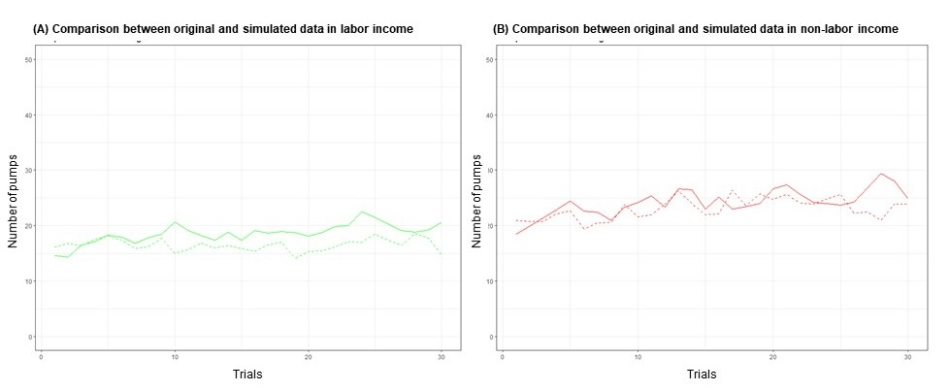
Figure S1. Group-level comparison between original number of pumps (solid line) and simulate data (dotted line) for participants in labor income group (green) (A) and non-labor income group (red) (B).

S4 Parameter Recovery
We calculated the Pearson correlation coefficient between original and recovered parameter estimates across different participants. Mean and standard deviation of the 20 Pearson correlations for each parameter was presented in Table S3.

Table S3 The mean (SD) of the Pearson correlation coefficients of estimated parameters and recovered parameters in the STL-D model.
 |  | νwin | νloss | $$ω_{1}$$ | $$β$$ | $$α$$
Labor income | Mean  (SD) | 0.78  (0.04) | 0.89  (0.02) | 0.97  (0.01) | 0.94  (0.01) | 0.76  (0.06)
Non-labor income | Mean  (SD) | 0.86  (0.03) | 0.76  (0.07) | 0.98  (0.01) | 0.94  (0.02) | 0.75  (0.06)

