Supporting Information

- Instruments
¹H-NMR and solid-state ¹³C CP-MAS NMR spectra were obtained on Bruker Avance-400 HD and AVANCE II 400 spectrometers, respectively. HRMS analysis was recorded on a Bruker maXis ultra-high resolution mass spectrometer. FT-IR spectroscopy was conducted on a Bruker ALPHA spectrometer. SEM was employed using the Gemini Zeiss SUPRA scanning electron microscope. TEM was recorded on a Hitachi HT7700 120 kV Compact-Digital Transmission Electron Microscope. The PXRD patterns were measured on a D8 Advance X-ray powder diffractometer with Cu Κα radiation (λ = 1.5405 Å). Nitrogen-adsorption isotherms were performed on an ASAP 2020/TriStar 3000 (Micromeritics) at 77 K. TGA was performed on a TGA/DSC1-Thermogravimetric Analyzer (Mettler Toledo) from 25 to 800°C under flowing nitrogen atmosphere. The concentration of T705 was obtained with UV-Vis spectroscopy (TU-1900 Beijing PuXi). The particle size was measured on a Malvern Zetasizer Nano ZS90 apparatus. Fluorescence spectrums were recorded on the Edinburgh Fluorescence Spectrometer (FLS-980) with a Xenon lamp. Fluorescence images were captured on a Leica TCS SP8 Confocal Laser Scanning Microscopy. Microplate assays were carried out on a Molecular Devices SpectraMax i3x Multi-Mode Microplate Detection System. The morphology of the cells was taken with a Leica DMI3000 B Inverted Fluorescence Microscope.

- Synthesis and characterization of 1,3,5-triformylphloroglucinol (Tp)
Based on previous reports,¹ a mixture of hexamethylene tetraamine (7.42 g, 52.9 mmol), dried phloroglucinol (3.0 g, 23.8 mmol) in 45 mL of trifluoroacetic acid was heated at 100°C for 2.5 h in N2 atmosphere. After addition of 75 mL of 3 M HCl, the mixture was heated at 100°C for additional 1 h. After cooling to room temperature, the solution was filtered through Celite, extracted with dichloromethane, and dried over anhydrous magnesium sulfate. Rotary evaporation of the solution afforded 1,3,5-triformylphloroglucinol as an off-white powder (0.54 g, 18% yield). ¹H NMR (400 MHz, CDCl3, δ, ppm) 14.14 (s, 3H), 10.17 (s, 3H). ESI-MS: calcd for [C₉H₆O₆-H] m/z 209.01, found m/z 209.01; FT-IR (KBr, cm⁻¹): 2887(w), 1643(s), 1606(m), 1434(s), 1251(m), 1192(s), 968(s), 873(m), 788(m), 608(s).
Scheme S1. Synthesis of Tp.

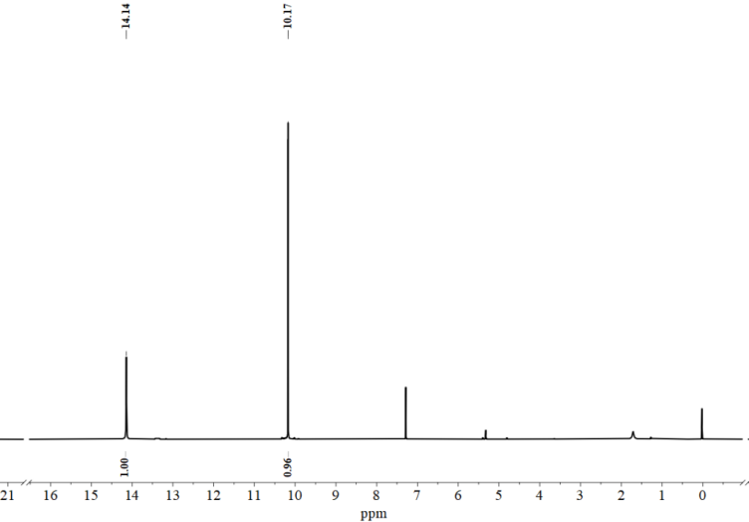
Figure S1 ¹H-NMR (in CDCl₃) spectra of Tp.

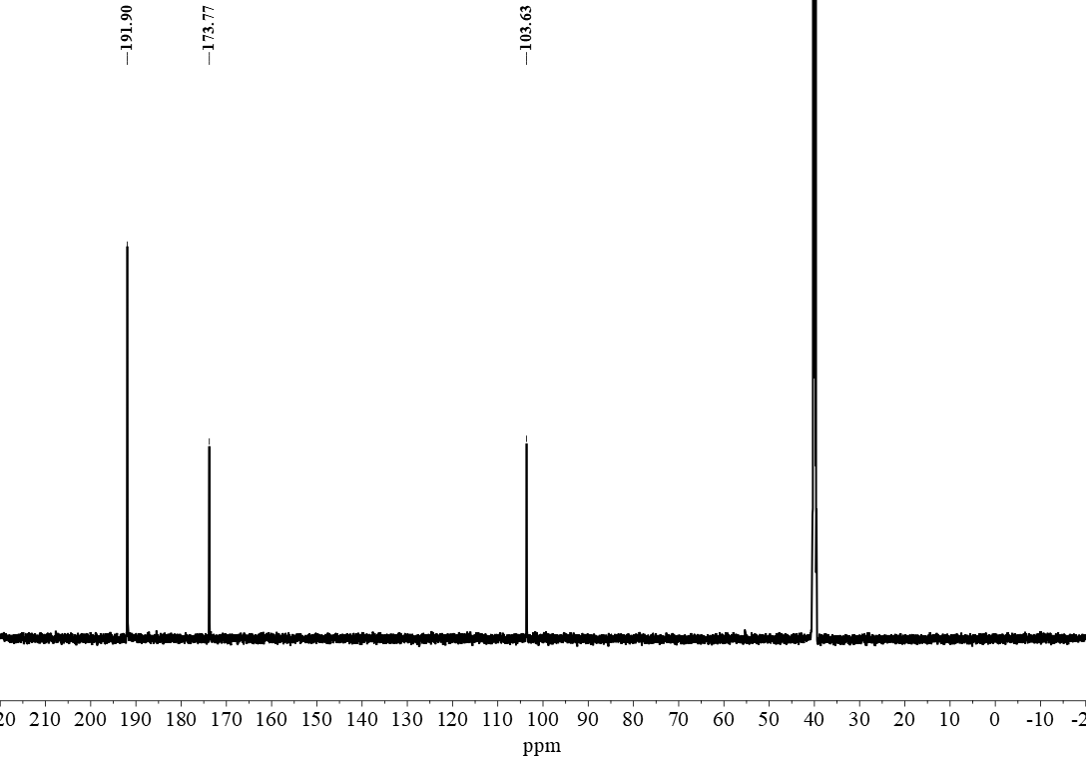
Figure S2 ¹³C-NMR (in DMSO-d₆) spectra of Tp.

Table S1 Information for ssDNA sequences employed in this work
Name | Specificity | Sequence (5′-3′)
Cy3-labeled ssDNA (T₀) |  | Cy3-TAA GAC CTG CTG TAG CAT CTT CGC CGT TGT aaa aa-NH₂
ssDNA-Probe |  | Cy3-TAA GAC CTG CTG TAG CAT CTT CGC CGT TGT
Target ssDNA (T) | Complementary ss-DNA for T₀ and ssDNA-Probe | aca acg gcg aag atg cta cag cag gtc tta
Mismatched ssDNA-1 (T₁) | Partial base pair mutated for T₀ and ssDNA-Probe | aca aca ata ggg aga cta agt tca gtc tta
Mismatched ssDNA-2 (T₂) | Non-specific ss-DNA for T₀ and ssDNA-Probe | acg cat act cgt aGT TCc act cat tcg tta
Mismatched ssDNA-3 (T₃) | Non-specific ss-DNA for T₀ and ssDNA-Probe | gag cca tca gct ata tgc cga gtg act cta
- Characterization of DATA-COF
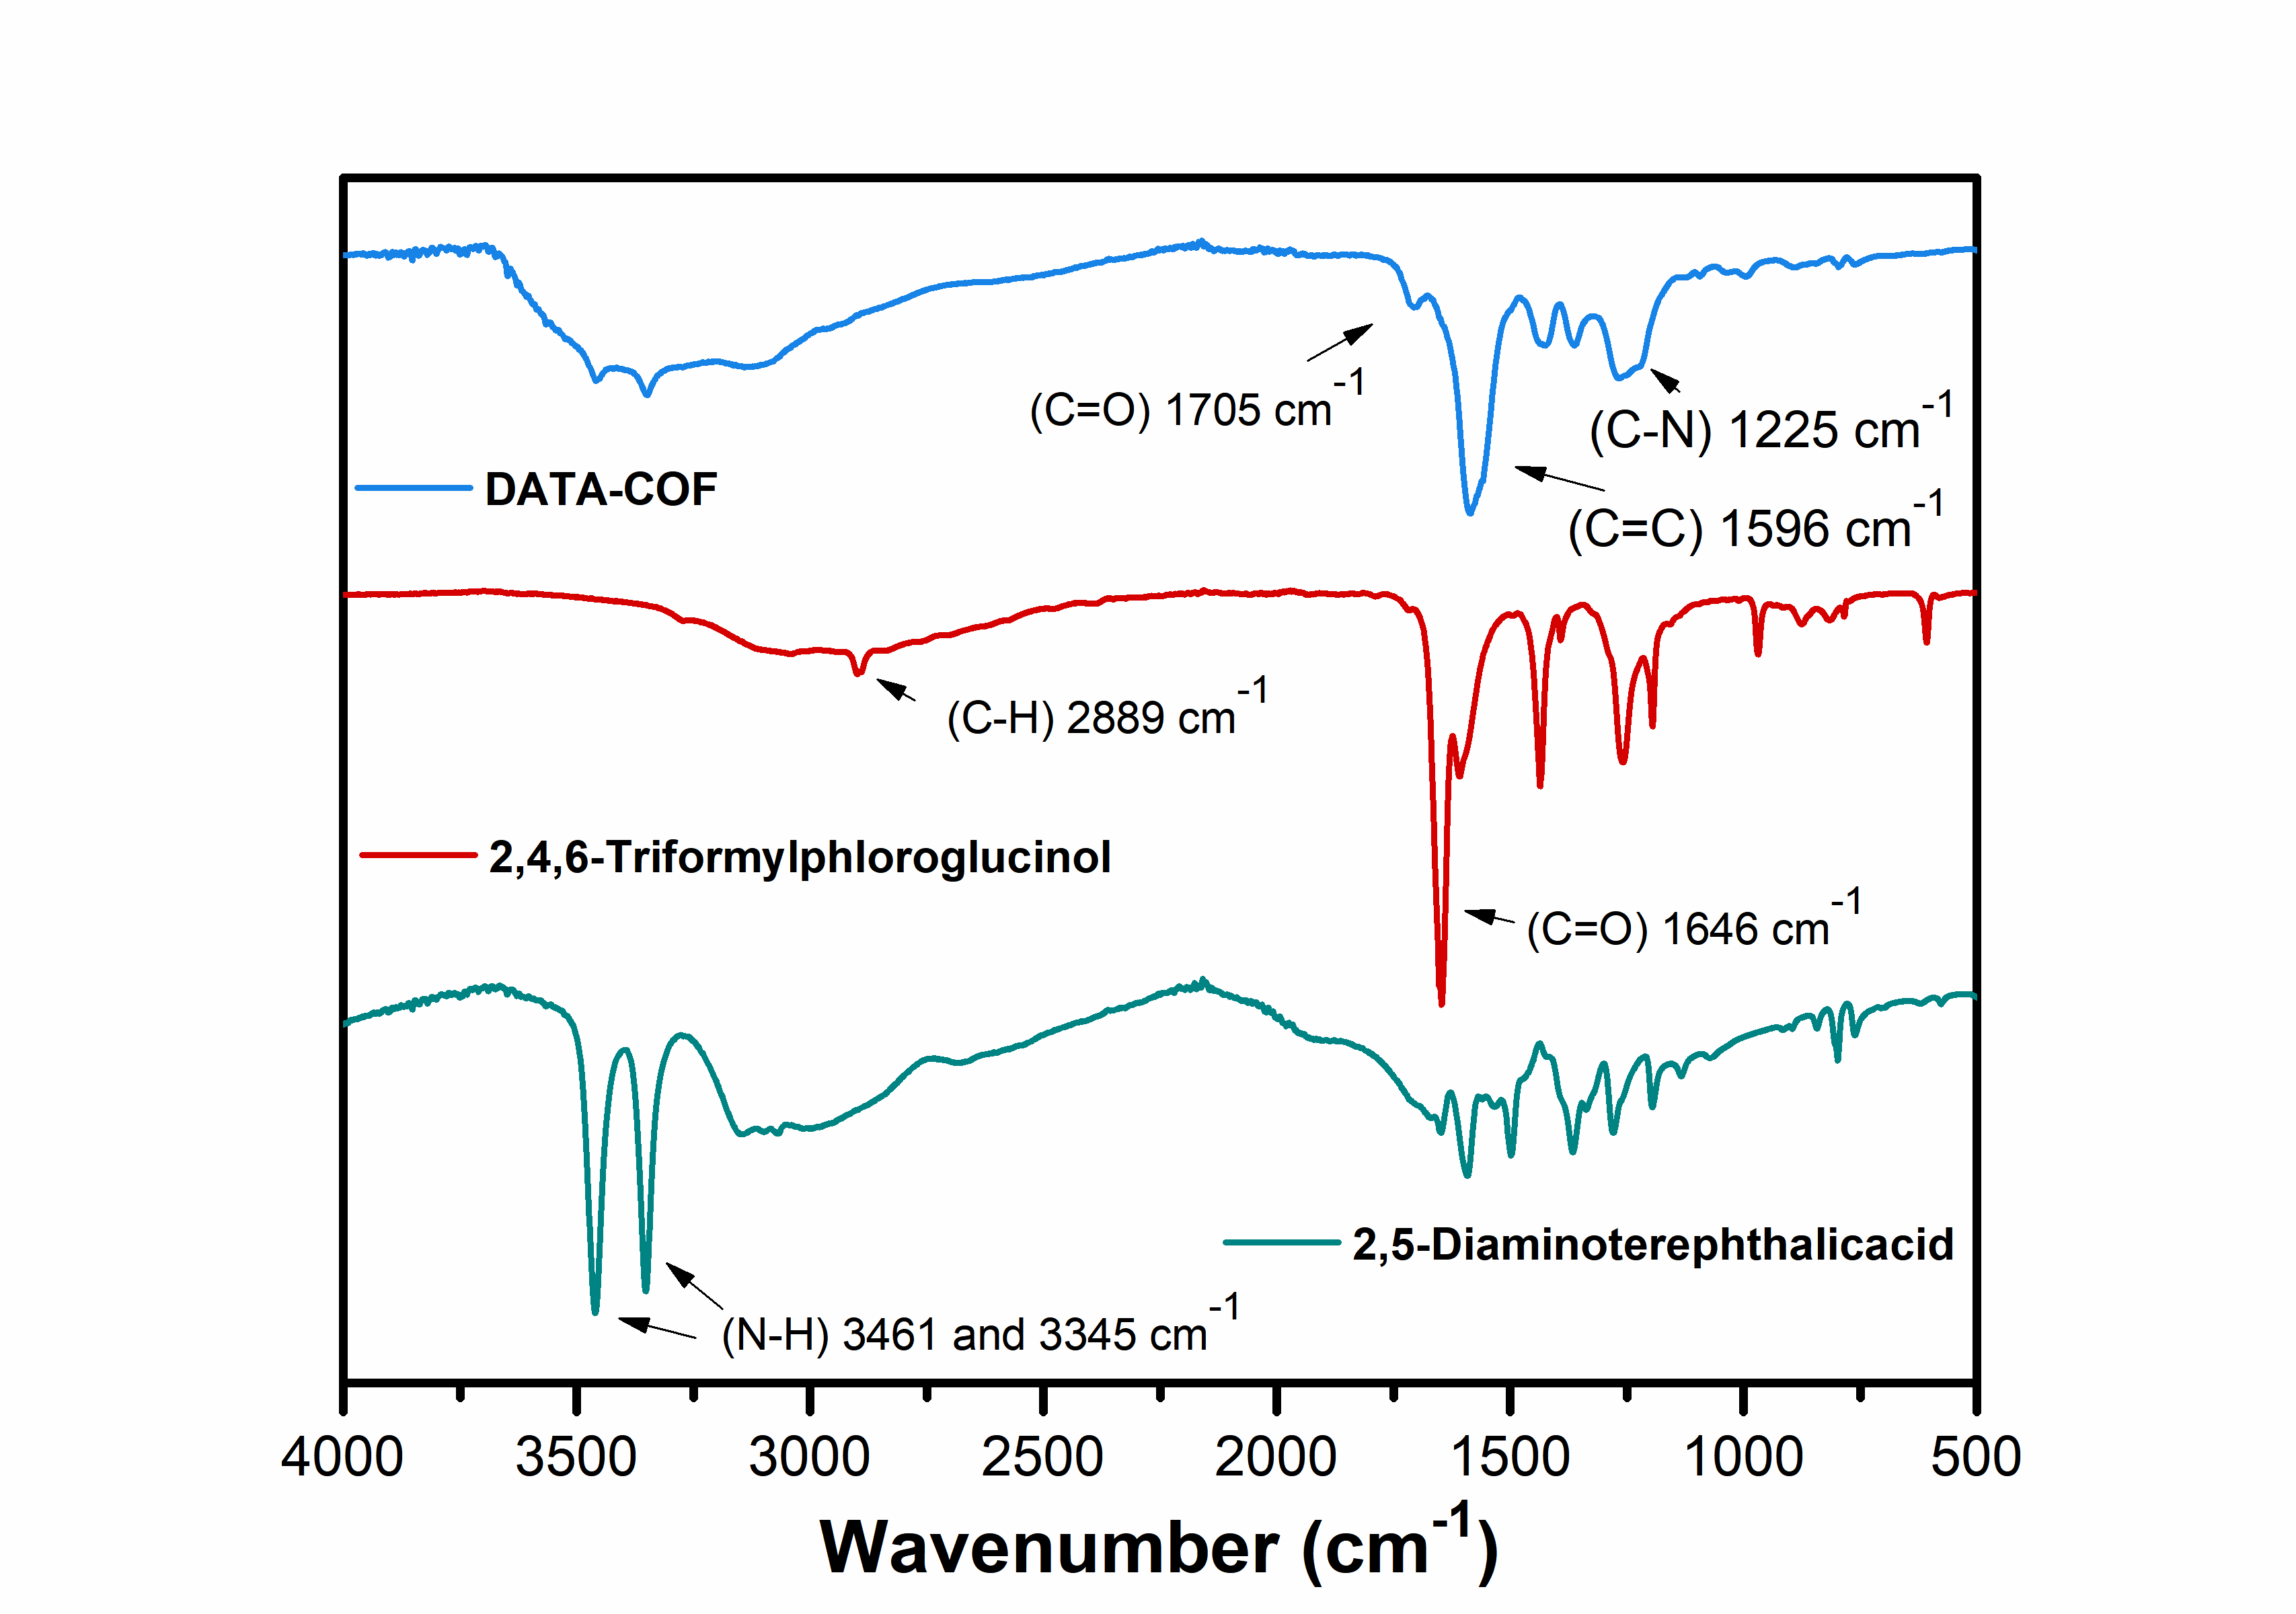
Figure S3 FT-IR spectra of DATA-COF and the starting monomers.

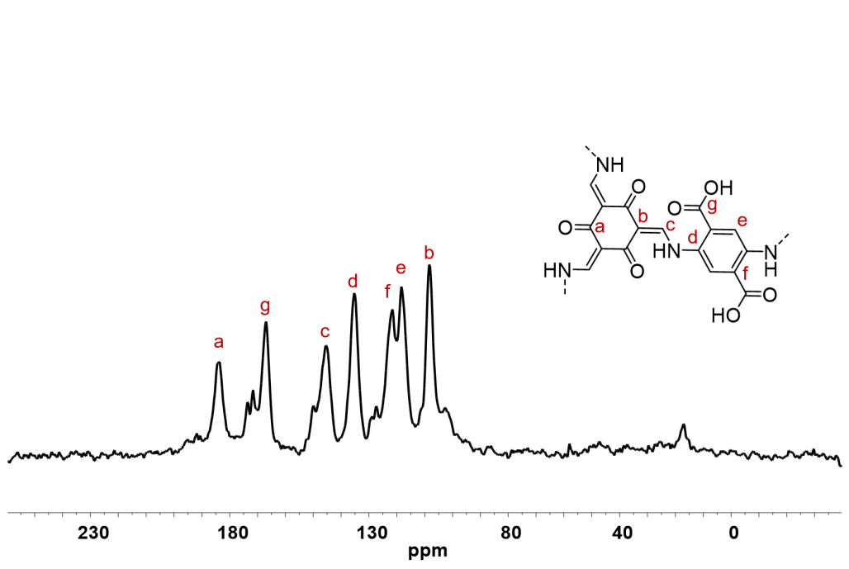
Figure S4 Solid-state ¹³C CP-MAS NMR spectrum of DATA-COF.

Figure S5 Top and side view of DATA-COF simulated structure of the AA stacking mode.
Table S2 Fractional atomic coordinates for the unit cell of DATA-COF.
AA stacking mode, Space group: P₆
a = b = 22.83 Å, c = 3.81 Å, α = β = 90.0°, γ = 120.0°, R_{wp}=10.14% and R_{p} = 7.75%
Atom | x | y | z
C1 | 0.42858 | 0.96182 | 0.49431
C2 | 0.46651 | 0.92822 | 0.53203
C3 | 0.53725 | 0.96731 | 0.51412
N4 | 0.43851 | 0.85699 | 0.60999
C5 | 0.37009 | 0.80321 | 0.56323
C6 | 0.35403 | 0.73941 | 0.47874
C7 | 0.35583 | 0.92764 | 0.40266
O8 | 0.31185 | 0.94586 | 0.55786
O9 | 0.33428 | 0.88569 | 0.16958
C10 | 0.28201 | 0.68721 | 0.43235
O11 | 0.24148 | 0.70413 | 0.3395
H12 | 0.56588 | 0.94119 | 0.50486
H13 | 0.47179 | 0.84381 | 0.72553
H14 | 0.32927 | 0.81237 | 0.62272
H15 | 0.33329 | 0.98021 | 0.75293

Figure S6 SEM images of DATA-COF.

- Characterization of T705@DATA-COF-Pro

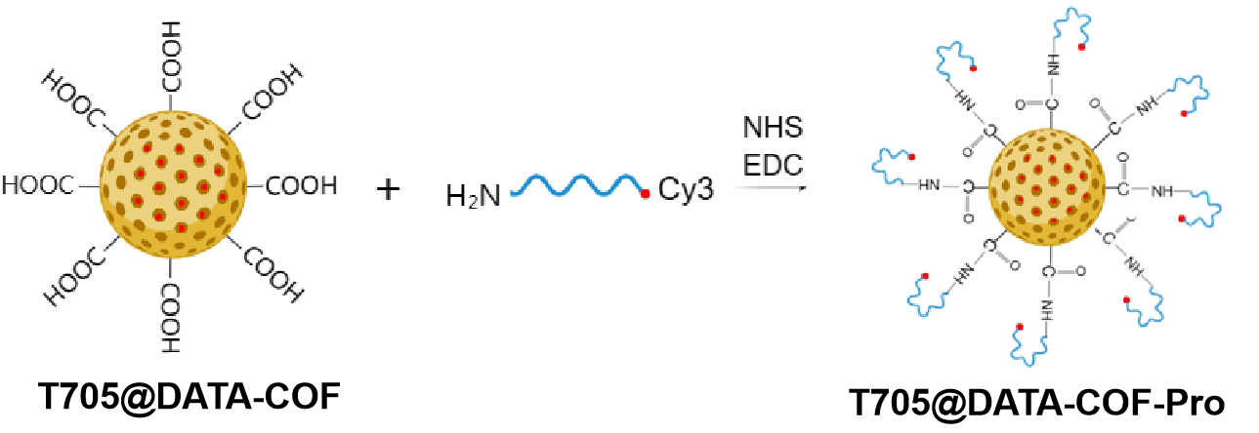
Scheme S2 Schematic illustration of the synthesis of T705@DATA-COF-Pro.
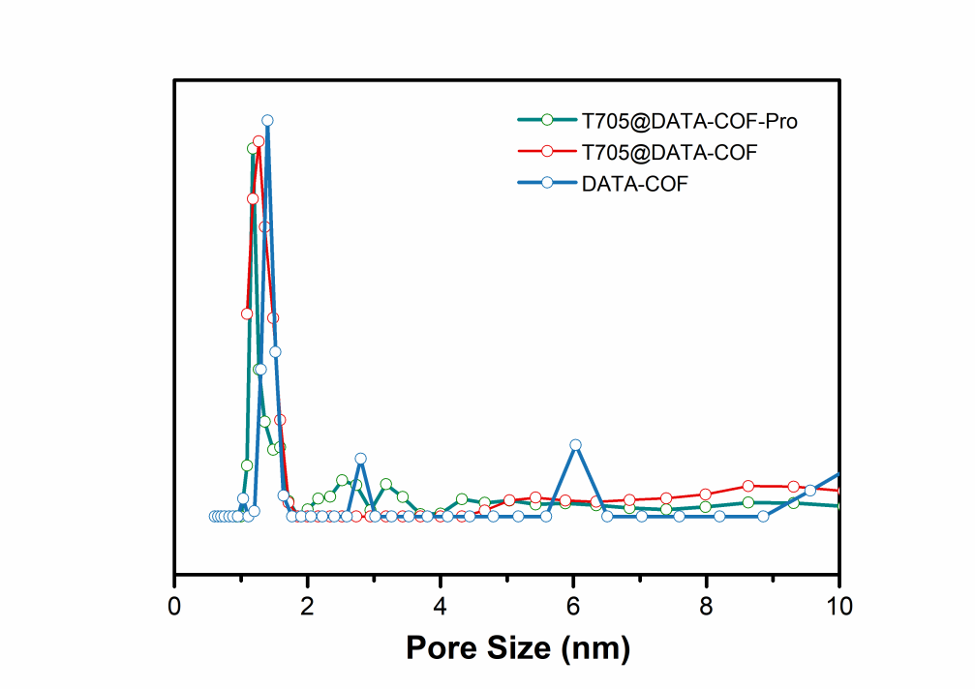
Figure S7 The pore size distribution of DATA-COF, T705@DATA-COF and T705@DATA-COF-Pro.

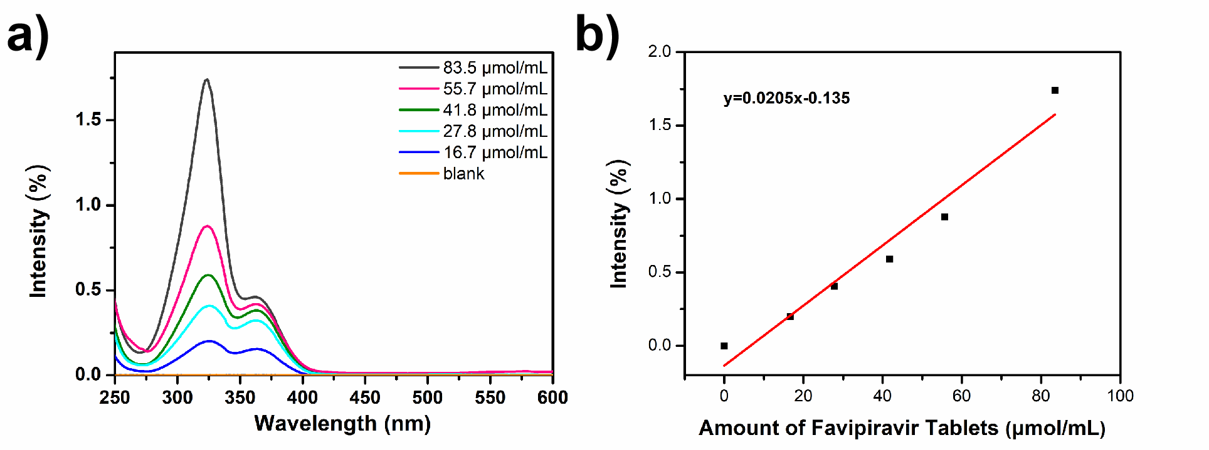
Figure S8 a) UV-Vis spectroscopy and b) standard curve of T705 in methanol.

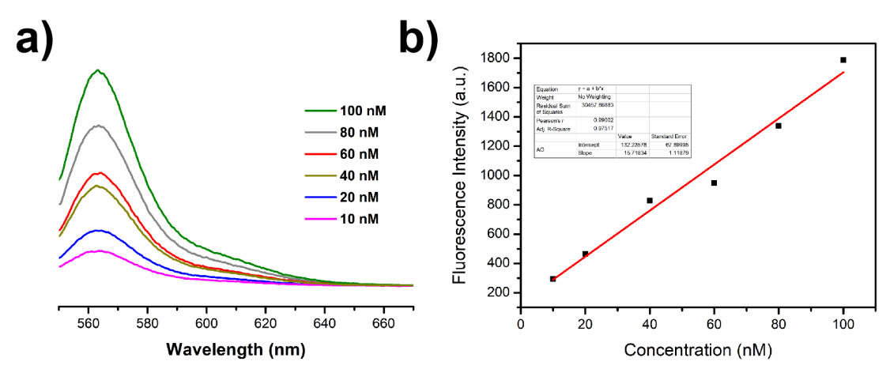
Figure S9 a) Fluorescence spectroscopy and b) fluorescence standard curve.

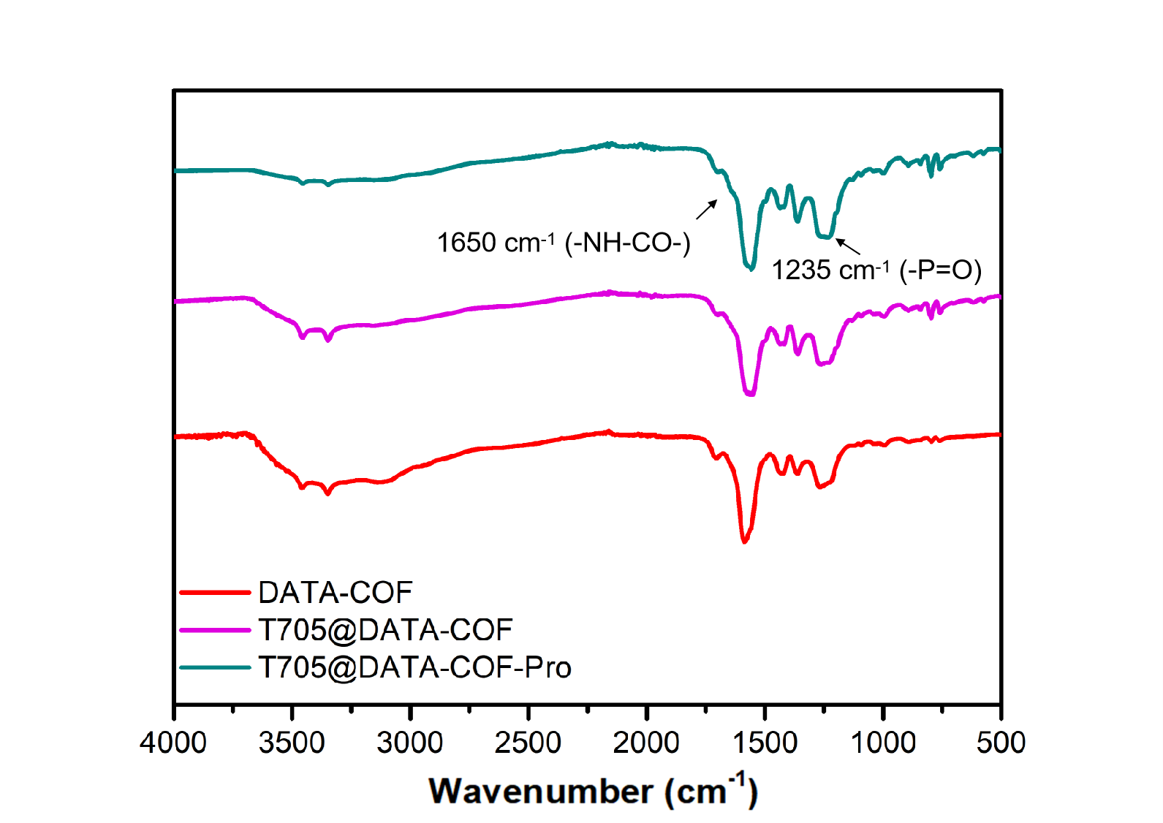
Figure S10 FT-IR pattern of DATA-COF, T705@DATA-COF and T705@DATA-COF-Pro.

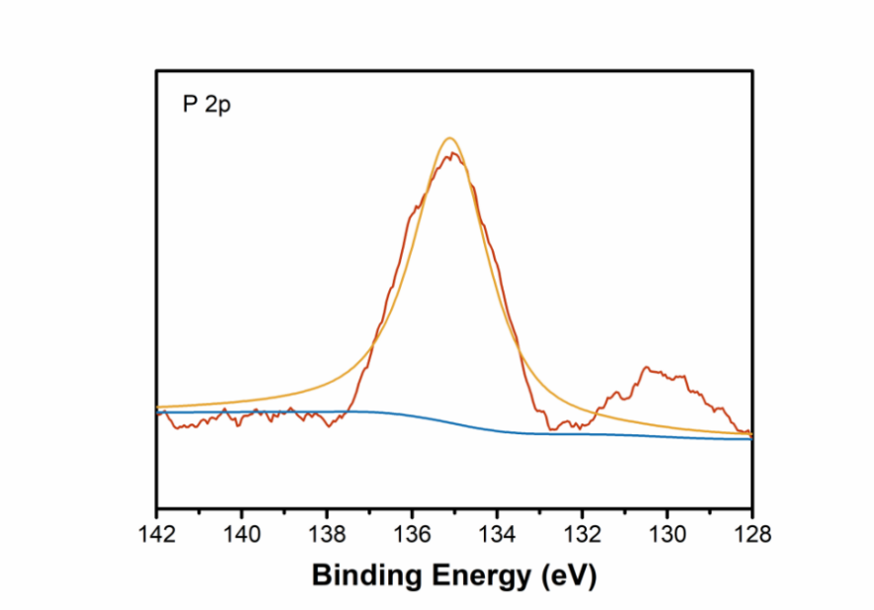
Figure S11 XPS spectrum of P2p in T705@DATA-COF-Pro.

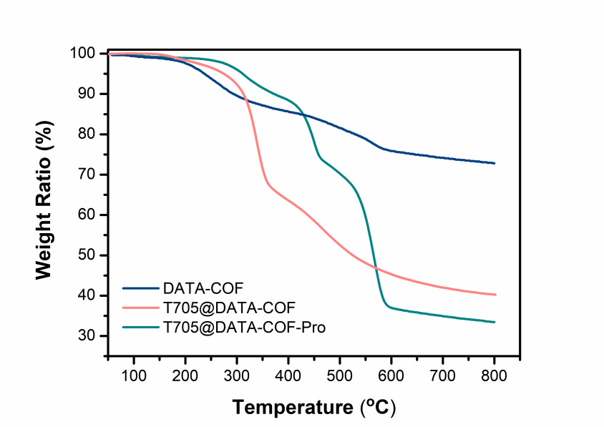
Figure S12 The TGA curves of DATA-COF, T705@DATA-COF and T705@DATA-COF-Pro.
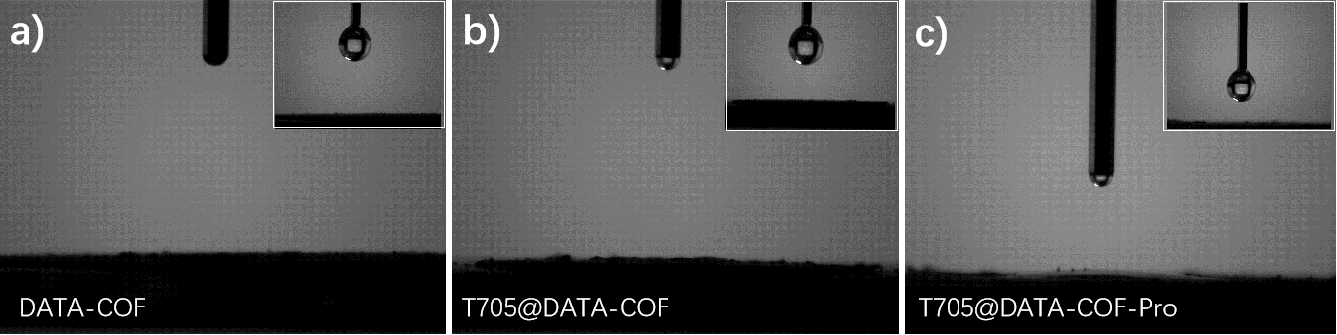
Figure S13 The water contact angles of a) DATA-COF, b) T705@DATA-COF and c) T705@DATA-COF-Pro, respectively. Inset：photographs of water droplets before falling.

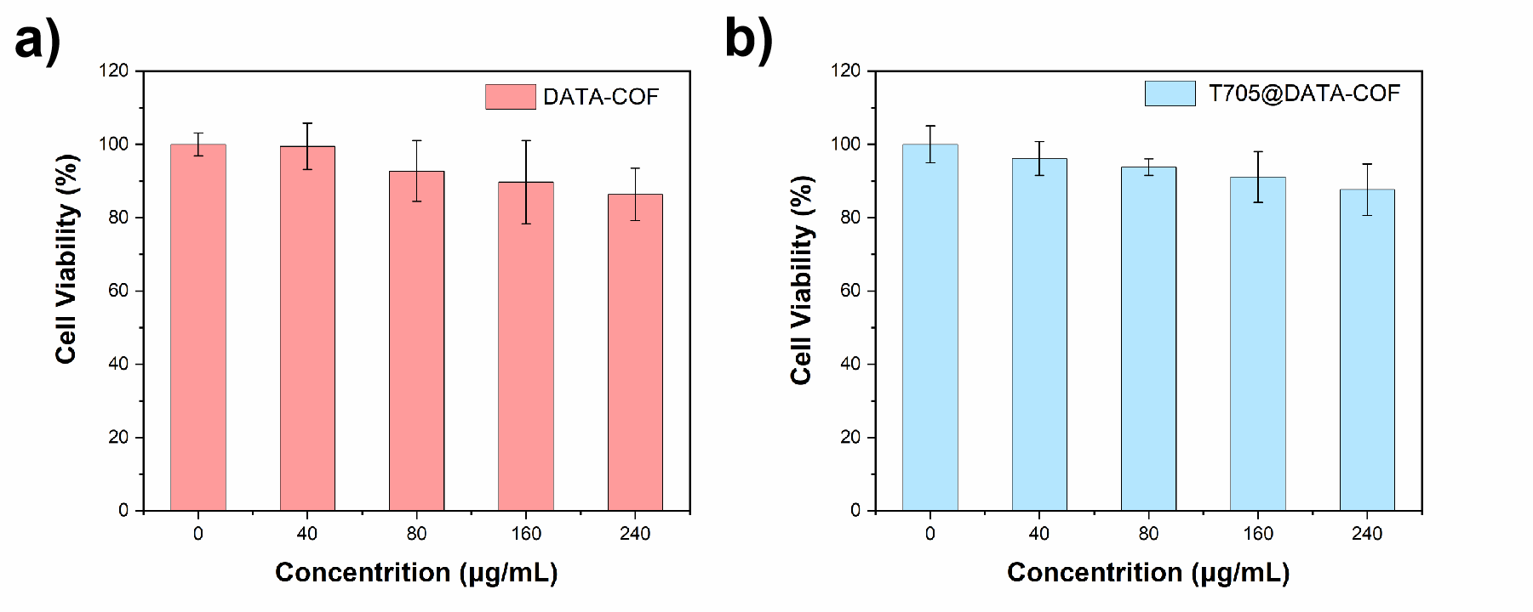
Figure S14 Cytotoxicity of a) DATA-COF and b) T705@DATA-COF.

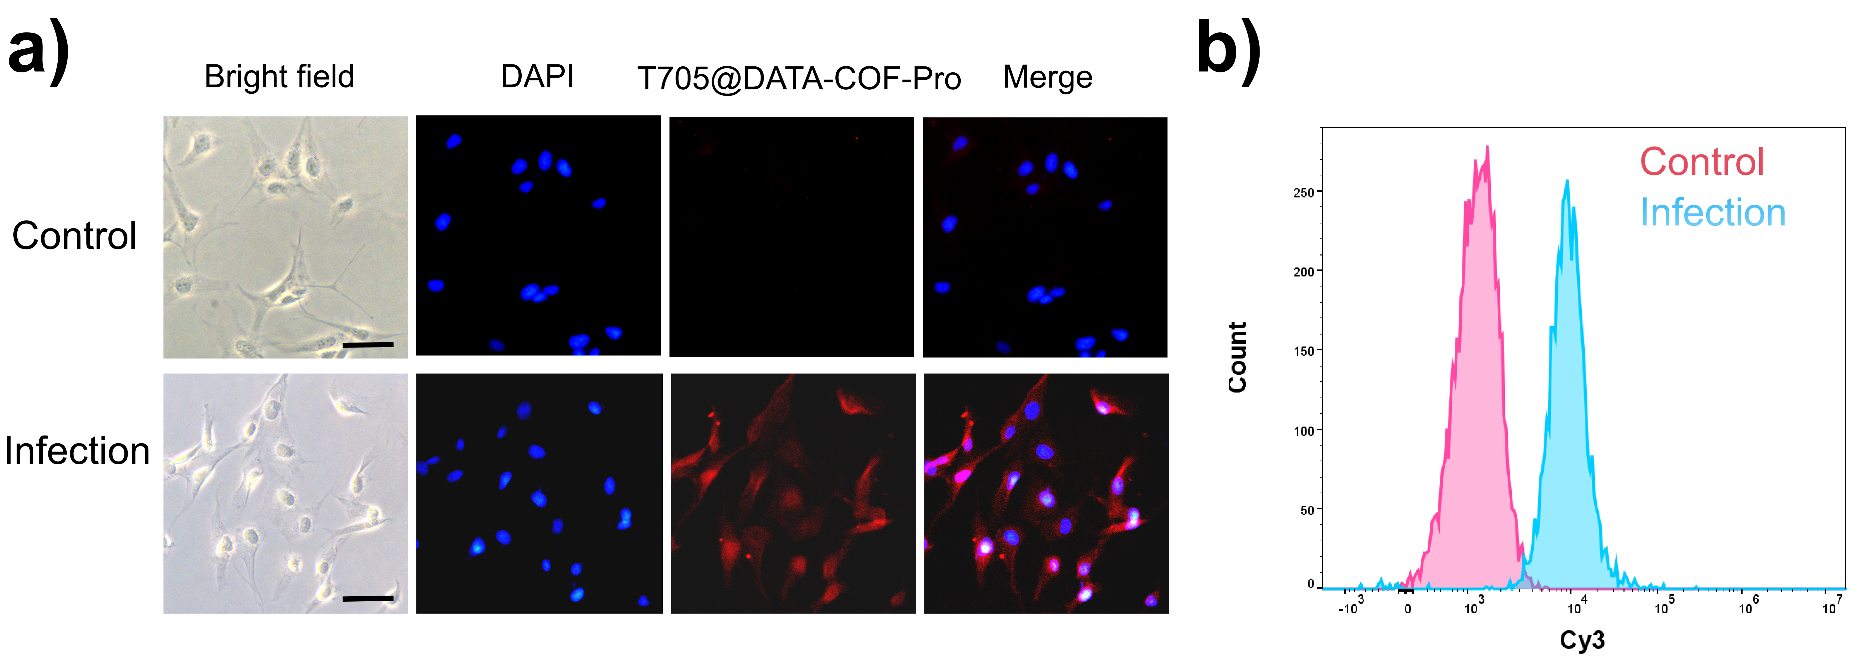
Figure S15 Infection diagnosis application of the T705@DATA-COF-Pro. a) Fluorescence imaging and b) Flow cytometry quantitative analysis of MDCK cells treated with T705@DATA-COF-Pro. Control group: Uninfected H1N1 group, Infection group: Infected H1N1 group. Scale bar: 100 μm.

- Therapeutic performance

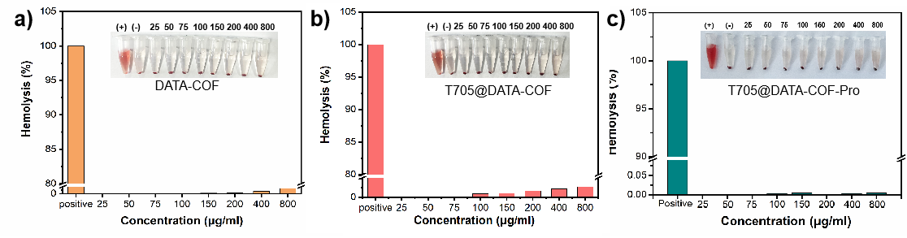
Figure S16 Hemolytic assay using red blood cells incubated with control solvents and different concentrations of a) DATA-COF, b) T705@DATA-COF, and c) T705@DATA-COF-Pro. Inset: Hemolysis in red blood cells created by different treatment. Water and PBS were used as the positive and negative control, respectively.

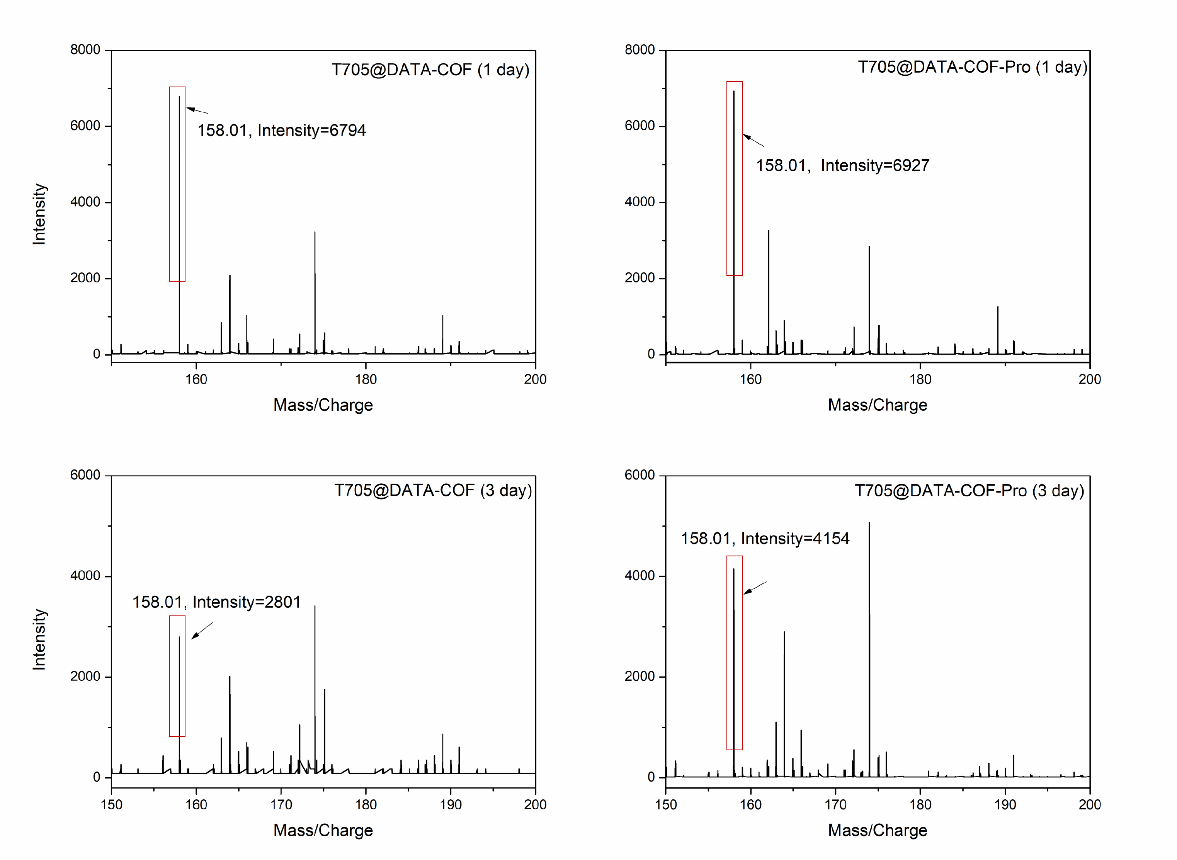
Figure S17 The amount of T705 in infected mice's blood using HRMS on 1st and 3rd day (158.01 is the molecular ion peak of T705).

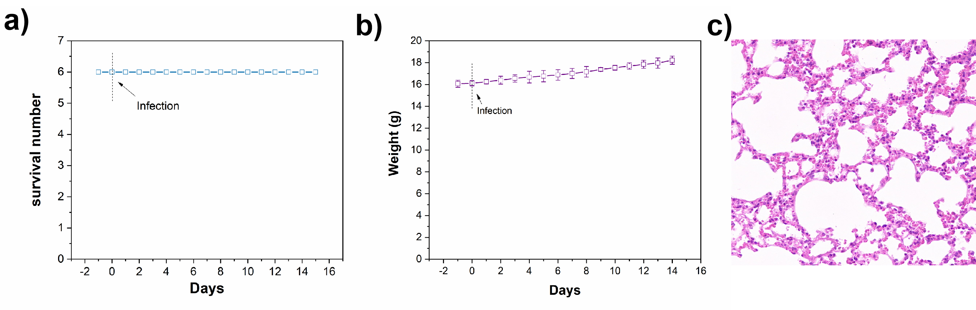
Figure S18 Mice were treated with T705@DATA-COF-Pro (2.0 mg/mL). a) Survival rates. b) Body weights of mice. c) H&E staining of mouse lungs on 7th day .
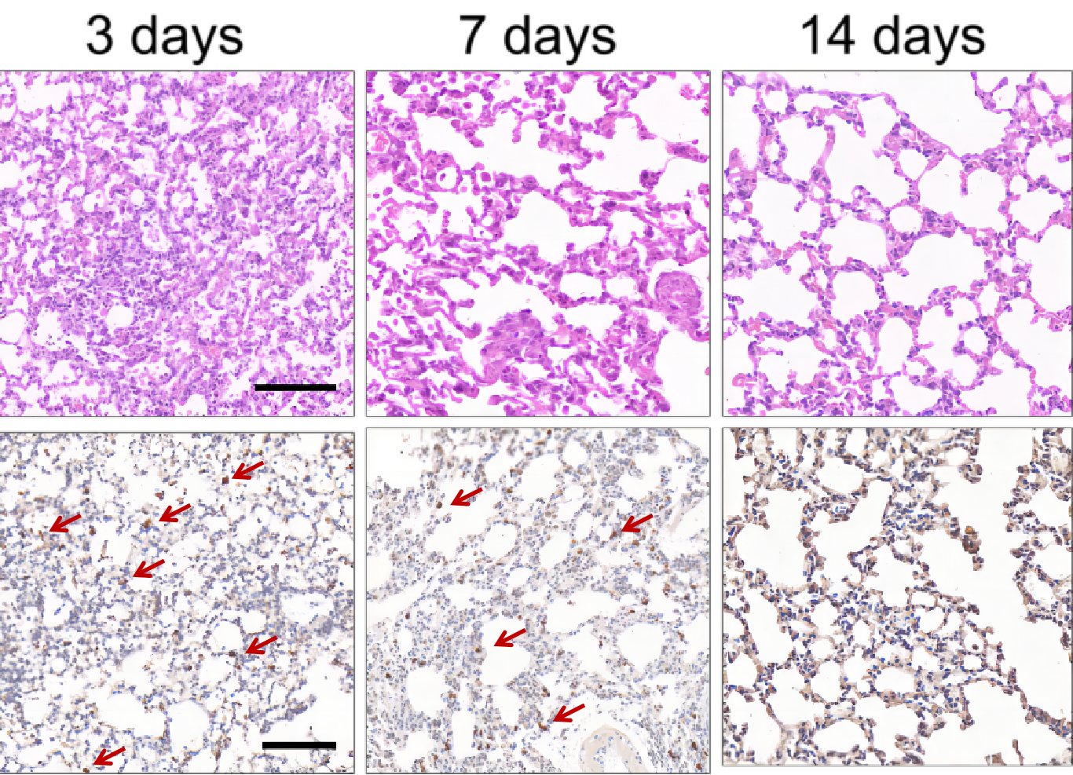
Figure S19 The lung organs of T705@DATA-COF-Pro group stained with H&E and immunohistochemistry for H1N1 infected BALB/c nude mice (The red arrow refers to H1N1 NP protein, bar: 100 μm).

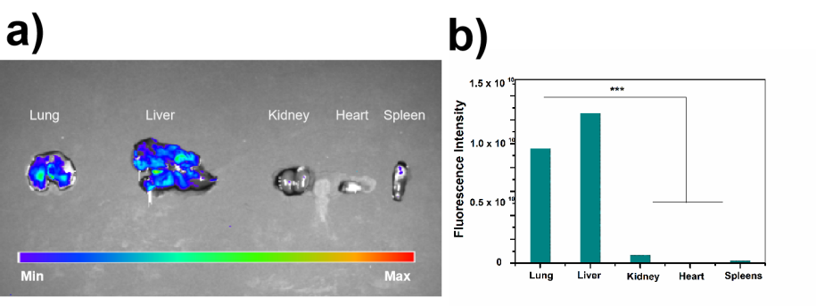
Figure S20 a, b) Fluorescence images of main organs of the T705@DATA-COF-Pro group was performed after 70 min post-injection.

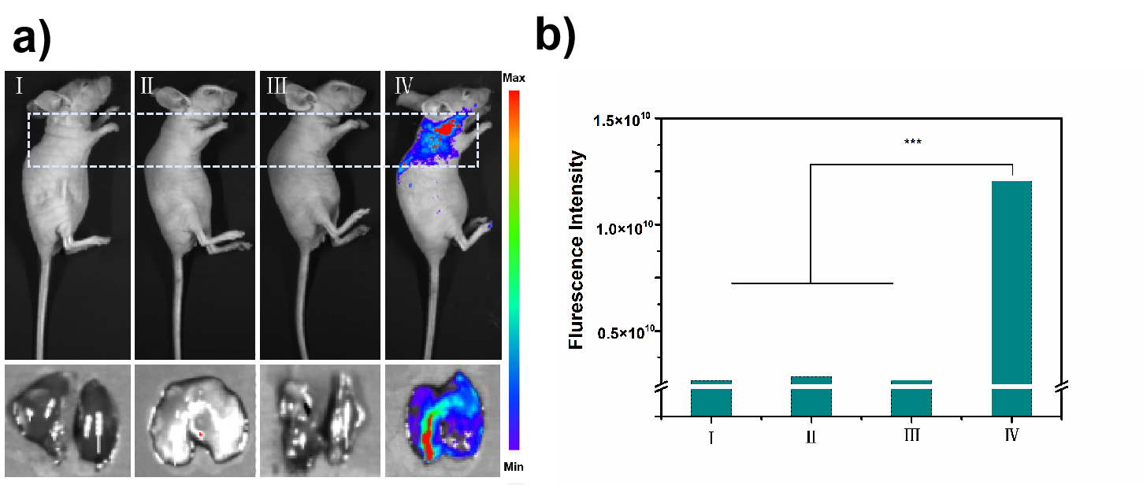
Figure S21 a, b) The representative image and fluorescence intensity analysis at 70 min of the H1N1 infected BALB/c nude mouse after the different administration (Ⅰ, Normal saline (100 µL); Ⅱ, DATA-COF (100 µL, 2.0 mg/mL); Ⅲ, T705@DATA-COF (100 µL, 2.0 mg/mL); Ⅳ, T705@DATA-COF-Pro (100 µL, 2.0 mg/mL)).
- The working mechanism

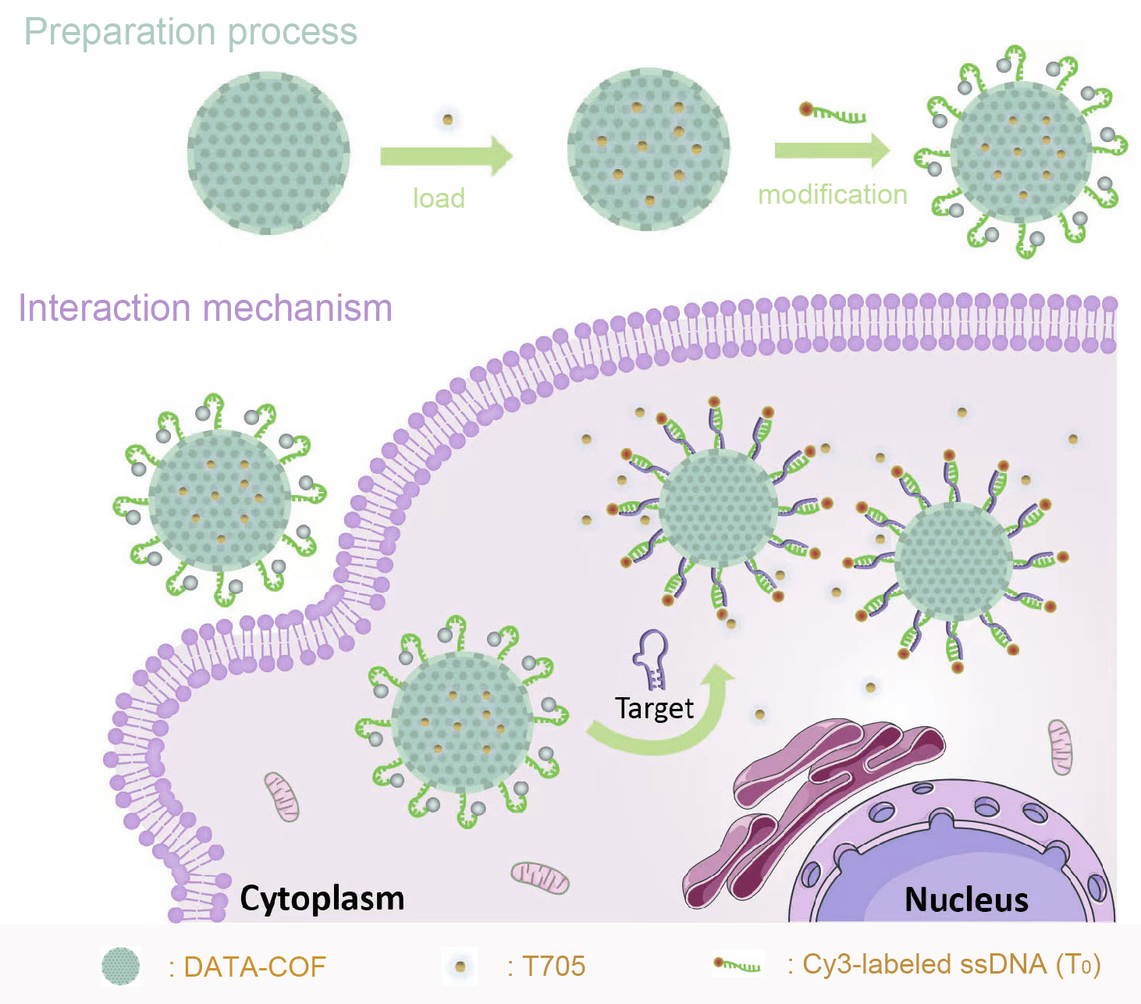
Figure S22 The preparation procedures and the working mechanism of T705@DATA-COF-Pro.

7. References
1, Li F, Ding LG, Yao BJ, et al. Pd loaded and covalent-organic framework involved chitosan aerogels and their application for continuous flow-through aqueous CB decontamination. J. Mater. Chem. A, 2018;6:11140-11146. doi: 10.1039/C8TA03275K

