Hairpin DNA-based nanomaterials for tumor targeting and synergistic therapy
Lingling Shan^{1∗∗}, Yudie Li¹, Yifan Ma², Yang Yang¹, Jing Wang¹, Lei Peng¹, Weiwei Wang¹, Fang Zhao¹, Wanrong Li¹, Xiaoyuan Chen^{3,4,5,6∗}

1. Institute of Pharmaceutical Biotechnology, School of Biology and Food Engineering, Suzhou University, Suzhou, People’s Republic of China.
2. Wuya College of Innovation, Shenyang Pharmaceutical University, Shenyang, People’s Republic of China.
3. Departments of Diagnostic Radiology, Chemical and Biomolecular Engineering, and Biomedical Engineering, Yong Loo Lin School of Medicine and College of Design and Engineering, National University of Singapore, Singapore, Singapore.
4. Clinical Imaging Research Centre, Centre for Translational Medicine, Yong Loo Lin School of Medicine, National University of Singapore, Singapore, Singapore.
5. Nanomedicine Translational Research Program, NUS Center for Nanomedicine, Yong Loo Lin School of Medicine, National University of Singapore, Singapore, Singapore.
6. Institute of Molecular and Cell Biology, Agency for Science, Technology, and Research (A*STAR), Singapore, Singapore.

∗Corresponding author.
∗∗Corresponding author.
E-mail addresses: chen.shawn@nus.edu.sg (Xiaoyuan Chen), ntlinger-300@163.com (Lingling Shan).

Supplementary Material
Doxorubicin hydrochloride (DOX), anhydrous N, N-dimethylformamide (DMF), Triethylamine (TEA), 3-(4,5-dimethylthiazol-2-yl)-2,5-diphenyltetrazolium bromide (MTT), iron (II) chloride (FeCl₂). and ICG-Der-02 (ICG02, MW 995) were obtained from the Biomedical Engineering Laboratory of China Pharmaceutical University. All reagents used in this study were of certified analytical reagent grade.
Thermo Fisher Scientific purchased the Telomerase Activities Kit, LPO levels Kit, DCF/ROS Kit, and Dead Cell Apoptosis Kit with Annexin V PE and SYTOX™ Green. The following sequences were purchased from Sangon Biological Engineering Technology & Co. Ltd (Shanghai, China) for this study:
Harpin DNA:
5’-6-FAM-TGGGATTGGGCGGGAAAAAAAAAAAAAAACCCGCCCAATCCCAGGAGGTGGTGGTGGGATT-Dabcyl-3’
Telomerase Primer: 5’-AATCCCACCACCACCTCC-3’
Cell culture
Human cardiomyocyte-like AC16 and human glioma cell lines (U87MG) were purchased from the Shanghai Institute of Cell Biology (Shanghai, China). The cell lines were cultured at 37 °C in a humidified atmosphere containing 5% CO₂ in minimum essential medium or Dulbecco’s modified eagle medium supplemented with 10% fetal bovine serum, 100 U/mL penicillin, and 100 µg/mL streptomycin.
Tumor model
Female BALB/c athymic nude mice were procured from Charles River Laboratories (Shanghai, China) for animal experimentation. The experimental procedures involving the animals were carried out by the Animal Management Rules of the Ministry of Health of the People's Republic of China (Document No. 55, 2001), as well as the guidelines for the Care and Use of Laboratory Animals of Suzhou University. The Animal Experimental Ethics Committee of Suzhou University authorized the animal experiment protocol under reference number 2023-0308.
Upon attaining tumor volumes between 80 and 150 mm³, nude mice were employed to assess the targeting potential of ICG-labeled BDDF NPs.
Characterization:
Transmission electron microscopy (TEM) images were obtained on a Tecnai TF30 transmission electron microscope (TEM) (FEI, Hillsboro, OR). Confocal microscopy images were acquired by a Zeiss LSM 780 microscope. Flow cytometry was analyzed with BD Beckman Coulter flow cytometer (Brea, CA) and FlowJo Software (TreeStar, Ashland, OR). Dynamic light scattering (DLS) measurement was collected on a nanoparticle analyzer (Mastersizer 3000, Britain). The extracted compound was identified by using a semi-preparative C18 HPLC column (XTerra Prep RP18, 10 μm, 7.8 × 300 mm, Waters). Statistical analysis was conducted by using the student’s two-tailed t-test.
Preparation of telomerase extracts
The telomerase was extracted from the U87MG tumor cell cultures by lysing cells (4 X10⁶) in 3.0 mL of ice-cold lysis buffer containing 10 mmol/L Tris-HCl (pH 7.5), 1 mmol/L MgCl₂, 1 mmol/L EGTA, 0.1 mmol/L phenylmethylsulfonyl fluoride (PMSF), 5 mmol/L-mercaptoethanol, 5 g/L CHAPS, and 100 mL/L glycerol. The mixture was homogenized in ice at 450 rpm/25 min and centrifugated at 16000 rpm at 4℃ for 20 min. Then, the 160 μL supernatant was removed and stored at -80℃.
Fe²⁺ standard curve
Take six 5mL volumetric bottles and add 10, 5, 2.5, 1.25, 0.625, and 0.3125 mg/mL FeCl₂ standard solution, respectively. Then, 0.5 mL of 100 mg/mL hydroxylamine hydrochloride solution was added at different concentrations. Then, add 1.00 mL of 1.5mg/mL o-diamorphine and 2.5 mL 1mmol/mL sodium acetate solution, respectively. Fill the scale with deionized water and measure at λmax=510 nm to plot the standard curve.
Drug loading capacity (DL%) = W_{test}/W_{total}×100%

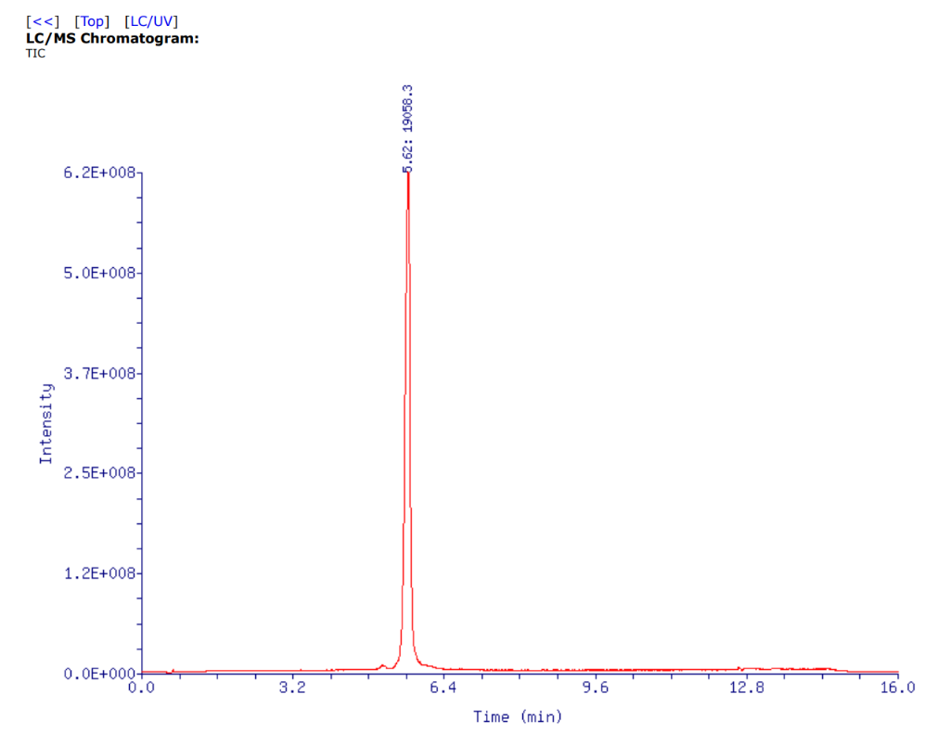

Figure S1. The LC/MS spectrum of hairpin DNA in D₂O.

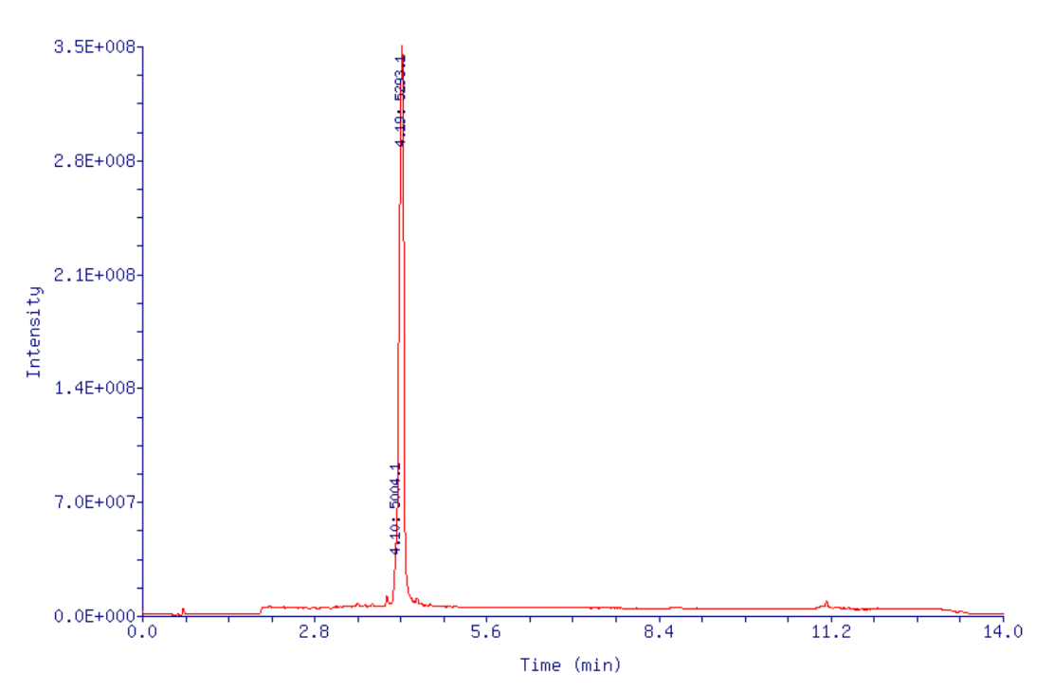
Figure S2. The LC/MS spectrum of telomerase Primer in D₂O.

Figure S3. Zeta potential (mV) measurement of BDDF NPs. n = 4, mean ± s.d.

Figure S4. Standard curve demonstrating HPLC peak area response to different concentrations of DOX. The standard curve shows the linear relation between the absorbance of DOX at λ = 254 nm and its concentration. It can be calculated that the loading capacity of DOX in BDDF NPs is about 57 wt.%.

Figure S5. Standard curve demonstrating UV-vis peak area response to different concentrations of Fe²⁺. The standard curve shows the linear relation between the absorbance of Fe²⁺ at λ = 510 nm and its concentration. It can be calculated that the loading capacity of Fe²⁺ in BDDF NPs is about 45 wt.%.

Figure S6. Confocal fluorescence images of the U87MG cells apoptosis after incubation with BDDF NPs for 24 h and 48 h, respectively.

Figure S7. Western blot results of GPX4 expression (a, b) from AC16 cells after 48 h incubation with free DOX and BDDF NPs.

Figure S8. (a) Photographs and (b) weights of U87MG tumors at 30 d after different treatments. n = 5, mean ± s.d., **P<0.01, *P<0.05.

Figure S9. H&E-stained heart, liver, and tumor section from bearing U87MG tumor mice after being treated by PBS (Control), DOX, and BDDF NPs. Scale bars are 50 μm. The black arrows point to dead cells.

Table S1.
Pharmacokinetic parameters of free DOX and BDDF NPs. Results represent mean ± S.E. (n = 4) (Plasma)
Parameter | Units | DOX | BDDF NPs
AUC | ng/mLh | 99261 ± 1082 | 125232 ± 1162
t_{1/2α} | h | 0.4334 ± 0.01 | 0.61 ± 0.01
t_{1/2β} | h | 3.49 ± 0.04 | 25.51 ± 0.82
Pharmacokinetic parameters were calculated using a two-compartment model.

