Supporting Information

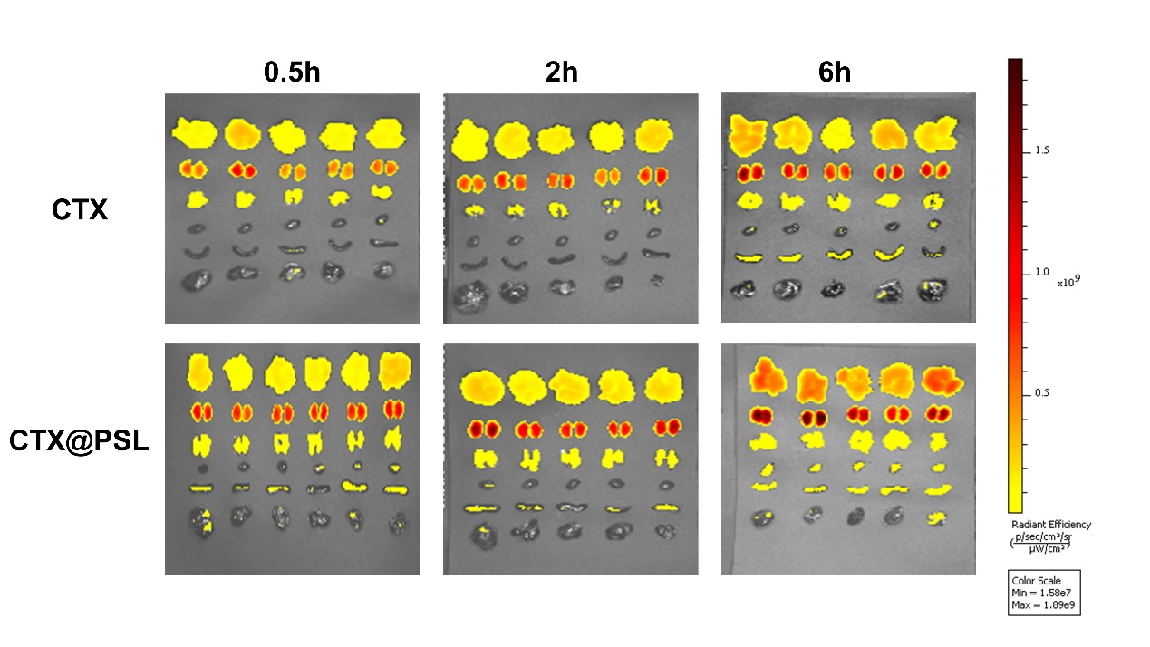
Figure S1. Fluorescence imaging analysis of tissue distribution from melanoma xenograft-bearing mice after intravenous administration of CTX and CTX@PSL at different time, Data are Mean ± SD (n=5).

Table S1. Storage stability evaluation of CTX@PSL, Data are Mean ± SD (n=3)
Time（day） | n | 1 | 7 | 15
zeta potential | 3 | -18.9 ± 0.00 | -20.03 ± 0.46 | -23.17 ± 0.23

