supplementary material

Construction and application of PDL1-targeted multimodal theranostics Probe
ChengXue He^{1,2#}, YanHui Guo^{3#}, Nina Zhou^{2#}，Zhen Wang^{4#}, Teli Liu², Xiaoxia Xu², Feng Wang², Hua Zhu², Zhi Yang^{1,2}*, Xianteng Yang^{1,5}*, Lei Xia²*

¹ Guizhou University Medical College, Guiyang, GuiZhou Province 550025, China
² Key Laboratory of Carcinogenesis and Translational Research (Ministry of Education/Beijing), NMPA Key Laboratory for Research and Evaluation of Radiopharmaceuticals (National Medical Products Administration), Department of Nuclear Medicine, Peking University Cancer Hospital & Institute, Beijing 100142, China
³ Department of Radiology, Peking University Third Hospital, Beijing 100088, China
⁴ Key Laboratory of Carcinogenesis and Translational Research (Ministry of Education, Beijing), Department of Hepato-Pancreato-Biliary Surgery, Sarcoma Center, Peking University Cancer Hospital and Institute, Beijing 100142, China
⁵ Department of Orthopedics, Guizhou Provincial People's Hospital 550025, China
#These authors contributed equally to this work

Correspondence: Lei Xia; Xianteng Yang; Zhi Yang
Key Laboratory of Carcinogenesis and Translational Research (Ministry of Education/Beijing), NMPA Key Laboratory for Research and Evaluation of Radiopharmaceuticals (National Medical Products Administration), Department of Nuclear Medicine, Peking University Cancer Hospital & Institute, Beijing 100142, China
Guizhou University Medical College, Guiyang, GuiZhou Province 550002, China
Department of Orthopedics, Guizhou Provincial People's Hospital 550025, China
Tel +86 010-88197852; 0851-85926691; +86 010-88196196
Email: xialei9012288@126.com; yangxian.teng@163.com; pekyz@163.com

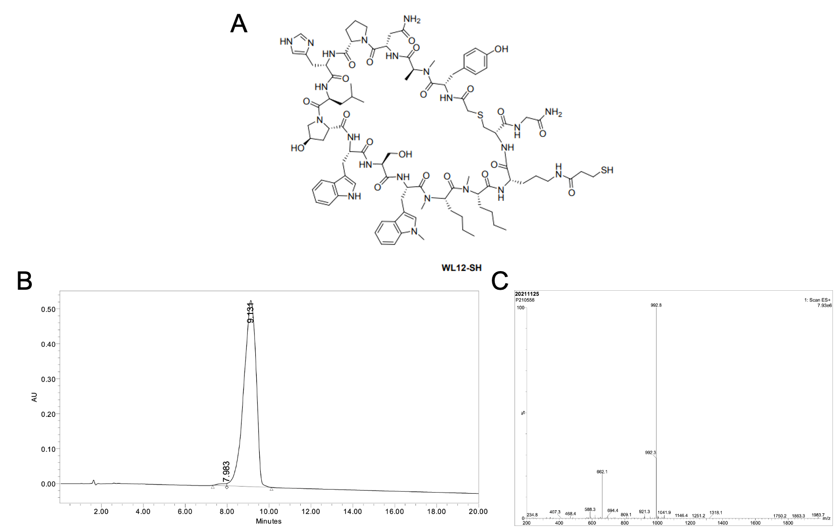
Figure S1. A) The characterization of WL12-SH. B) The HPLC analysis of WL12-SH in water. C) The ESI-MS of WL12-SH.

Figure S2. Synthetic route of WPMNs

Figure S3. Synthetic route of (¹³¹I/⁸⁹Zr, Mn)-WPMNs

Figure S4. Radio-TLC result of the (⁸⁹Zr, Mn)-WPMNs before purifying

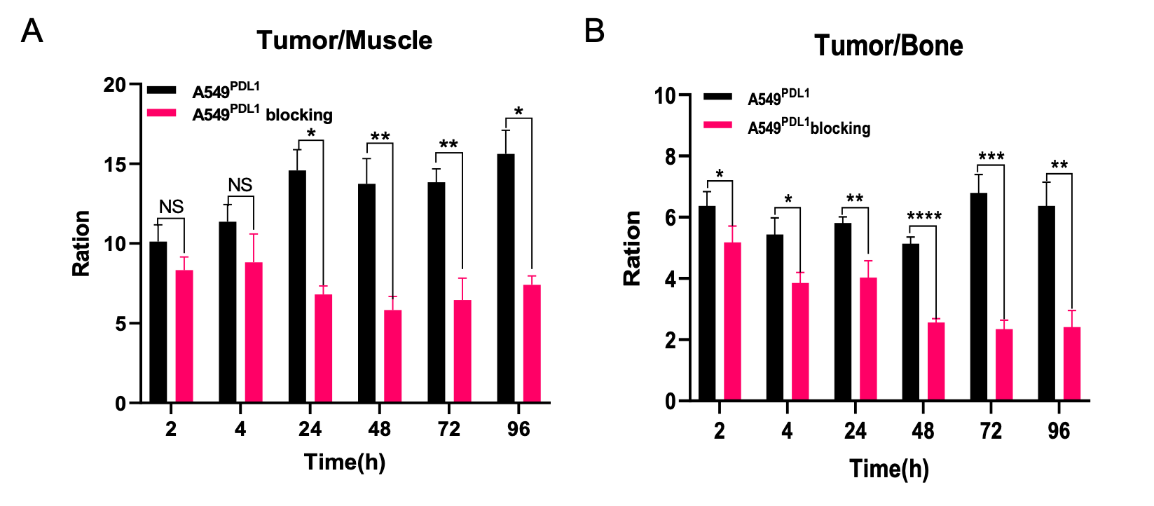
Figure S5. Plotting and calculating the SUVmax in important organs imaged by micro-PET/CT of ROI. A) The ration of tumor-to-muscle. B) The ration of the tumor-to-bone.

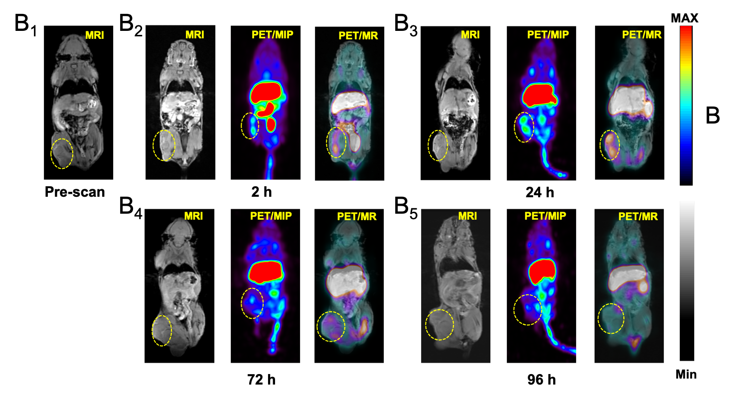
Figure S6. (B1-B5) T1-weighted MR axial images of A549^{PDL1} model at 2, 24, and 72 h and 96 h post-injection (⁸⁹Zr, Mn)-WPMNs and blocking by 2.5mg/kg of Mn-WPMNs. (tumor site enveloped by a yellow dotted line).

Figure S7. Changes in body weight of mice during toxicology experiments.

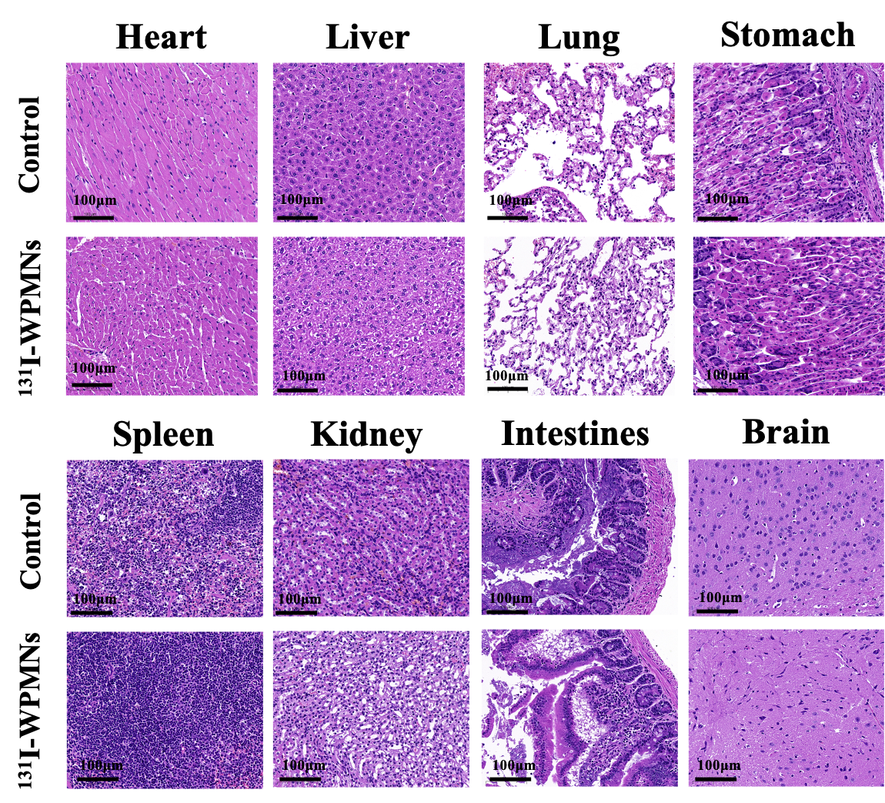
Figure S8. HE staining of important organs in mice during toxicology experiments.

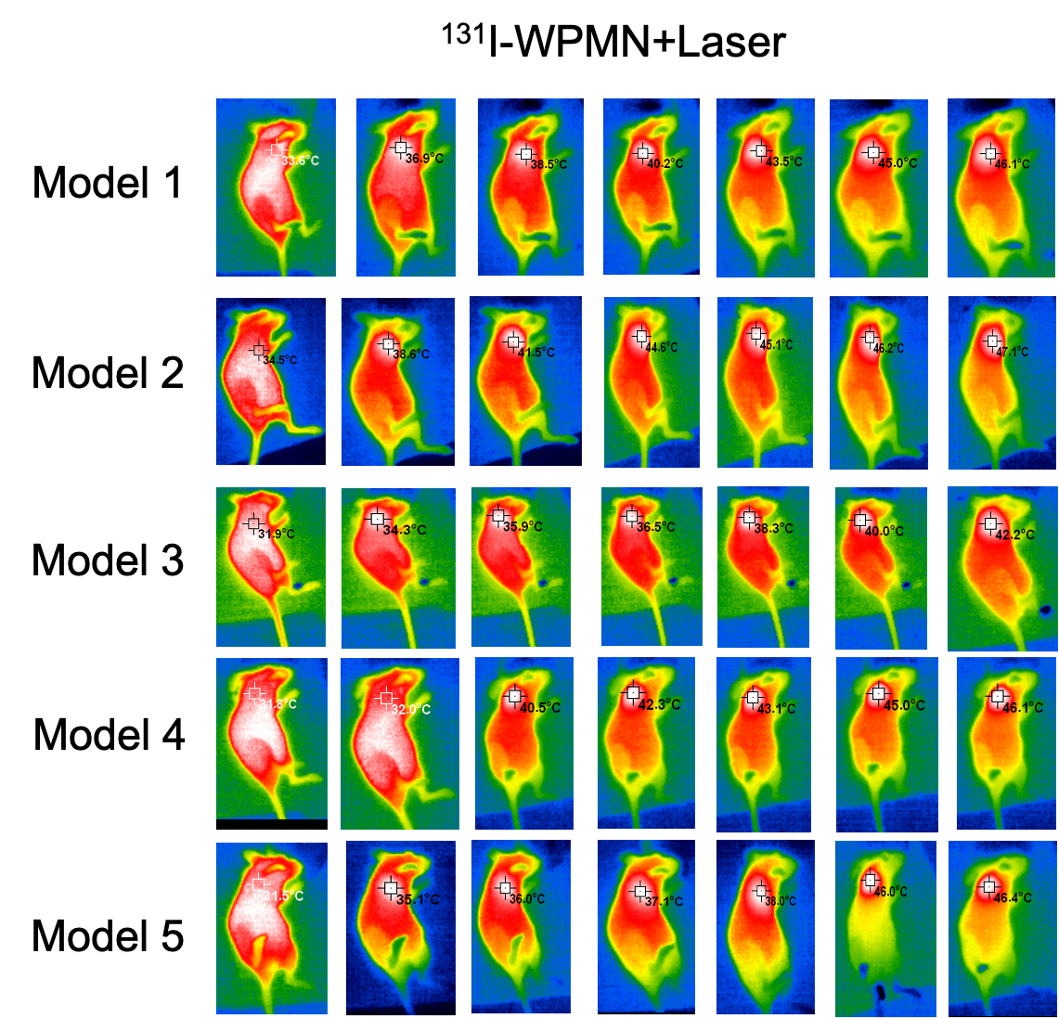
Figure S9. Infrared thermography during photothermal therapy in 5 mice treated in ¹³¹I-WPMN+Laser group.

