Supplementary Information

1. Supplementary Methods

2. Supplementary Table 1-3

3. Supplementary Figures 1-3

- Supplementary Methods

The synthesis procedures and chemical identification of 17302836.

(Abbreviations used: DCM for dichloromethane, EtOAc for ethylacetate, DIPEA for N,N-diisopropylethylamine, DMF for N,N-dimethylformamide, HATU for 1-[bis(dimethylamino)methylene]-1H-1,2,3-triazolo[4,5-b]pyridinium 3-oxid hexafluoro-phosphate, TEA for Triethylamine, DMAP for 4-dimethylaminopyridine, RT for room temperature.)

Tert-butyl (2S,4S)-2-((3-fluorophenethyl)carbamoyl)-4-hydroxypyrrolidine-1-carboxylate (S2). To a solution of (2S,4S)-1-(tert-butoxycarbonyl)-4-hydroxypyrrolidine-2-carboxylic acid (S1) (2.31 g, 10 mmol) in anhydrous DMF (50 mL), then HATU (4.56 g, 12 mmol) and DIPEA (3.87g, 30 mmol) were added at RT. The mixture was stirring for 0.5 h, 2-(3-fluorophenyl)ethan-1-amine was added and the mixture was stirred for another 10 h. The reaction mixture was concentrated in vacuo and diluted with EtOAc. The organic phase was washed with water, dried over sodium sulfate, and concentrated in vacuo. The crude product was purified by a flash chromatography (30-60% EtOAc / hexane) to obtain the desired product S2 as a white solid (1.4 g, 30%).

Tert-butyl (2S,4S)-2-((3-fluorophenethyl)carbamoyl)-4-(tosyloxy)pyrrolidine-1-carboxylate (S3). To a solution of S2 (1.4 g, 4 mmol), TEA (2.6 g, 26 mmol) and DMAP (0.36 g, 3 mmol) in anhydrous DCM (20 mL) cooled to -78 ºC, 4-methylbenzenesulfonyl chloride (0.91 g, 4.8 mmol) was added dropwise. The mixture was stirred at -78 ºC for 15 minutes, resulting in the precipition of an off-white solid. The reaction mixture was warmed to 75 ºC and stirring for another 8 h. The reaction mixture was concentrated in vacuo and diluted with DCM. The organic phase was washed with water, dried over sodium sulfate, and concentrated in vacuo. The crude product was purified by a flash chromatography (30-50% EtOAc / hexane) to obtain the desired product S3 as a white solid (0.26 g, 10%).

Tert-butyl (2S,4R)-4-((1H-benzo[d]imidazol-2-yl)thio)-2-((3-fluorophenethyl)carbamoyl) pyrrolidine-1-carboxylate (S4). To a solution of S3 (0.2 g, 0.4 mmol) and potassium carbonate (0.11 g, 0.8 mmol) in a 1:1 mixture (4 mL) of acetonitrile and dioxane, 2-thiobenzimidazole (0.066 g, 0.44 mmol) was added. The reaction mixture was stirred at 90 ºC for 18 h. The reaction mixture was cooled to room temperature, concentrated in vacuo, and then diluted with EtOAc. The organic phase was washed with water, dried over sodium sulfate, and concentrated in vacuo. The crude product was purified by a flash chromatography (50% EtOAc / hexane) to obtain the desired product S4 as a white solid (0.12g, 62%).

(2S,4R)-4-((1H-benzo[d]imidazol-2-yl)thio)-N-(3-fluorophenethyl)pyrrolidine-2-carboxamide(S5). To a solution of S4 (0.12 g, 0.25 mmol) in a mixture of 4 M hydrogen ethyl acetate (4 mL), and the reaction mixture was stirred at 25 ºC for 0.5 h. The reaction mixture was poured into EtOAc (30 mL), washed with 10% aqueous potassium carbonate (30 mL), dried over sodium sulfate, and concentrated in vacuo. The crude product was purified by a flash chromatography (EtOAc) to obtain the desired product S5 as a white solid (0.035g, 36%).

(2S,4R)-4-((1H-benzo[d]imidazol-2-yl)thio)-1-(3-chlorobenzyl)-N-(3-luorophenethyl)pyrrolidine-2-carboxamide (17302836). To a solution of S5 (0.035 g, 0.091 mmol) and 3-chlorobenzaldehyde (0.016 g, 0.11 mmol) in 1,2-dichloroethane (1 mL), a catalytic quantity of glacial acetic acid (1 μL, 0.01 mmol) was added, and the reaction mixture was stirred at room temperature for 10 minutes. Sodium triacetoxyborohydride (0.084 g, 0.4 mmol) was added, then the reaction mixture was stirred at RT for an additional 18 h. The reaction mixture was diluted with DCM and was washed with saturated aqueous sodium bicarbonate solution followed by brine, then dried over sodium sulfate and concentrated in vacuo. The crude product was purified by a flash chromatography (50% EtOAc / hexane) to obtain the desired product 17302836 as a white solid (0.03g, 65%). ¹H NMR (600 MHz, CDCl₃) δ 7.48 (s, 1H), 7.27 – 7.25 (m, 1H), 7.22 – 7.13 (m, 5H), 7.03 (s, 1H), 6.92 (d, J = 7.6 Hz, 1H), 6.89 – 6.80 (m, 3H), 4.21 - 4.15 (m, 1H), 3.67 (d, J = 13.2 Hz, 1H), 3.58 – 3.52 (m, 2H), 3.48 – 3.35 (m, 3H), 2.81 - 2.70 (m, 2H), 2.50 (m, 1H), 2.37 – 2.29 (m, 2H). ¹³C NMR (150 MHz, CDCl₃) δ 173.4, 163.0, 148.4, 141.0, 139.4, 134.4, 130.2, 129.9, 128.5, 127.8, 126.6, 124.3, 124.3, 122.4, 115.5, 115.4, 113.7, 113.5, 66.7, 60.1, 59.4, 42.3, 39.7, 37.8, 35.2. See Figure S3.

Supplementary Table 1. Validation of the 4 models using ERRAT, VERIFY 3D and Ramachandran Plot.

Method | ERRAT | VERIFY 3D | Ramachandran Plot
Method | ERRAT | VERIFY 3D | core | allow | gener | disall
Robetta | 95.3216 | Pass (80.00%) | 93.3% | 5.4% | 0.0% | 1.3%
AlphaFold | 93.4328 | Fail (76.00%) | 93.6% | 6.1% | 0.3% | 0.0%
SWISS-MODEL | 93.1343 | Fail (72.00%) | 93.6% | 6.1% | 0.0% | 0.3%
I-TASSER | 96.1988 | Fail (68.57%) | 83.1% | 14.1% | 1.6% | 1.3%

Supplementary Table 2. The hydrogen bonds formed by GIT1 and β-Pix with occupancy over 10%.

GIT1 | β-Pix | Occupancy | Average Distance | Average Angle
SER_322@OH | ASP_532@OD2 | 97.98 % | 2.66 | 165.86
ASP_346@OD2 | TYR_542@OH | 96.03 % | 2.7 | 166.87
ARG_274@NH2 | GLU_531@OE1 | 63.00 % | 2.8 | 162.17
ARG_274@NH1 | GLU_531@OE2 | 61.65 % | 2.79 | 161.72
ARG_274@NH1 | GLU_531@OE1 | 27.00 % | 2.81 | 158.97
ARG_274@NH2 | GLU_531@OE2 | 19.98 % | 2.81 | 160.47

Supplementary Table 3. Results of the 50 top-ranked compounds in virtual screening.
ZINC No. | Smiles | Total Score | CSCORE | GLOBAL CSCORE
ZINC19227962_000 | Cc1cnccc1C[N@H+](C)Cc1ccc(c(c1)OC[C@@H](CN1CC[N@@H+](CC1)C)O)OC | 9.8537 | 2 | 5
ZINC72407632_000 | c1cn([c+](n1)c1cc2n(n1)CC[NH2+]C2)CCC[N@H+]1CCCC[C@@H]1CO | 9.7997 | 3 | 5
ZINC91708057_000 | C[c+]1nccn1Cc1nnc(n1C)[C@@H]1CCN(CC1)C1=[C](=CNC=C1)F | 9.7101 | 5 | 5
ZINC72422858_000 | CC1=N=C(C2=C(N1)CC[NH2+]CC2)N[C@@H](C)c1ccccc1n1cccn1 | 9.6628 | 3 | 4
ZINC72456894_000 | c1cn([c+](n1)c1cc2n(n1)CC[NH2+]C2)C[C@@H]1CCCN(C1)C(=O)C1CC1 | 9.6553 | 4 | 5
ZINC01213352_000 | CC1=C([C@H](C2=C(N1)CCCC2=O)c1ccc(cc1)C(C)C)C(=O)OC1CCCCC1 | 9.518 | 5 | 4
ZINC11790592_000 | Cn1cc(c2c1cccc2)C[N@@H+]1CC[C@]2(CC[C@@H](O2)CNC(=O)c2ccccc2)CC1 | 9.393 | 5 | 5
ZINC72420145_000 | CC1=C=C(N(N1)CCCN(C)C1=N=C(NC2=C1CC[NH2+]CC2)C1CC1)C | 9.3574 | 4 | 4
ZINC71774917_000 | c1ccc(cc1)c1nnc2n1CCN(CC2)C1=C=C(NC=C1)C(=O)NC1CC1 | 9.2165 | 4 | 5
ZINC72475772_000 | CC1=N=C(C2=C(N1)CC[NH2+]CC2)N1CCC[C@@H](C1)Cn1ccn[c+]1C | 9.1569 | 3 | 3
ZINC72436423_000 | c1ccc(cc1)CO[C@@H]1CCC[C@H]1n1ccn[c+]1c1cc2n(n1)CC[NH2+]C2 | 9.1437 | 4 | 5
ZINC12456277_000 | Cc1c(ccc(c1OC)c1nc(c(o1)C)C[N@H+](C)Cc1cccc2c1cccc2)OC | 9.118 | 4 | 5
ZINC72407633_000 | c1cn([c+](n1)c1cc2n(n1)CC[NH2+]C2)CCC[N@H+]1CCCC[C@H]1CO | 9.0565 | 2 | 5
ZINC72477649_000 | CC(C)C[C@H](c1cccnc1)NC1=N=C(NC2=C1CC[NH2+]CC2)N(C)C | 8.9702 | 5 | 5
ZINC95498571_000 | Cc1cc([nH]c2=C=CC=Cc12)N1CC[C@H](CC1)[c+]1nccn1Cc1ccccn1 | 8.8705 | 3 | 5
ZINC00998679_000 | CCC(=O)N1c2ccccc2NC2=C([C@@H]1c1ccc(cc1)N(CC)CC)C(=O)C[C@H](C2)c1ccc(cc1)OC | 8.8411 | 4 | 4
ZINC95385941_000 | C[NH+](C)CCCn1ccn[c+]1[C@H]1CCN(CC1)C1=C=CNC=C1 | 8.6709 | 5 | 5
ZINC11789432_000 | c1ccc2c(c1)[nH]c(n2)S[C@@H]1C[C@@H](C(=O)NCCc2cccc(c2)F)[N@@H+](C1)Cc1cccc(c1)Cl | 8.6503 | 5 | 5
ZINC71748395_000 | CC(C)Cn1[c+]ncc1CN1CCC[C@H](C1)C(=O)c1cccc(c1)OC(C)C | 8.6417 | 5 | 5
ZINC02868526_000 | CC1=C([C@H](C2=C(N1)CCCC2=O)c1ccc(cc1)OC(C)C)C(=O)OC1CCCCCC1 | 8.6313 | 3 | 4
ZINC12020876_000 | CC(=O)N1CC[NH+](CC1)Cc1ccc2c(c1)C[N@H+](CCO2)Cc1cnn(c1)c1ccccc1 | 8.6312 | 5 | 5
ZINC72429461_000 | CC1=N=C(C2=C(N1)CC[NH2+]CC2)NCC[N@@H+]1CCCC[C@@H]1CO | 8.6271 | 3 | 3
ZINC95509820_000 | CC1=CNC=C=C1N1CC[C@H](CC1)[c+]1nccn1Cc1cccnc1 | 8.5852 | 3 | 5
ZINC14542542_000 | CCn1c2c(c(n1)C(=O)N1CCCCCC1)C[C@H](CC2)N(C)Cc1ccon1 | 8.5723 | 2 | 3
ZINC72474854_000 | c1cn([c+](n1)c1cc2n(n1)CC[NH2+]C2)CCN1CCOCC1 | 8.4926 | 5 | 5
ZINC95392012_000 | C[c+]1nccn1Cc1nnc(n1C)[C@H]1CCCN(C1)C1CC[NH2+]CC1 | 8.4614 | 5 | 3
ZINC72470221_000 | c1cc(cnc1)CCn1ccn[c+]1c1cc2n(n1)CC[NH2+]C2 | 8.4587 | 4 | 5
ZINC91779840_000 | COc1ccc(cc1)[C@H]1CN(C[C@@H]1[NH3+])C(=O)CCc1c[nH]c2c1cccc2 | 8.454 | 2 | 4
ZINC91877170_000 | COCC[C@]1(CCC[N@H+](C1)CCCn1ccn[c+]1)CO | 8.4379 | 2 | 2
ZINC72456897_000 | c1cn([c+](n1)c1cc2n(n1)CC[NH2+]C2)C[C@H]1CCCN(C1)C(=O)C1CC1 | 8.4102 | 4 | 5
ZINC65383213_000 | Cc1cc(c(c(c1)N1C=C=CN1)CN1CCN(CC1)c1ccncc1)C | 8.4029 | 4 | 4
ZINC72163825_000 | C[NH+](C)C[C@@H](c1ccccc1)Nc1c2c(nc(n1)c1ccccn1)C[NH2+]CC2 | 8.401 | 5 | 5
ZINC65370858_000 | CC1=N=C(C2=C(N1)CC[N@@H+](CC2)C)N1CCC[C@@H](C1)CN1CCCC1=O | 8.3852 | 5 | 5
ZINC15072551_000 | Cc1ccc(s1)c1cc2c(c(c1)OC[C@H]1CCCCO1)OCCN(C2)Cc1cn(nc1C)C | 8.3766 | 5 | 4
ZINC91792771_000 | CC1=C(NC=C=C1)N1CC[C@H](CC1)[c+]1nccn1Cc1cccnc1 | 8.3593 | 3 | 5
ZINC72145805_000 | CN(C)C1=N=C(C2=C(N1)CCCC2)N1CCC[C@]2(CC1)CNC(=O)O2 | 8.3561 | 4 | 4
ZINC77470623_000 | c1cc(cnc1)c1nc(on1)[C@H]1CCCN(C1)C(=O)c1cn(nn1)CC[NH3+] | 8.3506 | 5 | 4
ZINC72426208_000 | c1cn([c+](n1)c1cc2n(n1)CCC[NH2+]C2)C1CCN(CC1)C(=O)N1CCCC1 | 8.3376 | 1 | 5
ZINC95524928_000 | CC1=CC(=C=CN1)N1CC[C@@H](CC1)[c+]1nccn1CCC[NH+](C)C | 8.3288 | 5 | 5
ZINC04317807_000 | COC(=O)c1ccc(cc1)N1C(=O)C[C@H](C1=O)Nc1ccc(cc1)N1CCCCC1 | 8.3252 | 5 | 5
ZINC71765445_000 | CCCO[C@@H]1CCCN(C1)c1c2c(nc(n1)c1cccnc1)C[NH2+]CC2 | 8.3112 | 5 | 5
ZINC72165028_000 | c1cc(ccc1[c+]1nccn1CCC[N@H+]1CCCC[C@@H]1CO)C(=O)O | 8.2999 | 4 | 5
ZINC65410801_000 | CC1=N=C(C2=C(N1)CC[N@@H+](CC2)C)N(C)CC[C@H]1CCCCO1 | 8.2966 | 5 | 5
ZINC67804466_000 | CN(C)C1=N=C(C2=C(N1)CNCC2)N(C)Cc1[nH]c2ccc(cc2n1)Cl | 8.2889 | 5 | 5
ZINC01213284_000 | CC1=C([C@@H](C2=C(N1)CC(CC2=O)(C)C)c1cccc(c1)OCc1ccccc1)C(=O)OC[C@@H]1CCCO1 | 8.2874 | 2 | 4
ZINC77486464_000 | CC1=CNC=C=C1N1CCCN(CC1)C(=O)c1ccc(cc1)c1cc[nH]n1 | 8.284 | 4 | 4
ZINC13518904_000 | CC/N=[C+](/N1CC[C@@H](CC1)C(c1ccccc1)(c1ccccc1)O)\S | 8.2821 | 5 | 4
ZINC95385328_000 | C[NH+](C)CCCn1ccn[c+]1[C@H]1CCN(CC1)C1=CC=[C](=CN1)C(=O)O | 8.2814 | 4 | 5
ZINC72480507_000 | c1c([nH][c+]n1)CCNc1c2c(nc(n1)C1CCCC1)CC[NH2+]CC2 | 8.2801 | 3 | 4
ZINC19812756_000 | c1ccc(c(c1)N1CC[NH+](CC1)[C@H]1CCCN(C1)Cc1c[nH]nc1C1CCCCC1)F | 8.2792 | 5 | 4

Supplementary Figure 1. Cytotoxicity of 17302836 in cell lines HCT116 and MGC803 detected by CCK8 assay (n = 6).

Supplementary Figure 2. Statistical analysis of quantitative analysis of the WB blots of ZO-1, E-cadherin and N- cadherin (n = 5).

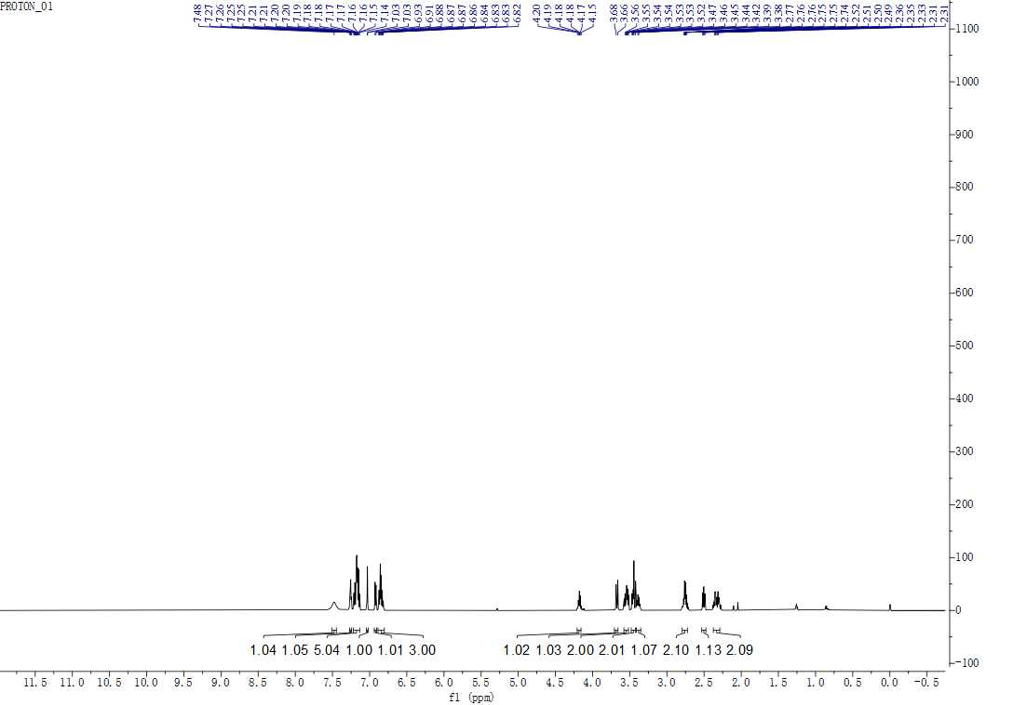

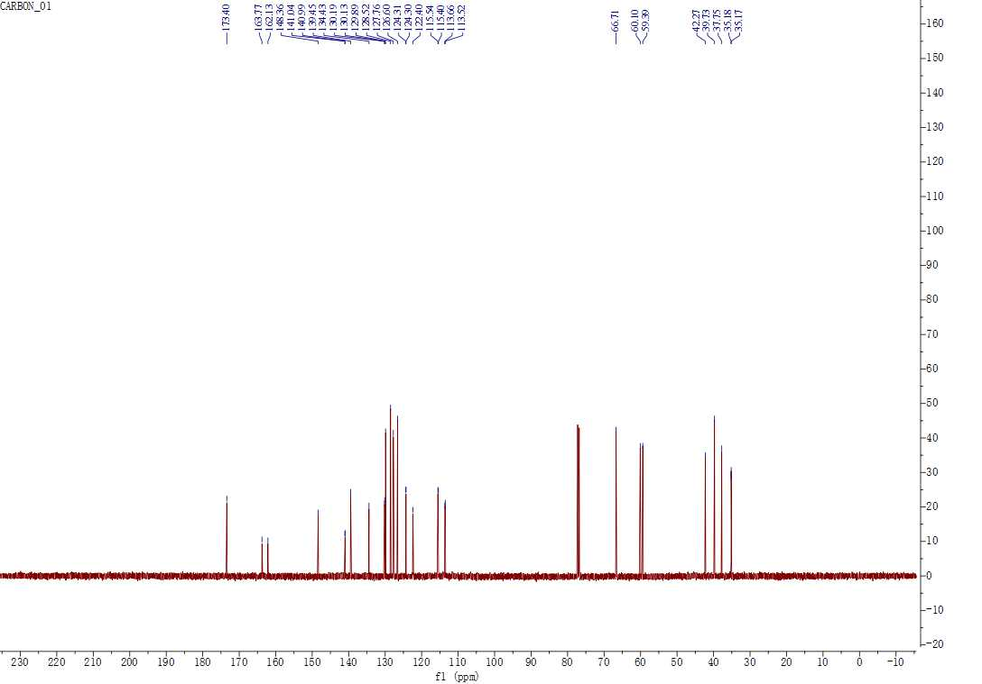
Supplementary Figure 3. ¹H NMR and ¹³C NMR spectra of 17302836.

