Supplementary data

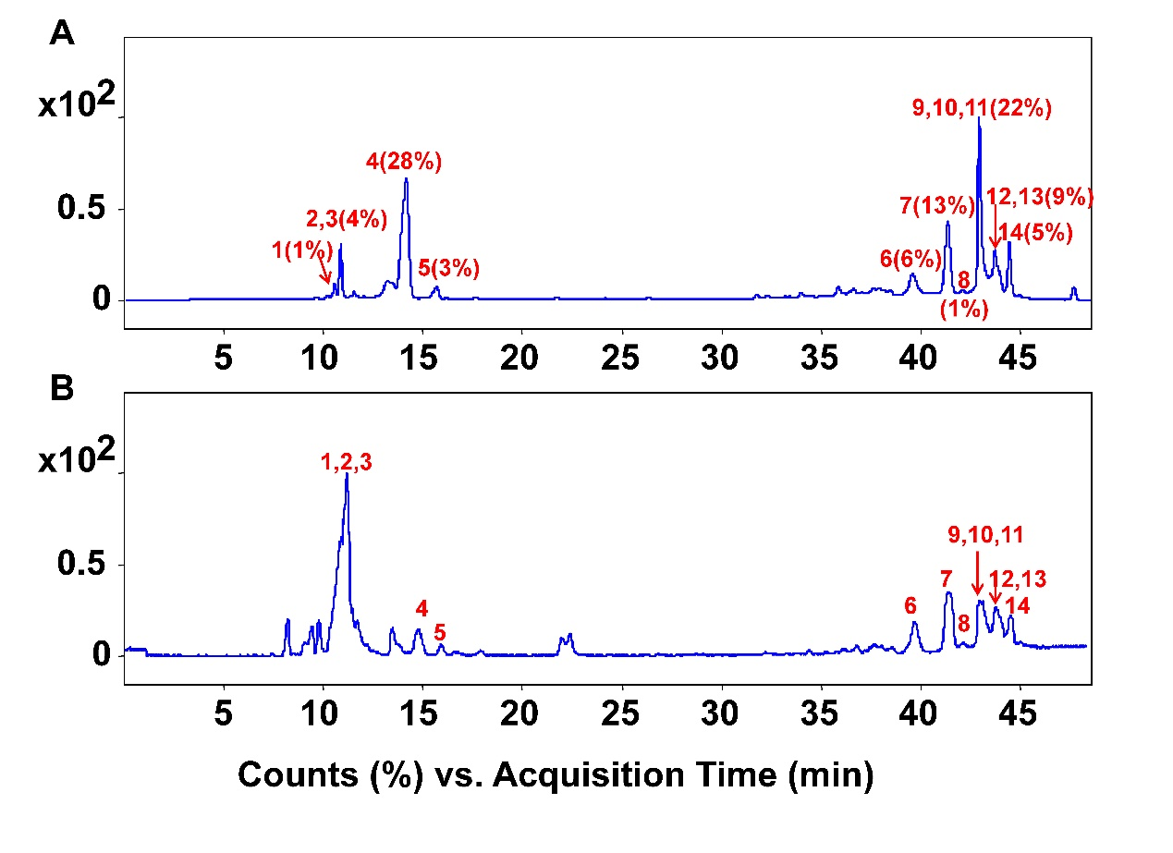
Figure S1. (A) UV chromatogram at 254 nm and (B) total ion chromatogram in negative mode of SCBPE. The sample was separated on an Ultimate XB-C₁₈ column (4.6 mm × 250 mm, 5 µM). The mobile phase was 0.1% formic acid aqueous solution and methanol, and the gradient elution conditions were as follows: 0-30 min: 20% methanol; 30-31 min: 65%-80% methanol; 31-48 min: 80% methanol. The flow rate was set at 0.25 mL/min. (1) adenosine, (2) sucrose, (3) gluconic acid, (4) uridine, (5) guanosine, (6, 7, 9) caffeoyl-feruloylquinic acid or caffeoyl-isoferuloylquinic acid nitrogen-containing derivative, (8, 10, 12) caffeoyl-3′-methoxycinnamylquinic acid or caffeoyl-4′-methoxycinnamylquinic acid nitrogen-containing derivative, (11, 13, 14) p (or m)-coumaroyl-3′-methoxycinnamylquinic acid or p (or m)-coumaroyl-4′-methoxycinnamylquinic acid nitrogen-containing derivative.

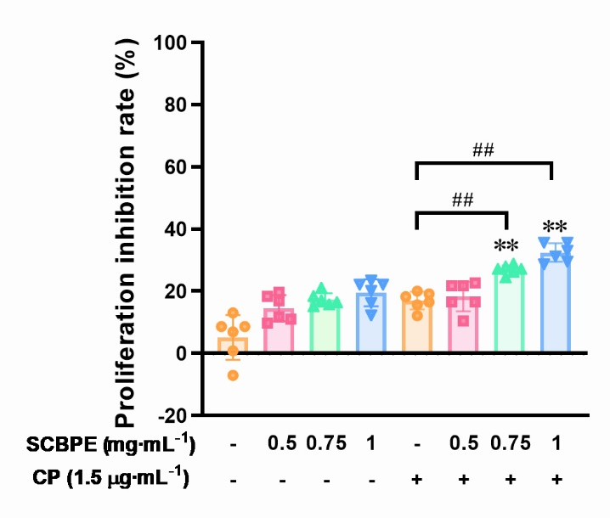
Figure S2. Effects of SCBPE in combination with CP on the proliferation of normal adult liver epithelial THLE-2 cells (n=6). Compared with the same concentration of SCBPE group, ** p < 0.01. Compared with the CP group, ## p < 0.01.

Table S1. The up-regulated proteins of SCBPE group compared with control group.
Protein accession | Protein description | P value
Q86YL5 | Testis development-related protein | 0.003644656
P35542 | Serum amyloid A-4 protein | 0.000466689
Q9Y5W9 | Sorting nexin-11 | 0.036446901
Q8N4C6 | Ninein | 0.000309484
Q86TP1 | Exopolyphosphatase PRUNE1 | 0.00872388
P08631 | Tyrosine-protein kinase HCK | 0.000875586
P05121 | Plasminogen activator inhibitor 1 | 0.001769687
Q9UJF2 | Ras GTPase-activating protein nGAP | 0.008692437
Q99735 | Microsomal glutathione S-transferase 2 | 0.012918134
A6NDX5 | Putative zinc finger protein 840 | 1.74882E-07
Q9UPY5 | Cystine/glutamate transporter | 1.31611E-05
Q14186 | Transcription factor Dp-1 | 0.001133591
Q6PCB5 | Lysine-specific demethylase RSBN1L | 4.39732E-06
P0C221 | Coiled-coil domain-containing protein 175 | 0.000265053
P04798 | Cytochrome P450 1A1 | 5.78025E-05
Q96FN4 | Copine-2 | 0.000171479
Q14117 | Dihydropyrimidinase | 0.001208248
P08243 | Asparagine synthetase [glutamine-hydrolyzing] | 0.000227235
P24390 | ER lumen protein-retaining receptor 1 | 0.001031627
P02656 | Apolipoprotein C-III | 0.002262613
Q86X52 | Chondroitin sulfate synthase 1 | 0.020869349
O15431 | High affinity copper uptake protein 1 | 0.004064734
Q02952 | A-kinase anchor protein 12 | 0.000129342
P15407 | Fos-related antigen 1 | 0.000250295
Q6AI12 | Ankyrin repeat domain-containing protein 40 | 0.004079412
Q8N4N3 | Kelch-like protein 36 | 0.000136629
Q8IWU2 | Serine/threonine-protein kinase LMTK2 | 0.001234986
Q8TF40 | Folliculin-interacting protein 1 | 0.005208917
Q9Y2I7 | 1-Phosphatidylinositol 3-phosphate 5-kinase | 0.000308621
P57737 | Coronin-7 | 0.04606597
Q7L9B9 | Endonuclease/exonuclease/phosphatase family domain-containing protein 1 | 0.013276051
O60229 | Kalirin | 0.002098984
P09601 | Heme oxygenase 1 | 5.37859E-05
P17275 | Transcription factor jun-B | 0.046331285
P19012 | Keratin, type I cytoskeletal 15 | 8.36617E-05
P25208 | Nuclear transcription factor Y subunit beta | 0.00546824
P48200 | Iron-responsive element-binding protein 2 | 0.001621132
P19971 | Thymidine phosphorylase | 0.001927096
P02795 | Metallothionein-2 | 0.008834622
Q14728 | Major facilitator superfamily domain-containing protein 10 | 0.000794393
Q9UEG4 | Zinc finger protein 629 | 0.043422216
P35030 | Trypsin-3 | 3.45221E-06
P78556 | C-C motif chemokine 20 | 5.83932E-05

Table S2. The down-regulated proteins of SCBPE group compared with control group.
Protein accession | Protein description | P value
P21980 | Protein-glutamine gamma-glutamyltransferase 2 | 5.15888E-05
Q6DN03 | Putative histone H2B type 2-C | 0.000174779
P54710 | Sodium/potassium-transporting ATPase subunit gamma | 0.004485852
O75110 | Probable phospholipid-transporting ATPase IIA | 0.016253383
P17405 | Sphingomyelin phosphodiesterase | 0.01490697
P24385 | G1/S-specific cyclin-D1 | 0.02443952
P41594 | Metabotropic glutamate receptor 5 | 0.019982836
Q14116 | Interleukin-18 | 0.001674766
Q8IWD4 | Coiled-coil domain-containing protein 117 | 0.01361842
P02794 | Ferritin heavy chain | 3.09313E-05
O60353 | Frizzled-6 | 0.049400174
P02792 | Ferritin light chain | 0.00023302
Q16625 | Occludin | 0.000940399
P11169 | Solute carrier family 2, facilitated glucose transporter member 3 | 0.000133461
Q14135 | Transcription cofactor vestigial-like protein 4 | 0.025249077
Q9UK33 | Zinc finger protein 580 | 0.028542249
Q01995 | Transgelin | 8.2192E-05
Q9H6R7 | WD repeat and coiled-coil-containing protein | 0.006804845

Table S3. Differential proteins in focal adhesion pathway of SCBPE group compared with control group.
Protein accession | Protein description | P value
Q9Y490 | Talin-1 | 0.0248195
O75369 | Filamin-B | 0.0009264
Q14185 | Dedicator of cytokinesis protein 1 | 0.0269965
O43707 | Alpha-actinin-4 | 0.0007031
O75116 | Rho-associated protein kinase 2 | 0.0001463
Q13177 | Serine/threonine-protein kinase PAK 2 | 0.0335032
P63000 | Ras-related C3 botulinum toxin substrate 1 | 0.0033368
P49841 | Glycogen synthase kinase-3 beta | 0.0281055
P12814 | Alpha-actinin-1 | 0.0161851
P21333 | Filamin-A | 0.0001603
P28482 | Mitogen-activated protein kinase 1 | 0.0210829
P18206 | Vinculin | 0.0007978
O15230 | Laminin subunit alpha-5 | 0.0005863
P61586 | Transforming protein RhoA | 0.0023396
Q9NVD7 | Alpha-parvin | 0.0343254
O14950 | Myosin regulatory light chain 12B | 0.0175853
Q9NRY4 | Rho GTPase-activating protein 35 | 0.0026916
Q92934 | Bcl2-associated agonist of cell death | 0.0421719
P16144 | Integrin beta-4 | 0.038054
P06756 | Integrin alpha-V | 0.0070587
P56199 | Integrin alpha-1 | 0.0112165
P02751 | Fibronectin | 0.0001812

