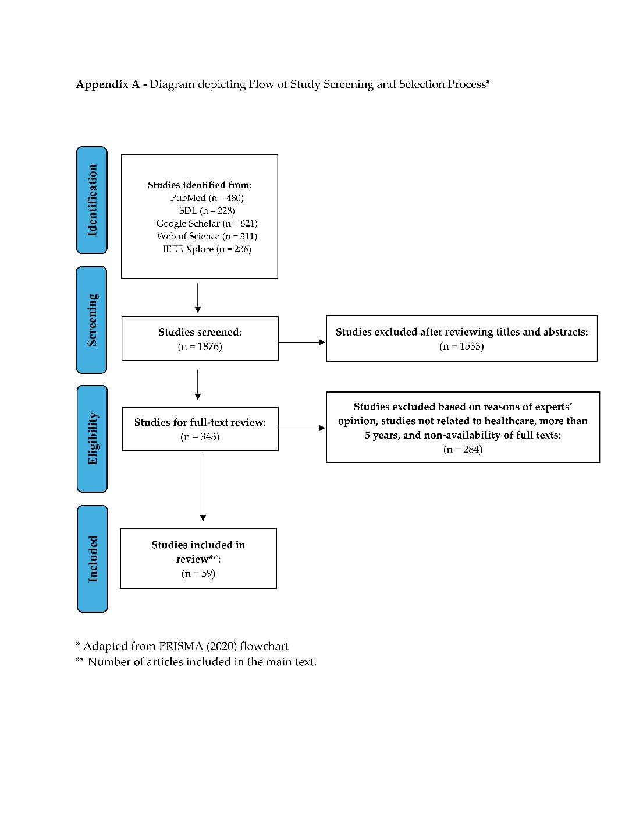
Appendix B: The summary of some essential studies related to AI and its uses in diagnosis and treatment.

Author (s) | Study design | Participants and methods | AI models and their uses | Key findings / Interpretations | Limitations and Recommendations
Zhang E et al.³⁴ (2023) | Retrospective study | Cases: 14915 patients, Control: 4538 healthy participants | Digital models were used to detect severe mental illness based on clinical MRI. | AI model that used clinical MRI identified the severe mental illness patients with good accuracy.  This AI model can assess Populations at risk so that early intervention measures can be taken. | The size of the validation dataset led to precision limitations.  The generalizability of their findings is limited.  Continuous efforts should be made to minimize ethical concerns.
Le Glaz A et al.⁵⁹ (2019) | Systematic review | Analyzed systematically 58 included studies according to the set criteria. | The role of machine learning and natural language processes in mental health was evaluated. | Both models can be effective in providing details from unexplored data that are generally not accessible by mental health professionals.  Two major concerns raised by this research are ethical and language-specific features. | Two major concerns raised by this research are ethical and language-specific features.  Machine learning and natural language processes should be cautiously evaluated in future research, especially in relation to the patient-provider relationship.
Kalmady SV et al. ²⁷ (2019) | Retrospective study | Cases: 81 schizophrenic patients who were on antipsychotic medicines. Controls: 93 matched healthy participants | Evaluated the diagnostic accuracy of the AI model “EMPaSchiz” based on resting scale functional MRI. | Much higher accuracy (about 90%) in classifying schizophrenic patients who were on antipsychotic medicines than earlier models. | The presented results and accuracy are limited to the drug-naïve schizophrenic patients. Therefore, these findings may not be applicable in other forms of psychiatric illness.
Wrightson-Hester AR et al.⁴⁷ (2023) | Prospective study | Subjects aged 16 to 24 with the experience of anxiety or depression were included.  Sample size: 27 | This study evaluated the use and acceptability of the Manage Your Life Online. | Manage Your Life Online chatbot helped their participants overcome their mental health problems.  However, they recommended conducting futuristic trials on a larger sample size. | The study findings are to be interpreted with caution as they were not based on more advanced analysis (inferential), and the follow-up duration was also short (14 days).  The authors recommended conducting futuristic trials on a larger sample size.
van der Schyff EL et al.⁵⁰ (2023) | Prospective study | Patients with mild to moderate anxiety and depression | Evaluated the use and feasibility of a conversation chatbot (Leora). | The AI-powered Leora model is seen to have the ability to give mental health support to patients with mild to moderate anxiety and depression.  However, the authors suggested more rigorous user testing for more effectiveness. | Developers must stay alert and cautious to avoid clinical or user experience bias.  Furthermore, it is crucial to prioritize equity, especially for individuals with little health-related knowledge, non-native speakers, or individuals with disabilities.
Xu H et al.³⁹ (2022) | Experimental study | Sample size: 1500 college students | Evaluated the effectiveness of multimodal models that recognize voice, facial expression, etc. | The observed occurrence of depression, anxiety, and stress is constant with the multiple targeted tests used in their study. | The authors suggested using a multimodal emotion recognition model in large-scale mental health screening programs.  The two major limitations of the study were the possibility of sampling bias and the low discriminant validity of the tool used.
Sharma and Verbeke³⁸ (2021) | Retrospective study | Sample size: 11081 Dutch citizens. | Evaluated the significance of some selected biomarkers in anxiety disorder. Machine learning techniques assessed these biomarkers. | Machine learning techniques were practical to find the correlation between these biomarkers and anxiety disorders. However, these findings might be limited to the local population. | However, these findings might be limited to the local population.  They recommended conducting future studies based on making a perfect classification model with a more extensive dataset and more variables presented in their research.
Abd-alrazaq A et al.²¹ (2022) | Umbrella review | They included 15 systematic reviews in their study. | They evaluated the effectiveness of AI models in diagnosing mental health disorders such as cognitive impairment, schizophrenia, bipolar disorders, etc. | The authors reported that the effectiveness of the AI models in diagnosing psychiatric illness ranged from 21% to 100%, depending on the type of illness. | Mental healthcare providers must start learning about the potential of AI-based approaches for their daily clinical practice.  For effective implementation, a higher level of evidence is imperative in this discipline.
Sadeh-Sharvit S et al.⁵² (2023) | Randomized control trial | Sample size: 47 adult patients with the main diagnosis of depressive or anxiety disorder. | They compared the conventional (treatment as usual) and the AI platform provided by Eleos Health in a community-based clinic. | AI platform provided therapy had a better outcome than the conventional (treatment as usual) method. | Sample size and duration of follow-up were the two major limitations of this randomized controlled trial.  Another limitation was the lack of detailed information on the patients.
Malik T et al.⁵³ (2023) | Satisfaction survey | Patients were suffering from different mental health issues.  Sample size: 7929 | Evaluated the feedback of the Wysa app used for cognitive behavioral therapy. | Their study revealed overwhelmingly positive feedback from the Wysa app users regarding safety, comfort, and a supportive environment | The study findings are limited by:  1. Single source (google app) data  2.No demographic information  3. No data regarding the duration of app usage.

