Supplementary Figure 1. Asthma Impairment and Risk Questionnaire (AIRQ®)
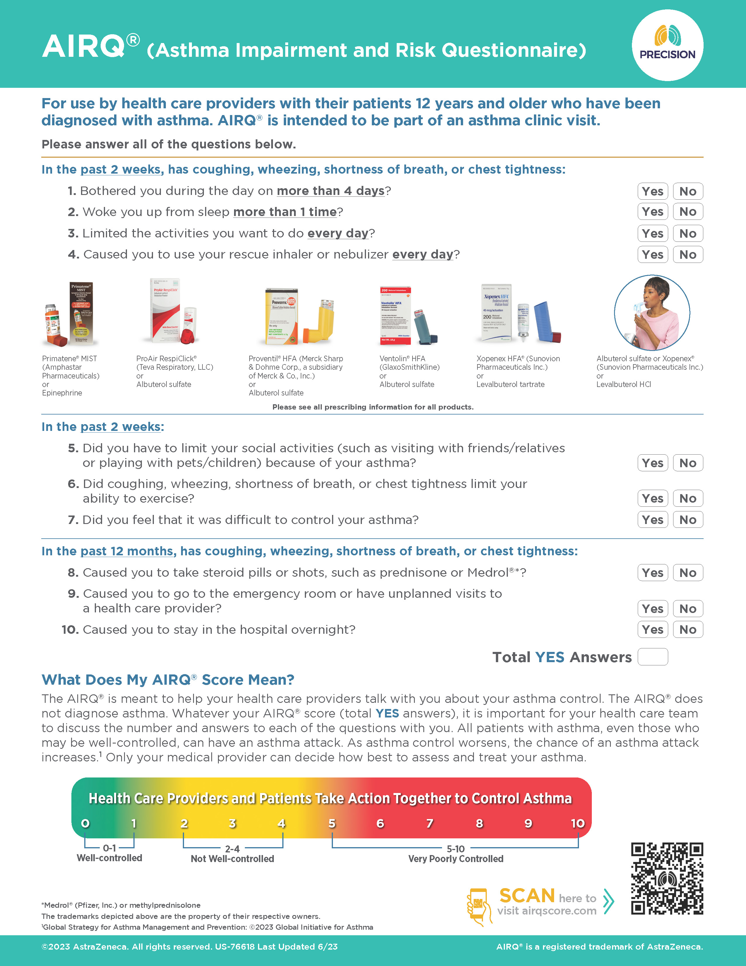
AIRQ® is a trademark of AstraZeneca. The AIRQ® is reproduced with permission from AstraZeneca. AstraZeneca is the copyright owner of the AIRQ®. However, third parties will be allowed to use the AIRQ® free of charge. The AIRQ® must always be used in its entirety. Except for limited reformatting, the AIRQ® may not be modified or combined with other instruments without prior written approval. The ten questions of the AIRQ® must appear verbatim, in order, and together as they are presented and not divided on separate pages. All copyright and trademark information must be maintained as it appears on the bottom of the AIRQ® and on all copies. The layout of the final authorized AIRQ® may differ slightly, but the item wording will not change.
Supplementary Methods
The cross-sectionally validated AIRQ is a 10-item, equally weighted, yes/no composite asthma control questionnaire consisting of 7 impairment items with a 2-week recall period and 3 risk items with a 12-month recall period. The methodology for the development of the AIRQ has been previously described in full (Murphy et al. 2020) but is briefly summarized here.
A multinominal logistic regression evaluating the concordance index of the summed AIRQ score for the chosen items and the levels of control identified by the ACT + prior-year exacerbations standard produced a receiver operating characteristic area under the curve (ROC AUC) of 0.94 to separate well-controlled from not well- and very poorly controlled asthma and a ROC AUC of 0.93 to separate very poorly controlled from well- and not well-controlled asthma.
Against the ACT + prior-year exacerbations standard, well-controlled asthma was indicated by 0–1 yes response, not well-controlled asthma by 2–4 yes responses, and very poorly controlled asthma by 5–10 yes responses. The chosen cut points for the three levels of asthma control resulted in 90% sensitivity to identify well-controlled (0–1) vs not well-controlled (2–4) or very poorly controlled asthma (5–10) and 96% specificity to identify very poorly controlled (5–10) vs well-controlled (0–1) or not well-controlled asthma (2–4).
Reference: Murphy KR, Chipps B, Beuther DA, et al. Development of the Asthma Impairment and Risk Questionnaire (AIRQ): a composite control measure. J Allergy Clin Immunol Pract. 2020;8(7):2263-2274 e2265.

Supplementary Table 1. Annotated bibliography of published AIRQ validation analyses
Reference | Brief Summary
Murphy KR, Chipps B, Beuther D, Wise R, McCann W, Gilbert I, Eudicone JM, Gandhi HN, Harding G, Coyne KS, Zeiger RS, on behalf of the US PRECISION Advisory Board. Development of the Asthma Impairment and Risk Questionnaire (AIRQ): A Composite Control Measure. J Allergy Clin Immunol Pract. 2020;8(7):P2263-2274.E5 | This study presents the development and cross-sectional validation of the AIRQ in patients with asthma aged ≥ 12 years. The 10 items selected for inclusion in the AIRQ were able to discriminate between well-controlled versus not well-/very poorly controlled asthma and very poorly controlled versus well-/not-well controlled asthma based on a validation standard of Asthma Control Test (ACT) score plus prior-year exacerbations.
Chipps B, Murphy KR, Wise RA, McCann W, Beuther DA, Reibman J, George M, Gilbert I, Eudicone JM, Gandhi HN, Harding G, Ross M, Zeiger RS. Assessing Construct Validity of the Asthma Impairment and Risk Questionnaire Using a 3-Month Exacerbation Recall. Ann Allergy Asthma Immunol. 2022;128(5):544-552. | This study sought to determine whether a Follow-up AIRQ could be used as a recurring assessment of asthma control in between annual clinic visits using a 3-month recall for the exacerbation risk items and the same seven impairment items as in the previously validated AIRQ. Results showed construct validity for this follow-up version of the AIRQ with respect to a validation standard of ACT plus prior 3-month exacerbations, occurrence of two or more exacerbations in the prior three months, health-related quality of life, and patient perception of symptom severity, disease control, and health risk due to asthma.
Beuther DA, Murphy KR, Zeiger RS, Wise RA, McCann W, Reibman J, George M, Gilbert I, Eudicone JM, Gandhi HN, Ross M, Coyne KS, Chipps B. Asthma Impairment and Risk Questionnaire (AIRQ) Control Level Predicts Future Risk of Asthma Exacerbations. J Allergy Clin Immunol Pract. 2022;10(12):P3204-3212.E2. | This study reports the results of a longitudinal study in 1112 US adolescents and adults that demonstrated the ability of the AIRQ to predict patient-reported asthma exacerbations over a 12-month follow-up period. With these data, the AIRQ may be used to measure both current impairment and future risk and provide HCPs and patients with information for shared decision making.
Wise RA, Chipps B, Murphy KR, Beuther DA, Reibman J, McCann W, Gilbert I, Eudicone JM, Gandhi HN, Harding G, Cutts K, George M, Zeiger RS. Confirmatory Cross-Sectional Validation of the Asthma Impairment and Risk Questionnaire (AIRQ). J Allergy Clin Immunol Pract. 2023;11(11):3531-3533. | The analyses presented in this paper confirmed the validation of the AIRQ items and control cut points using a confirmatory convenience sample of 400 additional patients that were more diverse in terms of race and ethnicity than the initial 442-patient cohort used in the initial AIRQ validation. This study further indicates that the AIRQ is a rigorous, composite measure that accurately differentiates asthma control among demographically and clinically diverse patients aged 12 years and older.
Chipps B, Zeiger RS, Beuther DA, Reibman J, Wise RA, McCann W, Gilbert I, Eudicone JM, Gandhi HN, Harding G, Cutts K, George M, Murphy KR. The Asthma Impairment and Risk Questionnaire Enhances the Assessment of Asthma Control. Ann Allergy Asthma Immunol. 2023;131(4):436-443. | This analysis evaluated the ability of the AIRQ to assess asthma control compared with patient and physician opinion and the ACT. The study found that asthma control is often overestimated by patients, physicians, and the ACT. The AIRQ, which assesses risk from past exacerbation occurrence in addition to symptom control improves asthma control determination by placing fewer patients with prior and subsequent exacerbations into the well-controlled asthma category.
Reibman J, Chipps B, Zeiger RS, Beuther DA, Wise RA, McCann W, Gilbert I, Eudicone JM, Gandhi HN, Harding G, Cutts K, Coyne KS, Murphy K, George M. Relationship between asthma control as measured by the Asthma Impairment and Risk Questionnaire (AIRQ) and patient perception of disease status, health-related quality of life, and treatment adherence. J Asthma Allergy. 2023;2023(16):59-72. | This study aimed to assess the validity of the AIRQ in relation to patient self-perception of asthma status and validated disease-specific patient-reported outcome measures. The results indicate that AIRQ has construct validity relative to patient self-perception of asthma status, disease-specific patient-reported outcome measures, and treatment adherence barriers and may be useful to raise awareness of the unrecognized impacts of asthma on patients' lives.
McCann W, Murphy KR, Zeiger RS, Beuther DA, Wise RA, Reibman J, George M, Gilbert I, Eudicone JM, Gandhi HN, Cutts K, Coyne KS, Chipps B. Assessing Meaningful Change in the Asthma Impairment and Risk Questionnaire. Ann Allergy Asthma Immunol. 2024 Feb 16. doi: 10.1016/j.anai.2024.02.013. Online ahead of print. | This study evaluated differences in AIRQ scores over time relative to Patient Global Impression of Change ratings, the minimal important differences (MID) for ACT and the St. George Respiratory Questionnaire (SGRQ), and exacerbation occurrence over 12 months to identify an AIRQ and follow-up AIRQ MID score which may be used to monitor changes in a patient’s asthma control and exacerbation risk over time. The study found that a change score of ± 2 represents a meaningful score for patients who improve (-) or worsen (+).
Chipps BE, Zeiger RS, Beuther DA, Wise RA, McCann W, Reibman J, George M, Gilbert I, Eudicone JM, Coyne KS, Harding G, Murphy KR. Advancing assessment of asthma control with a composite tool: the Asthma Impairment and Risk Questionnaire. Ann Allergy Asthma Immunol. 2024 Mar 16. doi: 10.1016/j.anai.2024.03.011. Online ahead of print. | This analysis compared the abilities of the AIRQ, Global Initiative for Asthma (GINA) four symptom control questions, expert physician opinion based on the GINA questions and GINA-defined risk factors for exacerbations and adverse asthma outcomes, and the ACT to assess current asthma impairment and predict exacerbation occurrence. Results showed that the AIRQ was highly predictive of well-controlled and uncontrolled asthma and rated fewer patients as having well-controlled asthma who had current impairment or previous-year and subsequent-year exacerbations than the other tools.
Murphy KR, Beuther DA, Chipps B, Wise RA, McCann W, Reibman J, et al. Impact of clinical characteristics and biomarkers on AIRQ exacerbation prediction. J Allergy Clin Immunol Pract. 2024 May 3. doi: 10.1016/j.jaip.2024.04.050. Online ahead of print. | This analysis evaluated the ability of the AIRQ to predict exacerbations when combined with a simple set of patient characteristics (ie, age, sex, race, and BMI) compared with a more complex set of patient characteristics and biomarkers. The analysis confirmed previous findings of the exacerbation prediction ability of the AIRQ and found that exacerbation prediction performance did not differ significantly when either a simple or complex set of clinical characteristics and biomarkers was used. Moreover, AIRQ itself was a better predictor of exacerbations than the combination of clinical characteristics and biomarkers that on an individual basis have been shown to be related to future exacerbation occurrence.

ACT, Asthma Control Test; AIRQ, Asthma Impairment and Risk Questionnaire; BMI, body mass index; GINA, Global initiative for Asthma; HCP, health care professional; SCT, symptom control test, SGRQ, St George Respiratory Questionnaire.

