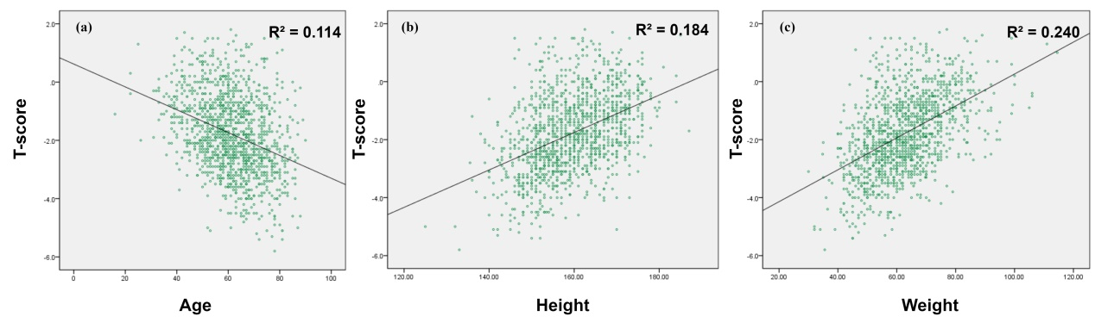
Supplementary Fig 1. Scatter plots (a), (b), and (c) show the correlation of T-score with age, height, and weight, respectively.

