APPENDIX
APPENDIX 1

Cultural Humility
Humble self-reflection and curiosity that leads to knowing self and maintaining other-oriented perspective. A process of Lifelong Commitment to Learning & Compassionate Self-reflection. A commitment to recognize and mitigate power imbalances to promote a respectful provider-client dynamic and partnership. Institutional accountability & mutual respectful partnership based on trust
Agenda

Category | Activity | Time
1) Pre-survey: | Participants complete a short survey awareness and knowledge regarding Cultural Humility. This will provide baseline for the participants. | 10 minutes
2) Presentations: | PowerPoint presentation on  Culture  Health Equities; Health Disparities  Social Determinants of Health  Allostatic load  Competence vs. Humility  Cultural Humility Principles  Compassionate self-reflection  Power Imbalance  Intersectionality  Institutional accountability & mutual respectful partnership  Cultural Humility tools | 45 minutes
3) Self-reflection 1 | Participants complete a personal identity or cultural wheel. The participant will review changes over time, including privileges and subjugation | 10 minutes
4) Video based intervention: | Participants will view multiple video clips such as:  - Implicit Bias: Lifelong impact on education, workforce, and economy | 10 minutes
5) Self-reflection Activity 2 | Participants will review their own Intersectionality; Identity & Power | 10 minutes
6) Group Activity | Participants in groups will discuss cultural humility concerns and identify 3 strategies or recommendations | 10 minutes
7) Post-survey: | For wrap up, the participants will complete the short survey to objectively determine any changes in perception from the video-based intervention | 10 minutes

APPENDIX 2
Pre-test
Have you ever been trained on Cultural Humility before? YES NO
If yes, how many trainings have you attended, and when were they?

Title/Specialty: City/country of birth:

Gender: F M (circle 1) Race:

In answering the following questions think about your current workplace and your existing awareness regarding Cultural Humility; respond using a Likert scale of:
1=strongly disagree, 2= disagree; 3= neutral; 4= agree; 5= strongly agree

Perception & Experience questions

- I have personally had a negative healthcare encounter which I attributed to my culture/identity
1 2 3 4 5

- I have observed a healthcare encounter in which the care provided could have been improved if the patient was treated with respect and encouraged to negotiate the treatment plans
1 2 3 4 5

- I will feel very comfortable in doing a cross-cultural Interview with a patient
1 2 3 4 5

- It is very clear to me that the power that I have over my patient may prevent them from getting the care that they need
1 2 3 4 5

- I am confident that I can make changes in myself that will enable me to learn from my patient
1 2 3 4 5

- I realize that I have sat in judgment over patients that I have encountered
1 2 3 4 5

- I am confident that I willing to work to make changes in workplace or institution to increase respect of patients and negotiation
1 2 3 4 5

- I believe I have the skills to help create an environment where homeless or immigrant or incarcerated or non-English speaking or substance abusing patients will trust us
1 2 3 4 5

Knowledge Questions

- Cupping and coining are therapies practiced by
  - African Americans
  - Native American Indians
  - Asians
  - Hispanics
  - Native Pacific Islanders

- The Tuskegee study involved
  - African American males
  - Native Indian American males
- Native Indian American males and females
- African American males and females
- Multiracial males and females

- Common symptoms and may be categorized as hot and cold illnesses by
  - African Americans
  - Native American Indians
  - Asians
  - Hispanics
  - Native Pacific Islanders

- Your 2 brothers one is 5 years old and 17 years old need to get their meal from a very high cupboard. You give both a 3-foot ladder to help them get fed. Is this an example of:
  - Disparity
  - Equality
  - Equity
  - Liberation
  - Reality

- Which of the following is NOT true of Health equity and inequity?
  - Attainment of highest level of health for underrepresented minorities
  - Rooted in social injustices
  - Health differences that are unnecessary and avoidable
  - Health differences related to social determinants of health

- Allostasis results in
  - Compensated equilibrium
  - Oscillating point
  - Oxytocin dominance
  - No adjustment based on history
  - Parasympathetic dominance
- Cultural humility is about
  - Learning other cultures better
  - Values academic knowledge and education
  - No end results
  - Reaching competence in other cultures

- Which of the following is NOT a primary characteristic of cultural humility?
  - Self-reflection
  - Mitigate power imbalances
  - Institutional accountability
  - Promote skill building

- Intersectionality is
- Multiple rights or advantages gained by birth, social class, ethnicity, gender, ability level, religion, sexual orientation, and/or gender identity
- The complex, cumulative way in which the effects of multiple forms of discrimination (such as racism, sexism, and classism) combine, overlap
- The intersection of cultural competence, cultural humility and cultural sensitivity
- The complex, cumulative way in which forces and systems include economic policies and systems, development agendas, social norms, social policies and political systems cause health inequities

- The institution can best improve accountability by
  - Promoting a similar governance and leadership
  - Offering focused language assistance
  - Partnering with the governing body
  - Getting community to support activities of the institution
  - Creating a conflict & grievance resolution process

- Which of the following is helpful in reducing Power Imbalance?
  - Emphasizing the weakness and disparities of the patient
  - Reviewing the goals of the provide and those of the patient
  - Learning from the patient
  - Interpersonal contact with culturally similar individuals

- I can help myself best by
  - Focus on the personal bias and assumptions of the patient
  - Be comfortable with my own values as the norm
  - Become aware of being different from others
  - Highlight one of the identities in which the patient has power & privilege
  - Encourage others to become allies and advocate of the patient

STOP PRETEST HERE
APPENDIX 3
Diversity Wheel
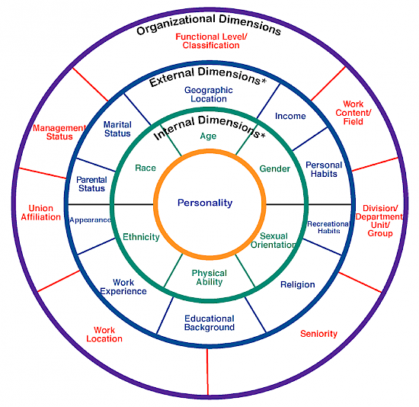

ACTIVITY 1- CULTURAL/IDENTITY/DIVERSITY WHEEL
Name each one of the identities that you hold in the identity wheel diagram. List in order of priority with number 1 as your most important identity
IDENTITIES
- Race/Ethnicity
- Gender
- Age
- Disability
- Non-US-born
- Sexual orientation
- Religion
- English as a Second language
- First in family to go to college
- Low Income
- Appearance (height, weight)
- Marital status
- Parental status
- Personal habits
- Personality
- Mental illness
- Substance abuse
- Homelessness
- Others
10
9
8
7
6
5
4
3
2
1
List any identity that you think has change over time:
1)
2)
3)
List any of your identity that has experienced subjugation or oppression:
1)
2)
3)
List any of your identity that has experienced advantages or privilege:
1)
2)
3) APPENDIX 4
Activity 2: Intersectionality; Identity & Power
Place the names of 6 of your identities from the cultural wheel in each of the 6 boxes in this diagram
Select the degree of power for each identity from -100 to +100%. Write the percentage selected in the box
Draw a line to connect with Power Axis at the level of the percentage selected
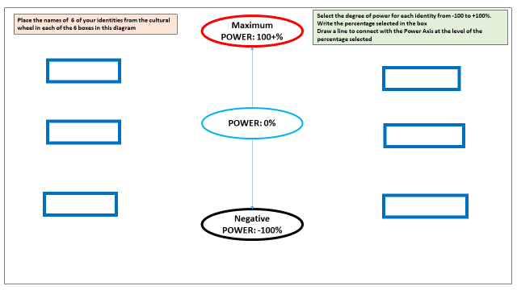

How does your experiences, your upbringing and background form and influence your attitudes and beliefs about privilege and power?

Any identity in which you are unsure of the power or lack thereof?

APPENDIX 5
GROUP ACTIVITY (BREAK OUT SESSIONS 5-8 residents)

In breakout groups discuss one of the follow & deliberate on 3 strategies or recommendations:

Please checkmark your groups’ selection
- How can we practice cultural humility with marginalized patients such as homeless or incarcerated patients?
- How can our power and privilege be addressed to improve patient’s trust?
- What can we do to right the wrongs?
- What should the residency programs do to address power imbalance?
- What can we do to become humble and practice humility with our team?

Please list your 3 strategies of your group:

Strategy 1:

Strategy 2:

Strategy 3:

Comments:

APPENDIX 6
Post-test
Perception & Experience questions

- I have personally had a negative healthcare encounter which I attributed to my culture/identity
1 2 3 4 5

- I have observed a healthcare encounter in which the care provided could have been improved if the patient was treated with respect and encouraged to negotiate the treatment plans
1 2 3 4 5

- I will feel very comfortable in doing a cross-cultural Interview with a patient
1 2 3 4 5

- It is very clear to me that the power that I have over my patient may prevent them from getting the care that they need
1 2 3 4 5

- I am confident that I can make changes in myself that will enable me to learn from my patient
1 2 3 4 5

- I realize that I have sat in judgment over patients that I have encountered
1 2 3 4 5

- I am confident that I willing to work to make changes in workplace or institution to increase respect of patients and negotiation
1 2 3 4 5

- I believe I have the skills to help create an environment where homeless or immigrant or incarcerated or non-English speaking or substance abusing patients will trust us

1 2 3 4 5

Knowledge Questions
- Cupping and coining are therapies practiced by
  - African Americans
  - Native American Indians
  - Asians
  - Hispanics
  - Native Pacific Islanders

- The Tuskegee study involved
  - African American males
  - Native Indian American males
- Native Indian American males and females
- African American males and females
- Multiracial males and females

- Common symptoms and may be categorized as hot and cold illnesses by
  - African Americans
  - Native American Indians
  - Asians
  - Hispanics
  - Native Pacific Islanders

- Your 2 brothers one is 5 years old and 17 years old need to get their meal from a very high cupboard. You give both a 3-foot ladder to help them get fed. Is this an example of:
  - Disparity
  - Equality
  - Equity
  - Liberation
  - Reality

- Which of the following is NOT true of Health equity and inequity?
  - Attainment of highest level of health for underrepresented minorities
  - Rooted in social injustices
  - Health differences that are unnecessary and avoidable
  - Health differences related to social determinants of health

- Allostasis results in
  - Compensated equilibrium
  - Oscillating point
  - Oxytocin dominance
  - No adjustment based on history
  - Parasympathetic dominance

- Cultural humility is about
  - Learning other cultures better
  - Values academic knowledge and education
  - No end results
  - Reaching competence in other cultures

- Which of the following is NOT a primary characteristic of cultural humility?
  - Self-reflection
  - Mitigate power imbalances
  - Institutional accountability
  - Promote skill building

- Intersectionality is
- Multiple rights or advantages gained by birth, social class, ethnicity, gender, ability level, religion, sexual orientation, and/or gender identity
- The complex, cumulative way in which the effects of multiple forms of discrimination (such as racism, sexism, and classism) combine, overlap
- The intersection of cultural competence, cultural humility and cultural sensitivity
- The complex, cumulative way in which forces and systems include economic policies and systems, development agendas, social norms, social policies and political systems cause health inequities

- The institution can best improve accountability by
- Promoting a similar governance and leadership
- Offering focused language assistance
- Partnering with the governing body
- Getting community to support activities of the institution
- Creating a conflict & grievance resolution process

- Which of the following is helpful in reducing Power Imbalance?
- Emphasizing the weakness and disparities of the patient
- Reviewing the goals of the provide and those of the patient
- Learning from the patient
- Interpersonal contact with culturally similar individuals

- I can help myself best by
- Focus on the personal bias and assumptions of the patient
- Be comfortable with my own values as the norm
- Become aware of being different from others
- Highlight one of the identities in which the patient has power & privilege
- Encourage others to become allies and advocate of the patient

Answers:

9= c 10= a 11= d 12= b
13= a 14= a 15= c 16= d
17= b 18= e 19= c 20= c

