Suppelmentary material

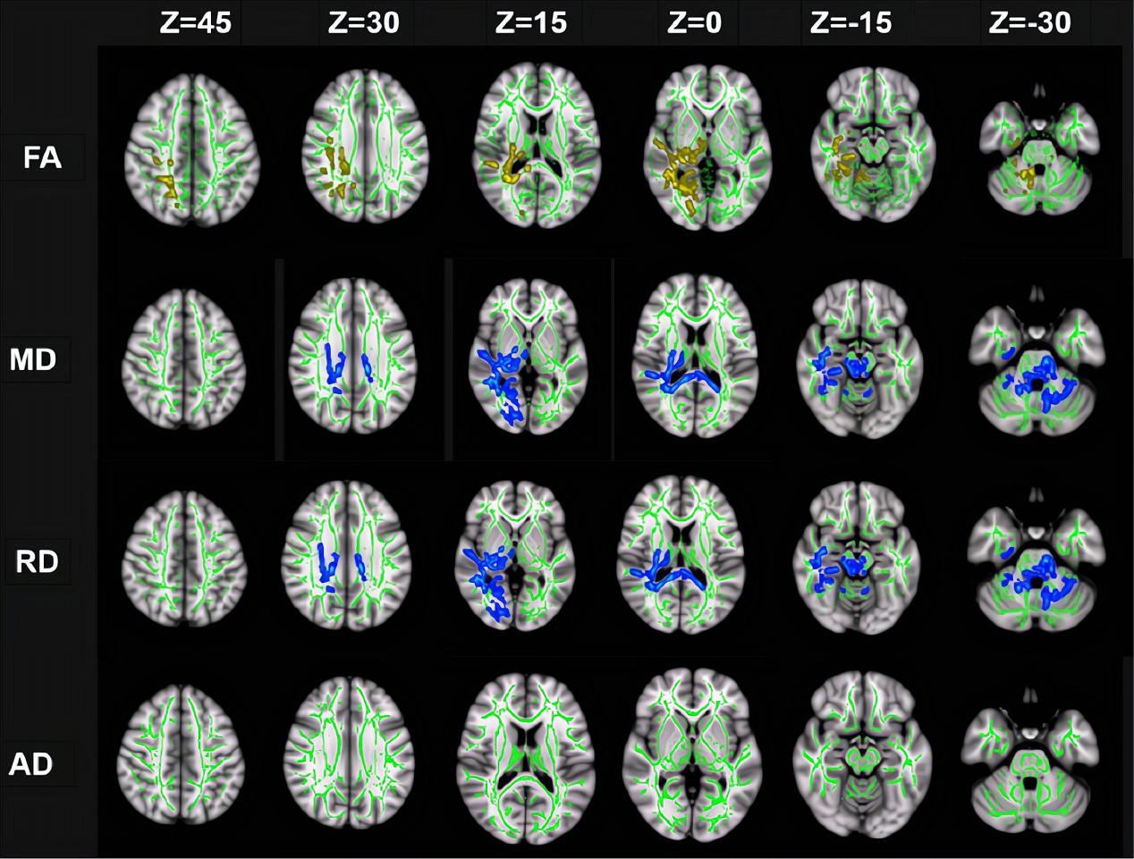
Figure S1： TBSS analysis of white matter fibres in OSA patients before and after CPAP treatment, green: mean fractional anisotropy (FA) skeleton; yellow represents the area of change in DTI values in the OSA group after CPAP treatment (FA), blue represents the area of change in DTI values in the OSA group after CPAP treatment (MD and RD), P<0.09.

