Supplementary appendix

Supplementary Table 1 Variables analyzed at index or during the baseline period
Variable | Operational definition | Measurement period
Age | Calculated based on birth year | At index
Sex | Male or female | At index
Length of follow-up | Length of the available follow-up period (in days) of each cohort, described with sample statistics (mean, median, SD, min, max) | During follow-up (from index until censorship due to death, end of study period, or end of continuous insurance)
Censorship | Number and percentage of patients censored due to death, end of continuous insurance, and end of the study period | During follow-up (from index until censorship due to death, end of study period, or end of continuous insurance)
Level of care | Ranked level of nursing support ranging from independence to heavy impairment of autonomy (nursing care level 5), frequency distribution from level 0–5 | At index
Comorbidities | Number and percentage of patients reported based on list of relevant conditions and the top comorbidities (based on three-digit inpatient/outpatient ICD-10 codes)  - Depression  - Anxiety  - Gastroesophageal reflux disease  - Acute myocardial infarction  - Congestive heart failure  - Stroke  - Bronchiectasis  - Dementia/cognitive impairment  - Rheumatoid/osteoarthritis | During baseline
CCI score | CCI without age component, reported using sample statistics (mean, median, SD, min, max) | During baseline
Smoking status/history | Number and percentage of patients who smoke or have smoked reported based on the following outpatient and inpatient ICD-10 codes:  Mental and behavioral disorders due to tobacco (F17)  Toxic effects of tobacco and nicotine (T65.2) | During baseline
Number of visits to a lung doctor | Number of outpatient visits to a lung specialist (specialist code 30). Outcomes reported using summary statistics (mean, median, SD, min, max). | During baseline
Number of moderate/severe exacerbations | Number of hospitalizations with a J44.1 code (acute exacerbation) or J44 (COPD) recorded as the main diagnosis. Outcomes reported using summary statistics (mean, median, SD, min, max) and frequency distributions (based on the number/percentage of patients with 0, 1, 2, and ≥3 exacerbations) | During baseline
Asthma diagnosis | Whether patients had at least one inpatient/two confirmed outpatient asthma diagnoses by a lung specialist (ICD-10 J45–J46) | During baseline
FEV₁% predicted | Reported using frequency distributions based on ICD-10 codes:  FEV₁% predicted <35% (J44.00)  FEV₁% predicted ≥35% and <50% (J44.01)  FEV₁% predicted ≥50% and <70% (J44.02)  FEV₁% predicted ≥79% (J44.03)  FEV₁% predicted not specified (J44.09) | During the baseline period – the last registered code before the index date
All-cause hospitalizations | Number of all-cause hospitalizations reported using summary statistics (mean, median, SD, min, max) and frequency distributions (based on the number/percentage of patients with 0, 1, 2, and ≥3 hospitalizations) | During baseline
COPD therapy use during baseline | Number and percentage of patients receiving prescriptions for each agent/combination as well as each agent class | During baseline
Use of inhalation/respiratory devices during baseline | Inhalation and respiratory devices, prescribed in an outpatient setting, identified through the catalog of remedies and aids (Product Group 14-) | During baseline
COPD therapy use during follow-up | Number and percentage of patients receiving prescriptions for MITT, FF/UMEC/VI, FOR/BDP/GLY, and FOR/GLY/BUD (where applicable) and each agent/combination | During individual patient follow-up period
Use of inhalation/respiratory devices during follow-up | Inhalation and respiratory devices, prescribed in an outpatient setting, identified through the catalog of remedies and aids (Product Group 14-) | During individual patient follow-up period
Abbreviations: CCI, Charlson Comorbidity Index; COPD, chronic obstructive pulmonary disease;
FEV₁, forced expiratory volume in 1 second; FF/UMEC/VI, fluticasone furoate/umeclidinium/vilanterol; FOR/BDP/GLY, formoterol/beclomethasone/glycopyrronium bromide; FOR/GLY/BUD, formoterol/glycopyrronium bromide/budesonide; ICD-10, International Statistical Classification of Diseases and Related Health Problems, Tenth Revision; MITT, multiple-inhaler triple therapy; SD, standard deviation.

Supplementary Table 2 Mean PDC for MITT, SITT, FF/UMEC/VI, and FOR/BDP/GLY cohorts at 6, 12, and 18 months post-index, using different methods to calculate adherence (Baseline, 1A, 1B, 2, and 3)
 | Mean (SD) PDC, %
 | MITT | SITT | FF/UMEC/VI | FOR/BDP/GLY
Baseline approach
6 months | 45.91 (6.54) | 59.98 (9.16) | 62.53 (9.71) | 58.18 (8.71)
12 months | 35.45 (6.71) | 52.08 (10.32) | 54.30 (11.20) | 50.52 (9.66)
18 months | 31.45 (6.71) | 48.67 (10.65) | 50.56 (11.54) | 47.34 (10.00)
1A
6 months | 65.39 (5.06) | 77.29 (4.22) | 79.52 (3.56) | 75.76 (4.62)
12 months | 52.34 (6.16) | 69.62 (6.30) | 71.12 (6.11) | 68.59 (6.43)
18 months | 47.21 (6.79) | 66.22 (7.34) | 67.25 (7.55) | 65.52 (7.21)
1B
6 months | 69.62 (5.46) | 79.49 (3.96) | 81.36 (3.41) | 78.21 (4.32)
12 months | 59.55 (7.45) | 73.67 (5.78) | 75.14 (5.59) | 72.65 (5.91)
18 months | 55.89 (8.51) | 71.14 (6.65) | 72.37 (6.82) | 70.30 (6.54)
2
6 months | 49.99 (7.97) | 61.77 (9.92) | 64.22 (10.44) | 60.04 (9.49)
12 months | 39.43 (8.50) | 54.27 (11.41) | 56.63 (12.43) | 52.60 (10.64)
18 months | 35.30 (8.60) | 51.09 (11.94) | 53.20 (12.98) | 49.60 (11.16)
3
6 months | 51.39 (8.25) | 62.85 (9.99) | 65.06 (10.45) | 61.30 (9.62)
12 months | 40.75 (9.00) | 55.44 (11.68) | 57.64 (12.62) | 53.89 (10.97)
18 months | 36.59 (9.20) | 52.25 (12.27) | 54.18 (13.22) | 50.90 (11.58)
Notes: Methods to calculate adherence were as follows: Baseline approach) PDC reported among all patients without accounting for stockpiling or hospitalization; 1A) PDC was only reported among patients with ≥1 follow-up prescription for the index triple therapy within 2 months of the index date; 1B) PDC was only reported during periods of continuous therapy (ie no discontinuation or treatment switches);
2) stockpiling was permitted (ie treatment supply could be allocated to a later point in the observation period); 3) stockpiling was permitted and periods of hospitalization were considered covered.
Abbreviations: FF/UMEC/VI, fluticasone furoate/umeclidinium/vilanterol; FOR/BDP/GLY, formoterol/beclomethasone/glycopyrronium bromide; MITT, multiple-inhaler triple therapy;
PDC, proportion of days covered; SD, standard deviation; SITT, single-inhaler triple therapy.

Supplementary Figure 1 Difference in the proportion of adherent patients (PDC ≥80%) using different methods to calculate adherence (Baseline, 1A, 1B, 2, and 3): SITT vs MITT, IPTW weighted.
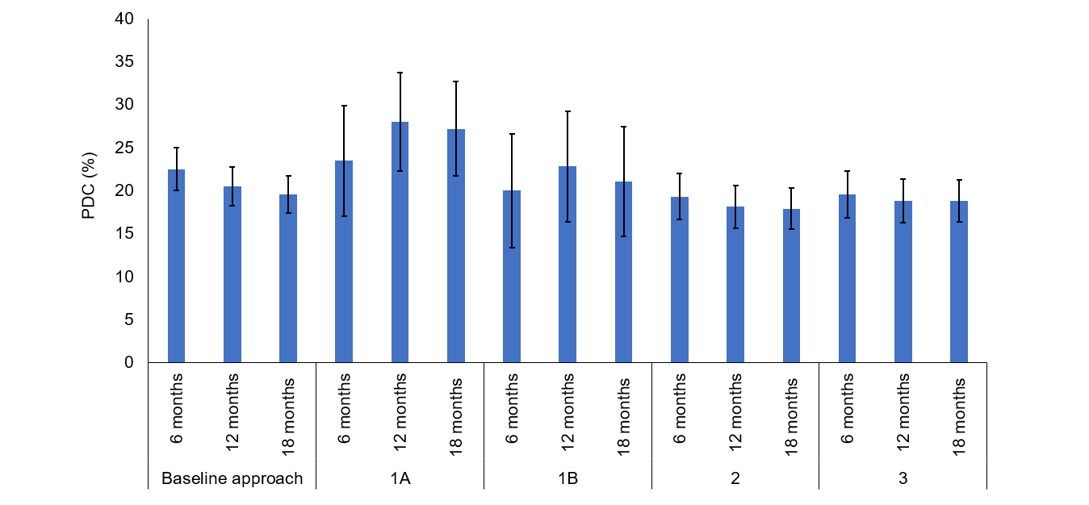
Notes: Methods to calculate adherence were as follows: Baseline approach) PDC reported among all patients without accounting for stockpiling or hospitalization; 1A) PDC was only reported among patients with ≥1 follow-up prescription for the index triple therapy within 2 months of the index date; 1B) PDC was only reported during periods of continuous therapy (ie no discontinuation or treatment switches); 2) stockpiling was permitted (ie treatment supply could be allocated to a later point in the observation period); 3) stockpiling was permitted and periods of hospitalization were considered covered.
Abbreviations: IPTW, inverse probability of treatment weighting; MITT, multiple-inhaler triple therapy; PDC, proportion of days covered;
SITT, single-inhaler triple therapy.

Supplementary Figure 2 (A) proportion of adherent patients (PDC ≥80%) and (B) Kaplan–Meier curve of persistence (exploratory analysis during COVID-19 period).
A
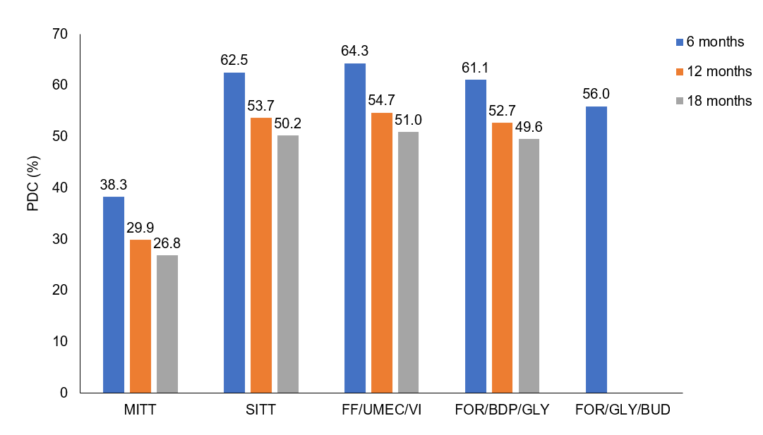
B
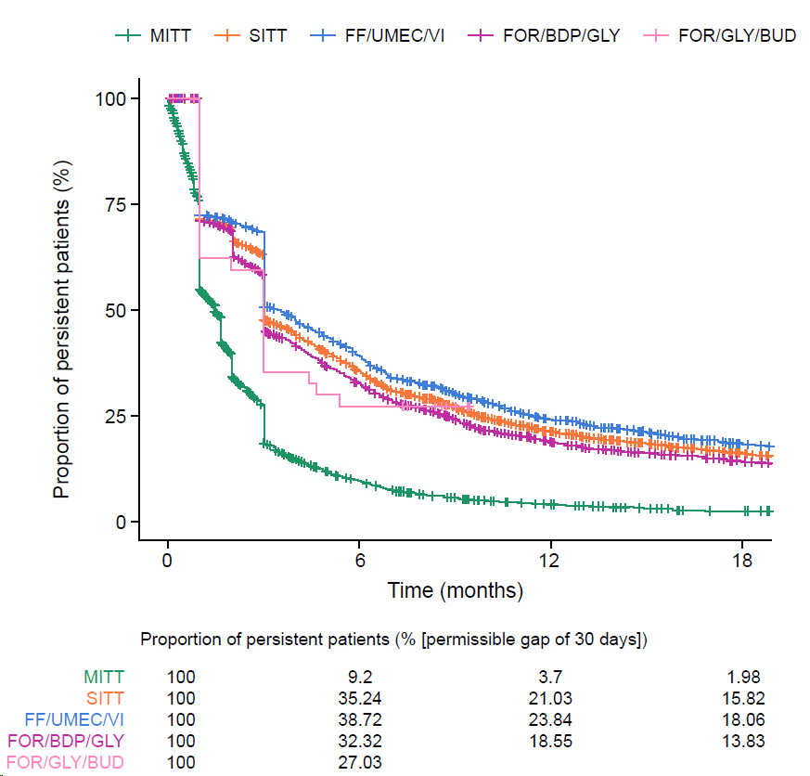
Abbreviations: FF/UMEC/VI, fluticasone furoate/umeclidinium/vilanterol; FOR/BDP/GLY, formoterol/beclomethasone/glycopyrronium bromide; FOR/GLY/BUD, formoterol/glycopyrronium bromide/budesonide; MITT, multiple-inhaler triple therapy; PDC, proportion of days covered;
SITT, single-inhaler triple therapy.

