eTable 1. Univariate and Multivariate Cox Regression Analysis
 | Univariate Cox analysis |  |  | Multivariate Cox analysis
 | P Value | HR (95% CI) |  | P Value | HR (95% CI)
Age | * | 1.02 (1.01-1.04) |  | 0.523 | 0.99 (0.97-1.01)
BMI | 0.378 | 0.97 (0.91-1.04)
Noninvasive breast cancer
No |  | Reference |  |  | Reference
Yes | ** | 0.14 (0.03-0.55) |  | * | 0.14 (0.03-0.62)
T stage
T2 |  | Reference |  |  | Reference
T1 | *** | 0.35 (0.21-0.58) |  | 0.574 | 0.85 (0.50-1.48)
T3 | 0.441 | 1.30 (0.67-2.53) |  | 0.727 | 0.88 (0.43-1.81)
T4 | 0.997 | 0.00 (0.00 - Inf) |  | 98 | 0.00 (0.00 - Inf)
Tis | 0.995 | 0.00 (0.00 - Inf) |  | 0.996 | 0.00 (0.00 - Inf)
T0 | 0.850 | 0.83 (0.11-5.96) |  | 0.702 | 0.30 (0.00-133.81)
Tx | 0.998 | 0.00 (0.00 - Inf) |  | 0.998 | 0.00 (0.00 - Inf)
N stage
N3 |  | Reference |  |  | Reference
N0 | *** | 0.13 (0.08-0.22) |  | *** | 0.29 (0.16-0.50)
N1 | *** | 0.20 (0.11-0.37) |  | * | 0.46 (0.24-0.87)
N2 | * | 0.48 (0.27-0.86) |  | 0.710 | 0.89 (0.47-1.66)
Nx | 0.076 | 6.13 (0.83-45.54) |  | 0.242 | 38.09 (0.09-16908.72)
M stage
M0 |  | Reference |  |  | Reference
M1 | *** | 12.06 (5.25-27.71) |  | ** | 4.78 (1.80-12.72)
Mx | 0.192 | 3.72 (0.52-26.76) |  | 0.058 | 8.10 (0.93-70.45)
Axillary lymph node dissection
No |  | Reference |  |  | Reference
Yes | *** | 0.02 (0.00-0.16) |  | * | 0.08 (0.01-0.57)
Wound dehiscence, infection or nonhealing
No |  | Reference |  |  | Reference
Yes | * | 3.11 (1.14-8.50) |  | *** | 8.31 (2.78-24.86)
Chemotherapy
No |  | Reference
Yes | 0.339 | 1.29 (0.77-2.15)
Radiation therapy
No |  | Reference
Yes | 0.350 | 1.31 (0.74-2.32)
Endocrine therapy
Yes |  | Reference |  |  | Reference
No | *** | 0.05 (0.02-0.14) |  | *** | 0.09 (0.03-0.28)
Targeted therapy
Yes |  | Reference
No | 0.087 | 0.49 (0.21-1.11)
Preoperative light diet
Yes |  | Reference |  |  | Reference
No | ** | 0.53 (0.35-0.80) |  | 0.167 | 0.73 (0.46-1.14)
Wound drain placement
No |  | Reference |  |  | Reference
Yes | * | 3.20 (1.29-7.95) |  | ** | 4.97 (1.85-13.32)
Ports
No |  | Reference |  |  | Reference
Yes | *** | 0.46 (0.29-0.72) |  | *** | 0.36 (0.22-0.59)
PICCs
No |  | Reference
Yes | 0.274 | 1.27 (0.83-1.95)
Functional exercise of affected limb
Occasionally |  | Reference |  |  | Reference
Everyday | *** | 3.26 (2.14-4.95) |  | 0.051 | 1.58 (1.00-2.50)
Never | 0.061 | 2.67 (0.96-7.48) |  | * | 3.07 (1.05-9.03)
Postoperative sex life
No |  | Reference |  |  | Reference
Yes | *** | 0.02 (0.01-0.09) |  | *** | 0.08 (0.02-0.35)
Pain of the disease
Yes |  | Reference |  |  | Reference
No | *** | 0.37 (0.21-0.64) |  | * | 0.45 (0.25-0.83)
Hairpiece
No |  | Reference |  |  | Reference
Yes | * | 0.54 (0.32-0.91) |  | 0.151 | 0.66 (0.38-1.16)
Prosthetic breast
No |  | Reference |  |  | Reference
Yes | *** | 0.07 (0.02-0.18) |  | * | 0.31 (0.11-0.87)
Light makeup
No |  | Reference
Yes | 0.307 | 2.80 (0.39-20.10)
* P < 0.05, ** P < 0.01, *** P < 0.001. In the 95% confidence interval (CI) for the hazard ratio (HR), 'Inf' indicates that the upper limit of the interval is infinite. This suggests that the effect of the variable is considered highly significant in the statistical analysis.

eTable 2. Table Hyperparameters
Model | Hyperparameters
XGB | nrounds：500 | max_depth：6 | eta：0.01 | gamma：0
 | colsample_bytree：1 | min_child_weight：1 | subsample：0.05
SVM | sigma：0.01 | C：0.2
Ridge | alpha：0 | lambda:10
KNN | k：50
NNet | size：1 | decay:100
RF | mtry：1 | splitrule：extratrees | min.node.size：600

eFigure1 Study flow chart
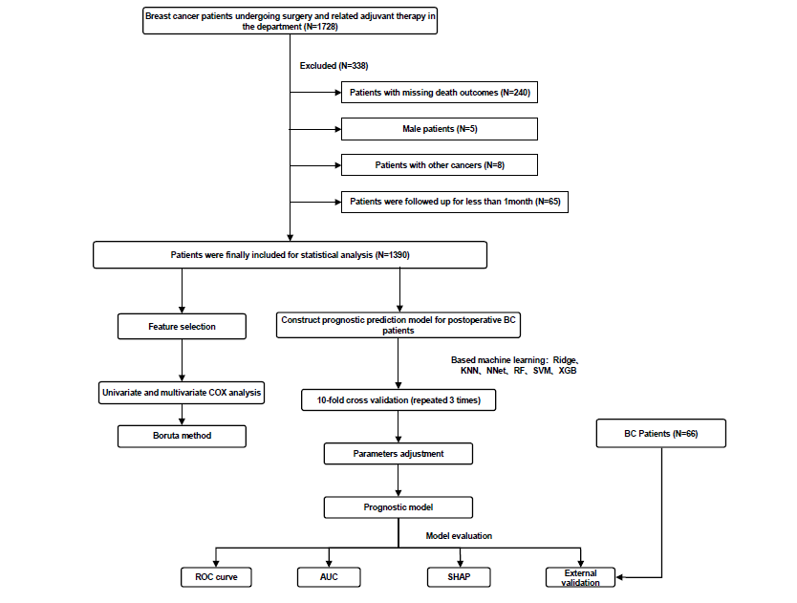

eFigure 2 Feature selection by the Boruta algorithm
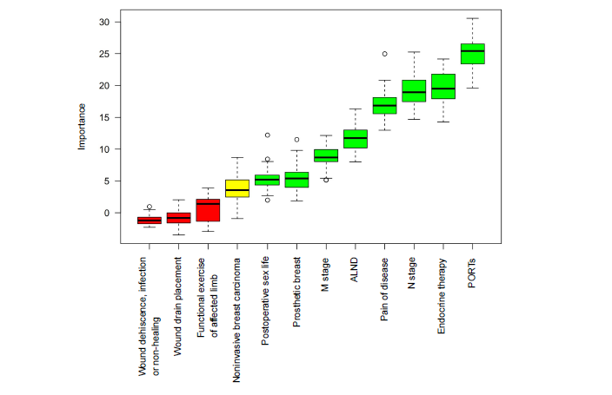

eFigure 3 Screenshot of web app
