Supplementary Materials
Mesoporous graphene oxide nanocomposite effective for combined chemo/photo therapy against Non-Small Cell Lung Cancer
Peigang Zhang^{3*}, Lingling Zheng^{1,4,*}, Xiaorui Zhang², Miao Liu², Mingli Li³, Mengting Zhang², Jianlin Wu⁴, Martin M.F. Choi⁵, Wei Bian^{1,2,3}

¹ Key Laboratory of Cellular Physiology at Shanxi Medical University, Ministry of Education, Taiyuan, Shanxi, 030000, People’s Republic of China; ² Department of Medical Chemistry, School of Basic Medical Science, Shanxi Medical University, Taiyuan, Shanxi, 030000, People’s Republic of China; ³ Department of Cardiothoracic Surgery, People’s Hospital of Lvliang, Lvliang, Shanxi, 033099, People’s Republic of China; ⁴ State Key Laboratory for Quality Research of Chinese Medicines, Macau University of Science and Technology, Taipa, Macao, People’s Republic of China; ⁵ Department of Chemistry, The Hong Kong University of Science and Technology, Clear Water Bay, Kowloon, Hong Kong SAR, People's Republic of China.

Correspondence: Wei Bian
Key Laboratory of Cellular Physiology at Shanxi Medical University, Ministry of Education, 030000, Taiyuan, Shanxi, People’s Republic of China. E-mail: weibian@sxmu.edu.cn

*These authors contributed equally to this work

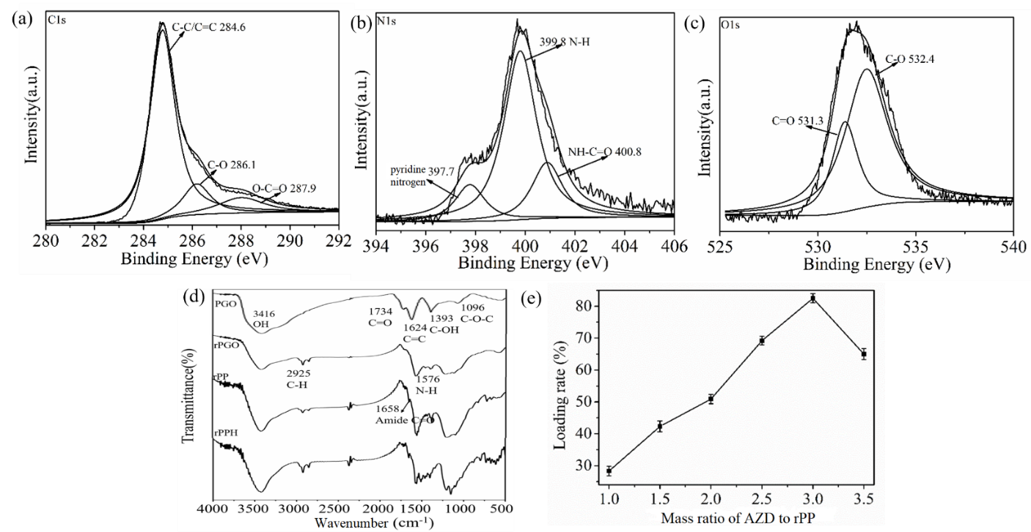
Fig. S1. XPS fine spectrum of rPPH@AZD: (a) C1s, (b) N1s, and (c) O1s. (d) FT-IR spectra of PGO, rPGO, rPP, and rPPH. (e) Loading rate of rPP at different mass ratios of AZD to rPP.

Fig. S2. The cell viability of (a) A549 cells and (b) HLF cells incubated with various concentrations of rPPH for 24h.

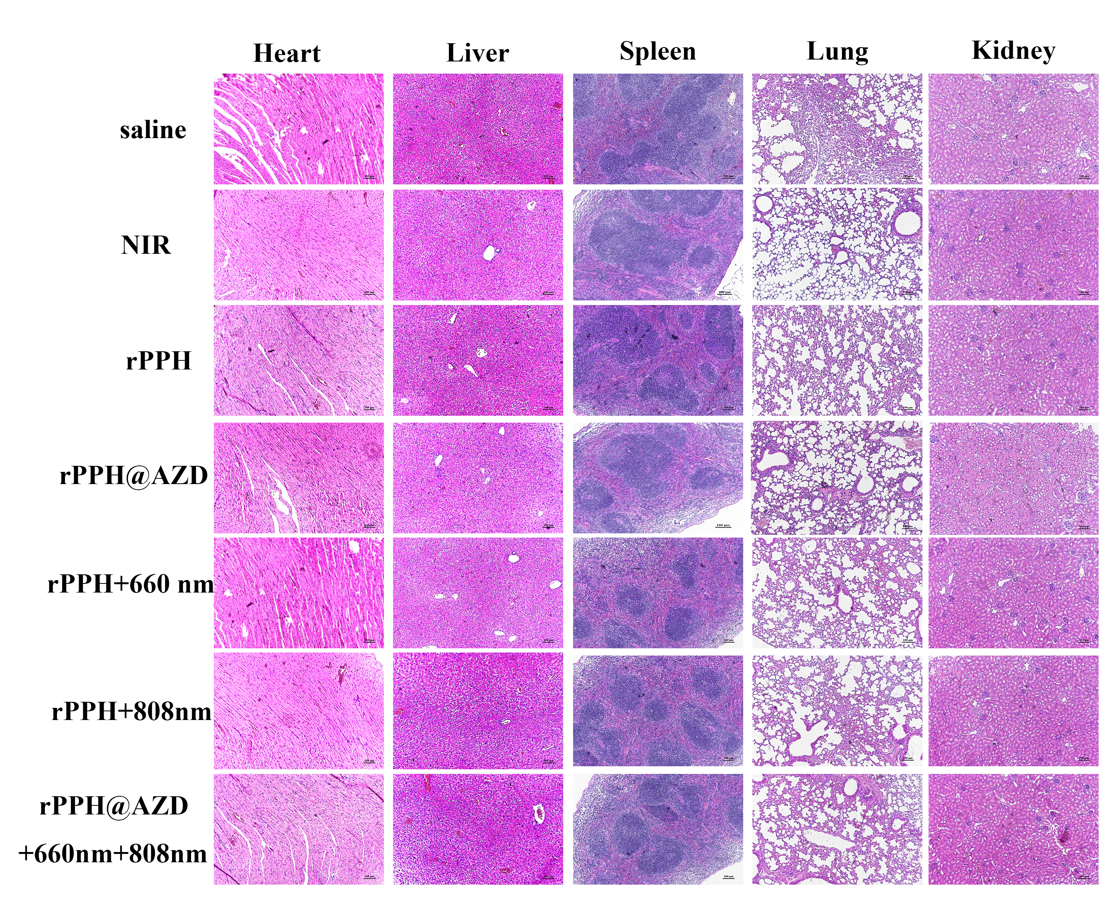
Fig. S3. H&E staining images of heart, liver, spleen, lung, and kidney tissues of mice subjected to various treatments.

Fig. S4. Liver and kidney indices of mice subjected to various treatments after 14 days.
Fig. S5. Blood indices of mice subjected to various treatments after 14 days.

