Supplementary Materials Section
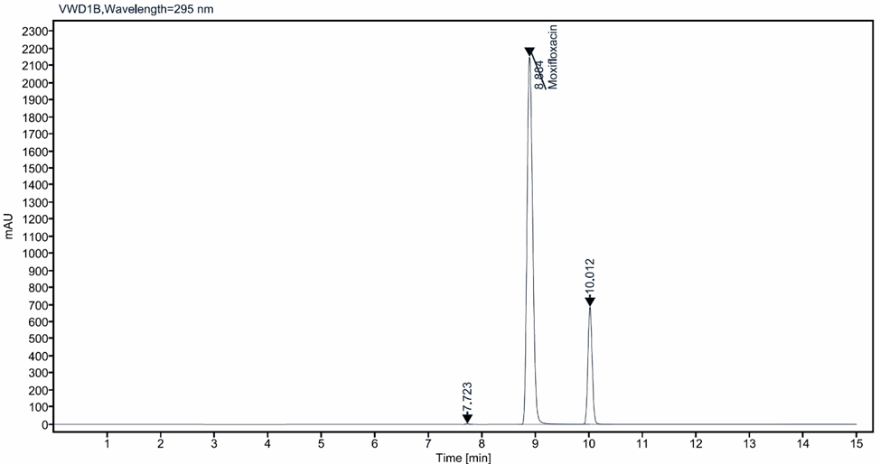
A
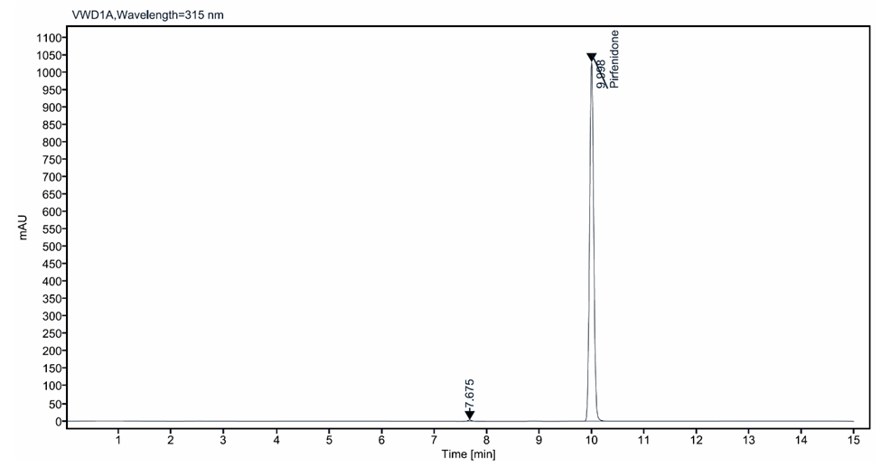
B
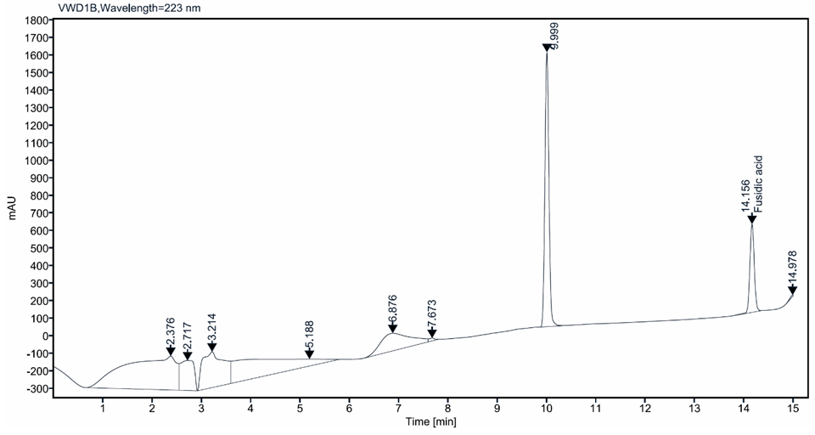
C
Supplementary Figure 1. The Detected retention times for Moxifloxacin (A), Pirfenidone (B), and Fusidic acid(C). Notes: The retention times were detected by using 1260 Infinity II HPLC system with Rt= 8.9 min (295 nm) for (A), 10.0 min (315 nm) and 14.2 min (223 nm). Data analysis was processed using OpenLab CDS software.

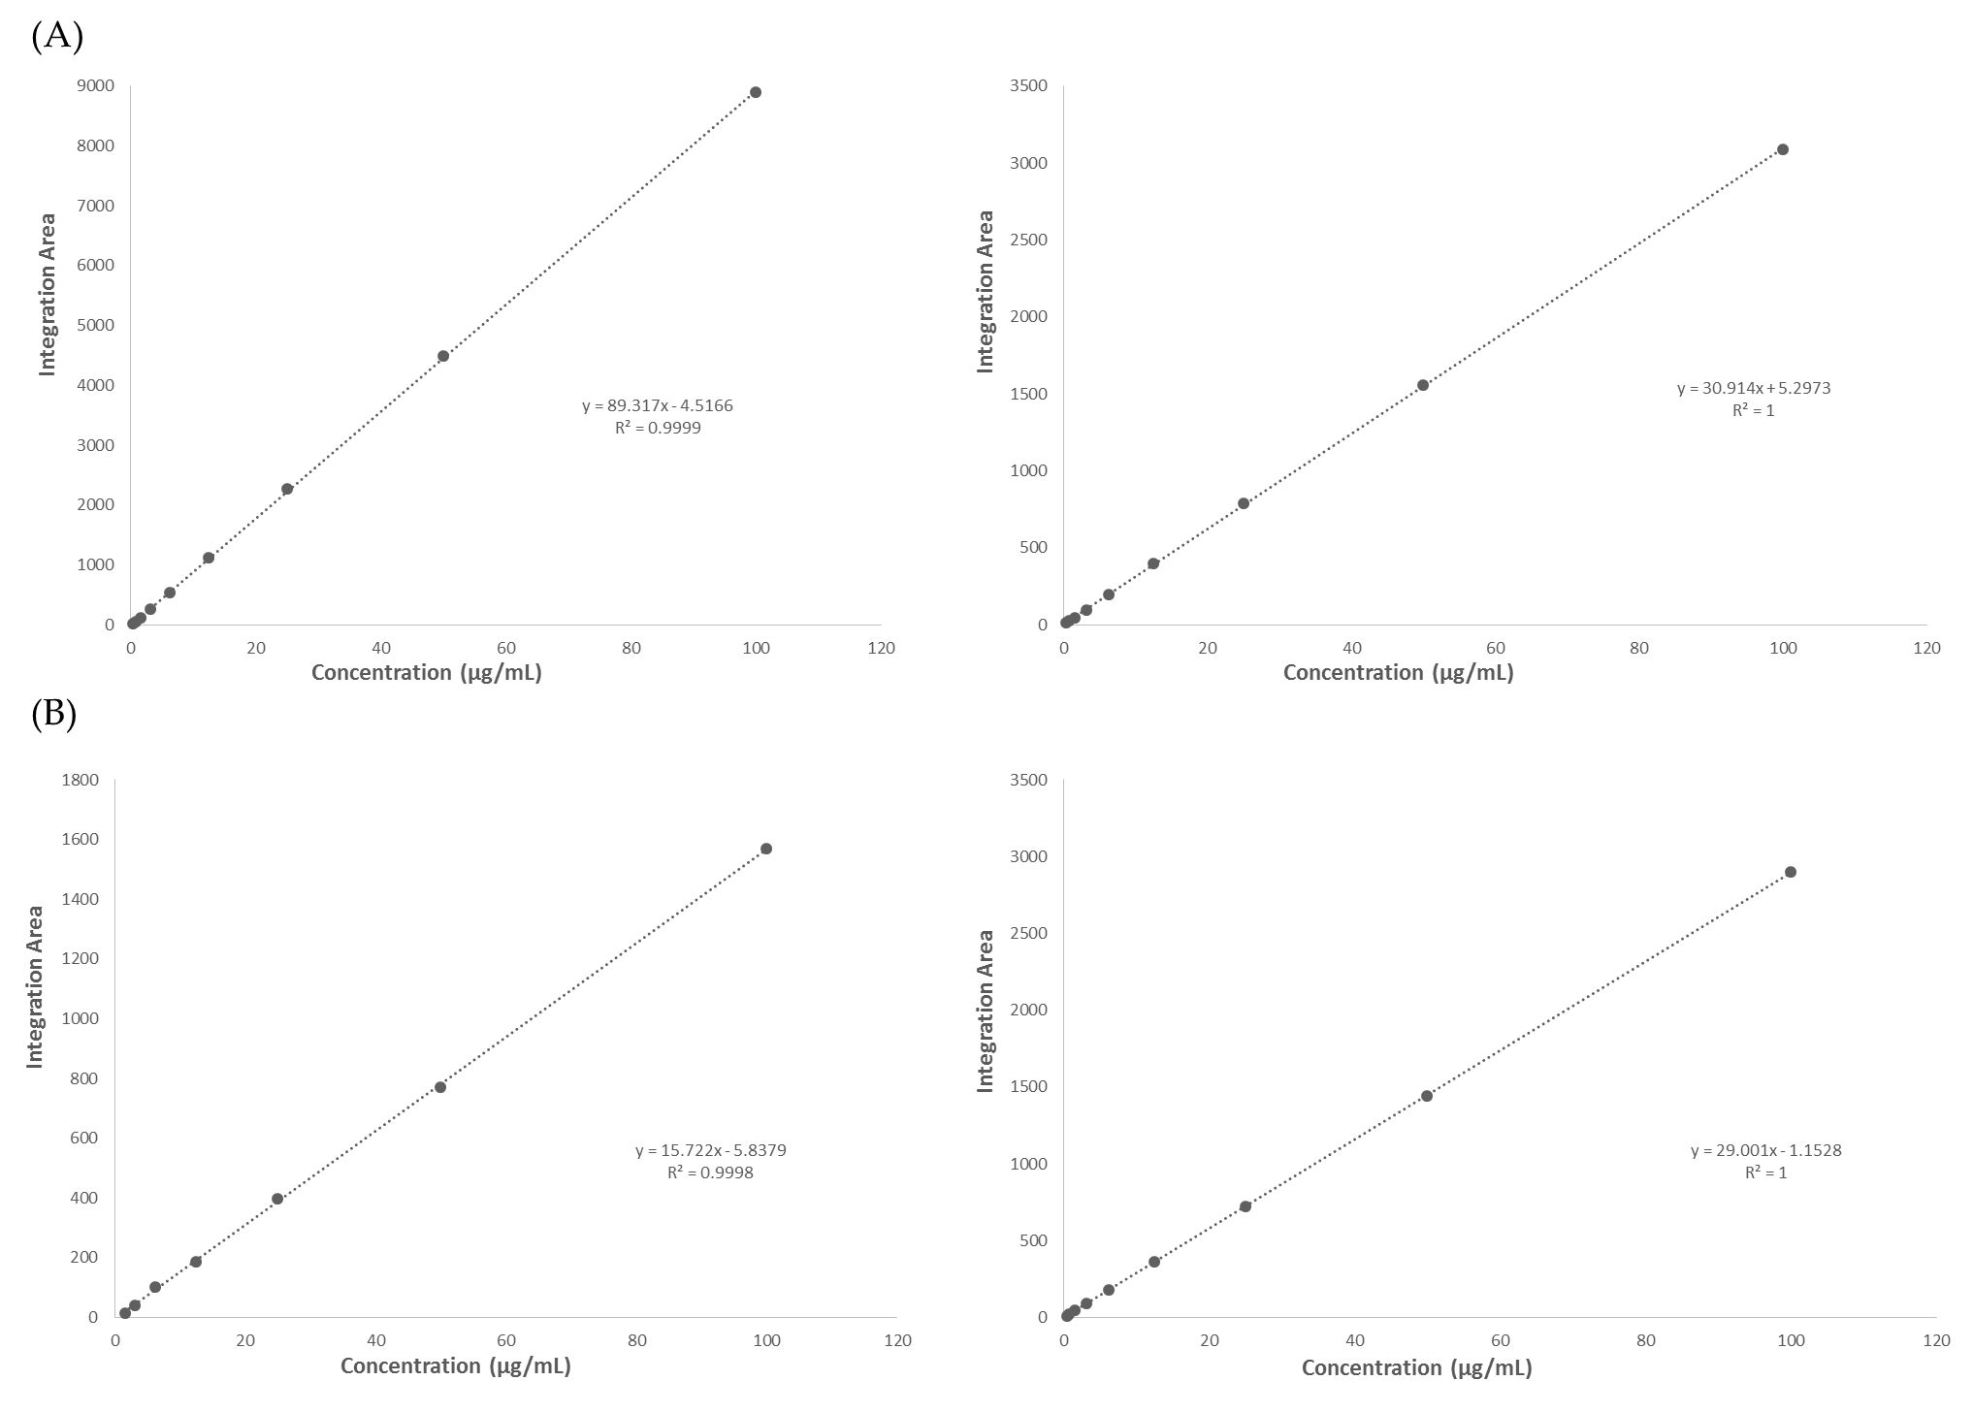
Supplementary Figure 2. Calibration curves of (A) moxifloxacin (left) and pirfenidone (right), and (B) fusidic acid (left) and pirfenidone (right) for determination of the drug encapsulation efficiency, drug loading and the amount of drug release. Notes: The concentration ranges were from 100 to 0.4 μg/mL where all curves showed excellent linearity from R² ≥ 0.9998.

Supplementary Figure 3. The minimum inhibitory concentration (MIC) of moxifloxacin, fusidic acid and pirfenidone against different bacteria strains (S. aureus ATCC BAA-977, S. aureus ATCC 29213, P. aeruginosa ATCC 9721 and P. aeruginosa ATCC 27853). Notes: Results represent the average ± SD (n = 3).

Supplementary Figure 4. A summary of the zone of inhibition of Moxifloxacin/Pirfenidone (Moxifloxacin Disc and Fiber) and Fusidic acid/Pirfenidone (Fusidic Acid Disc and Fiber) against different bacteria strains (S. aureus ATCC 29213, S. aureus ATCC BAA-977, P. aeruginosa ATCC 27853 and P. aeruginosa ATCC 9721). Notes: Results represent the average ± SD (n = 3).

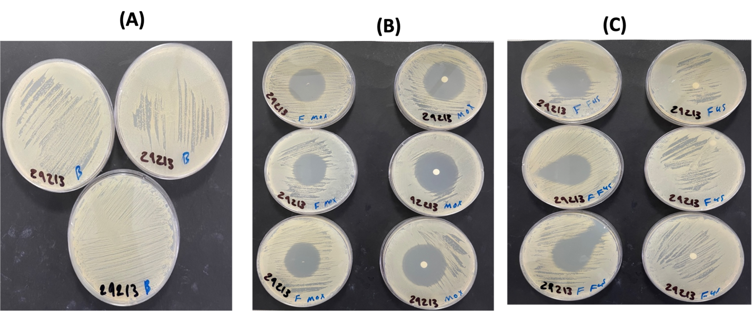

Supplementary Figure 5. Zone of inhibition of moxifloxacin/pirfenidone and fusidic acid/pirfenidone against S. aureus ATCC 29213. A, blank fibers; B, moxifloxacin/pirfenidone nanofibers (left) and moxifloxacin/pirfenidone disc (right); C, fusidic acid/pirfenidone nanofibers (left) and fusidic acid/pirfenidone disc (right). Notes: Results represent the average ± SD (n = 3).

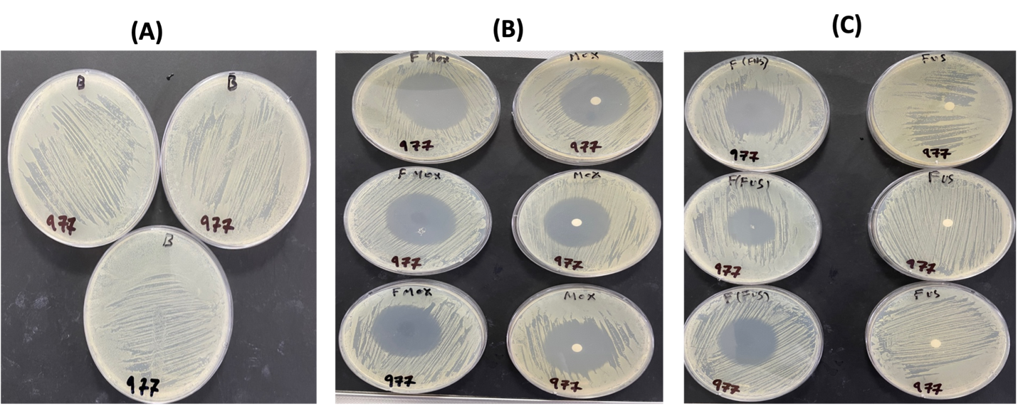

Supplementary Figure 6. Zone of inhibition of moxifloxacin/pirfenidone and fusidic acid/pirfenidone against S. aureus ATCC BAA 977. A, blank fibers; B, moxifloxacin/pirfenidone nanofibers (left) and moxifloxacin/pirfenidone disc (right); C, fusidic acid/pirfenidone nanofibers (left) and fusidic acid/pirfenidone disc (right). Notes: Results represent the average ± SD (n = 3).

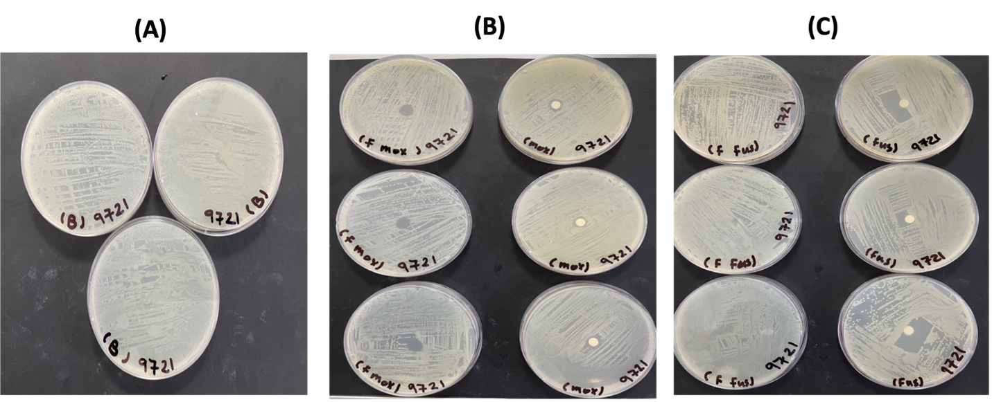

Supplementary Figure 7. Zone of inhibition of moxifloxacin/pirfenidone and fusidic acid/pirfenidone against P. aeruginosa ATCC 9721. A, blank fibers; B, moxifloxacin/pirfenidone nanofibers (left) and moxifloxacin/pirfenidone disc (right); C, fusidic acid/pirfenidone nanofibers (left) and fusidic acid/pirfenidone disc (right). Notes: Results represent the average ± SD (n = 3).

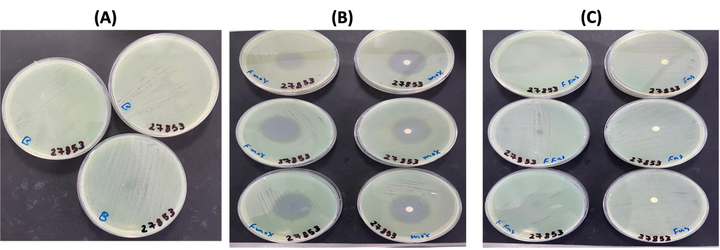
Supplementary Figure 8. Zone of inhibition of moxifloxacin/pirfenidone and fusidic acid/pirfenidone against P. aeruginosa ATCC 27853. A, blank fibers; B, moxifloxacin/pirfenidone nanofibers (left) and moxifloxacin/pirfenidone disc (right); C, fusidic acid/pirfenidone nanofibers (left) and fusidic acid/pirfenidone disc (right). Notes: Results represent the average ± SD (n = 3).

Supplementary Figure 9. Weight variations in diabetes- induces rats. Notes: The figure shows an increase of the weight over the days. Results are represented as average ± SD (n = 4). Moxi, moxifloxacin; Fus, fusidic acid; Pir, pirfenidone.

Supplementary Figure 10. Diabetes induction in rats. Blood glucose level in rats before and throughout the study. Notes: Streptozotocin was injected 72 hours (day-3) before wound induction and treatment which started at day 0. Results are represented as average ± SD (n = 4). Moxi, moxifloxacin; Fus, fusidic acid; Pir, pirfenidone.
Supplementary Figure 11. In vivo wound size reduction in diabetes-induced rats in two weeks. Notes: All Fus/Pir fibers induced a complete wound closure on day 8 followed by Moxi and Fus loaded fibers on day 11. Results are represented as average ± SD (n = 4). Moxi, moxifloxacin; Fus, fusidic acid; Pir, pirfenidone.
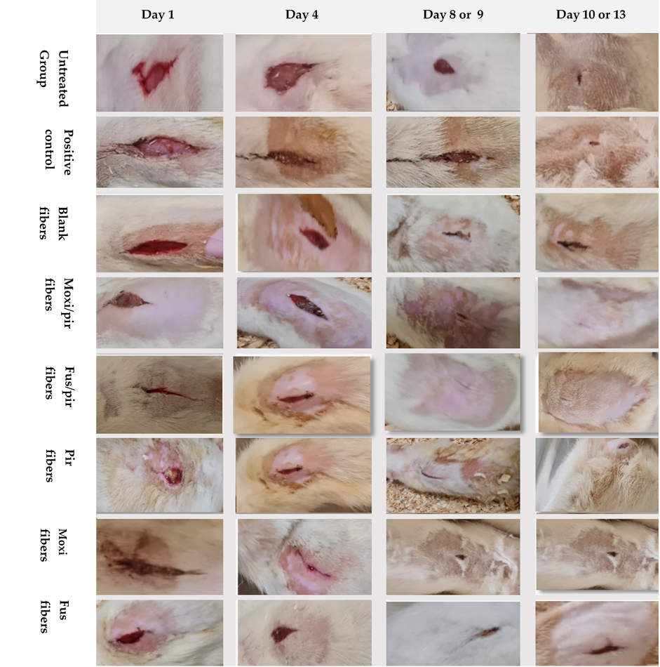

Supplementary Figure 12. Representative images of wound healing of diabetes-induced rats treated with different drug-loaded nanofibers. Notes: Moxi, moxifloxacin; Fus, fusidic acid; Pir, pirfenidone.
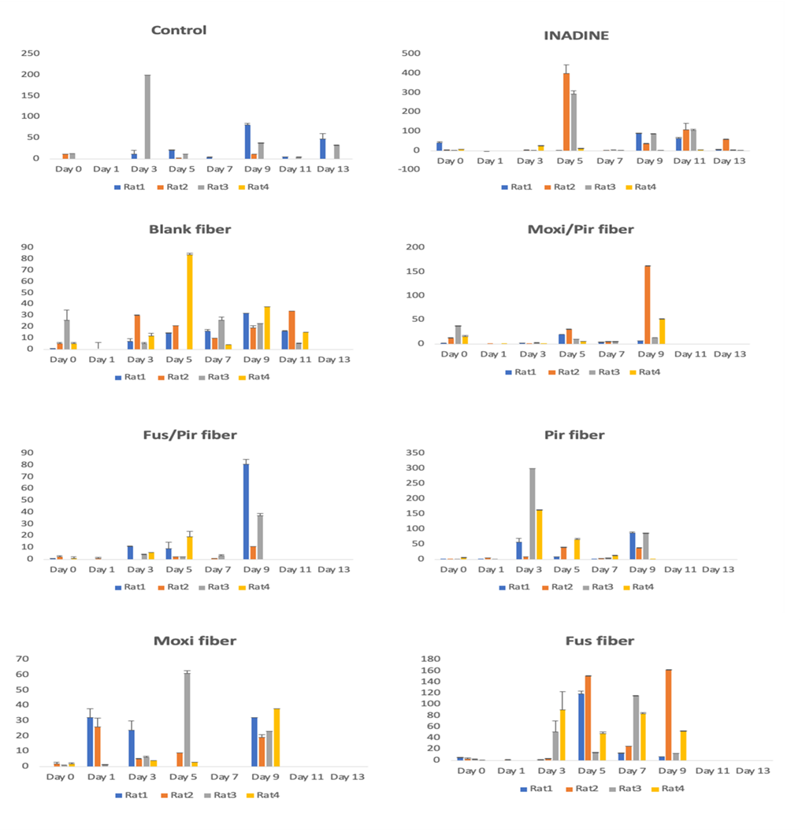
Supplementary Figure 13. Microbial total count of the diabetes-induced wound in untreated rats, INADINE treated group, Blank fiber treated group, Moxi/Pir fibers treated groups, Fus/Pir fibers treated group, Pir Fibers treated group, Moxi fiber treated group and Fus fibers treated group. Notes: Standard bacterial swabs were taken from the rats’ wounds on the start day and swabs were collected from each group in day 1, 3, 5, 7, 9, 11 and 13. Results are represented as average ± SD (n = 4). Moxi, moxifloxacin; Fus, fusidic acid; Pir, pirfenidone.

Supplementary Table 1. The MIC values of moxifloxacin, fusidic acid and pirfenidone against different bacteria strains (S. aureus ATCC BAA-977, S. aureus ATCC 29213, P. aeruginosa ATCC 9721 and P. aeruginosa ATCC 27853).
Bacterium | Moxifloxacin MIC Value (µg/mL) | Fusidic acid MIC Value (µg/mL) | Pirfenidone MIC Value (µg/mL)
S. aureus (ATCC BAA 977) | < 0.5 | < 0.5 | > 1024
S. aureus (ATCC 29213) | < 0.5 | < 0.5 | > 1024
P. aeruginosa (ATCC 9721) | 2 | > 512 | > 1024
P. aeruginosa (ATCC 27853) | 4 | > 512 | > 1024

Supplementary Table 2. Statistical analysis between different nanofiber formulations and controls. Notes: p-values of < 0.05 were considered statistically significance, where * p< 0.05, ** p< 0.005, *** p < 0.001, **** p < 0.0001, and ns, non-significant. Moxi, moxifloxacin; Fus, fusidic acid; Pir, pirfenidone.
Formulation | Day 2 | Day 4 | Day 6 | Day 8 | Day 9 | Day 11
Control vs. INADINE® | ns | ns | ns | ns | ns | **
Control vs. Blank Fiber | ns | ns | ns | * | ns | ****
Control vs. Moxi/Pir fibers | ns | ns | ** | **** | ** | ****
Control vs. Fus/Pir fibers | ns | ns | **** | **** | *** | ****
Control vs. Pir fibers | ns | ns | ns | ns | ** | ****
Control vs. Moxi fibers | ns | ns | ns | **** | *** | ****
Control vs. Fus fibers | ns | * | *** | **** | ** | ****
INADINE® vs. Blank Fiber | ns | ns | ns | * | ns | ns
INADINE® vs. Moxi/Pir fibers | * | ns | * | **** | * | **
INADINE® vs. Fus/Pir fibers | * | * | **** | **** | ** | ****
INADINE® vs. Pir fibers | * | ns | ns | ns | * | ****
INADINE® vs. Moxi fibers | ns | ns | ns | **** | ** | ****
INADINE® vs. Fus fibers | ns | ns | ** | **** | * | ****
Blank Fiber vs. Moxi/Pir fibers | ns | ns | * | **** | ns | ns
Blank Fiber vs. Fus/Pir fibers | ns | ns | **** | **** | ns | ***
Blank Fiber vs. Pir fibers | ns | ns | ns | ** | ns | **
Blank Fiber vs. Moxi fibers | ns | ns | ns | **** | ns | ***
Blank Fiber vs. Fus fibers | ns | ns | ** | **** | ns | ***
Moxi/Pir fibers vs. Fus/Pir fibers | ns | ns | **** | ** | ns | ns
Moxi/Pir fibers vs. Pir fibers | ns | ns | ** | **** | ns | ns
Moxi/Pir fibers vs. Moxi fibers | ns | ns | ns | ns | ns | ns
Moxi/Pir fibers vs. Fus fibers | ns | * | ns | ns | ns | ns
Fus/Pir fibers vs. Pir fibers | ns | ns | **** | **** | ns | ns
Fus/Pir fibers vs. Moxi fibers | ns | ns | **** | **** | ns | ns
Fus/Pir fibers vs. Fus fibers | * | ** | *** | ns | ns | ns
Pir fibers vs. Moxi fibers | ns | ns | ns | **** | ns | ns
Pir fibers vs. Fus fibers | ns | ns | *** | **** | ns | ns
Moxi fibers vs. Fus fibers | ns | ns | * | * | ns | ns

