ORIGINAL RESEARCH
Min Liu et al

High strength and shape memory spinal fusion device for minimally invasive interbody fusions
Sub ID: 460339

Degradation experiment: Thirty-five LSMPC-0.5 tablets of close mass were weighed and individually immersed in 10 mL of FBS solution (1.5×), which was changed every two days. Five of the tablets were taken each day, dried and weighed to calculate the percentage of remaining mass.
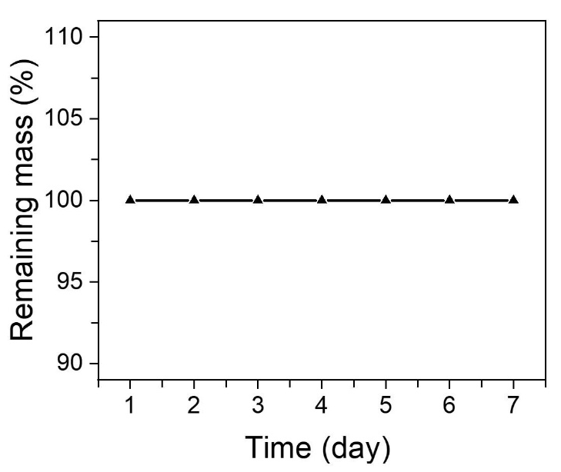
Supplementary Figure 1 Degradation experiment of SMPC-0.5 in 7 days.

