Swelling rate assay: First, the wet mass of the sample was measured after transferring to deionized water for up to 10 min to adequately absorb water, and recorded as w₀. Thereafter, samples were transferred to deionized water for up to 1, 5, 12, 24, 36, 48, 72 h. The wet mass was measured and recorded as w_{x}. The swelling rate of scaffolds was calculated using Eq. S1 (n = 6).
$$Swelling rate=\frac{(w_{x}-w_{0})}{w_{0}}×100\% (S1)$$

Degradation assay: The biodegradability of scaffolds was measured for up to 21 days in vitro. The samples were cut into small pieces (ca. 15 mg) and weighed as ‘m₀’ in the dry stare. Samples were added into 5 mL of EP tube containing 3 mL of PBS (pH = 7.28 ± 0.01) and incubated at 37 ℃ and 120 rpm. At pre-determined time points, samples were rinsed with the DI water three times and vacuum dried for up to a constant weight ‘m_{x}’. The degradation of scaffolds was calculated using Eq. S2 (n = 3).
$$Degradation mass=\frac{(m_{x}-m_{0})}{m_{0}}×100\% (S2)$$

Cumulative release: The release of Si and Sr ions from PG@PSiSr (ca. 25 mg) was assessed after immersion in 50 mL PBS solution at 37 °C for up to 7 days. At pre-determined time point (e.g., 3, 6, 12, 24, 48, 72, 120, 192 h, etc.), the solution was collected and an equal volume of the fresh solution was added. The concentration of the released Si and Sr ions was assayed by inductively-coupled plasma-atomic emission spectroscopy (ICP-AES, Prodigy Plus, Teledyne Leeman Labs, USA).

Western Blot Analysis: The protein expression levels of repaired skin at day 14 were detected by western blot, including interleukin-6 (IL-6), matrix metalloproteinases-9 (MMP-9), collagen type I (Col-Ⅰ), CD31, and β-actin protein. The total protein was extracted using a BCA Protein Assay kit. The samples were transferred to polyvinylidene fluoride (PVDF) membranes and analyzed by SDS-PAGE. Membranes were incubated with primary antibody and then washing with TBST buffer. Membranes were incubated with secondary antibodies for 2 h at RT, and then visualized by ECL reagent (Merck Millipore, Shanghai, China).

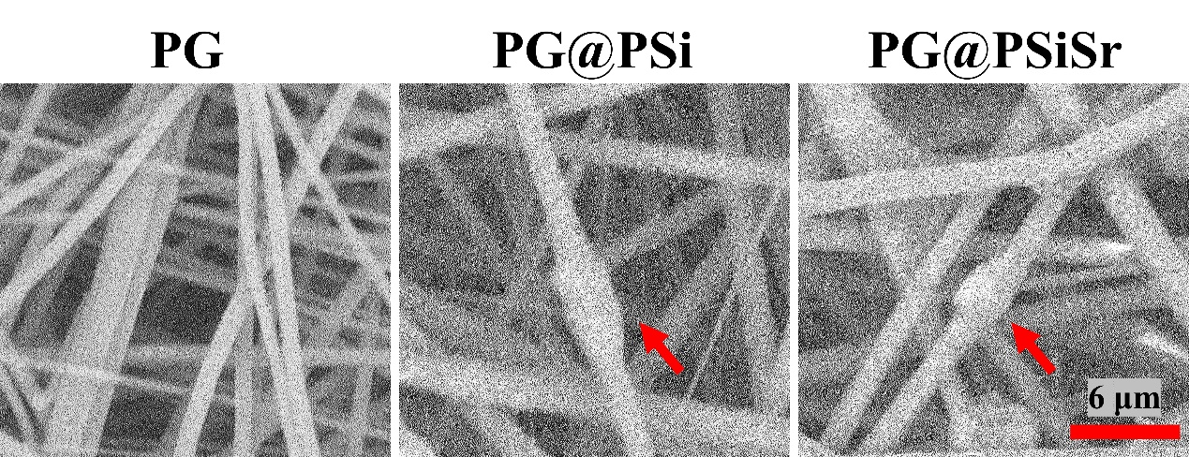
Fig. S1 The SEM of PG, PG@PSi, and PG@PSiSr scaffolds.

Fig. S2 The porosity of various scaffolds.

Fig. S3 The water absorption ratio of various scaffolds.

Fig. S4 Cumulative release of Si⁴⁺ and Sr²⁺ from PG@PSiSr.

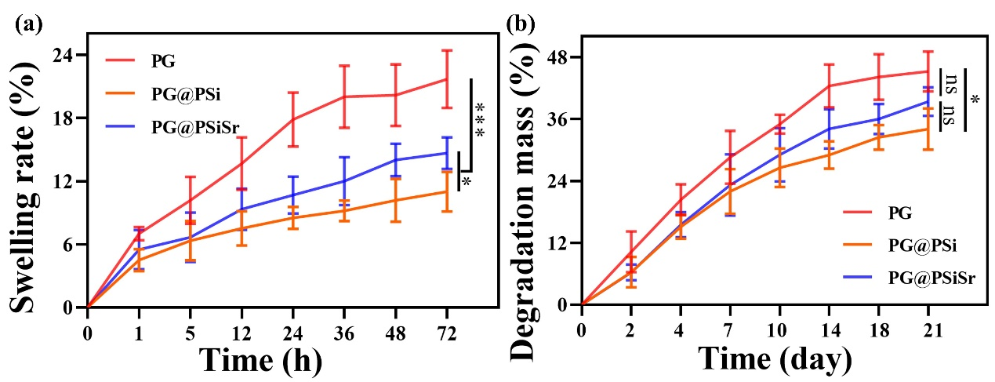
Fig. S5 The swelling rate (a) and residual weight (b) from the PG, PG@PSi, and PG@PSiSr scaffolds. The “ns” means no significant, *P < 0.05, **P < 0.01, and ***P < 0.001.

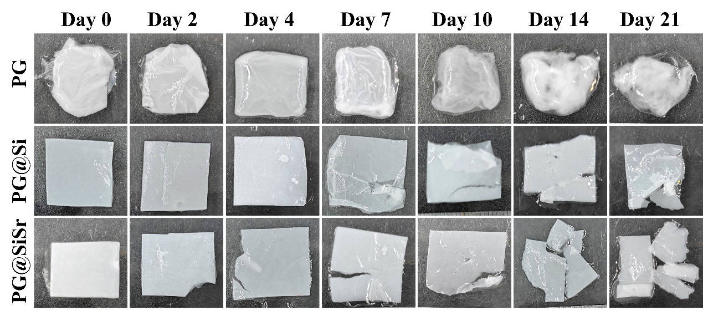
Fig. S6 The macroscopic appearance of wet PG, PG@PSi, and PG@PSiSr scaffolds after degradation for various time points.

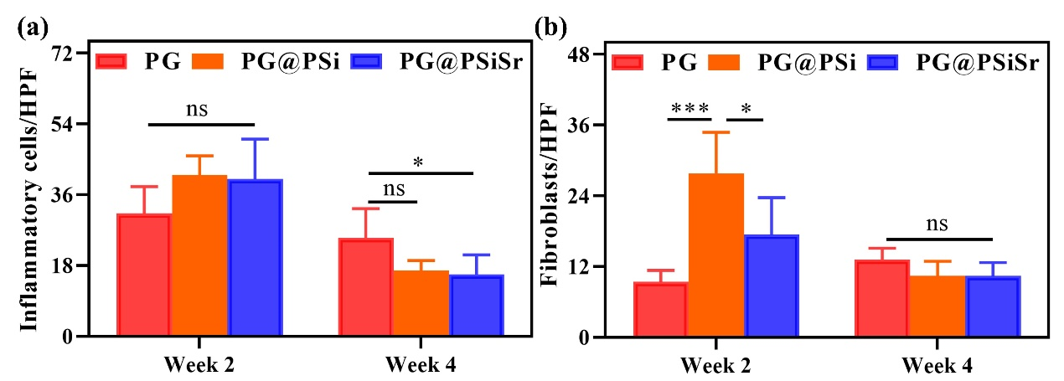
Fig. S7 The number of inflammatory cells (a) and fibroblasts (b) in a subcutaneous implantation model at 2 and 4 weeks. The “ns” means no significant, *P < 0.05, **P < 0.01, and ***P < 0.001.

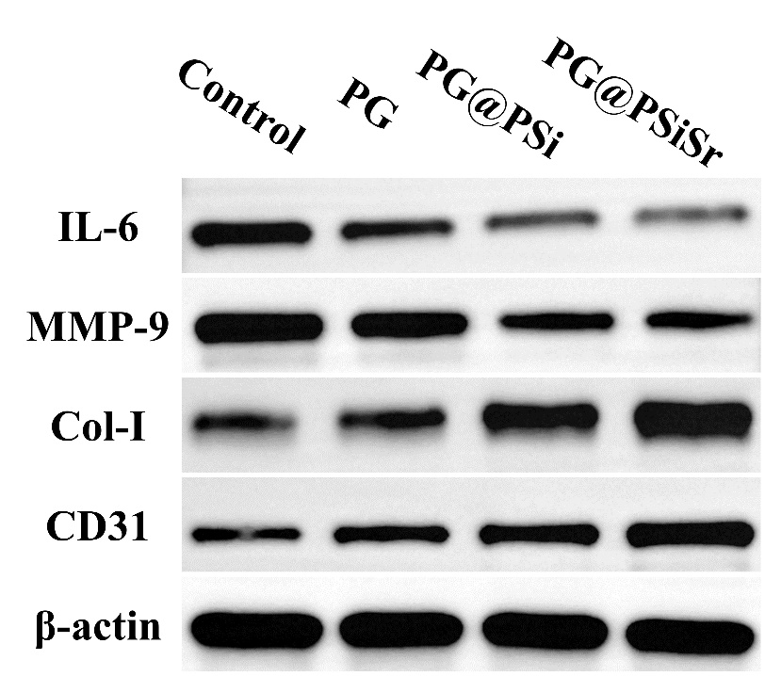
Fig. S8 Representative images of western blot analysis of IL-6, MMP-9, Col-Ⅰ, CD31, and β-actin.

Statistical analysis

Table S1: Water absorption
Name |  | Mean Diff. |  |  |  |  | 95.00% CI of diff. |  |  | Summary |  |  | P Value
PG vs. PG@PSi |  | 152.7 |  |  |  |  | 35.77 to 269.6 |  |  | * |  |  | 0.0166
PG vs. PG@PSiSr |  | 187.3 |  |  |  |  | 70.44 to 304.2 |  |  | ** |  |  | 0.0064
PG@PSi vs. PG@PSiSr |  | 34.67 |  |  |  |  | -82.23 to 151.6 |  |  | ns |  |  | 0.6543
Noted: The “ns” means no significant, *P < 0.05, **P < 0.01, and ***P < 0.001.
Table S2: Porosity of membranes
Name | Mean Diff. |  |  |  | 95.00% CI of diff. |  |  |  | Summary |  |  |  |  | P Value
PG vs. PG@PSi | 2.127 |  |  |  | -0.8595 to 5.113 |  |  |  | ns |  |  |  |  | 0.1526
PG vs. PG@PSiSr | 4.047 |  |  |  | 1.060 to 7.033 |  |  |  | * |  |  |  |  | 0.0141
PG@PSi vs. PG@PSiSr | 1.92 |  |  |  | -1.066 to 4.906 |  |  |  | ns |  |  |  |  | 0.1997
Noted: The “ns” means no significant, *P < 0.05, **P < 0.01, and ***P < 0.001.
Table S3: pH of the supernatant after degradation of the membranes
Name |  |  | Mean Diff. |  |  | 95.00% CI of diff. |  |  |  |  | Summary |  |  |  |  | P Value
PG vs. PG@Si |  |  | -0.2 |  |  | -0.3123 to -0.08765 |  |  |  |  | ** |  |  |  |  | 0.0038
PG vs. PG@SiSr |  |  | -0.3333 |  |  | -0.4457 to -0.2210 |  |  |  |  | *** |  |  |  |  | 0.0002
PG@Si vs. PG@SiSr |  |  | -0.1333 |  |  | -0.2457 to -0.02099 |  |  |  |  | * |  |  |  |  | 0.0252
Noted: The “ns” means no significant, *P < 0.05, **P < 0.01, and ***P < 0.001.
Table S4: Hemolysis rate of the scaffolds
Tukey's multiple comparisons test |  |  |  | Mean Diff. |  |  |  | 95.00% CI of diff. |  |  |  | Summary |  |  | Adjusted P Value
P-control vs. N-Control |  |  |  | 100 |  |  |  | 99.14 to 100.9 |  |  |  | **** |  |  | <0.0001
P-control vs. PG |  |  |  | 99.41 |  |  |  | 98.55 to 100.3 |  |  |  | **** |  |  | <0.0001
P-control vs. PG@PSi |  |  |  | 98.8 |  |  |  | 97.94 to 99.67 |  |  |  | **** |  |  | <0.0001
P-control vs. PG@PSiSr |  |  |  | 98.79 |  |  |  | 97.93 to 99.65 |  |  |  | **** |  |  | <0.0001
N-Control vs. PG |  |  |  | -0.5863 |  |  |  | -1.448 to 0.2750 |  |  |  | ns |  |  | 0.2954
N-Control vs. PG@Psi |  |  |  | -1.196 |  |  |  | -2.057 to -0.3343 |  |  |  | ** |  |  | 0.0034
N-Control vs. PG@PsiSr |  |  |  | -1.208 |  |  |  | -2.070 to -0.3471 |  |  |  | ** |  |  | 0.0031
PG vs. PG@PSi |  |  |  | -0.6093 |  |  |  | -1.471 to 0.2520 |  |  |  | ns |  |  | 0.2607
PG vs. PG@PSiSr |  |  |  | -0.6221 |  |  |  | -1.483 to 0.2392 |  |  |  | ns |  |  | 0.2427
PG@PSi vs. PG@PsiSr |  |  |  | -0.0128 |  |  |  | -0.8741 to 0.8485 |  |  |  | ns |  |  | >0.9999
Noted: The “ns” means no significant, *P < 0.05, **P < 0.01, and ***P < 0.001.

Table S5: OD value of NIH-3T3 fibroblasts at day 1
Tukey's multiple comparisons test | Mean Diff. | 95.00% CI of diff. | Summary | Adjusted P Value
Control vs. PG | -0.04174 | -0.09820 to 0.01472 | Ns | 0.1904
Control vs. PG@PSi | -0.06996 | -0.1264 to -0.01350 | * | 0.0129
Control vs. PG@PSiSr | -0.07916 | -0.1356 to -0.02270 | ** | 0.005
PG vs. PG@PSi | -0.02822 | -0.08468 to 0.02824 | Ns | 0.4999
PG vs. PG@PSiSr | -0.03742 | -0.09388 to 0.01904 | Ns | 0.2684
PG@PSi vs. PG@PsiSr | -0.0092 | -0.06566 to 0.04726 | Ns | 0.9654
Noted: The “ns” means no significant, *P < 0.05, **P < 0.01, and ***P < 0.001.
Table S6: OD value for NIH-3T3 fibroblasts at day 3
Tukey's multiple comparisons test | Mean Diff. | 95.00% CI of diff. | Summary | Adjusted P Value
Control vs. PG | -0.06874 | -0.1075 to -0.03000 | *** | 0.0006
Control vs. PG@PSi | -0.11 | -0.1487 to -0.07124 | **** | <0.0001
Control vs. PG@PSiSr | -0.1205 | -0.1593 to -0.08178 | **** | <0.0001
PG vs. PG@PSi | -0.04124 | -0.07998 to -0.002502 | * | 0.0349
PG vs. PG@PSiSr | -0.05178 | -0.09052 to -0.01304 | ** | 0.0073
PG@PSi vs. PG@PsiSr | -0.01054 | -0.04928 to 0.02820 | ns | 0.8631
Noted: The “ns” means no significant, *P < 0.05, **P < 0.01, and ***P < 0.001.
Table S7: OD value for NIH-3T3 fibroblasts at day 5
Tukey's multiple comparisons test | Mean Diff. | 95.00% CI of diff. | Summary | Adjusted P Value
Control vs. PG | -0.08008 | -0.2248 to 0.06460 | ns | 0.4149
Control vs. PG@PSi | -0.09352 | -0.2382 to 0.05116 | ns | 0.2877
Control vs. PG@PSiSr | -0.1477 | -0.2924 to -0.003018 | * | 0.0446
PG vs. PG@PSi | -0.01344 | -0.1581 to 0.1312 | ns | 0.9932
PG vs. PG@PSiSr | -0.06762 | -0.2123 to 0.07706 | ns | 0.554
PG@PSi vs. PG@PSiSr | -0.05418 | -0.1989 to 0.09050 | ns | 0.7112
Noted: The “ns” means no significant, *P < 0.05, **P < 0.01, and ***P < 0.001.
Table S8: OD value for HUVECs at day 1
Tukey's multiple comparisons test | Mean Diff. | 95.00% CI of diff. | Summary | Adjusted P Value
Control vs. PG | -0.01653 | -0.02996 to -0.003094 | * | 0.0151
Control vs. PG@PSi | -0.00975 | -0.02318 to 0.003681 | ns | 0.1911
Control vs. PG@PSiSr | -0.000225 | -0.01366 to 0.01321 | ns | >0.9999
PG vs. PG@PSi | 0.006775 | -0.006656 to 0.02021 | ns | 0.4685
PG vs. PG@PSiSr | 0.0163 | 0.002869 to 0.02973 | * | 0.0165
PG@PSi vs. PG@PSiSr | 0.009525 | -0.003906 to 0.02296 | ns | 0.2061
Noted: The “ns” means no significant, *P < 0.05, **P < 0.01, and ***P < 0.001.

Table S9: OD value for HUVECs at day 3
Tukey's multiple comparisons test | Mean Diff. | 95.00% CI of diff. | Summary | Adjusted P Value
Control vs. PG | -0.02023 | -0.1046 to 0.06419 | ns | 0.8907
Control vs. PG@PSi | -0.0439 | -0.1283 to 0.04052 | ns | 0.4437
Control vs. PG@PSiSr | -0.04283 | -0.1272 to 0.04159 | ns | 0.4639
PG vs. PG@PSi | -0.02368 | -0.1081 to 0.06074 | ns | 0.8381
PG vs. PG@PSiSr | -0.0226 | -0.1070 to 0.06182 | ns | 0.8555
PG@PSi vs. PG@PSiSr | 0.001075 | -0.08334 to 0.08549 | ns | >0.9999
Noted: The “ns” means no significant, *P < 0.05, **P < 0.01, and ***P < 0.001.
Table S10: OD value for HUVECs at day 5
Tukey's multiple comparisons test | Mean Diff. | 95.00% CI of diff. | Summary | Adjusted P Value
Control vs. PG | -0.05365 | -0.1687 to 0.06144 | ns | 0.5317
Control vs. PG@PSi | -0.076 | -0.1911 to 0.03909 | ns | 0.2554
Control vs. PG@PSiSr | -0.0864 | -0.2015 to 0.02869 | ns | 0.1706
PG vs. PG@PSi | -0.02235 | -0.1374 to 0.09274 | ns | 0.9372
PG vs. PG@PSiSr | -0.03275 | -0.1478 to 0.08234 | ns | 0.8323
PG@PSi vs. PG@PSiSr | -0.0104 | -0.1255 to 0.1047 | ns | 0.9929
Noted: The “ns” means no significant, *P < 0.05, **P < 0.01, and ***P < 0.001.
Table S11: Transwell assay for HUVECs
Tukey's multiple comparisons test | Mean Diff. | 95.00% CI of diff. | Summary | P Value
Control vs. PG | -19.67 | -40.45 to 1.114 | ns | 0.0637
Control vs. PG@PSi | -28.33 | -49.11 to -7.552 | * | 0.0103
Control vs. PG@PSiSr | -48.33 | -69.11 to -27.55 | *** | 0.0003
PG vs. PG@PSi | -8.667 | -29.45 to 12.11 | ns | 0.5681
PG vs. PG@PSiSr | -28.67 | -49.45 to -7.886 | ** | 0.0096
PG@PSi vs. PG@PsiSr | -20 | -40.78 to 0.7810 | ns | 0.0592
Noted: The “ns” means no significant, *P < 0.05, **P < 0.01, and ***P < 0.001.
Table S12: Transwell assay for NIH-3T3 fibroblasts
Tukey's multiple comparisons test | Mean Diff. | 95.00% CI of diff. | Summary | P Value
Control vs. PG | -14 | -22.41 to -5.595 | ** | 0.0031
Control vs. PG@PSi | -44 | -52.41 to -35.59 | **** | <0.0001
Control vs. PG@PSiSr | -48 | -56.41 to -39.59 | **** | <0.0001
PG vs. PG@PSi | -30 | -38.41 to -21.59 | **** | <0.0001
PG vs. PG@PSiSr | -34 | -42.41 to -25.59 | **** | <0.0001
PG@PSi vs. PG@PsiSr | -4 | -12.41 to 4.405 | ns | 0.4678
Noted: The “ns” means no significant, *P < 0.05, **P < 0.01, and ***P < 0.001.

Table S13: Tube-formation assay for HUVECs
Tukey's multiple comparisons test | Mean Diff. | 95.00% CI of diff. | Summary | P Value
Control vs. PG | -13.33 | -27.67 to 1.008 | ns | 0.0687
Control vs. PG@Si | -27 | -41.34 to -12.66 | ** | 0.0014
Control vs. PG@SiSr | -37 | -51.34 to -22.66 | *** | 0.0002
PG vs. PG@Si | -13.67 | -28.01 to 0.6746 | ns | 0.0618
PG vs. PG@SiSr | -23.67 | -38.01 to -9.325 | ** | 0.0033
PG@Si vs. PG@SiSr | -10 | -24.34 to 4.341 | ns | 0.194
Noted: The “ns” means no significant, *P < 0.05, **P < 0.01, and ***P < 0.001.
Table S14: Migration assay for NIH-3T3 fibroblasts
Tukey's multiple comparisons test | Mean Diff. | 95.00% CI of diff. | Summary | P Value
Control vs. PG | -4.833 | -15.26 to 5.590 | ns | 0.4879
Control vs. PG@PSi | -31.94 | -42.36 to -21.52 | **** | <0.0001
Control vs. PG@PSiSr | -41.75 | -52.17 to -31.33 | **** | <0.0001
PG vs. PG@PSi | -27.11 | -37.53 to -16.68 | *** | 0.0002
PG vs. PG@PSiSr | -36.92 | -47.34 to -26.49 | **** | <0.0001
PG@PSi vs. PG@PsiSr | -9.81 | -20.23 to 0.6135 | ns | 0.0652
Noted: The “ns” means no significant, *P < 0.05, **P < 0.01, and ***P < 0.001.
Table S15: Migration assay for HUVECs
Tukey's multiple comparisons test | Mean Diff. | 95.00% CI of diff. | Summary | P Value
Control vs. PG | -5.653 | -22.97 to 11.66 | ns | 0.7294
Control vs. PG@PSi | -42.07 | -59.39 to -24.75 | *** | 0.0002
Control vs. PG@PSiSr | -48.99 | -66.31 to -31.67 | **** | <0.0001
PG vs. PG@PSi | -36.42 | -53.73 to -19.10 | *** | 0.0007
PG vs. PG@PSiSr | -43.34 | -60.65 to -26.02 | *** | 0.0002
PG@PSi vs. PG@PsiSr | -6.92 | -24.24 to 10.40 | ns | 0.5991
Noted: The “ns” means no significant, *P < 0.05, **P < 0.01, and ***P < 0.001.
Table S16: Thickness of Granulation tissues
Tukey's multiple comparisons test | Mean Diff. | 95.00% CI of diff. | Summary | P Value
Control vs. P-control | -0.006333 | -0.07870 to 0.06603 | ns | 0.9982
Control vs. PG | -0.01567 | -0.08803 to 0.05670 | ns | 0.9489
Control vs. PG@PSi | -0.03433 | -0.1067 to 0.03803 | ns | 0.5502
Control vs. PG@PSiSr | -0.067 | -0.1394 to 0.005367 | ns | 0.073
P-control vs. PG | -0.009333 | -0.08170 to 0.06303 | ns | 0.9921
P-control vs. PG@PSi | -0.028 | -0.1004 to 0.04437 | ns | 0.712
P-control vs. PG@PSiSr | -0.06067 | -0.1330 to 0.01170 | ns | 0.1133
PG vs. PG@PSi | -0.01867 | -0.09103 to 0.05370 | ns | 0.9089
PG vs. PG@PSiSr | -0.05133 | -0.1237 to 0.02103 | ns | 0.2111
PG@PSi vs. PG@PSiSr | -0.03267 | -0.1050 to 0.03970 | ns | 0.5927
Noted: The “ns” means no significant, *P < 0.05, **P < 0.01, and ***P < 0.001.

Table S17: Wound healing at day 14
Tukey's multiple comparisons test |  | Mean Diff. |  | 95.00% CI of diff. |  | Summary |  | P Value
Control vs. P-control |  | -7.87 |  | -20.66 to 4.917 |  | ns |  | 0.3209
Control vs. PG |  | -15.89 |  | -28.68 to -3.103 |  | * |  | 0.0146
Control vs. PG@PSi |  | -20.55 |  | -33.33 to -7.760 |  | ** |  | 0.0025
Control vs. PG@PSiSr |  | -24.41 |  | -37.19 to -11.62 |  | *** |  | 0.0007
P-control vs. PG |  | -8.02 |  | -20.81 to 4.767 |  | ns |  | 0.3052
P-control vs. PG@PSi |  | -12.68 |  | -25.46 to 0.1104 |  | ns |  | 0.0523
P-control vs. PG@PSiSr |  | -16.54 |  | -29.32 to -3.750 |  | * |  | 0.0113
PG vs. PG@PSi |  | -4.657 |  | -17.44 to 8.130 |  | ns |  | 0.7525
PG vs. PG@PSiSr |  | -8.517 |  | -21.30 to 4.270 |  | ns |  | 0.2573
PG@PSi vs. PG@PSiSr |  | -3.86 |  | -16.65 to 8.927 |  | ns |  | 0.8525
Noted: The “ns” means no significant, *P < 0.05, **P < 0.01, and ***P < 0.001.
Table S18: Collagen deposition
Tukey's multiple comparisons test | Mean Diff. |  | 95.00% CI of diff. |  | Summary |  | P Value
Control vs. P-control | -0.4167 |  | -13.53 to 12.70 |  | ns |  | >0.9999
Control vs. PG | -3.723 |  | -16.84 to 9.389 |  | ns |  | 0.8771
Control vs. PG@PSi | -10.58 |  | -23.70 to 2.529 |  | ns |  | 0.1321
Control vs. PG@PSiSr | -18.23 |  | -31.35 to -5.121 |  | ** |  | 0.007
P-control vs. PG | -3.307 |  | -16.42 to 9.806 |  | ns |  | 0.9152
P-control vs. PG@PSi | -10.17 |  | -23.28 to 2.946 |  | ns |  | 0.1543
P-control vs. PG@PSiSr | -17.82 |  | -30.93 to -4.704 |  | ** |  | 0.0082
PG vs. PG@PSi | -6.86 |  | -19.97 to 6.252 |  | ns |  | 0.4636
PG vs. PG@PSiSr | -14.51 |  | -27.62 to -1.398 |  | * |  | 0.029
PG@PSi vs. PG@PSiSr | -7.65 |  | -20.76 to 5.462 |  | ns |  | 0.3667
Noted: The “ns” means no significant, *P < 0.05, **P < 0.01, and ***P < 0.001.
Table S19: Wound area at day 4
Tukey's multiple comparisons test | Mean Diff. | 95.00% CI of diff. | Summary | P Value
Control vs. P-control | 1.127 | -30.03 to 32.29 | ns | >0.9999
Control vs. PG | 6.233 | -24.93 to 37.39 | ns | 0.9611
Control vs. PG@PSi | 26.34 | -4.825 to 57.50 | ns | 0.1095
Control vs. PG@PSiSr | 42.11 | 10.95 to 73.27 | ** | 0.0085
P-control vs. PG | 5.107 | -26.05 to 36.27 | ns | 0.9809
P-control vs. PG@PSi | 25.21 | -5.951 to 56.37 | ns | 0.1309
P-control vs. PG@PSiSr | 40.98 | 9.819 to 72.14 | * | 0.0102
PG vs. PG@PSi | 20.1 | -11.06 to 51.26 | ns | 0.2823
PG vs. PG@PSiSr | 35.87 | 4.712 to 67.03 | * | 0.0231
PG@PSi vs. PG@PSiSr | 15.77 | -15.39 to 46.93 | ns | 0.4933
Noted: The “ns” means no significant, *P < 0.05, **P < 0.01, and ***P < 0.001.
Table S20: Wound area at day 7
Tukey's multiple comparisons test | Mean Diff. | 95.00% CI of diff. | Summary | P Value
Control vs. P-control | 36.67 | -3.904 to 77.24 | ns | 0.0816
Control vs. PG | 67.51 | 26.94 to 108.1 | ** | 0.0019
Control vs. PG@PSi | 79.82 | 39.25 to 120.4 | *** | 0.0005
Control vs. PG@PSiSr | 82.85 | 42.28 to 123.4 | *** | 0.0004
P-control vs. PG | 30.84 | -9.731 to 71.41 | ns | 0.166
P-control vs. PG@PSi | 43.15 | 2.579 to 83.72 | * | 0.0361
P-control vs. PG@PSiSr | 46.18 | 5.609 to 86.75 | * | 0.0247
PG vs. PG@PSi | 12.31 | -28.26 to 52.88 | ns | 0.8503
PG vs. PG@PSiSr | 15.34 | -25.23 to 55.91 | ns | 0.7279
PG@PSi vs. PG@PSiSr | 3.03 | -37.54 to 43.60 | ns | 0.999
Noted: The “ns” means no significant, *P < 0.05, **P < 0.01, and ***P < 0.001.
Table S21: Wound area at day 10
Tukey's multiple comparisons test | Mean Diff. | 95.00% CI of diff. | Summary | P Value
Control vs. P-control | 7.647 | -13.41 to 28.70 | ns | 0.7542
Control vs. PG | 22.08 | 1.027 to 43.13 | * | 0.039
Control vs. PG@PSi | 29.81 | 8.754 to 50.86 | ** | 0.0062
Control vs. PG@PSiSr | 48.67 | 27.62 to 69.72 | *** | 0.0001
P-control vs. PG | 14.43 | -6.619 to 35.49 | ns | 0.2355
P-control vs. PG@PSi | 22.16 | 1.107 to 43.21 | * | 0.0382
P-control vs. PG@PSiSr | 41.02 | 19.97 to 62.08 | *** | 0.0006
PG vs. PG@PSi | 7.727 | -13.33 to 28.78 | ns | 0.7475
PG vs. PG@PSiSr | 26.59 | 5.537 to 47.64 | * | 0.0132
PG@PSi vs. PG@PSiSr | 18.86 | -2.189 to 39.92 | ns | 0.0848
Noted: The “ns” means no significant, *P < 0.05, **P < 0.01, and ***P < 0.001.
Table S22: Wound area at day 14
Tukey's multiple comparisons test | Mean Diff. | 95.00% CI of diff. | Summary | P Value
Control vs. P-control | 19.46 | -8.059 to 46.97 | ns | 0.2133
Control vs. PG | 34.18 | 6.668 to 61.70 | * | 0.0146
Control vs. PG@PSi | 40.42 | 12.90 to 67.94 | ** | 0.0048
Control vs. PG@PSiSr | 52.55 | 25.03 to 80.06 | *** | 0.0007
P-control vs. PG | 14.73 | -12.79 to 42.24 | ns | 0.4432
P-control vs. PG@PSi | 20.96 | -6.552 to 48.48 | ns | 0.1646
P-control vs. PG@PSiSr | 33.09 | 5.575 to 60.61 | * | 0.0178
PG vs. PG@PSi | 6.237 | -21.28 to 33.75 | ns | 0.9403
PG vs. PG@PSiSr | 18.36 | -9.152 to 45.88 | ns | 0.2557
PG@PSi vs. PG@PSiSr | 12.13 | -15.39 to 39.64 | ns | 0.6126
Noted: The “ns” means no significant, *P < 0.05, **P < 0.01, and ***P < 0.001.

