Nomogram Development and Validation for Predicting Postoperative Recurrent Lumbar Disc Herniation Based on Paraspinal Muscle Parameters

Supplementary Material
1. Supplementary information
1. Surgical Approach
2. MRI Parameters and Imaging Manifestations of Intervertebral Disc Degeneration
3. Statistical Analysis Details
2. Supplementary tables
1. Table S1 Characteristics of Recurrence and No-recurrence Groups
2. Table S2 Comparison of Contralateral and Ipsilateral Muscle Parameters
3. Table S3 The Intraclass Correlation Coefficient of The Muscle Parameters of The Two Readers
4. Table S4 Nomogram Predicts the Diagnostic Performance of PRLDH Based on Age/Gender Subgroups
3. Supplementary figures
1. Figure S1 Comparison of ROC of Nomogram and Other Independent Factors
2. Figure S2 Transparent Reporting of a Multivariable Prediction Model for Individual Prognosis or Diagnosis (TRIPOD)

1. Supplementary information
S1. Surgical Approach
All patients underwent PETD surgery (taking L4/5 as an example), completed routine preparation, and took the affected side up lateral position. Using the Maxmore intervertebral foramen endoscope (1001-TS 001, Germany Hoogland Spine Product GmbHg), the intervertebral foramen approach was adopted. The puncture point was located at the intersection of the body surface projection of the tip of the upper articular process to the posterior upper edge of the lower vertebra under lateral fluoroscopy and the body surface projection of the midpoint of the line connecting the tip of the upper articular process to the upper edge of the lower vertebra under anteroposterior fluoroscopy as the body surface puncture point. Local infiltration anesthesia was used. An 18 G puncture needle was used to puncture the superior articular process, and a guide wire was inserted through the puncture needle. Then, the surgical approach was gradually expanded with an expansion sheath, and a TOMShidi point sheath was inserted. A first-level TOM needle was used to puncture the tip of the superior articular process. After successful puncture, a second-level TOM needle was used to expand the channel. Then, 4, 6, and 7 mm bone drills were used to enlarge the puncture channel and grind the tip of the superior articular process. After successful grinding, the working sheath was smoothly inserted through the intervertebral foramen. Under the anteroposterior view, the working cannula head is close to the midline, and under the lateral view, it is located within the spinal canal behind the line of the posterior edge of the lumbar vertebrae. Then connect the imaging system and use a nucleus forceps to clamp and remove the protruding nucleus tissue under the endoscope, and check whether there is any residual nucleus tissue, observe the nerve root compression relief, good congestion activity, normal dural sac pulsation, and use low-temperature plasma ablation to stop bleeding if there is any bleeding during the operation. At the end of the operation, pull out the working cannula and suture the incision.

S2. MRI Parameters and Imaging Manifestations of Intervertebral Disc Degeneration
All patients underwent 3.0T MRI examination (Signa HDxt, Siemens, Germany) before surgery, and T2-weighted axial images were obtained. The relevant parameters were TR/TE=3200/950, slice thickness 4mm, field of view 260mm, matrix 256±512.
The Pfirrmann grading was assessed on T2-weighted sagittal images as follows: Grade I represented a normal disc structure and height with bright signal; Grade II indicated abnormal disc structure, normal height, and a white signal with distinct demarcation between the nucleus pulposus and annulus fibrosus; Grade III exhibited abnormal disc structure, slightly reduced or normal height, a gray signal, and unclear demarcation between the nucleus pulposus and annulus fibrosus; Grade IV showed abnormal disc structure, moderately reduced or normal height, a dark gray signal, and the absence of demarcation between the nucleus pulposus and annulus fibrosus; Grade V depicted abnormal disc structure with collapse and the absence of demarcation between the nucleus pulposus and annulus fibrosus.
The Modic changes were assessed on T1 and T2-weighted sagittal images: Normal showed isointensity on T1WI and T2WI; Type I displayed hypointensity on T1WI and hyperintensity on T2WI; Type II exhibited hyperintensity on both T1WI and T2WI, or isointensity on T2WI; and Type III revealed hypointensity on both T1WI and T2WI.

S3. Statistical Analysis Details
All statistical analyses were conducted using R Studio software (v4.2.3, http://www.rproject.org/). The normality of continuous data was assessed using the Shapiro-Wilk test. Normally distributed metric data were expressed as mean ± standard deviation (x±s), and comparisons between groups were performed using independent samples t-test. Non-normally distributed metric data were represented as median (P25, P75), and group comparisons were made using the Mann-Whitney U test. Categorical data were presented as frequencies (%), and group comparisons were conducted using the chi-square test or Fisher's exact probability test. The consistency of the measurement data of the two readers was analyzed by intra-class correlation coefficient (ICC), and the result ≥0.75 indicated good consistency. Predictive factors associated with PRLDH were determined using Least Absolute Shrinkage and Selection Operator (LASSO) regression. After incorporating these factors into a multivariable logistic regression analysis, we assessed multicollinearity using tolerance and variance inflation factor tests, ultimately selecting variables with P<0.05 significance.
After obtaining the variables from the Logistic regression model, the Nomogram was constructed using the "nomogramFormula" package. The model's accuracy was evaluated by performing 1,000 enhanced bootstrap resampling using the "pROC" package to generate the Receiver Operating Characteristic (ROC) curve. The calibration of the model was assessed by employing the "rms" package to generate calibration curves (1,000 enhanced bootstrap resampling) and conducting the Hosmer-Lemeshow goodness-of-fit test. meanwhile, to validate the clinical utility of the model, decision curve analysis (DCA) and clinical impact curve (CIC) were plotted using the "rmda" package. Statistical significance was set at P<0.05.

2. Supplementary tables
Table S1. Characteristics of Recurrence and No-recurrence Groups.
Characteristics | Recurrence (n=26) | No-recurrence (n=206) | t/z/χ² | P
Age | 50.42±11.48 | 53.26±14.15 | 0.983 | 0.327
Gender (Male) | 16(61.54%) | 124(60.19%) | 0.000 | 1.000
BMI(kg/m²) | 25.94±2.58 | 24.19±2.72 | 3.115 | 0.002#
Height (cm) | 167.50±9.60 | 166.50±7.64 | 0.613 | 0.541
Diabetes | 6(23.08%) | 18(8.74%) | 3.689 | 0.055
Hypertension | 7(26.92%) | 56(27.18%) | <0.001 | 1.000
Smoking | 11(42.31%) | 66(32.04%) | 0.684 | 0.408
Drinking | 5(19.23%) | 40(19.42%) | <0.001 | 1.000
Preoperative VAS score * | 5(5, 6) | 5(5, 6) | 10.470 | 0.682
Postoperative VAS score * | 2(2, 3) | 2(2,3) | 11.352 | 0.007#
Educational level |  |  | 6.508 | 0.039#
Primary school≤ | 4(15.38%) | 68(33.01%)
Secondary and High school | 19(73.08%) | 96(46.60%)
≥College | 3(11.54%) | 42(20.39%)
Occupation |  |  | 9.183 | 0.057
Unemployed | 8(30.77%) | 55(26.70%)
Laborer | 6(23.08%) | 26(12.62%)
Farmer | 4(15.38%) | 57(27.67%)
Office worker | 1(3.85%) | 40(19.42%)
Self-employed households | 7(26.92%) | 28(17.39%)
Course of disease (months)* | 30(6, 48) | 12(3, 60) | 10.740 | 0.629
Hospital stay (days)* | 11.92±3.20 | 11.49±2.94 | 0.707 | 0.480
Duration of surgery(min) | 72.19±12.17 | 69.31±11.45 | 1.201 | 0.231
Pfirrmann grade |  |  | 6.488 | 0.166
I | 0(0.00%) | 31(15.05%)
Ⅱ | 14(53.85%) | 114(55.34%)
Ⅲ | 12(46.15%) | 59(28.64%)
Ⅳ | 0(0.00%) | 1(0.49%)
Ⅴ | 0(0.00%) | 1(0.49%)
Modic change |  |  | 28.639 | <0.001#
Nomral | 9(34.62%) | 154(74.76%)
Type I | 3(11.54%) | 1(0.49%)
Type II | 13(50.00%) | 47(22.82%)
Type III | 1(3.85%) | 4(1.94%)
IDA | 9.89±5.08 | 8.32±4.87 | 1.546 | 0.124
Left FJA (°) | 42.15±11.20 | 44.81±10.52 | 1.206 | 0.229
Right FJA (°) | 45.56±13.54 | 46.07±12.03 | 0.204 | 0.838
SFCSA(%)
contralesional multifidus | 32.29±9.11 | 38.29±14.21 | 10.002 | 0.063
ipsilesional multifidus | 27.69±11.26 | 37.92±13.62 | 3.673 | <0.001#
contralesional erector spinae | 38.83±10.66 | 49.34±18.62 | 9.711 | 0.005#
ipsilesional erector spinae | 33.90±11.58 | 49.85±18.84 | 4.212 | <0.001#
contralesional psoas major | 63.55±20.03 | 65.13±19.28 | 0.392 | 0.696
ipsilesional psoas major | 64.93±21.70 | 65.69±20.60 | 0.176 | 0.860
SMI(mm²/m²)
contralesional multifidus | 212.12±68.78 | 292.02±103.33 | 3.833 | <0.001#
ipsilesional multifidus | 181.55±77.82 | 288.98±99.02 | 5.325 | <0.001#
contralesional erector spinae | 257.10±84.97 | 381.50±149.65 | 4.149 | <0.001#
ipsilesional erector spinae | 224.31±89.43 | 386.40±157.27 | 5.146 | <0.001#
contralesional psoas major | 414.10±130.00 | 506.90±174.01 | 2.626 | 0.009#
ipsilesional psoas major | 425.60±152.48 | 510.90±175.90 | 2.363 | 0.019#
Herniation type |  |  | 0.237 | 0.626
herniation | 16(61.54%) | 141(68.45%)
prolapse | 10(38.46%) | 65(31.55%)
Herniation Segments |  |  | 1.152 | 0.562
L4/5 | 11(42.31%) | 109(52.91%)
L5/S1 | 13(50.00%) | 81(39.32%)
Others | 2(7.69%) | 16(7.77%)
BMI: Body Mass Index; IDA: Intervertebral Disc Angle; FJA: Facet Joint Angle; SFCSA: Standardized Functional Cross-Sectional Area = Paraspinal Muscle FCSA / Same-Level Vertebral Surface Area × 100%; SMI: Skeletal Muscle Index = Paraspinal Muscle FCSA (mm²) / Height2 (m²).
*Median (P25, P75); #Bold font indicates statistical significance.

Table S2. Comparison of Contralateral and Ipsilateral Muscle Parameters
 | Contralesional | Ipsilesional | t | P
Total (n=232)
Multifidus SFCSA (%) | 37.61±13.84 | 36.77±13.74 | 0.657 | 0.511
Erector spinae SFCSA (%) | 48.16±18.20 | 48.06±18.84 | 0.059 | 0.953
Psoas major SFCSA (%) | 64.95±19.32 | 65.60±20.68 | 0.350 | 0.727
Multifidus SMI (mm²/m²) | 283.06±103.08 | 276.94±102.52 | 0.641 | 0.522
Erector spinae SMI (mm²/m²) | 367.54±149.00 | 368.27±159.51 | 0.051 | 0.959
Psoas major SMI (mm²/m²) | 496.50±171.93 | 501.30±175.22 | 0.297 | 0.767
Recurrence (n=26)
Multifidus SFCSA (%) | 32.30±9.11 | 27.69±11.26 | 1.622 | 0.111
Erector spinae SFCSA (%) | 38.83±10.66 | 33.90±11.58 | 1.597 | 0.117
Psoas major SFCSA (%) | 63.55±20.03 | 64.93±21.70 | 0.238 | 0.813
Multifidus SMI (mm²/m²) | 212.12±68.78 | 181.55±77.82 | 1.501 | 0.140
Erector spinae SMI (mm²/m²) | 257.10±84.97 | 224.31±89.43 | 1.356 | 0.181
Psoas major SMI (mm²/m²) | 414.10±130.00 | 425.60±152.48 | 0.291 | 0.773
No-recurrence (n=206)
Multifidus SFCSA (%) | 38.29±14.21 | 37.92±13.62 | 0.268 | 0.789
Erector spinae SFCSA (%) | 49.34±18.62 | 49.85±18.84 | 0.276 | 0.783
Psoas major SFCSA (%) | 65.13±19.28 | 65.69±20.60 | 0.284 | 0.777
Multifidus SMI (mm²/m²) | 292.02±103.33 | 288.98±99.02 | 0.304 | 0.761
Erector spinae SMI (mm²/m²) | 381.50±149.65 | 386.40±157.27 | 0.328 | 0.743
Psoas major SMI (mm²/m²) | 506.90±174.01 | 510.90±175.90 | 0.229 | 0.819
Recurrence vs. No-recurrence
Multifidus SFCSA-1 (%) | 38.29±14.21 | 27.69±11.26 | 3.660 | <0.001#
Erector spinae SFCSA-1 (%) | 49.34±18.62 | 33.90±11.58 | 4.123 | <0.001#
Psoas major SFCSA-1 (%) | 65.13±19.27 | 64.93±21.70 | 0.050 | 0.960
Multifidus SFCSA-2 (%) | 32.29±9.11 | 37.92±13.62 | 2.046 | 0.042#
Erector spinae SFCSA-2 (%) | 38.83±10.66 | 49.85±18.84 | 2.920 | 0.004#
Psoas major SFCSA-2 (%) | 63.55±20.03 | 65.69±20.60 | 0.500 | 0.618
Multifidus SMI-1 (mm²/m²) | 292.02±103.33 | 181.55±77.82 | 5.262 | <0.001#
Erector spinae SMI-1 (mm²/m²) | 381.50±149.65 | 224.31±89.43 | 5.233 | <0.001#
Psoas major SMI-1 (mm²/m²) | 506.90±174.01 | 425.60±152.48 | 2.276 | 0.024#
Multifidus SMI-2 (mm²/m²) | 212.12±68.78 | 288.98±99.02 | 3.839 | <0.001#
Erector spinae SMI-2 (mm²/m²) | 257.10±84.97 | 386.40±157.27 | 4.113 | <0.001#
Psoas major SMI-2 (mm²/m²) | 414.10±130.00 | 510.90±175.90 | 2.711 | 0.007#
SFCSA: Standardized Functional Cross-Sectional Area = Paraspinal Muscle FCSA / Same-Level Vertebral Surface Area × 100%; SMI: Skeletal Muscle Index = Paraspinal Muscle FCSA (mm²) / Height2 (m²).
Multifidus SFCSA-1 is the comparison between the ipsilesional muscle parameters of recurrent patients and the contralesional muscle parameters of non-recurrent patients; Multifidus SFCSA-2 is the comparison between the contralesional muscle parameters of recurrent patients and the ipsilesional muscle parameters of non-recurrent patients, and so on and so forth.
*Median (P25, P75); #Bold font indicates statistical significance.

Table S3. The Intraclass Correlation Coefficient of The Muscle Parameters of The Two Readers
 | Reader A | Reader B | ICC
SFCSA(%)
contralesional multifidus | 37.36±14.23 | 37.67±15.01 | 0.887
ipsilesional multifidus | 36.53±13.96 | 36.99±14.56 | 0.894
contralesional erector spinae | 48.45±19.81 | 48.06±18.53 | 0.867
ipsilesional erector spinae | 48.30±19.45 | 47.97±18.97 | 0.891
contralesional psoas major | 65.17±21.21 | 64.01±19.87 | 0.875
ipsilesional psoas major | 65.70±22.02 | 65.21±21.82 | 0.869
SMI(mm²/m²)
contralesional multifidus | 283.24±113.22 | 282.41±114.85 | 0.852
ipsilesional multifidus | 276.95±112.51 | 276.80±114.48 | 0.847
contralesional erector spinae | 367.76±155.27 | 367.06±161.01 | 0.877
ipsilesional erector spinae | 370.31±166.91 | 368.78±169.22 | 0.885
contralesional psoas major | 494.10±184.07 | 502.60±181.95 | 0.902
ipsilesional psoas major | 498.80±178.68 | 504.50±184.77 | 0.922
SFCSA: Standardized Functional Cross-Sectional Area = Paraspinal Muscle FCSA / Same-Level Vertebral Surface Area × 100%; SMI: Skeletal Muscle Index = Paraspinal Muscle FCSA (mm²) / Height2 (m²); ICC: Intraclass correlation coefficient.

Table S4. Nomogram Predicts the Diagnostic Performance of PRLDH Based on Age/Gender Subgroups
 | AUC  (95%CI) | Accuracy | Sensitivity  (95%CI) | Specificity  (95%CI) | PPV  (95%CI) | NPV  (95%CI)
Age < 60 | 0.914  (0.855, 0.973) | 0.828 | 1.000  (0.715, 1.000) | 0.807  (0.709, 0.883) | 0.393  (0.215, 0.594) | 1.000  (0.949, 1.000)
Age ≥ 60 | 0.950  (0.868, 1.000) | 0.829 | 1.000  (0.478, 1.000) | 0.806  (0.640, 0.918) | 0.417  (0.152, 0.723) | 1.000  (0.881, 1.000)
Male | 0.915  (0.851, 0.978) | 0.821 | 0.909  (0.587, 0.998) | 0.806  (0.691, 0.892) | 0.435  (0.232, 0.655) | 0.982  (0.903, 1.000)
Female | 0.972  (0.929, 1.000) | 0.936 | 1.000  (0.478, 1.000) | 0.930  (0.830, 0.981) | 0.556  (0.212, 0.863) | 1.000  (0.933, 1.000)
Accuracy, sensitivity, and specificity are all obtained by evaluating the performance using the cutoff value when the Youden index is maximized. Subgroup analysis was performed using Age (60 years old), and the p-value was obtained by Delong test as 0.4906. Subgroup analysis was performed using gender, and the p-value was obtained by Delong test as 0.1459. AUC: Area under the receiver operating characteristic curve; PPV: Positive Predictive Value; NPV: Negative Predictive Value.

3. Supplementary figures
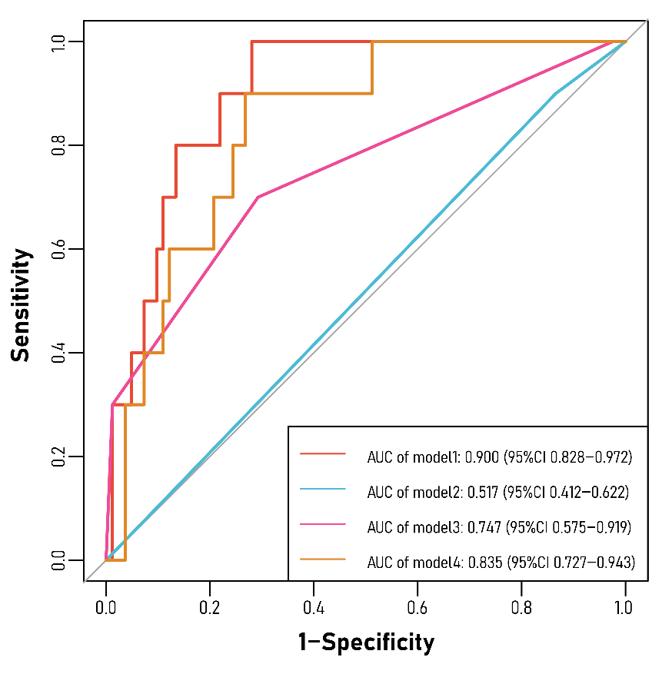
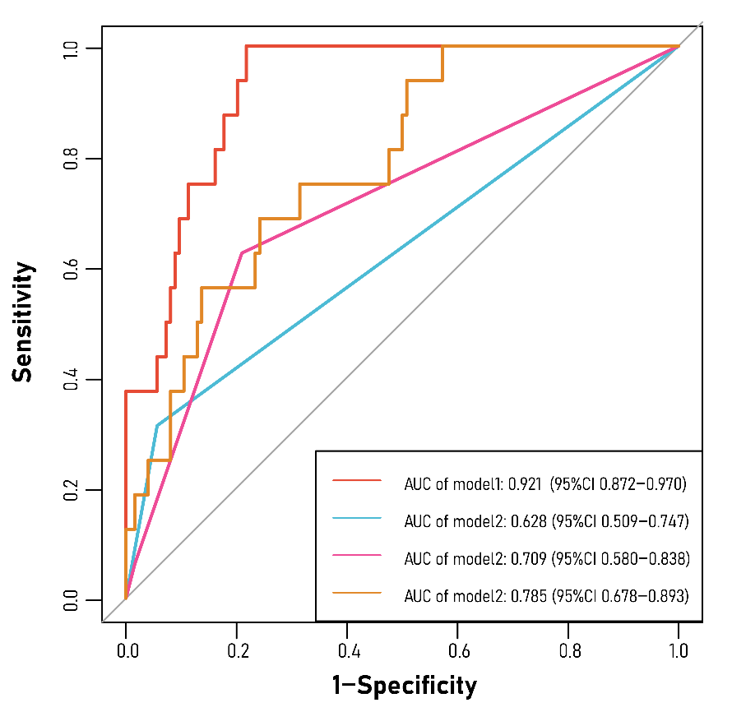
Figure S1. Comparison of ROC of Nomogram and Other Independent Factors
ROCs of nomogram and other independent factors (training set: left, validation set: right). Model1: Nomogram (diabetes + Modic change + Ipsilesional multifidus SMI); Model2: diabetes; Model3: Modic Change; Model4: Ipsilesional multifidus SMI.

Figure S2. Transparent Reporting of a Multivariable Prediction Model for Individual Prognosis or Diagnosis (TRIPOD)
