Supplementary material
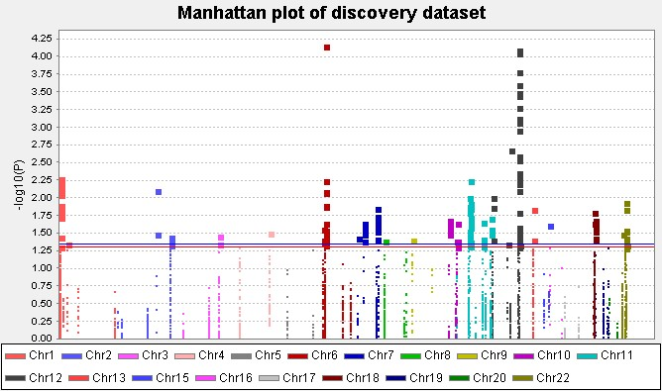
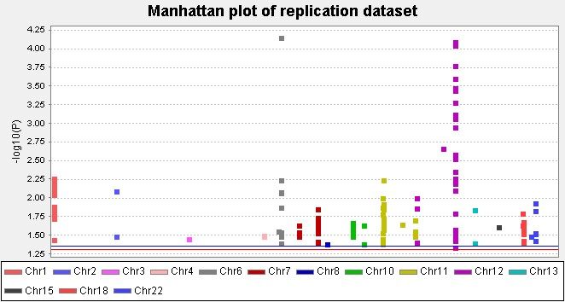
A
B
Figure S1. The Manhattan plot. (A) The Manhattan plot for 4,698 SNPs in the discovery dataset. (B) The Manhattan plot for 236 SNPs in the replication dataset. The red horizontal line indicates P = 0.05, and the blue horizontal line represents an BFDP = 0.80.
CD82
rs7925603 A>G

PMAIP1
rs7925603 A>G
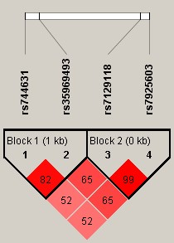
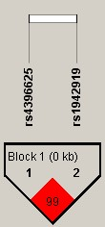
A
B
Figure S2. The linkage disequilibrium plot of genetic variants in CD82 (A) and PMAIP1 (B).
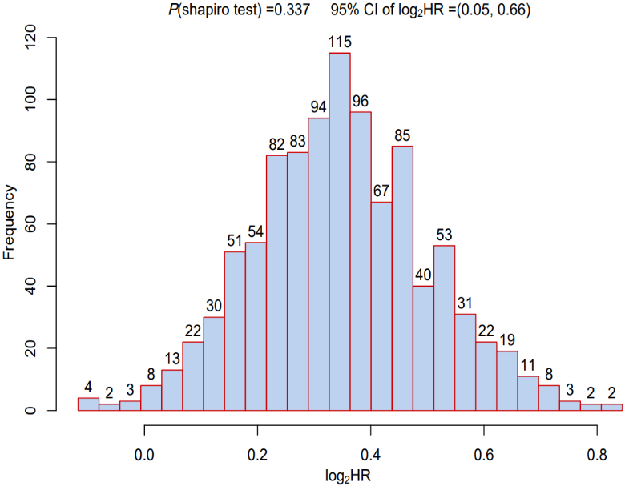
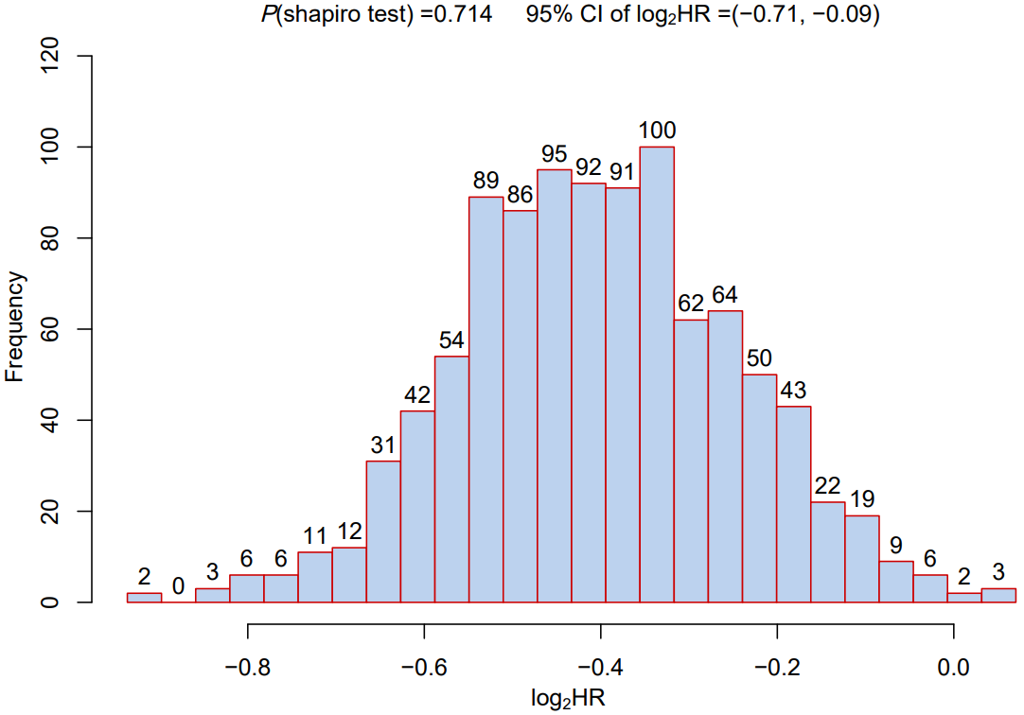
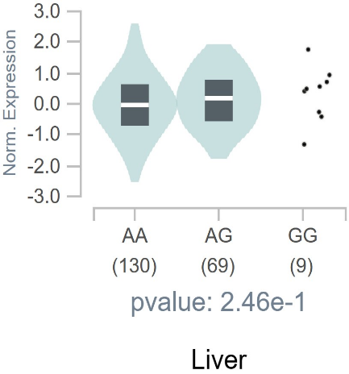
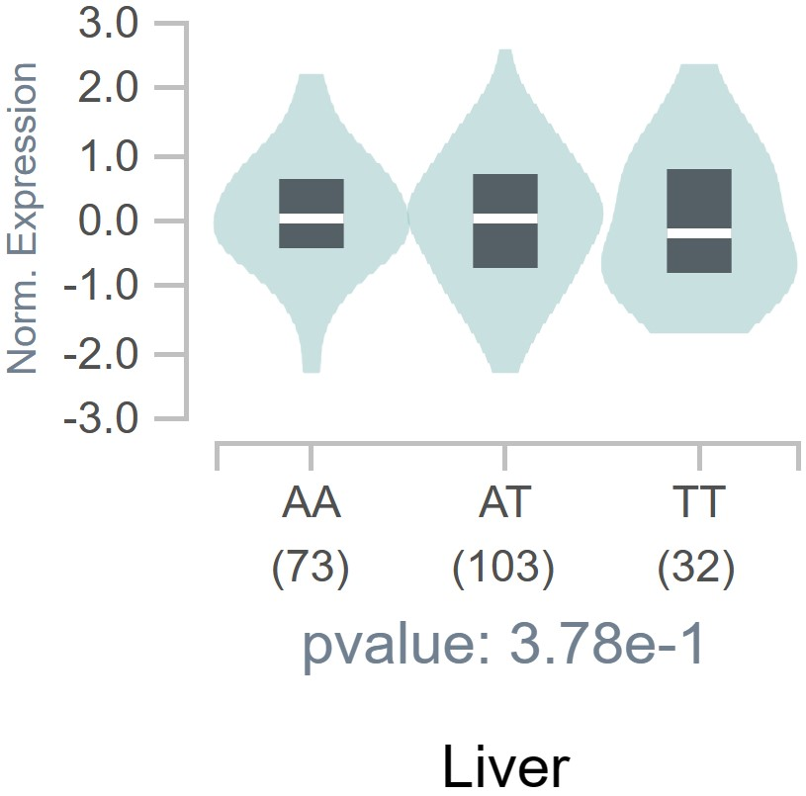
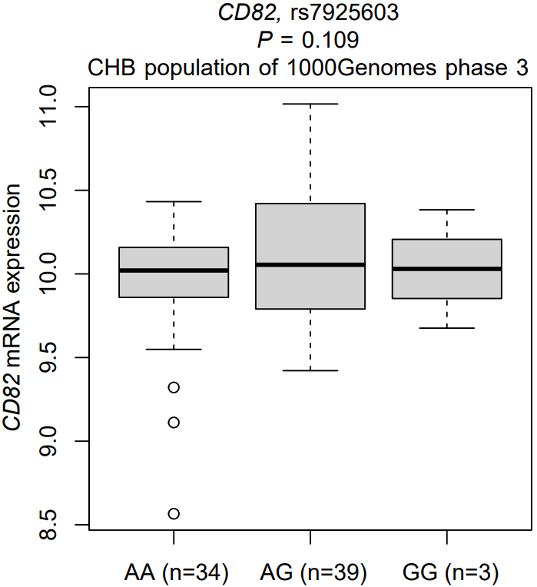
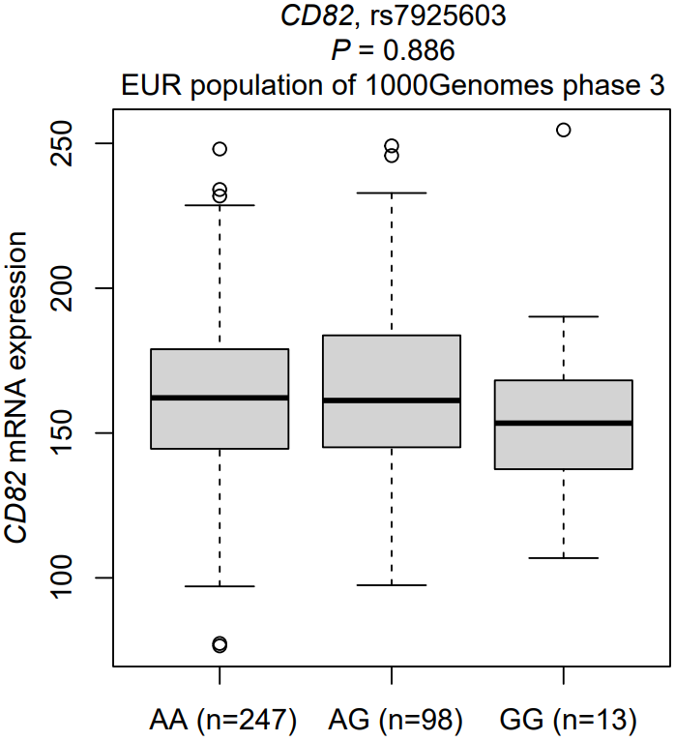
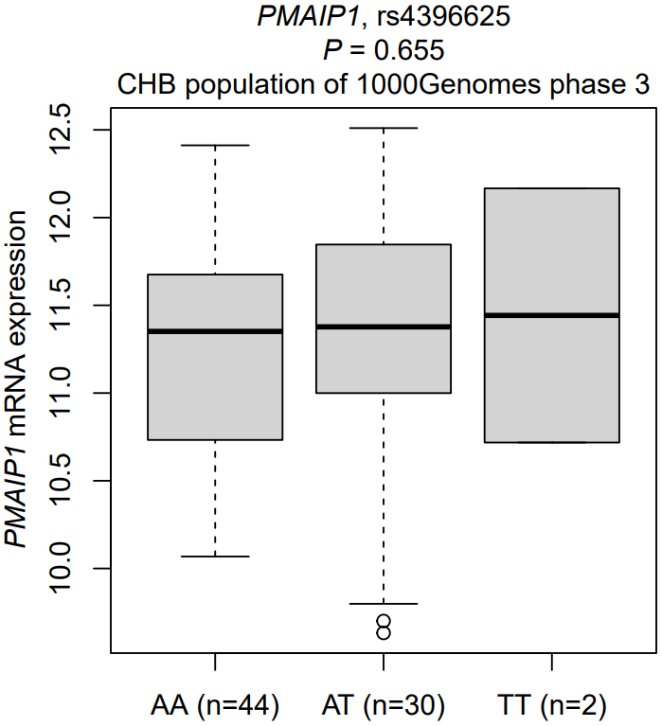
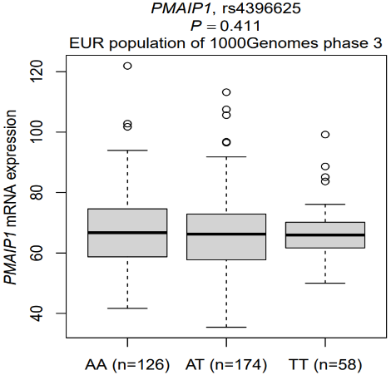
A
B
Figure S3. The distribution histogram of 1000 HR after grouped by bootstrapping for 1000 times in a dominant model. (A) CD82 rs7925603 AG/GG vs. AA and (B) PMAIP1 rs4396625 AT/TT vs. AA.
CD82, rs7925603
liver
P =0.246
A
PMAIP1, rs4396625
liver
P =0.378
Figure S4. The e-QTL analysis of the significant SNPs CD82 rs7925603 A > G and PMAIP1 rs4396625 A > T. (A) The association between CD82 rs7925603 A > G and mRNA expression levels of CD82 in normal liver tissues from the GTEx database; (B) The association between CD82 rs7925603 A > G and mRNA expression levels of CD82 from the 1000 Genomes phase 3. CHB, Han Chinese in Beijing; (C) The association between CD82 rs7925603 A > G and mRNA expression levels of CD82 from the 1000 Genomes phase 3. EUR, European; (D) The association between PMAIP1 rs4396625 A > T and mRNA expression levels of PMAIP1 in normal liver tissues from the GTEx database; (E) The association between PMAIP1 rs4396625 A > T and mRNA expression levels of PMAIP1 from the 1000 Genomes phase 3. CHB, Han Chinese in Beijing; (F) The association between PMAIP1 rs4396625 A > T and mRNA expression levels of PMAIP1 from the 1000 Genomes phase 3. EUR, European.
B
D
C
E
F
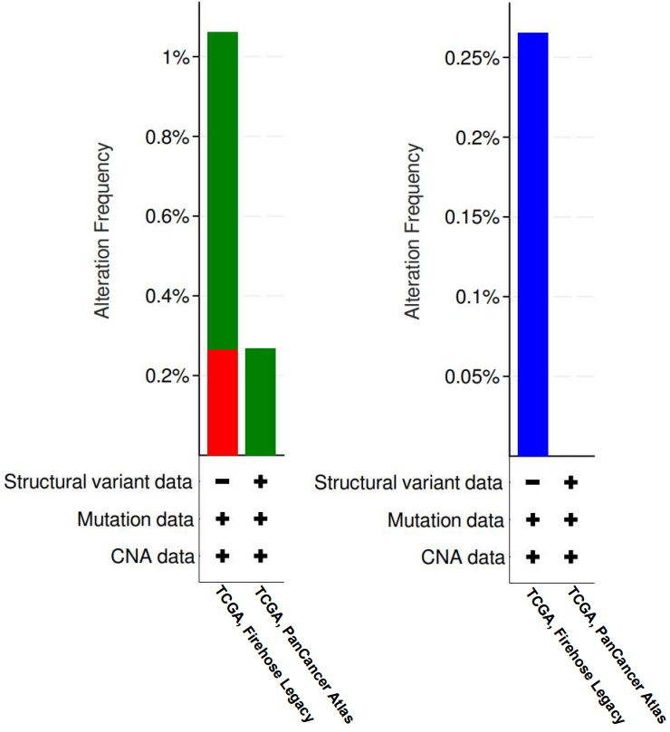
A
B
Figure S5. The somatic mutations analysis of CD82 (A) and PMAIP1 (B) in HCC tissues by using the cBioPortal database.
Table S1. List of 70 p53 signaling pathway genes from MsigDB
Dataset | Name of pathway | Selected genes | Number of genes
WP | BIOCARTA_P53_SIGNALING_PATHWAY | CDK2, TP53, PCNA, MDM2, ATM, CDK4, RB1, TIMP3, CDKN1A, BCL2, APAF1, GADD45A, CCNE1, BAX, E2F1, CCND1 | 16
KEGG | P53_SIGNALING_PATHWAY | CDK2, CDK4, CDK6, CDKN1A, CDKN2A, GADD45G, CHEK1, CHEK2, SESN3, DDB2, GADD45A, RCHY1, BBC3, SESN1, SFN, APAF1, IGF1, IGFBP3, FAS, CD82, MDM2, MDM4, GADD45B, ATM, RRM2B, SERPINE1, SHISA5, GTSE1, SERPINB5, PMAIP1, CYCS, ATR, STEAP3, PIDD1, RPRM, PTEN, ADGRB1, BAX, CCND1, RRM2, BID, TP53AIP1, PERP, COP1, ZMAT3, SIAH1, THBS1, TP53, TP73, TSC2, CASP3, SESN2, CASP8, CASP9, PPM1D, CCNB3, TNFRSF10B, CCNB1, CCND2, CCND3, CCNE1, CCNG1, CCNG2, CCNB2, CCNE2, EI24, TP53I3, CDK1, | 68
Exclude |  | 11 duplicated genes, 2 genes are not in the hg19 reference and 1 gene (CCNB3) on the X chromosome | 14
All |  |  | 70
Keyword: p53
Organism: Homo sapiens

Table S2. The associations of demographics and clinical characteristics with OS of HBV-HCC patients
Variables | Whole dataset (n = 866) |  | MST  (Month) | Univariable analysis |  | Multivariable analysis
Variables | ALL | Deaths (%) | MST  (Month) | HR (95% CI) | P | HR (95% CI) ª | P ª
All subjects | 866 | 419 (48.38) | 39.05 | - | - | - | -
Age ^{b}
≤ 47 | 434 | 233 (53.69) | 47.00 | 1.00 |  | 1.00
> 47 | 432 | 186 (43.06) | 82.60 | 0.72 (0.59-0.87) | < 0.001 | 0.81 (0.66-0.99) | 0.036
Sex
Female | 106 | 42 (39.62) | 66.97 | 1.00 |  | 1.00
Male | 760 | 377 (49.61) | 71.98 | 1.25 (0.90-1.71) | 0.179 | 1.26 (0.90-1.76) | 0.176
Smoking
Never | 545 | 268 (49.17) | 62.00 | 1.00 |  | 1.00
Ever | 321 | 151 (47.04) | 60.00 | 0.96 (0.79-1.18) | 0.724 | 0.91 (0.71-1.17) | 0.475
Drinking
Never | 614 | 292 (47.56) | 66.00 | 1.00 |  | 1.00
Ever | 252 | 127 (59.40) | 54.00 | 1.07 (0.87-1.32) | 0.500 | 1.08 (0.84-1.41) | 0.541
AFP (ng/ml)
≤ 400 | 522 | 232 (44.44) | 70.30 | 1.00 |  | 1.00
> 400 | 344 | 187 (54.36) | 39.10 | 1.59 (1.31-1.93) | < 0.001 | 1.29 (1.05-1.57) | 0.015
Cirrhosis
Never | 390 | 184 (47.18) | 61.90 | 1.00 |  | 1.00
Ever | 476 | 235 (49.37) | 61.50 | 1.00 (0.82-1.22) | 0.996 | 1.04 (0.85-1.41) | 0.702
Cancer embolus
Never | 636 | 260 (40.88) | 90.60 | 1.00 |  | 1.00
Ever | 230 | 159 (69.13) | 23.10 | 2.73 (2.32-3.34) | < 0.001 | 1.74 (1.38-2.21) | < 0.001
BCLC Stage
0/A | 427 | 146 (34.19) | 99.60 | 1.00 |  | 1.00
B/C | 439 | 273 (62.19) | 30.10 | 2.73 (2.23-3.35) | < 0.001 | 1.98 (1.56-2.52) | < 0.001
ª The adjusted variables for Cox proportional hazards regression analysis were age, sex, smoking, drinking, AFP, cirrhosis, cancer embolus, BCLC stage;
^{b} The median age in the whole dataset was 47 years old.
Abbreviations: OS, overall survival; HBV: hepatitis B virus; HCC, hepatocellular carcinoma; MST: median survival time; HR: hazards ratio; CI: confidence interval; AFP: alpha-fetoprotein; BCLC: Barcelona clinic liver cancer.

