SUPPORTING INFORMATION
Mitochondrial targeted cerium oxide nanoclusters for radiation protection and promoting hematopoiesis

Luxun Yang ^{1,}*, Haiying Ran ^{2,}*, Yaru Yin ¹, Jing Liu ¹, Binghui Lu ¹, Xi Ran ³
Shenglin Luo ¹, Weidong Wang ⁴, Zhangyou Yang ^{5,#}, Rong Li ^{1,#}

1 Institute of Combined Injury, National Key Laboratory of Trauma and Chemical Poisoning, Army Key Laboratory of Nanomedicine, Department of Military Preventive Medicine, Army Medical University, Chongqing 400038, People’s Republic of China.
2 Biomedical Analysis Center, Army Medical University, Chongqing 400038, People’s Republic of China.
3 Department of Medical Laboratory, Xinqiao Hospital, Army Medical University, Chongqing 400037, People’s Republic of China.
4 Department of Radiation Oncology, Sichuan Cancer Hospital, Chengdu 610041, People’s Republic of China.
5 Chongqing Key Laboratory for Pharmaceutical Metabolism Research, Chongqing pharmacodynamic evaluation engineering technology research center, College of Pharmacy, Chongqing Medical University, Chongqing 400016, People’s Republic of China.

* These authors contributed equally to this work

Correspondence: Zhangyou Yang
Chongqing Medical University, No 1, Yixueyuan Road, Chongqing 400016, People’s Republic of China
Email yangzhangyou@cqmu.edu.cn.

Rong Li
Army Medical University, No 30, Gaotanyan St., Chongqing, 400038, People’s Republic of China
Tel +86-13883996627
Fax +86023-68753127
Email lrong361@126.com

Figure S1 Characterization of CNLs, PCNLs and TPP-PCNLs. (A) Results of hemolysis experiments with CNLs, PCNLs and TPP-PCNLs at different concentrations. (B) ICP–MS analysis of ceria in PCNLs and TPP-PCNLs at different time points and phases.

Figure S2 Radioprotection effect of TPP-PCNLs in irradiated cells. Images and quantitative analysis of L-02 cells treated with PCNLs and TPP-PCNLs. Fluorescence images of Calcein AM and PI containing L-02 cells (100×) pretreated with PCNLs and TPP-PCNLs followed by 6 Gy irradiation. * Represents a significant difference compared with the IR group, * P <0.05.

Figure S3 Cellular mechanism of radiation protection of TPP-PCNLs. Bar graphs of apoptosis and the percentage of total apoptotic cells after 72 h. * compared with the control group, * P <0.05，** P<0.01.

Figure S4 Distribution of PCNLs and TPP PCNLs loaded with imaging agent ICG throughout the body and organs. (A) Whole body distribution after 0h-24h. (B) The distribution of b in the heart (H), liver (Li), spleen (Sp), lungs (Lu), and kidneys (Ki) after 24 hours.

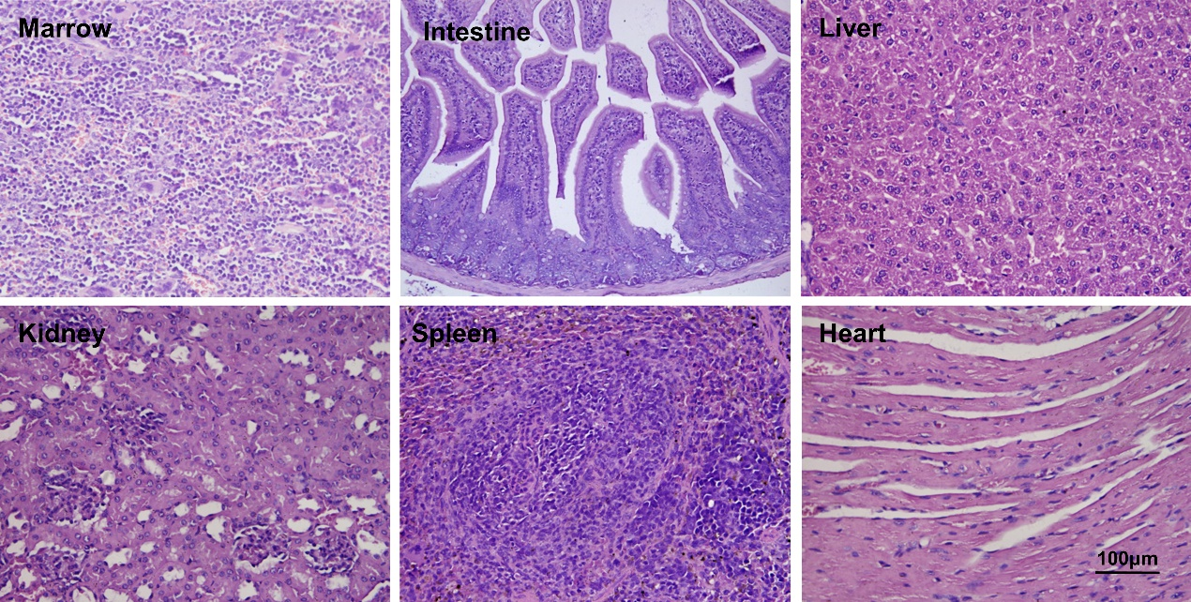
Figure S5 Histological safety analysis and evaluation of TPP-PCNLs.

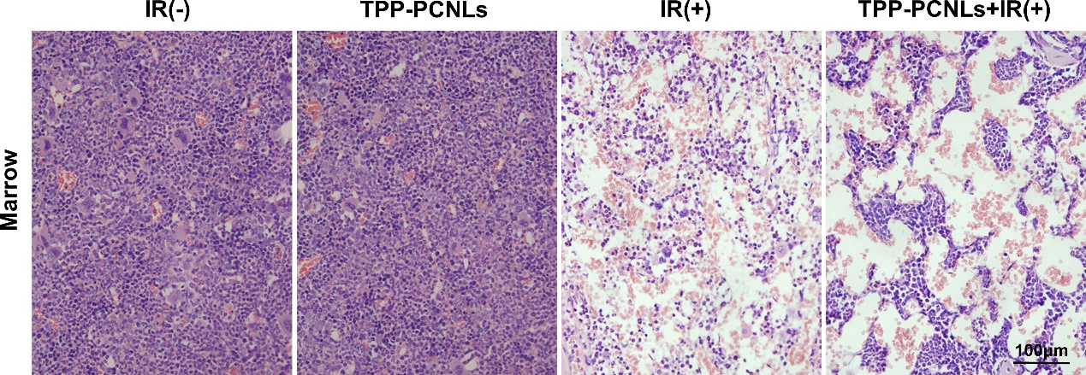
Figure S6 Pathological observation and analysis of hematopoietic system after 7 days and pretreatment with TPP-PCNLs before irradiation.

