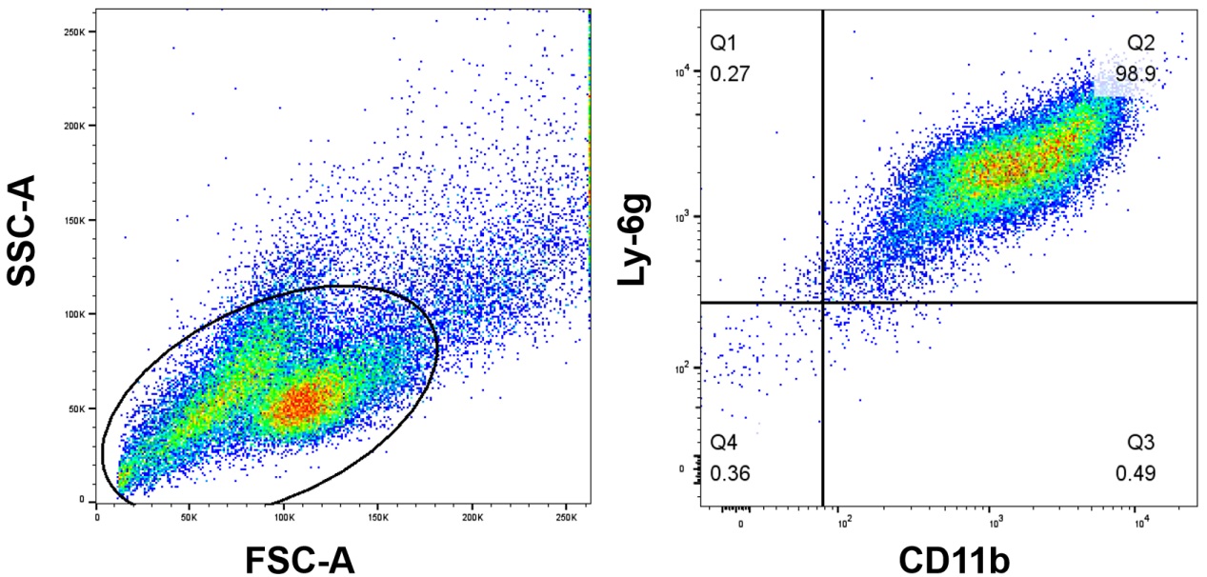
Figure S1. Flow cytometry analyzed the purification of neutrophils that derived from bone marrow samples of mice. Neutrophil population was characterized as CD11b+Ly-6g+ cells.

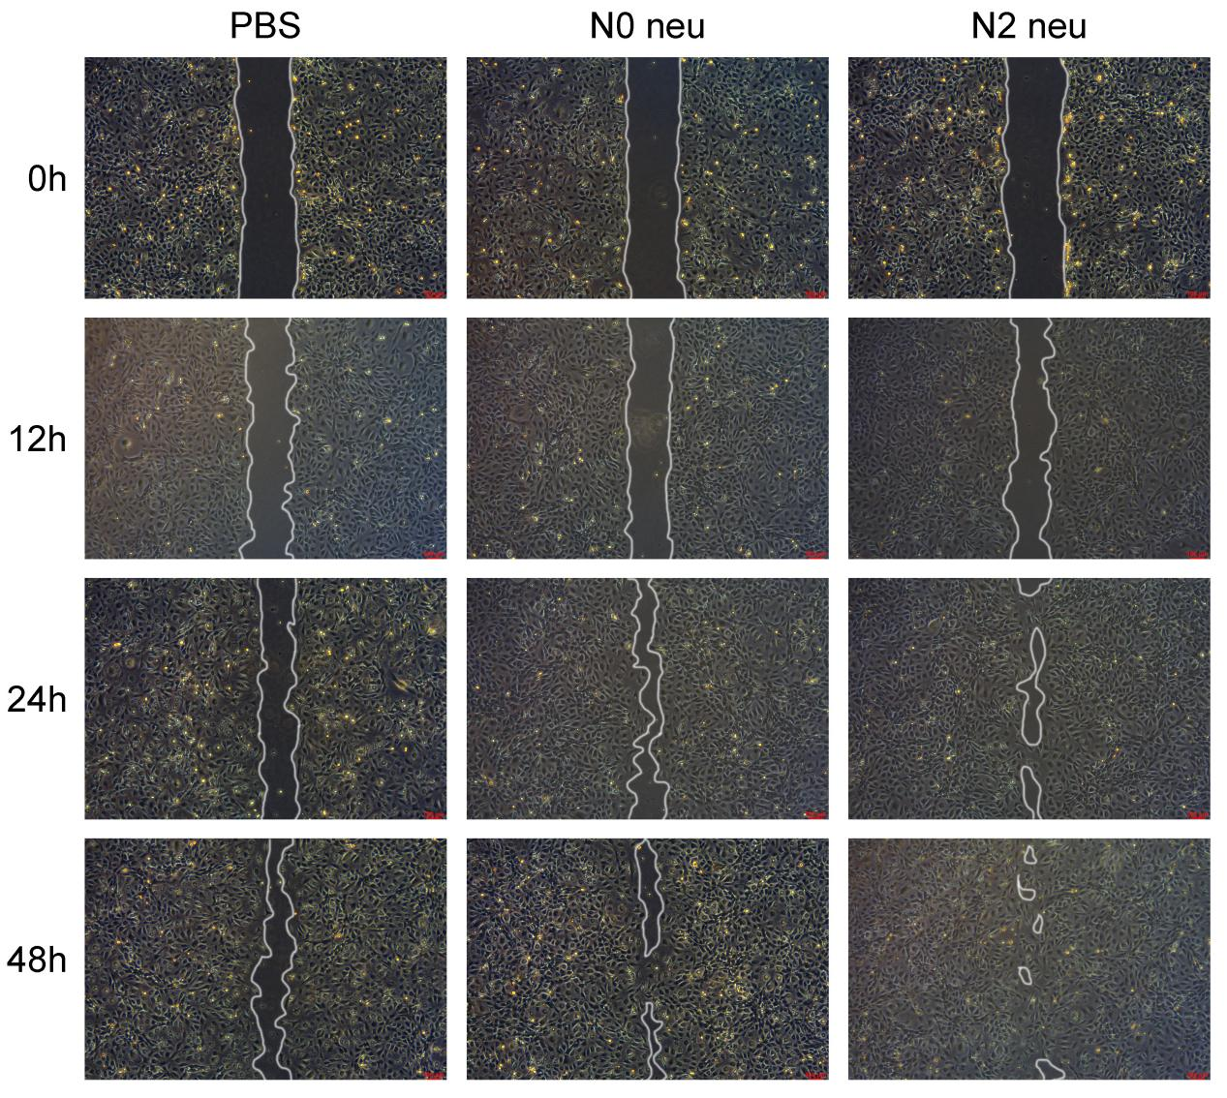
Figure S2. Representative images of the scratch healing assay. Different phenotype of neutrophils were co-cultured with endothelial cell and evaluated the effects on repair rate.
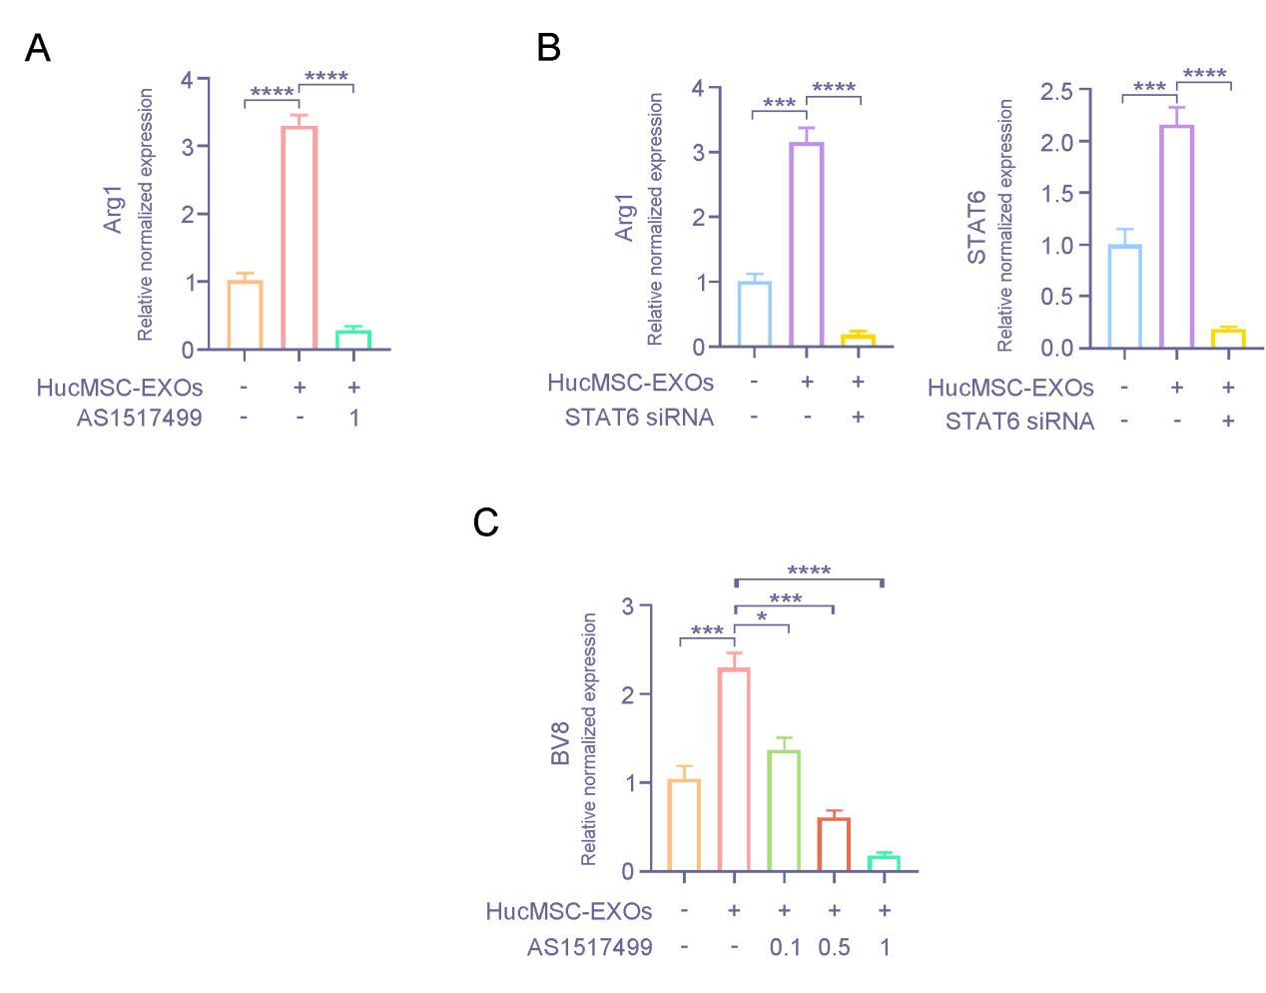
Figure S3. HucMSC-Exo induced stat6 activation and thereby skewed neutrophil to an N2 phenotype. (A) HL-60 neutrophils were treated with HucMSC-Exo or AS1517499 and Arg1 expressions were examined by qRT-PCR. GAPDH was used as a normalization control (n=3). (B) HL-60 cells were treated with or without STAT6 siRNA in the presence of HucMSC-Exo followed by examining the expressions of STAT6 and N2 (Arg1) marker by qRTPCR. GAPDH was used as a normalization control (n=3). (C) Mouse primary neutrophils were treated with hucMSC-Exo or AS1517499 at various concentrations and BV8 expressions were examined by qRT-PCR. GAPDH was used as a normalization control (n=3). [*p < 0.05, **p < 0.01, ***p < 0.001, ****p < 0.0001; data were expressed as mean ± SD and analyzed by unpaired two-tailed t-test].

Table S1.
Sequences of the synthetic siRNA against human STAT6 and mouse BV8
Strand Name | Sequence (5’-3’)
STAT6: Sense | UGGAAGCAGGAAGAACUCAAGUUUA
STAT6: Anti-sense | UAAACUUGAGUUCUUCCUGCUUCCA
BV8: Sense | GGACUUCUUUCAACCGGUUUAUUUG
BV8: Anti-sense | CAAAUAAACCGGUUGAAAGAAGUCC

Table S2. List of primers used in the study
Primer name (Mouse) | Sequence (5’ to 3’)
miNOS-F | GTTCTCAGCCCAACAATACAAGA
miNOS-R | GTGGACGGGTCGATGTCAC
mIL-1β-F | GAAATGCCACCTTTTGACAGTG
mIL-1β-R | TGGATGCTCTCATCAGGACAG
mTNF-α-F | CAGGCGGTGCCTATGTCTC
mTNF-α-R | CGATCACCCCGAAGTTCAGTAG
mArg-1-F | CTCCAAGCCAAAGTCCTTAGAG
mArg-1-R | GGAGCTGTCATTAGGGACATCA
mCD206-F | CTCTGTTCAGCTATTGGACGC
mCD206-R | TGGCACTCCCAAACATAATTTGA
mCD163-F | GGTGGACACAGAATGGTTCTTC
mCD163-R | CCAGGAGCGTTAGTGACAGC
mSTAT6-F | CTCTGTGGGGCCTAATTTCCA
mSTAT6-R | GCATCTGAACCGACCAGGAAC
mPPARγ-F | GGAAGACCACTCGCATTCCTT
mPPARγ-R | GTAATCAGCAACCATTGGGTCA
mCpt1b-F | GACTTCCGGCTTAGTCGGG
mCpt1b-R | GAATAAGGCGTTTCTTCCAGGA
mAcadm-F | AACACAACACTCGAAAGCGG
mAcadm-R | TTCTGCTGTTCCGTCAACTCA
mAcadl-F | TTTCCTCGGAGCATGACATTTT
mAcadl-R | GCCAGCTTTTTCCCAGACCT
mBV8-F | GCCCCGCTACTGCTACTTC
mBV8-R | CCGCACTGAGAGTCCTTGTC
mGAPDH-F | AGGTCGGTGTGAACGGATTTG
mGAPDH-R | GGGGTCGTTGATGGCAACA

