Supplementary Table 1. Technical details of the CT assessments
Acquisition | Orientation | FOV | Slice thickness (mm) | Interval (mm) | Convolution kernel*
Inspiratory | axial | lung | 1.25-1.50 | 0.70-0.75 | B70f/LUNG/L
Inspiratory | axial | lung | 0.625-1.00 | 0.50 | B30f/SOFT/B
Inspiratory | axial | including soft tissue of torso | 0.625-1.00 | 0.50 | B30f/SOFT/B
Expiratory | axial | lung | 0.625-1.00 | 0.50 | B30f/SOFT/B
*Vendor-specific generic names for Siemens/GE/Philips
Scanner models | Siemens Definition Siemens Definition AS 40/ 64/ Flash 128  GE Lightspeed VCT 64/ GE Optima 64/ Philips Brilliance 64/ iCT 256
Scan Type | Spiral
Rotation Time (s) | 0.33 – 0.50 s
Collimation | 40 / 64 / 128 x 0.6-0.625 mm
Pitch | 0.6-1.0
kVp | 120 kVp
mA | 30 - 35 eff. mAs
Dose modulation | Off
Matrix | 512 x 512
Calibration phantom | Air / water phantom / CatPhan
Max. eff dose/scan | < 1.75 mSv
Max. eff. overall dose | < 3.50 mSv

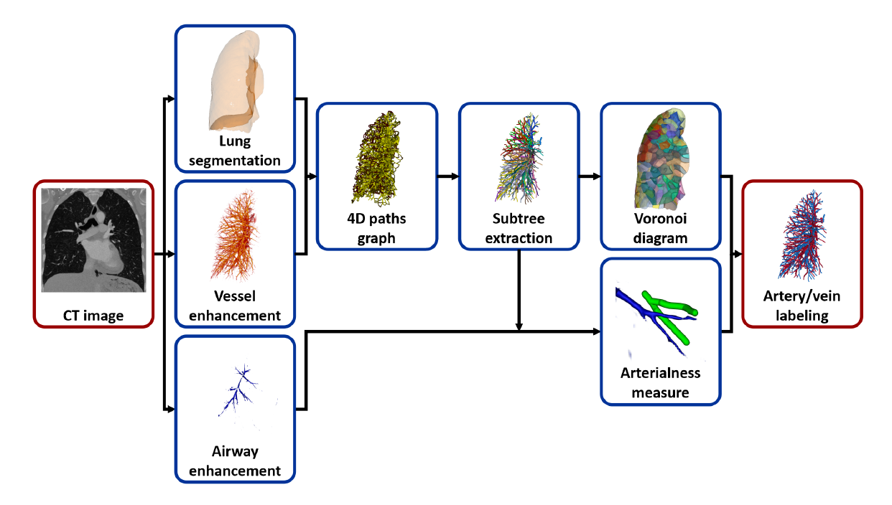
Supplementary Figure S1: Flow chart of the fully-automatic vessel segmentation algorithm. A detailed description and validation of the automatic vessel extraction algorithm is presented in Payer et al. (2016)⁴⁰. Briefly, input for the software is the CT image stack. After lung segmentation, a multi-scale vessel enhancement filter produces images with a high response for bright tubular structures on a dark background, together with the respective radius and orientation. Following these tubular structures, optimized vessel paths are generated with sub-voxel accuracy. These are then used to reconstruct vessel trees, which are subsequently separated at the bifurcations into individual vessel segments. Only segments with diameters between 2 and 10 mm are included. Finally, the artery/vein labelling is realized by using two anatomical properties. First, we exploit the roughly uniformly distribution of arteries and veins in the lung, maximising the contact surfaces in the Voronoi diagram. And second, we use that bronchi run approximately parallel and in close proximity to the arteries.

