NK cell mitochondrial membrane potential-associated model predicts outcomes in critically ill patients with COVID-19

Supplementary Materials

Table S1. Correlation analysis between clinical parameters and MMP MFI of NK cells among critical patients.
 | r | 95% CI | p-value value | Summary
PT | -0.14 | -0.4252 to 0.1643 | 0.3600 | ns
APTT | -0.19 | -0.4641 to 0.1168 | 0.2217 | ns
TT | 0.09 | -0.2154 to 0.3807 | 0.5627 | ns
INR | -0.13 | -0.4113 to 0.1806 | 0.4184 | ns
Fbg | 0.28 | -0.01723 to 0.5389 | 0.0644 | ns
D-Dimer | 0.39 | 0.1013 to 0.6178 | 0.0098 | **
NT-proBNP | -0.33 | -0.5674 to -0.01592 | 0.0399 | *
hscTnI | -0.22 | -0.4922 to 0.08855 | 0.1589 | ns
CK | -0.09 | -0.3911 to 0.2273 | 0.5781 | ns
Myo | -0.14 | -0.4437 to 0.1837 | 0.3869 | ns
CRP | -0.10 | -0.3890 to 0.2062 | 0.5218 | ns
PCT | 0.01 | -0.2997 to 0.3155 | 0.9569 | ns
IL-6 | -0.03 | -0.3466 to 0.2923 | 0.8570 | ns
IL-8 | -0.19 | -0.4871 to 0.1391 | 0.2507 | ns
IL-10 | -0.13 | -0.4394 to 0.1981 | 0.4273 | ns
TNF α | -0.03 | -0.3597 to 0.3063 | 0.8641 | ns

Pearson’s correlation analysis was used for analyses.

APTT: activated partial thromboplastin time, AUC: area under the curve, CK: creatine kinase, CRP: C-reactive protein, Fbg: fibrinogen, hscTnI: high-sensitivity cardiac troponin I, IL-10: interleukin 10, IL-6: interleukin 6, IL-8: interleukin 8, MFI: mean fluorescence intensity, MMP: mitochondrial membrane potential, myo: myoglobin, NK: natural killer, NT-proBNP: N-terminal pro-brain natriuretic peptide, PCT: procalcitonin, PT: prothrombin time, TNF: tumor necrosis factor.

Table S2. Correlation analysis between clinical parameters and MMP MFI of NK cells in dead patients
 | r | 95% CI | p-value | Summary
PT | 0.00 | -0.3823 to 0.3777 | 0.9895 | ns
APTT | -0.01 | -0.3872 to 0.3728 | 0.9667 | ns
TT | 0.10 | -0.2872 to 0.4657 | 0.6051 | ns
INR | 0.02 | -0.3622 to 0.3975 | 0.9186 | ns
Fbg | -0.02 | -0.3968 to 0.3629 | 0.9218 | ns
D-Dimer | 0.56 | 0.2310 to 0.7760 | 0.0023 | **
NT-proBNP | -0.19 | -0.5297 to 0.2074 | 0.3492 | ns
hscTnI | -0.08 | -0.4445 to 0.3116 | 0.7003 | ns
CK | 0.03 | -0.3699 to 0.4198 | 0.8883 | ns
Myo | -0.02 | -0.4217 to 0.3848 | 0.9185 | ns
CRP | 0.08 | -0.3071 to 0.4485 | 0.6824 | ns
PCT | 0.07 | -0.3277 to 0.4440 | 0.7400 | ns
IL-6 | -0.17 | -0.5400 to 0.2461 | 0.4144 | ns
IL-8 | -0.16 | -0.5372 to 0.2695 | 0.4644 | ns
IL-10 | -0.20 | -0.5691 to 0.2264 | 0.3483 | ns
TNF α | 0.24 | -0.2172 to 0.6064 | 0.3016 | ns

Pearson’s correlation analysis was used for analyses.

APTT: activated partial thromboplastin time, AUC: area under the curve, CK: creatine kinase, CRP: C-reactive protein, Fbg: fibrinogen, hscTnI: high-sensitivity cardiac troponin I, IL-10: interleukin 10, IL-6: interleukin 6, IL-8: interleukin 8, MFI: mean fluorescence intensity, MMP: mitochondrial membrane potential, myo: myoglobin, NK: natural killer, NT-proBNP: N-terminal pro-brain natriuretic peptide, PCT: procalcitonin, PT: prothrombin time, TNF: tumor necrosis factor.

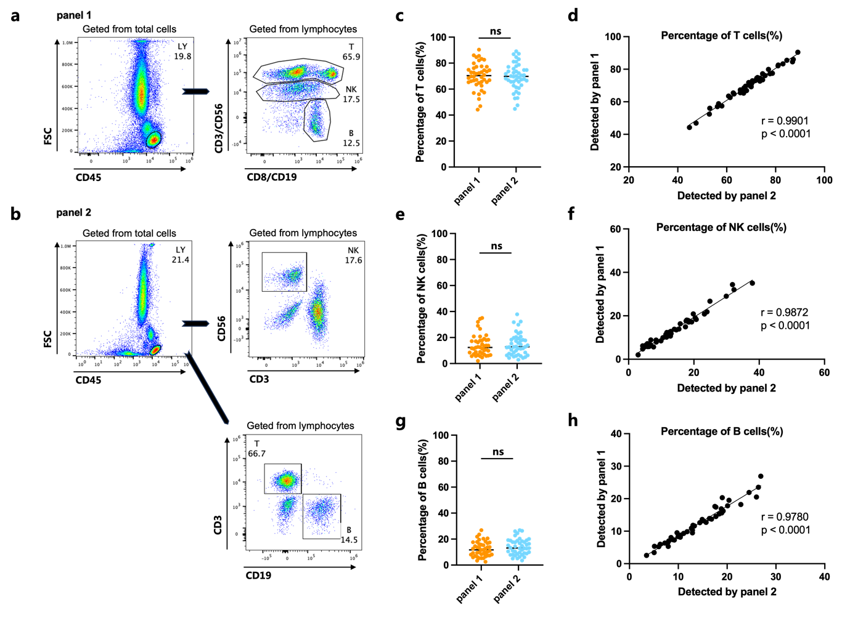
Figure S1. Comparison of T, NK, and B cell subset detection results between two flow cytometry antibody panels. (a) Gating strategy for the dual-antibody detection panel used in this study; (b) Gating strategy for the traditional single-antibody detection panel; (c) Comparison of T cell proportions between the two detection panels; (d) Correlation analysis of T cell proportions between the two detection panels; (e) Comparison of NK cell proportions between the two detection panels; (f) Correlation analysis of NK cell proportions between the two detection panels; (g) Comparison of B cell proportions between the two detection panels; (h) Correlation analysis of B cell proportions between the two detection panels. An unpaired t-test was used for comparison between the two groups, and Pearson correlation analysis was used to analyze correlations. Significant differences were defined as p < 0.05. ns indicates no significant statistical difference.

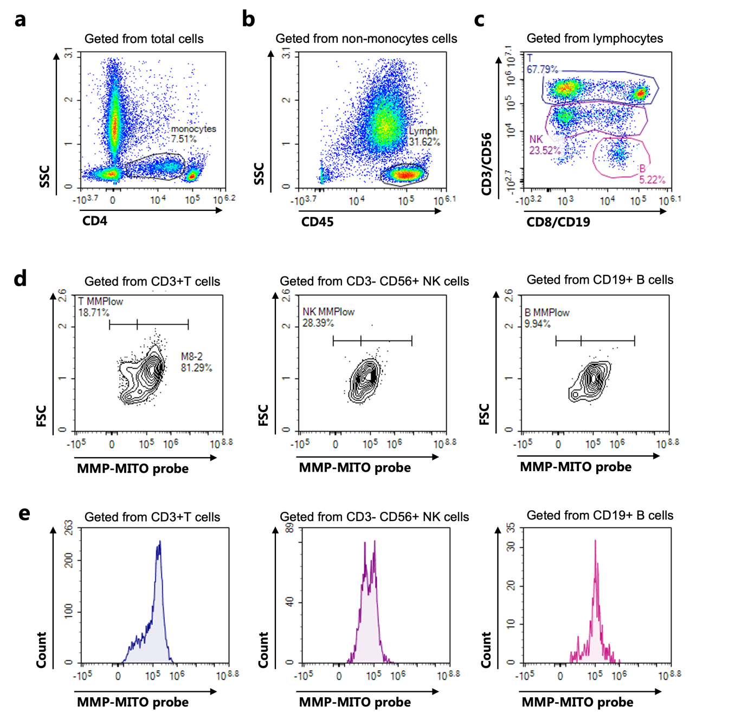

Figure S2. Flow cytometry gating strategy for detecting MMP in lymphocyte subsets using MMP-MITO probes. The gating strategy is as follows: (a) Monocytes are gated based on CD4 expression and SSC; (b) CD45⁺ lymphocytes are gated within non-monocytes PBMCs; (c) CD3/CD56/CD19 markers are used to identify CD3⁺ T cells, CD3⁻CD56⁺ NK cells, and CD3⁻CD19⁺ B cells; (d) MMPlow cell proportions are determined within CD3⁺ T cells, CD3⁻CD56⁺ NK cells, and CD3⁻CD19⁺ B cells based on FSC/MMP-MITO-probe characteristics; (e) Count/MMP-MITO-probe histograms are set up to determine the MMP MFI within CD3⁺ T cells, CD3⁻CD56⁺ NK cells, and CD3⁻CD19⁺ B cells.

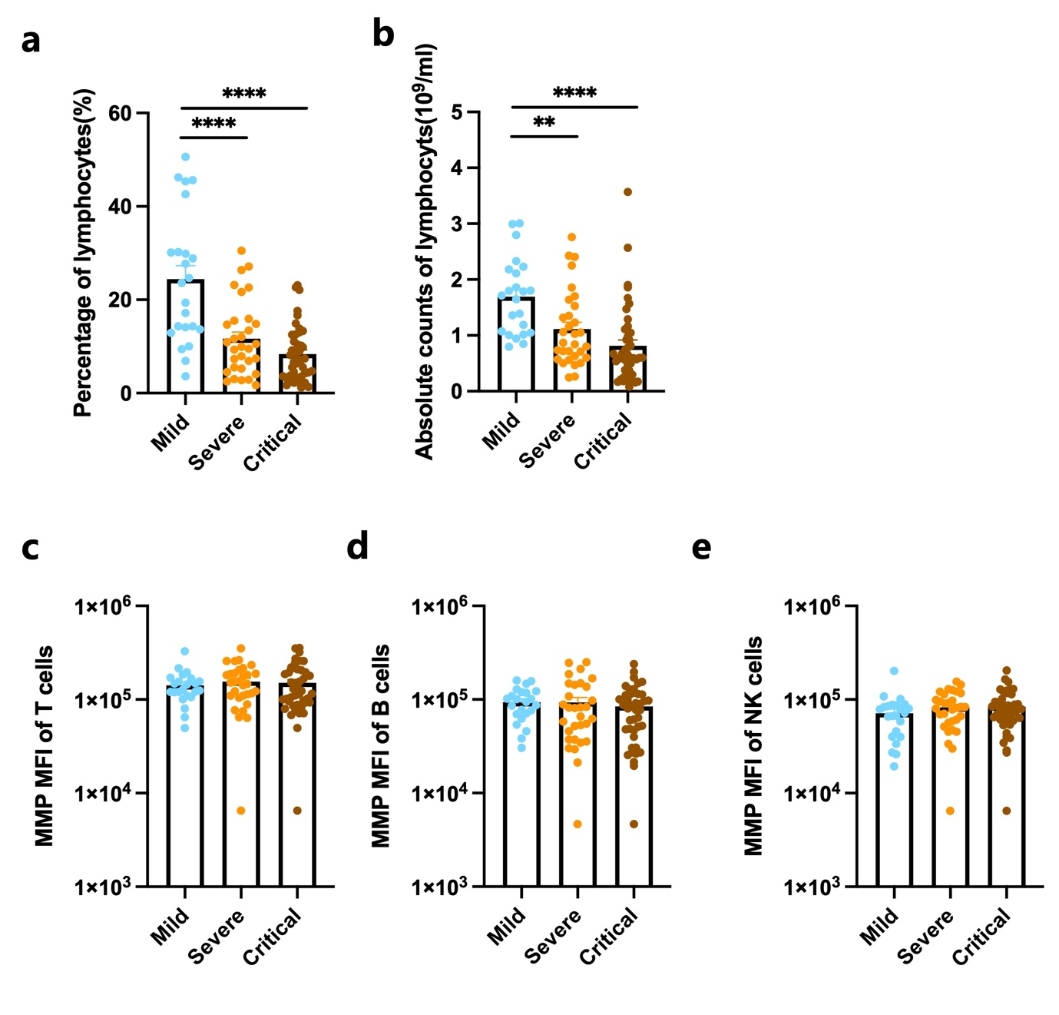

Figure S3. Changes in lymphocyte subset proportions and MMP MFI in patients with mild, severe, and critical COVID-19. (a-b) Proportional (a) and absolute count (b) changes of peripheral blood lymphocytes, (c-e) Changes in the MMP MFI of T (c), B (d), and NK (e) lymphocyte subsets. Unpaired t-tests or Mann-Whitney U test were used for statistical analysis; **p < 0.01, ****p < 0.0001.

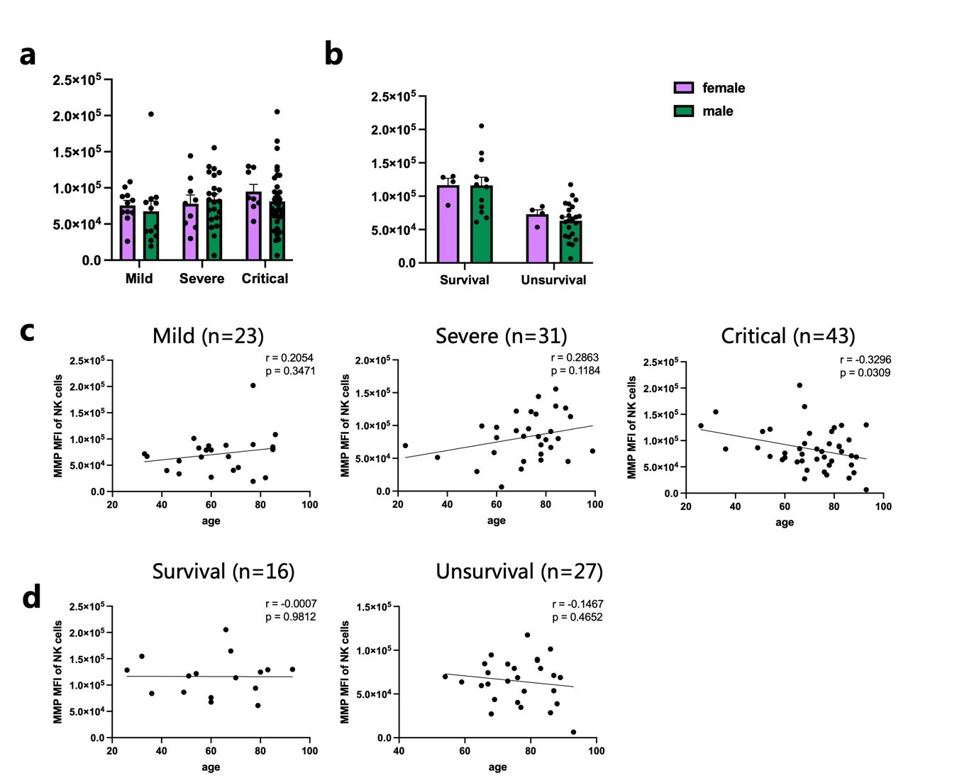

Figure S4. Correlation between NK cell MMP MFI and age and sex in patients with different states. (a) Comparison of male and female NK cell MMP MFI in mild, severe and critically ill patients; (b) Comparison of male and female NK cell MMP MFI in critically ill patients who survived and died; (c) Analysis of correlation between NK cell MMP MFI and age in mild, severe and critically ill patients; (d) Analysis of correlation between NK cell MMP MFI and age in critically ill patients who survived and died. Unpaired t-tests or Mann-Whitney U test was used in comparison between the two groups. Pearson correlation analysis is used to analyze correlations. Significant differences were defined as P < 0.05.

Figure S5. Correlation analysis between NK cells MMP MFI and clinical parameters among critically ill and dead patients. (a-c) Pairwise correlation analysis between NK Cells MMP MFI and coagulation markers (a), myocardial injury markers (b), infection markers, and cytokines (c) among the overall critically ill patients. (d-e) Pairwise correlation analysis between NK Cells MMP MFI and myocardial injury markers (d), infection markers, and cytokines (e) in critically ill patients who died.

