Figure S1
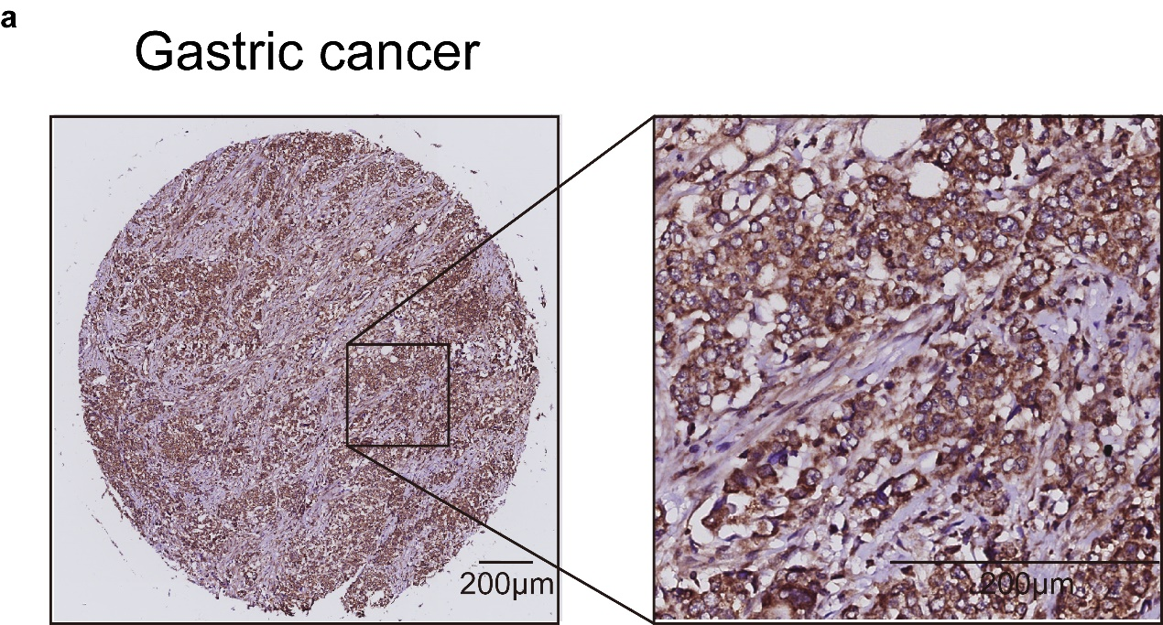

Figure S1 Subcellular localization of CLEC4D. (a). Through immunohistochemical analysis, we identified the subcellular localization of CLEC4D in GC cells and observed its predominant distribution on the cell membrane. Scale bars, 200 μm.

Figure S2
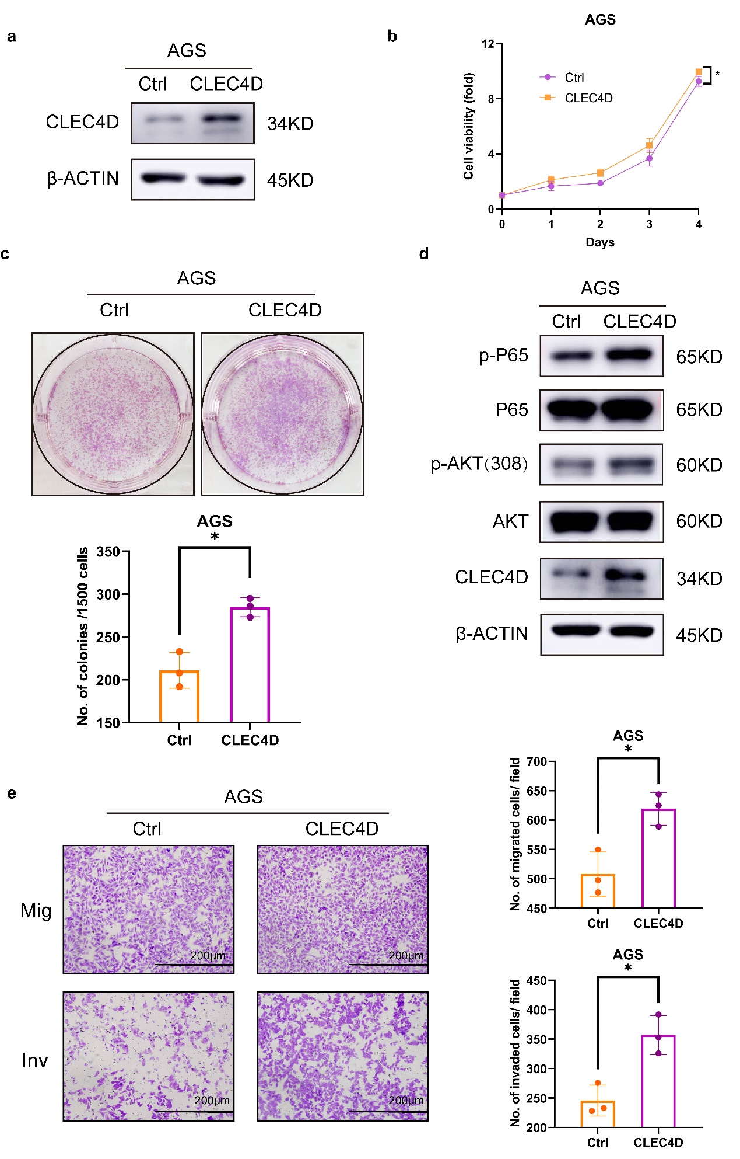
Figure S2 Overexpression of CLEC4D promotes the malignant progression of gastric cancer. (a). We used CLEC4D high expression lentivirus infection to enhance the expression of CLEC4D in AGS cells. Immunoblot assays were used to verify the overexpression efficiency. (b). CCK-8 assays showed that high expression of CLEC4D enhanced the propagation in AGS cells compared with control. (c). CLEC4D overexpressing AGS cells formed more colonies compared to control cells (P<0.05). (d). Immunoblotting analysis was conducted to demonstrate that high expression of CLEC4D significantly increased the expression of phosphorylated-p65 (Ser536) and phosphorylated Akt (Thr308) in AGS cells. (e). CLEC4D overexpressing AGS cells exhibited stronger invasion and migration capabilities. Scale bars, 200 μm. P < 0.05. *, P < 0.05.

