Supplemental material
Table S1. qPCR primer sequences
Primer | sequence
CD44-F1 | 5’-TCGATTTGAATGTAACCTGCCG-3’
CD44-R1 | 5’-CAGTCCGGGAGATACTGTAGC-3’
CD47-F1 | 5’-TGGTGGGAAACTACACTTGCG-3’
CD47-R1 | 5’-CGTGCGGTTTTTCAGCTCTAT-3’
HAVCR2-F1 | 5’-TCAGGTCTTACCCTCAACTGTG-3’
HAVCR2-R1 | 5’-GGCATTCTTACCAACCTCAAACA-3’
SIRPA-F1 | 5’-CCACGGGGAAGGAACTGAAG-3’
SIRPA-R1 | 5’-ACGTATTCTCCTGCGAAACTGTA-3’
TNFSF9-F1 | 5’-CGGCGCTCCTCAGAGATAC-3’
TNFSF9-R1 | 5’-ATCCCGAACATTAACCGCAGG-3’
VTCN1-F1 | 5’-GGCCTGGGCATCTCAAGTC-3’
VTCN1-R1 | 5’-TTGTAGAGCACAGATACGACCT-3’

Table S2. GO terms enrichment analysis
ONTOLOGY | ID | Description | p.adjust
CC | GO:0098793 | presynapse | 5.87E-15
BP | GO:0023061 | signal release | 7.88E-15
BP | GO:0010817 | regulation of hormone levels | 6.27E-11
CC | GO:0030133 | transport vesicle | 8.77E-13
BP | GO:0050804 | modulation of chemical synaptic transmission | 7.17E-11
BP | GO:0099177 | regulation of trans-synaptic signaling | 7.26E-11
BP | GO:0009306 | protein secretion | 2.22E-12
BP | GO:0035592 | establishment of protein localization to extracellular region | 2.22E-12
BP | GO:0071692 | protein localization to extracellular region | 3.85E-12
CC | GO:0043025 | neuronal cell body | 4.00E-08
BP | GO:0015833 | peptide transport | 3.27E-13
BP | GO:0046879 | hormone secretion | 4.38E-12
BP | GO:0042886 | amide transport | 7.07E-12
BP | GO:0009914 | hormone transport | 8.56E-12
BP | GO:0030072 | peptide hormone secretion | 1.58E-13
BP | GO:0002790 | peptide secretion | 1.98E-13
BP | GO:0072503 | cellular divalent inorganic cation homeostasis | 6.34E-05
BP | GO:0051223 | regulation of protein transport | 6.46E-05
CC | GO:0070382 | exocytic vesicle | 4.52E-13
BP | GO:0006887 | exocytosis | 4.00E-07
BP | GO:0050808 | synapse organization | 1.02E-05
BP | GO:0055074 | calcium ion homeostasis | 6.87E-05
CC | GO:0008021 | synaptic vesicle | 4.52E-13
CC | GO:0030658 | transport vesicle membrane | 8.77E-13
MF | GO:0046873 | metal ion transmembrane transporter activity | 0.000123
BP | GO:0030073 | insulin secretion | 1.64E-12
BP | GO:0006836 | neurotransmitter transport | 2.37E-11
BP | GO:0046883 | regulation of hormone secretion | 2.01E-10
BP | GO:0050708 | regulation of protein secretion | 1.24E-09
BP | GO:0006874 | cellular calcium ion homeostasis | 0.000125
MF | GO:0015267 | channel activity | 0.001205
MF | GO:0022803 | passive transmembrane transporter activity | 0.001205
BP | GO:0051047 | positive regulation of secretion | 2.41E-07
CC | GO:0097060 | synaptic membrane | 5.00E-06
MF | GO:0005261 | cation channel activity | 4.99E-05
MF | GO:0005216 | ion channel activity | 0.000955
BP | GO:0090276 | regulation of peptide hormone secretion | 3.74E-11
BP | GO:0002791 | regulation of peptide secretion | 5.07E-11
BP | GO:0090087 | regulation of peptide transport | 6.42E-11
BP | GO:0099003 | vesicle-mediated transport in synapse | 2.63E-10
BP | GO:1903532 | positive regulation of secretion by cell | 1.97E-07
BP | GO:0061564 | axon development | 0.001853
CC | GO:0098978 | glutamatergic synapse | 1.22E-06
BP | GO:0099504 | synaptic vesicle cycle | 3.69E-10
BP | GO:0007409 | axonogenesis | 0.001074
BP | GO:0090066 | regulation of anatomical structure size | 0.005496
CC | GO:0150034 | distal axon | 2.56E-07
BP | GO:0001505 | regulation of neurotransmitter levels | 4.67E-08
BP | GO:0045055 | regulated exocytosis | 2.44E-07
BP | GO:0050796 | regulation of insulin secretion | 2.93E-10
BP | GO:0006816 | calcium ion transport | 0.005535
BP | GO:0042391 | regulation of membrane potential | 0.005658
BP | GO:0034765 | regulation of ion transmembrane transport | 0.019441
MF | GO:0022836 | gated channel activity | 0.001192
BP | GO:0048167 | regulation of synaptic plasticity | 3.80E-07
BP | GO:0017157 | regulation of exocytosis | 6.00E-07
BP | GO:0006813 | potassium ion transport | 1.03E-05
BP | GO:0060249 | anatomical structure homeostasis | 0.000446
BP | GO:0010038 | response to metal ion | 0.00148
BP | GO:0051480 | regulation of cytosolic calcium ion concentration | 0.001762
BP | GO:0010975 | regulation of neuron projection development | 0.014997
BP | GO:0051960 | regulation of nervous system development | 0.018375
CC | GO:0030672 | synaptic vesicle membrane | 8.99E-13
CC | GO:0099501 | exocytic vesicle membrane | 8.99E-13
CC | GO:0005911 | cell-cell junction | 0.027963
BP | GO:0007269 | neurotransmitter secretion | 1.37E-08
BP | GO:0099643 | signal release from synapse | 1.37E-08
BP | GO:0010959 | regulation of metal ion transport | 0.016874
BP | GO:0034329 | cell junction assembly | 0.024487
CC | GO:1990351 | transporter complex | 0.006757
BP | GO:0071805 | potassium ion transmembrane transport | 4.11E-05
CC | GO:1902495 | transmembrane transporter complex | 0.008354
BP | GO:0007188 | adenylate cyclase-modulating G protein-coupled receptor signaling pathway | 0.000546
BP | GO:1903522 | regulation of blood circulation | 0.001111
BP | GO:0007204 | positive regulation of cytosolic calcium ion concentration | 0.011304
CC | GO:0034703 | cation channel complex | 5.53E-05
CC | GO:0034702 | ion channel complex | 0.001558
BP | GO:0016079 | synaptic vesicle exocytosis | 5.49E-08
BP | GO:0009743 | response to carbohydrate | 0.000769
BP | GO:0003018 | vascular process in circulatory system | 0.003912
BP | GO:0001894 | tissue homeostasis | 0.005489
BP | GO:0043270 | positive regulation of ion transport | 0.005496
BP | GO:0001764 | neuron migration | 8.29E-05
BP | GO:0009749 | response to glucose | 0.00042
BP | GO:0009746 | response to hexose | 0.000515
BP | GO:0034284 | response to monosaccharide | 0.000755
BP | GO:0042593 | glucose homeostasis | 0.005489
BP | GO:0033500 | carbohydrate homeostasis | 0.005496
CC | GO:0042734 | presynaptic membrane | 5.83E-06
CC | GO:0098984 | neuron to neuron synapse | 0.041645
CC | GO:0044306 | neuron projection terminus | 9.17E-06
MF | GO:0022843 | voltage-gated cation channel activity | 0.000471
MF | GO:0005244 | voltage-gated ion channel activity | 0.005381
MF | GO:0022832 | voltage-gated channel activity | 0.005381
BP | GO:0046887 | positive regulation of hormone secretion | 8.13E-05
BP | GO:0051592 | response to calcium ion | 0.00043
BP | GO:0098657 | import into cell | 0.03026
BP | GO:0015850 | organic hydroxy compound transport | 0.038405
CC | GO:0043679 | axon terminus | 1.16E-05
CC | GO:0045211 | postsynaptic membrane | 0.033987
BP | GO:0017156 | calcium-ion regulated exocytosis | 6.11E-07
BP | GO:0051588 | regulation of neurotransmitter transport | 5.92E-05
BP | GO:0015837 | amine transport | 6.34E-05
BP | GO:1903305 | regulation of regulated secretory pathway | 0.001365
BP | GO:0007416 | synapse assembly | 0.010552
BP | GO:0050803 | regulation of synapse structure or activity | 0.035488
CC | GO:0043204 | perikaryon | 0.001109
MF | GO:0000149 | SNARE binding | 0.00058
MF | GO:0015079 | potassium ion transmembrane transporter activity | 0.005381
MF | GO:0005516 | calmodulin binding | 0.026398
BP | GO:0046928 | regulation of neurotransmitter secretion | 8.60E-05
BP | GO:0090277 | positive regulation of peptide hormone secretion | 0.000144
BP | GO:0051952 | regulation of amine transport | 0.000158
BP | GO:0002793 | positive regulation of peptide secretion | 0.000173
BP | GO:0043266 | regulation of potassium ion transport | 0.000769
BP | GO:0008277 | regulation of G protein-coupled receptor signaling pathway | 0.004838
BP | GO:0050806 | positive regulation of synaptic transmission | 0.014665
BP | GO:0010721 | negative regulation of cell development | 0.030922
BP | GO:0071248 | cellular response to metal ion | 0.041237
BP | GO:0007626 | locomotory behavior | 0.042464
BP | GO:0045664 | regulation of neuron differentiation | 0.042464
CC | GO:0098563 | intrinsic component of synaptic vesicle membrane | 1.34E-08
CC | GO:0030426 | growth cone | 0.006176
CC | GO:0030427 | site of polarized growth | 0.007872
CC | GO:0031225 | anchored component of membrane | 0.008354
BP | GO:0140029 | exocytic process | 0.000136
BP | GO:0050714 | positive regulation of protein secretion | 0.010043
BP | GO:0035296 | regulation of tube diameter | 0.018083
BP | GO:0097746 | blood vessel diameter maintenance | 0.018083
BP | GO:0035150 | regulation of tube size | 0.018812
BP | GO:0051048 | negative regulation of secretion | 0.047702
CC | GO:0048786 | presynaptic active zone | 5.53E-05
MF | GO:0005267 | potassium channel activity | 0.009773
MF | GO:0015085 | calcium ion transmembrane transporter activity | 0.018072
BP | GO:0036465 | synaptic vesicle recycling | 0.000853
BP | GO:0045921 | positive regulation of exocytosis | 0.002148
BP | GO:0006906 | vesicle fusion | 0.010064
BP | GO:0090174 | organelle membrane fusion | 0.012599
BP | GO:0098659 | inorganic cation import across plasma membrane | 0.019441
BP | GO:0099587 | inorganic ion import across plasma membrane | 0.019441
BP | GO:0051224 | negative regulation of protein transport | 0.026019
BP | GO:1904950 | negative regulation of establishment of protein localization | 0.031679
BP | GO:0060078 | regulation of postsynaptic membrane potential | 0.034612
BP | GO:0007586 | digestion | 0.043186
BP | GO:0031644 | regulation of nervous system process | 0.044749
BP | GO:0050768 | negative regulation of neurogenesis | 0.047989
BP | GO:0048284 | organelle fusion | 0.049817
BP | GO:0070555 | response to interleukin-1 | 0.049817
CC | GO:0008076 | voltage-gated potassium channel complex | 0.000559
CC | GO:0034705 | potassium channel complex | 0.001276
CC | GO:0099240 | intrinsic component of synaptic membrane | 0.044963
MF | GO:0005249 | voltage-gated potassium channel activity | 0.005843
MF | GO:0005262 | calcium channel activity | 0.023713
BP | GO:0048499 | synaptic vesicle membrane organization | 3.13E-06
BP | GO:0017158 | regulation of calcium ion-dependent exocytosis | 8.29E-05
BP | GO:0046888 | negative regulation of hormone secretion | 0.001365
BP | GO:0032024 | positive regulation of insulin secretion | 0.002816
BP | GO:0050709 | negative regulation of protein secretion | 0.00306
BP | GO:0051937 | catecholamine transport | 0.004463
BP | GO:0042310 | vasoconstriction | 0.009424
BP | GO:0015844 | monoamine transport | 0.010053
BP | GO:1901379 | regulation of potassium ion transmembrane transport | 0.019693
BP | GO:0060291 | long-term synaptic potentiation | 0.023862
BP | GO:0099565 | chemical synaptic transmission, postsynaptic | 0.028273
BP | GO:0022600 | digestive system process | 0.033275
BP | GO:0007218 | neuropeptide signaling pathway | 0.03822
CC | GO:0030285 | integral component of synaptic vesicle membrane | 1.92E-06
CC | GO:0098685 | Schaffer collateral - CA1 synapse | 0.001558
MF | GO:0001786 | phosphatidylserine binding | 0.002733
MF | GO:0019905 | syntaxin binding | 0.005843
MF | GO:0005546 | phosphatidylinositol-4,5-bisphosphate binding | 0.012152
MF | GO:0072341 | modified amino acid binding | 0.021603
MF | GO:1902936 | phosphatidylinositol bisphosphate binding | 0.042239
BP | GO:0031629 | synaptic vesicle fusion to presynaptic active zone membrane | 1.19E-05
BP | GO:0099500 | vesicle fusion to plasma membrane | 1.67E-05
BP | GO:0090278 | negative regulation of peptide hormone secretion | 0.000686
BP | GO:0002792 | negative regulation of peptide secretion | 0.000769
BP | GO:1903307 | positive regulation of regulated secretory pathway | 0.002918
BP | GO:0050433 | regulation of catecholamine secretion | 0.005496
BP | GO:0048278 | vesicle docking | 0.005729
BP | GO:0050432 | catecholamine secretion | 0.005729
BP | GO:0048488 | synaptic vesicle endocytosis | 0.00857
BP | GO:0140238 | presynaptic endocytosis | 0.00857
BP | GO:0019229 | regulation of vasoconstriction | 0.010841
BP | GO:0140056 | organelle localization by membrane tethering | 0.023147
BP | GO:0031016 | pancreas development | 0.033392
BP | GO:0019935 | cyclic-nucleotide-mediated signaling | 0.036553
BP | GO:0022406 | membrane docking | 0.03822
BP | GO:0071277 | cellular response to calcium ion | 0.03822
CC | GO:0031045 | dense core granule | 1.49E-05
CC | GO:0043195 | terminal bouton | 0.000846
CC | GO:0098889 | intrinsic component of presynaptic membrane | 0.008976
CC | GO:0098839 | postsynaptic density membrane | 0.023845
MF | GO:0030276 | clathrin binding | 0.018072
MF | GO:0017022 | myosin binding | 0.021603
BP | GO:0045956 | positive regulation of calcium ion-dependent exocytosis | 5.92E-05
BP | GO:0031338 | regulation of vesicle fusion | 0.000249
BP | GO:0046676 | negative regulation of insulin secretion | 0.002694
BP | GO:0006904 | vesicle docking involved in exocytosis | 0.003592
BP | GO:2001222 | regulation of neuron migration | 0.008474
BP | GO:0019933 | cAMP-mediated signaling | 0.01633
BP | GO:0043268 | positive regulation of potassium ion transport | 0.017752
BP | GO:2000300 | regulation of synaptic vesicle exocytosis | 0.026019
BP | GO:0070542 | response to fatty acid | 0.041237
BP | GO:0048857 | neural nucleus development | 0.043186
CC | GO:0048787 | presynaptic active zone membrane | 0.000417
CC | GO:0016328 | lateral plasma membrane | 0.0208
CC | GO:0099056 | integral component of presynaptic membrane | 0.024987
MF | GO:0005544 | calcium-dependent phospholipid binding | 0.023713
BP | GO:0031630 | regulation of synaptic vesicle fusion to presynaptic active zone membrane | 3.73E-05
BP | GO:1901632 | regulation of synaptic vesicle membrane organization | 3.73E-05
BP | GO:0048489 | synaptic vesicle transport | 0.033392
BP | GO:0051954 | positive regulation of amine transport | 0.033392
BP | GO:1901381 | positive regulation of potassium ion transmembrane transport | 0.044416
BP | GO:0060612 | adipose tissue development | 0.047989
BP | GO:1900271 | regulation of long-term synaptic potentiation | 0.047989
CC | GO:0098992 | neuronal dense core vesicle | 7.79E-05
CC | GO:0031201 | SNARE complex | 0.028524
MF | GO:0005227 | calcium activated cation channel activity | 0.006868
MF | GO:0005251 | delayed rectifier potassium channel activity | 0.018072
MF | GO:0022839 | ion gated channel activity | 0.046525
BP | GO:0098814 | spontaneous synaptic transmission | 0.004775
BP | GO:0048791 | calcium ion-regulated exocytosis of neurotransmitter | 0.011778
BP | GO:0016082 | synaptic vesicle priming | 0.016886
BP | GO:0098719 | sodium ion import across plasma membrane | 0.03822
BP | GO:0050995 | negative regulation of lipid catabolic process | 0.042467
CC | GO:0016342 | catenin complex | 0.033987
CC | GO:0098686 | hippocampal mossy fiber to CA3 synapse | 0.042113
MF | GO:0031489 | myosin V binding | 0.011796
MF | GO:0031690 | adrenergic receptor binding | 0.016452
MF | GO:0030507 | spectrin binding | 0.043567
MF | GO:0035925 | mRNA 3'-UTR AU-rich region binding | 0.043567
BP | GO:0033366 | protein localization to secretory granule | 0.001762
BP | GO:0003310 | pancreatic A cell differentiation | 0.010552
BP | GO:0010807 | regulation of synaptic vesicle priming | 0.014997
BP | GO:0045955 | negative regulation of calcium ion-dependent exocytosis | 0.014997
BP | GO:1990504 | dense core granule exocytosis | 0.014997
BP | GO:0032353 | negative regulation of hormone biosynthetic process | 0.019693
BP | GO:0086015 | SA node cell action potential | 0.019693
BP | GO:0086018 | SA node cell to atrial cardiac muscle cell signaling | 0.019693
BP | GO:0032351 | negative regulation of hormone metabolic process | 0.033392
BP | GO:0086070 | SA node cell to atrial cardiac muscle cell communication | 0.033392
BP | GO:0099624 | atrial cardiac muscle cell membrane repolarization | 0.033392
BP | GO:0016188 | synaptic vesicle maturation | 0.040582
BP | GO:0033604 | negative regulation of catecholamine secretion | 0.047989
CC | GO:0098993 | anchored component of synaptic vesicle membrane | 0.018881
CC | GO:0032045 | guanyl-nucleotide exchange factor complex | 0.041645
CC | GO:0098945 | intrinsic component of presynaptic active zone membrane | 0.041645
CC | GO:0044305 | calyx of Held | 0.046139
MF | GO:0038100 | nodal binding | 0.005381
MF | GO:0008331 | high voltage-gated calcium channel activity | 0.03364
MF | GO:0015269 | calcium-activated potassium channel activity | 0.042239
BP | GO:0021730 | trigeminal sensory nucleus development | 0.014997
BP | GO:0021740 | principal sensory nucleus of trigeminal nerve development | 0.014997
BP | GO:0007412 | axon target recognition | 0.033582
BP | GO:0061110 | dense core granule biogenesis | 0.033582
BP | GO:2000705 | regulation of dense core granule biogenesis | 0.033582
CC | GO:0070554 | synaptobrevin 2-SNAP-25-syntaxin-3-complexin complex | 0.006176
CC | GO:0070033 | synaptobrevin 2-SNAP-25-syntaxin-1a-complexin II complex | 0.015051
CC | GO:0099012 | neuronal dense core vesicle membrane | 0.038861
CC | GO:0098835 | presynaptic endocytic zone membrane | 0.049628
MF | GO:0031696 | alpha-2C adrenergic receptor binding | 0.016452

Table S3. KEGG pathway enrichment analysis
ID | Description | p.adjust
hsa04911 | Insulin secretion | 4.56E-09
hsa04024 | cAMP signaling pathway | 0.012694
hsa04728 | Dopaminergic synapse | 0.013387
hsa04723 | Retrograde endocannabinoid signaling | 0.021859
hsa04261 | Adrenergic signaling in cardiomyocytes | 0.02535
hsa04022 | cGMP-PKG signaling pathway | 0.03831
hsa04721 | Synaptic vesicle cycle | 0.002744
hsa04713 | Circadian entrainment | 0.01148
hsa04725 | Cholinergic synapse | 0.013977
hsa04724 | Glutamatergic synapse | 0.013977
hsa04726 | Serotonergic synapse | 0.03831
hsa04950 | Maturity onset diabetes of the young | 9.13E-05
hsa05031 | Amphetamine addiction | 0.013977
hsa04930 | Type II diabetes mellitus | 0.013387
hsa04973 | Carbohydrate digestion and absorption | 0.013387
hsa04720 | Long-term potentiation | 0.03831
hsa05033 | Nicotine addiction | 0.02535
hsa04940 | Type I diabetes mellitus | 0.031843

Table S4. GSEA results
ID | ES | NES | p.adjust
GOBP_TUBE_MORPHOGENESIS | 0.411867331 | 2.382684 | 0.030906
GOBP_EPITHELIUM_DEVELOPMENT | 0.363191388 | 2.321169 | 0.042884
GOBP_POSITIVE_REGULATION | 0.380674656 | 2.306994 | 0.030906
_OF_GENE_EXPRESSION | 0.380674656 | 2.306994 | 0.030906
GOBP_DEFENSE_RESPONSE | 0.360917042 | 2.405751 | 0.024467
GOBP_ANATOMICAL_STRUCTURE | 0.380053072 | 2.41048 | 0.028018
_FORMATION_INVOLVED_IN_MORPHOGENESIS | 0.380053072 | 2.41048 | 0.028018
GOBP_RESPONSE_TO_CYTOKINE | 0.466273905 | 2.69743 | 0.014243
GOBP_CYTOKINE_MEDIATED | 0.663830981 | 2.66616 | 0.014243
_SIGNALING_PATHWAY | 0.663830981 | 2.66616 | 0.014243
GOBP_BIOLOGICAL_PROCESS_INVOLVED | 0.460007803 | 2.66118 | 0.014243
_IN_INTERSPECIES_INTERACTION_BETWEEN_ORGANISMS | 0.460007803 | 2.66118 | 0.014243
GOBP_DEFENSE_RESPONSE_TO | 0.534273717 | 2.648598 | 0.014243
_OTHER_ORGANISM | 0.534273717 | 2.648598 | 0.014243
GOBP_INNATE_IMMUNE_RESPONSE | 0.501910764 | 2.308399 | 0.024467
GOBP_REGULATION_OF_RESPONSE_TO_STRESS | 0.465636631 | 2.821887 | 0.009609
GOBP_POSITIVE_REGULATION | -0.647302311 | -2.43203 | 0.020313
_OF_CYTOSOLIC_CALCIUM_ION_CONCENTRATION | -0.647302311 | -2.43203 | 0.020313
HP_ABNORMAL_JOINT_MORPHOLOGY | 0.410209244 | 2.621661 | 0.014817

Table S5. Druggability of ICGs
Target | Target full name | Drug or component name | Drug groups | Indication | Detailed information
CD44 | CD44 molecule | BIVATUZUMAB | Investigational | Investigated for use/treatment in cancer/tumors (unspecified) and head and neck cancer. | Detailes
 |  | Hyaluronic acid | Approved | The intra-articular preparations of hyaluronic acid are indicated for knee pain associated with osteoarthritis. Hyaluronic acid is used in cosmetic applications to prevent and reduce the appearance of wrinkles on the face, and as a dermal filler to correct facial imperfections or other imperfections on other parts of the body. It is frequently an ingredient in topical applications for wound healing and symptomatic treatment of skin irritation from various causes. Hyaluronic acid may also be indicated in ophthalmological preparations or oral capsules to treat discomfort caused by dry eyes or conjunctivitis and for its protective qualities during and before eye surgery. Finally, hyaluronic acid can be used off-label to coat the bladder for relief of interstitial cystitis symptoms. | Details
 |  | Docetaxel | Approved, Investigational | Docetaxel is indicated as a single agent for the treatment of locally advanced or metastatic breast cancer after chemotherapy failure; and with doxorubicin and cyclophosphamide as adjuvant treatment of operable node-positive BC. It is also indicated as a single agent for locally advanced or metastatic non-small cell lung cancer (NSCLC) after platinum therapy failure; and with cisplatin for unresectable, locally advanced or metastatic untreated NSCLC. For the treatment of metastatic castration-resistant prostate cancer, docetaxel is indicated with prednisone. Docetaxel is also indicated with cisplatin and fluorouracil for untreated, advanced gastric adenocarcinoma, including the gastroesophageal junction, and with cisplatin and fluorouracil for induction treatment of locally advanced squamous cell carcinoma of the head and neck (SCCHN). | Details
 |  | Gentamicin | Approved | Gentamicin is an aminoglycoside used to treat a wide variety of aerobic infections in the body. | Details
 |  | Progesterone | Approved | The gelatinized capsules are indicated for use in the prevention of endometrial hyperplasia in non-hysterectomized postmenopausal women who are receiving conjugated estrogens tablets. They are also indicated for use in secondary amenorrhea. Progesterone gel (8%) is indicated as progesterone supplementation or replacement as part of an Assisted Reproductive Technology (“ART”) treatment for infertile women with progesterone deficiency. The lower concentration progesterone gel (4%) is used in the treatment of secondary amenorrhea, with the use of the 8% concentration if there is no therapeutic response to the 4% gel. Gelatinized capsules  The gelatinized capsules are indicated for use in the prevention of endometrial hyperplasia in non-hysterectomized postmenopausal women who are receiving conjugated estrogens tablets. They are also indicated for use in secondary amenorrhea .  Vaginal gel  Progesterone gel (8%) is indicated as progesterone supplementation or replacement as part of an Assisted Reproductive Technology (“ART”) treatment for infertile women with progesterone deficiency. The lower concentration progesterone gel (4%) is used in the treatment of secondary amenorrhea, with the use of the 8% concentration if there is no therapeutic response to the 4% gel .  Vaginal insert  This form is indicated to support embryo implantation and early pregnancy by supplementation of corpus luteal function as part of an Assisted Reproductive Technology (ART) treatment program for infertile women.  Injection (intramuscular)  This drug is indicated in amenorrhea and abnormal uterine bleeding due to hormonal imbalance in the absence of organic pathology, such as submucous fibroids or uterine cancer.  Tablets, contraceptive  The tablet form of progesterone in contraceptive formulations is indicated for the prevention of pregnancy. | Details
 |  | MOMETASONE | Experimental | The inhaler is indicated for the maintenance treatment of asthma as prophylactic therapy. The nasal spray is indicated for the treatment of the nasal symptoms of seasonal allergic and perennial allergic rhinitis. | Details
CD47&SIRPA (CD47L) | CD47 molecule&Signal Regulatory Protein Alpha | Evorpacept | Investigational | Evorpacept is under investigation in clinical trial NCT04755244 (A Study of Evorpacept (ALX148) With Venetoclax and Azacitidine for Acute Myeloid Leukemia (ASPEN-05)). | Details
 |  | Magrolimab | Investigational | Magrolimab is under investigation in clinical trial NCT02953782 (Trial of Magrolimab (Hu5f9-g4) in Combination With Cetuximab in Participants With Solid Tumors and Advanced Colorectal Cancer). | Details
 |  | Ligufalimab | Investigational | Ligufalimab is a humanized immunoglobulin G4 (IgG4) monoclonal antibody targeting leukocyte surface antigen CD47. It is under investigation in clinical trial NCT04900350 (A Trial of AK117 (Anti-cd47) in Patients With Myelodysplastic Syndrome). | Details
 |  | Lemzoparlimab | Investigational | Lemzoparlimab is under investigation in clinical trial NCT04912063 (Study to Evaluate Adverse Events and Movement of Lemzoparlimab in Body When Used Intravenously (IV) With Azacitidine Subcutaneously or IV and Venetoclax Orally in Participants With Acute Myeloid Leukemia and With Azacitidine With or Without Venetoclax in Participants With Myelodysplastic Syndrome). | Details
 |  | ABT-510 | Investigational | ABT-510 is a peptide mimetic of thrombospondin-1 (TSP-1), blocks angiogenesis in vitro and in vivo, and slows tumor growth. It is developed by Abbott Laboratories for the treatment of Solid Tumors, Lymphoma and Melanoma. | Details
HAVCR2 | Hepatitis A Virus Cellular Receptor 2 | Sabatolimab | Investigational | Sabatolimab is under investigation in clinical trial NCT03946670 (A Study of MBG453 in Combination With Hypomethylating Agents in Subjects With IPSS-R Intermediate, High or Very High Risk Myelodysplastic Syndrome (MDS).). | Details
 |  | Cobolimab | Investigational | Cobolimab is under investigation in clinical trial NCT04655976 (Study of Cobolimab in Combination With Dostarlimab and Docetaxel in Advanced NSCLC Participants). | Details
TNFSF9&TNFRSF9 | TNF Superfamily Member 9&TNF Receptor Superfamily Member 9 | Utomilumab | Investigational | Utomilumab is under investigation in clinical trial NCT03318900 (T Cell Immunotherapy for Advanced Ovarian Cancer). | Details
 |  | Urelumab | Investigational | Urelumab has been used in trials studying the treatment of Leukemia, Multiple Myeloma, Malignant Tumors, and Cancer - Solid Tumors and B-Cell Non-Hodgkin's Lymphoma. Urelumab is a fully human antibody that targets CD137. The antibody product was developed using Medarex's UltiMAb(R) technology and was the first UltiMAb- derived antibody in clinical development by Bristol-Myers Squibb under the December 2003 agreement with Medarex. | Details
VTCN1 | V-Set Domain Containing T Cell Activation Inhibitor 1 | - | - | - | -

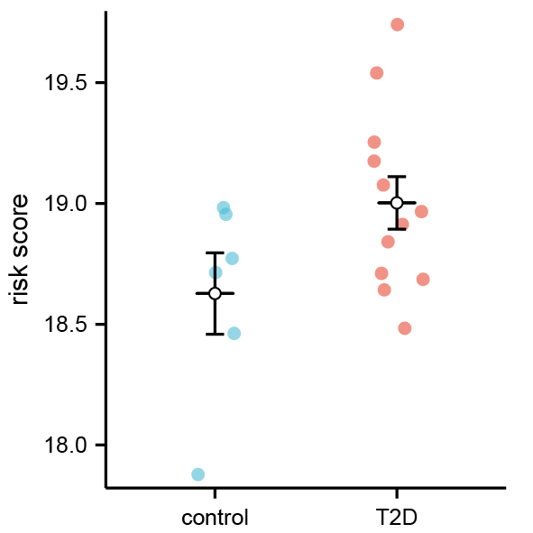
Figure S1: Type 2 diabetes risk score of case and control group based on PBMC samples from GSE156993. Red: type 2 diabetes group, blue: control group.
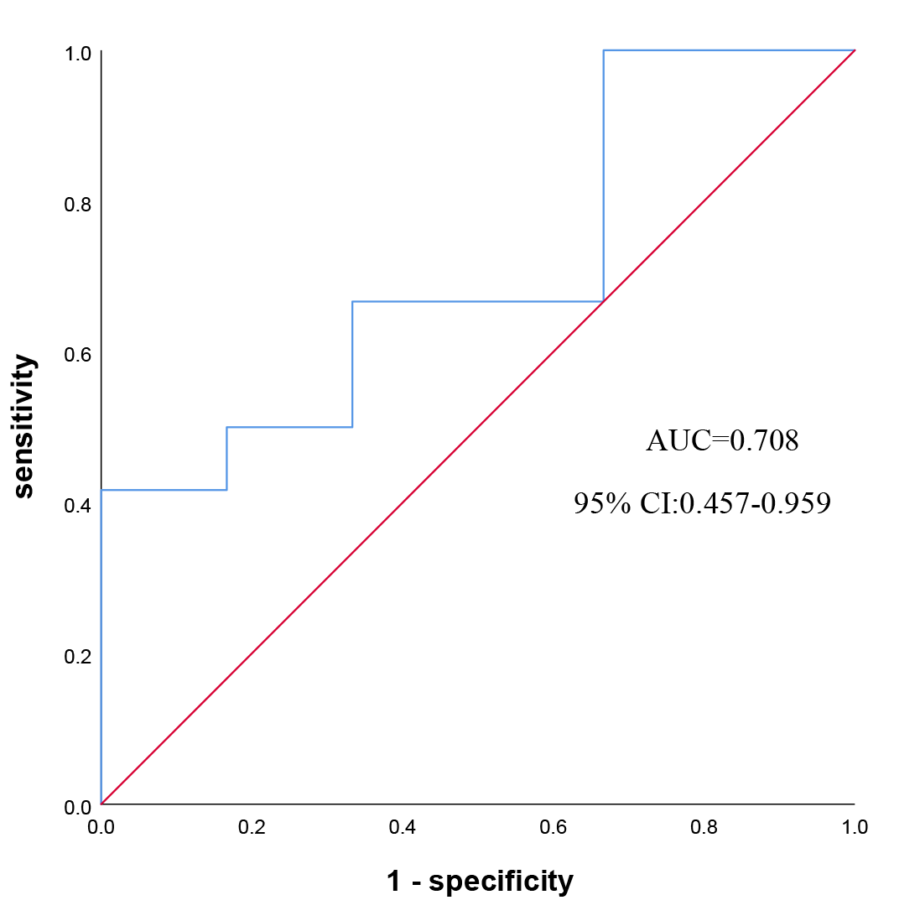
Figure S2: ROC curve of type 2 diabetes risk model based on PBMC samples. AUC: area under curve; CI: confidence interval.

Figure S3: Expression of ICGs between type 2 diabetes and control group in GSE156993; x-axis: ICGs, y-axis: gene expression level; red: type 2 diabetes group, blue: control group. *: P <0.05, **: P <0.01.

