Supplemental Tables and Figures
Supplemental Figure 1. Flowchart of study participants selection
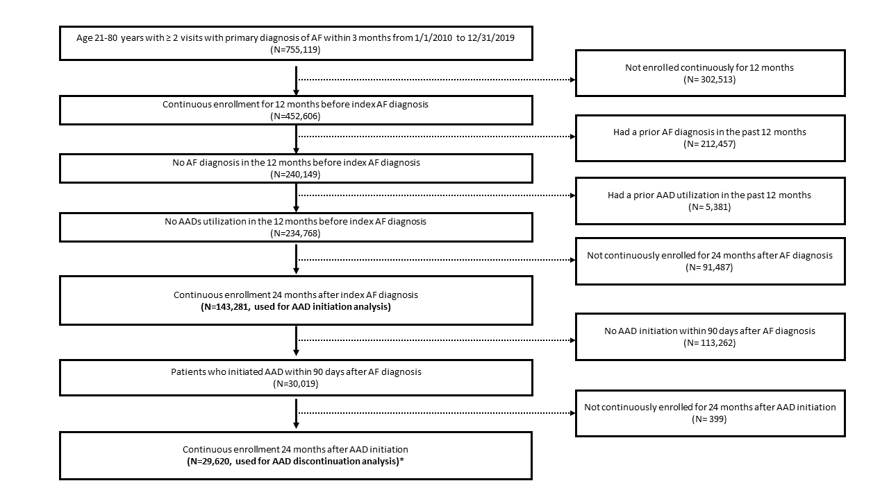
Abbreviations: AAD: antiarrhythmic drug, AF: atrial fibrillation
*The sample was also used to estimate rate of switching AAD, receipt of catheter ablation, and hospitalization during follow-up

Supplemental Table 1. ICD-9 and ICD-10 codes for cardiovascular hospitalization
Health conditions | ICD codes
Coronary artery disease | ICD-9: 413.0, 413.1, 413.9, 414, 414.01, 414.06, 414.8, 414.9  ICD-10: I20.1, I20.8, I20.9, I25.10, I25.110, I25.111, I25.118, I25.119, I25.5, I25.6, I25.701, I25.708, I25.709, I25.711, I25.718, I25.719, I25.721, I25.728, I25.729, I25.731, I25.738, I25.739, I25.750, I25.751, I25.758, I25.759, I25.761, I25.768, I25.769, I25.791, I25.798, I25.799, I25.811, I25.89, I25.9
Heart failure | ICD-9: 39891, 40201, 40211, 40291, 40401, 40403, 40411, 40413, 40491, 40493, 428, 4280, 4281, 4282, 42821, 42822, 42823, 4283, 42831, 42832, 42833, 4284, 42841, 42842, 42843, 4289  ICD-10: I099, I110, I130, I132, I50, I501, I502, I5020, I5021, I5022, I5023, I503, I5030, I5031, I5032, I5033, I504, I5040, I5041, I5042, I5043, I50810, I50811, I50812, I50813, I50814, I5082, I5083, I5084, I5089, I509, P290
Cardiomyopathy | ICD-9: 425.xx  ICD-10: I42.0, I42.1, I42.2, I42.3, I42.4, I42.5, I42.6, I42.7, I42.8, I42.9, I43
Cardiac arrhythmias | ICD-9: 426.89, 427.0, 427.1, 427.2, 427.31, 427.32, 427.41, 427.42, 427.5, 427.60, 427.61, 427.69, 427.81, 427.89, 427.9, 785.0, 785.1, 785.2, 785.3  ICD-10: I45.89, I46.2, I46.8, I46.9, I47.0, I47.1, I47.2, I47.9, I48.0, I48.1, I48.2, I48.3, I48.4, I48.91, I48.92, I49.01, I49.02, I49.1, I49.2, I49.3, I49.40, I49.49, I49.5, I49.8, I49.9
Cerebral hemorrhage | ICD-9: 430, 431, 432.x  ICD-10: I60.01, I60.02, I60.10, I60.11, I60.12, I60.2, I60.30, I60.31, I60.32, I60.4, I60.50, I60.51, I60.52, I60.6, I60.7, I60.8, I60.9, I61.0, I61.1, I61.2, I61.3, I61.4, I61.5, I61.6, I61.8, I61.9, I62.00, I62.01, I62.02, I62.03, I62.1, I62.9
Stroke | ICD-9: 433.xx, 434.xx  ICD-10: I65.1, I63.00, I63.011, I63.012, I63.013, I63.019, I63.02, I63.031, I63.032, I63.033, I63.039, I63.09, I63.10, I63.111, I63.112, I63.113, I63.119, I63.12, I63.131, I63.132, I63.133, I63.139, I63.19, I63.20, I63.211, I63.212, I63.213, I63.219, I63.22, I63.231, I63.232, I63.233, I63.239, I63.29, I63.30, I63.311, I63.312, I63.313, I63.319, I63.321, I63.322, I63.323, I63.329, I63.331, I63.332, I63.333, I63.339, I63.341, I63.342, I63.343, I63.349, I63.39, I63.40, I63.411, I63.412, I63.413, I63.419, I63.421, I63.422, I63.423, I63.429, I63.431, I63.432, I63.433, I63.439, I63.441, I63.442, I63.443, I63.449, I63.49, I63.50, I63.511, I63.512, I63.513, I63.519, I63.521, I63.522, I63.523, I63.529, I63.531, I63.532, I63.533, I63.539, I63.541, I63.542, I63.543, I63.549, I63.59, I63.6, I63.8, I63.9, I65.01, I65.02, I65.03, I65.09, I65.21, I65.22, I65.23, I65.29, I65.8, I65.9, I66.01, I66.02, I66.03, I66.09, I66.11, I66.12, I66.13, I66.19, I66.21, I66.22, I66.23, I66.29, I66.3, I66.8, I66.9, I67.89

Supplemental Table 2. Adjusted odds ratio for AAD initiation after new diagnosis of AF in subgroups of different age, sex, and income
 | OR (95% CI)
<65 yrs
NHW | Ref
NHB | 0.82 (0.75-0.90)
Hispanic | 0.88 (0.79-0.97)
Asian | 1.04 (0.86-1.25)
Other | 0.87 (0.71-1.05)
≥65 yrs
NHW | Ref
NHB | 0.93 (0.87-0.99)
Hispanic | 1.07 (1.01-1.13)
Asian | 0.96 (0.86-1.07)
Other | 1.00 (0.89-1.12)
Female
NHW | Ref
NHB | 0.88 (0.82-0.95)
Hispanic | 1.05 (0.98-1.13)
Asian | 0.92 (0.79-1.07)
Other | 1.02 (0.88-1.19)
Male
NHW | Ref
NHB | 0.91 (0.85-0.98)
Hispanic | 1.00 (0.94-1.08)
Asian | 1.02 (0.90-1.16)
Other | 0.92 (0.80-1.04)
Income ≤59 K
NHW | Ref
NHB | 0.88 (0.83-0.94)
Hispanic | 1.00 (0.94-1.07)
Asian | 0.88 (0.74-1.04)
Other | 0.97 (0.83-1.15)
Income ≥60 K
NHW | Ref
NHB | 0.90 (0.82-0.98)
Hispanic | 1.05 (0.97-1.13)
Asian | 1.03 (0.92-1.16)
Other | 0.95 (0.84-1.08)

Compared to NHW, patients identified as NHB are significantly less likely to initiate any AAD following initial diagnosis of AF.

Model adjusted for all covariates listed in Figure 1.

Abbreviations: AAD- antiarrhythmic drug; AF- atrial fibrillation; NHB- Non-Hispanic Black; NHW- Non-Hispanic White.
Supplemental Table 3. Sensitivity analyses for AAD initiation
 | Model 1 | Model 2
 | OR and 95% CI | OR and 95% CI
NHW | ref | ref
NHB | 0.92 (0.86, 0.99) | 0.89 (0.84, 0.93)
Hispanic | 1.09 (1.01, 1.16) | 1.03 (0.98, 1.08)
Asian | 0.95 (0.83, 1.09) | 0.97 (0.89, 1.07)
Other | 0.88 (0.76, 1.02) | 0.96 (0.87, 1.06)
Abbreviations: AAD: antiarrhythmic drug; AF: atrial fibrillation; CI: confidence interval; NHB: Non-Hispanic Black; NHW: Non-Hispanic White; OR: odds ratio.
Model 1 adjusted for all covariates listed in Figure 1 plus AF subtype. Only incident AF patients diagnosed between October 2015 – December 2019 were included in the model.
Model 2 adjusted for all covariates listed in Figure 1 plus individual types of comorbidities (obesity, congestive heart failure, cardiac arrhythmias, valvular disease, peripheral vascular disorders, pulmonary circulation disorders, chronic pulmonary disease, diabetes, hypertension, renal failure, and sleep apnea)

Supplemental Table 4. Fully adjusted hazard ratio for ablation within two years of AAD initiation
 | Model 1 | Model 2 | Model 3
 | HR and 95% CI | HR and 95% CI | HR and 95% CI
NHW | Ref | Ref | Ref
NHB | 0.83 (0.70, 0.97) | 0.84 (0.67, 1.05) | 0.85 (0.71, 1.02)
Hispanic | 0.88 (0.75, 1.03) | 0.81 (0.65, 1.00) | 0.86 (0.72, 1.02)
Asian | 0.82 (0.61, 1.09) | 0.81 (0.54, 1.22) | 0.76 (0.54, 1.06)
Other | 1.10 (0.84, 1.43) | 1.22 (0.83, 1.78) | 1.03 (0.76, 1.39)
Model 1 adjusted for all covariates in Figure 1
Model 2 adjusted for all covariates in Figure 1 plus AF subtype. Only incident AF patients diagnosed between October 2015 – December 2019 were included in the model.
Model 3 adjusted for all covariates in Figure 1 plus individual types of comorbidities (obesity, congestive heart failure, cardiac arrhythmias, valvular disease, peripheral vascular disorders, pulmonary circulation disorders, chronic pulmonary disease, diabetes, hypertension, renal failure, and sleep apnea).
Model 2 and model 3 were sensitivity analyses.
Compared to NHW, patients identified as NHB were significantly less likely to receive catheter ablation following initiation of AAD.

Model adjusted for all covariates listed in Figure 1.

Abbreviations: AAD- anti-arrhythmic drug; NHB- Non-Hispanic Black; NHW- Non-Hispanic White

Supplemental Table 5. Rate of AAD discontinuation within two years of AAD initiation stratified by AAD and race and ethnicity

 | Overall  N_{initiated on AAD}=29,620 | Non-Hispanic White  N_{initiated on AAD} =23,210 | Non-Hispanic Black  N_{initiated on AAD} =2,361 | Hispanic  N_{initiated on AAD} =2,434 | Asian  N_{initiated on AAD} =583 | Other  N_{initiated on AAD} =1,032
Any AAD | 19,189 (64.8) | 14,945 (64.4) | 1,452 (61.5) | 1,681 (69.1) | 418 (71.7) | 693 (67.2)
Amiodarone | 11,780 (78.4) | 9,008 (78.5) | 943 (73.6) | 1120 (79.7) | 259 (83.3) | 450 (83.0)
Dofetilide | 223 (45.9) | 185 (45.9) | 23 (46.9) | 4 (36.4) | 2 (40.0) | 9 (50.0)
Dronedarone | 2,221 (75.3) | 1,753 (74.8) | 166 (73.5) | 182 (79.8) | 48 (78.7) | 72 (80.0)
Flecainide | 2,922 (59.8) | 2,358 (59.6) | 186 (58.3) | 210 (62.0) | 63 (69.2) | 105 (57.7)
Propafenone | 1,276 (69.2) | 1,027 (69.8) | 85 (61.6) | 100 (70.4) | 31 (77.5) | 33 (62.3)
Sotalol | 2,269 (51.8) | 1,832 (52.1) | 167 (48.7) | 157 (51.5) | 43 (58.9) | 70 (48.0)

Abbreviations: AAD- antiarrhythmic drug
Supplemental Figure 2. Kaplan Meier curves for AAD discontinuation stratified by race and ethnicity
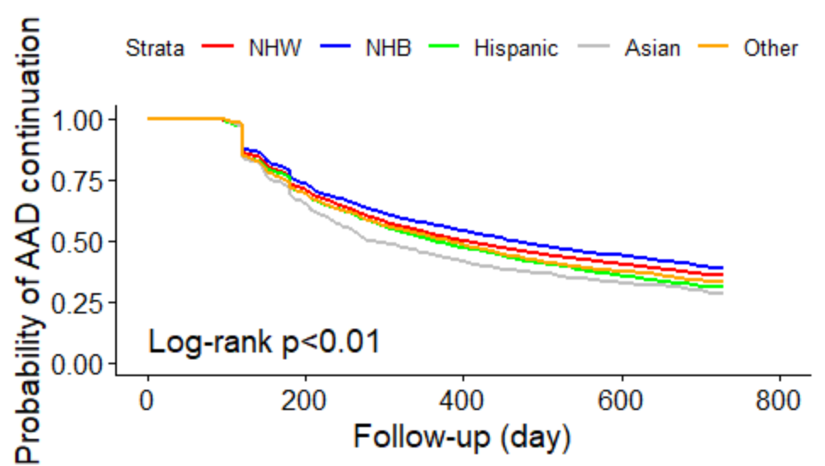

Following initiation of AAD for newly diagnosed AF, patients identified as NHB were least likely to discontinue AAD.

Abbreviations: AAD- antiarrhythmic drug; AF- atrial fibrillation; NHB- Non-Hispanic Black; NHW- Non-Hispanic White

Supplemental Table 6. Fully adjusted hazard ratios for AAD discontinuation within two years of antiarrhythmic drug initiation stratified by age, gender, and income
 | HR (95% CI)
<65 yrs
NHW | Ref
NHB | 1.01 (0.92, 1.12)
Hispanic | 1.13 (1.01, 1.25)
Asian | 1.06 (0.87, 1.29)
Other | 1.09 (0.89, 1.33)
≥65 yrs
NHW | Ref
NHB | 0.94 (0.88, 1.01)
Hispanic | 1.06 (1.00, 1.13)
Asian | 1.22 (1.09, 1.38)
Other | 0.99 (0.87, 1.12)
Female
NHW | Ref
NHB | 1.05 (0.97, 1.14)
Hispanic | 1.08 (0.99, 1.16)
Asian | 1.41 (1.21, 1.64)
Other | 0.99 (0.83, 1.18)
Male
NHW | Ref
NHB | 0.89 (0.82, 0.96)
Hispanic | 1.08 (1.00, 1.16)
Asian | 1.03 (0.90, 1.18)
Other | 1.03 (0.89, 1.18)
Income ≤59 K
NHW | Ref
NHB | 0.96 (0.90, 1.03)
Hispanic | 1.09 (1.01, 1.17)
Asian | 1.18 (0.98, 1.43)
Other | 1.07 (0.89, 1.29)
Income ≥60 K
NHW | Ref
NHB | 0.97 (0.88, 1.08)
Hispanic | 1.06 (0.98, 1.14)
Asian | 1.16 (1.03, 1.31)
Other | 0.98 (0.86, 1.12)

Compared to patients identified as NHW, patients identified as Hispanic and Asian were significantly more likely to discontinue AAD within two years of AAD initiation.
Abbreviations: AF- atrial fibrillation; NHB- Non-Hispanic Black; NHW- Non-Hispanic White

Supplemental Table 7. Sensitivity analyses for AAD discontinuation
 | Model 1 | Model 2
 | HR and 95% CI | HR and 95% CI
NHW | Ref | Ref
NHB | 0.96 (0.89, 1.03) | 0.95 (0.90, 1.01)
Hispanic | 1.08 (1.01, 1.16) | 1.07 (1.02, 1.13)
Asian | 1.12 (0.97, 1.29) | 1.15 (1.04, 1.28)
Other | 0.91 (0.77, 1.08) | 1.01 (0.90, 1.13)
Abbreviations: AAD: antiarrhythmic drug; AF: atrial fibrillation; CI: confidence interval; HR: hazard ratio; NHB: Non-Hispanic Black; NHW: Non-Hispanic White.
Model 1 adjusted for all covariates listed in Figure 4 plus AF subtype. Only incident AF patients diagnosed between October 2015 – December 2019 were included in the model.
Model 2 adjusted for all covariates listed in Figure 4 plus individual types of comorbidities (obesity, congestive heart failure, cardiac arrhythmias, valvular disease, peripheral vascular disorders, pulmonary circulation disorders, chronic pulmonary disease, diabetes, hypertension, renal failure, and sleep apnea)

Supplemental Table 8a. Comparison of OR between the primary model and trimmed model for AAD initiation
 | OR and 95% CI in the primary model† | OR and 95% CI in model 1* | % change in OR | OR and 95% CI in model 2** | % change in OR | OR and 95% CI in model 3*** | % change in OR
NHW | REF | REF | - | REF | - | REF | -
NHB | 0.90 (0.85, 0.94) | 0.90 (0.86, 0.95) | 0 | 0.88 (0.83, 0.92) | -2.22 | 0.88 (0.84, 0.93) | -2.22
Hispanic | 1.02 (0.97, 1.08) | 1.04 (0.99, 1.09) | +1.96 | 1.03 (0.98, 1.08) | +0.98 | 1.03 (0.99, 1.08) | +0.98
Asian | 0.98 (0.89, 1.07) | 0.97 (0.88, 1.07) | -1.02 | 0.99 (0.90, 1.09) | +1.02 | 0.99 (0.90, 1.08) | +1.02
Other | 0.96 (0.87, 1.06) | 0.96 (0.87, 1.06) | 0 | 0.95 (0.86, 1.05) | +1.04 | 0.88 (0.82, 0.94) | -8.33
Abbreviations: AAD: antiarrhythmic drugs, CI: confidence interval, NHB: non-Hispanic Black, NHW: non-Hispanic White, OR: odds ratio
†The primary model refers to the multivariable logistic regression model that adjusted for all variables in Figure 1.
*Model 1 removed education.
**Model 2 removed income.
***Model 3 removed both education and income.
The percentage change=(OR_{[trimmed model]} – OR_{[primary model]})/OR_{[primary model]} × 100%

Supplemental Table 8b. Comparison of HR between the primary model and trimmed model for AAD discontinuation
 | HR and 95% CI in the primary model† | HR and 95% CI in model 1* | % change in HR | HR and 95% CI in model 2** | % change in HR | HR and 95% CI in model 3*** | % change in HR
NHW | REF | REF | - | REF | - | REF | -
NHB | 0.96 (0.91, 1.02) | 0.96 (0.90, 1.01) | 0 | 0.96 (0.91, 1.02) | 0 | 0.95 (0.90, 1.00) | -1.04
Hispanic | 1.08 (1.02, 1.14) | 1.07 (1.01, 1.13) | -0.93 | 1.09 (1.04, 1.15) | +0.93 | 1.08 (1.03, 1.14) | 0
Asian | 1.17 (1.06, 1.29) | 1.17 (1.06, 1.29) | 0 | 1.15 (1.04, 1.27) | -1.71 | 1.16 (1.05, 1.27) | -0.85
Other | 1.01 (0.91, 1.13) | 1.01 (0.90, 1.12) | 0 | 1.03 (0.92, 1.14) | +1.98 | 1.06 (0.98, 1.14) | +4.95
Abbreviations: AAD: antiarrhythmic drugs, CI: confidence interval, HR: hazard ratio, NHB: non-Hispanic Black, NHW: non-Hispanic White
†The primary model refers to the multivariable Cox regression model that adjusted for all variables in Figure 1.
*Model 1 removed education.
**Model 2 removed income.
***Model 3 removed both education and income.
The percentage change=(HR_{[trimmed model]} – HR_{[primary model]})/HR_{[primary model]} × 100%

Supplemental Table 8c. Comparison of HR between the primary model and trimmed model for CA receipt
 | HR and 95% CI in the primary model† | HR and 95% CI in model 1* | % change in HR | HR and 95% CI in model 2** | % change in HR | HR and 95% CI in model 3*** | % change in HR
NHW | REF | REF | - | REF | - | REF | -
NHB | 0.83 (0.70, 0.97) | 0.82 (0.70, 0.97) | -1.20 | 0.73 (0.62, 0.86) | -12.05 | 0.70 (0.60, 0.83) | -15.66
Hispanic | 0.88 (0.75, 1.03) | 0.87 (0.75, 1.02) | -1.14 | 0.89 (0.76, 1.03) | +1.14 | 0.85 (0.73, 0.98) | -3.41
Asian | 0.82 (0.61, 1.09) | 0.78 (0.58, 1.05) | -4.88 | 0.80 (0.60, 1.06) | -2.44 | 0.81 (0.61, 1.08) | -1.22
Other | 1.10 (0.84, 1.43) | 1.07 (0.82, 1.40) | -2.73 | 1.05 (0.80, 1.37) | -4.55 | 0.98 (0.80, 1.21) | -10.91
Abbreviations: CA: catheter ablation, CI: confidence interval, HR: hazard ratio, NHB: non-Hispanic Black, NHW: non-Hispanic White
†The primary model refers to the multivariable Cox regression model that adjusted for all variables in Figure 1 except CA receipt.
*Model 1 removed education.
**Model 2 removed income.
***Model 3 removed both education and income.
The percentage change=(HR_{[trimmed model]} – HR_{[primary model]})/HR_{[primary model]} × 100%

